KWAME NKRUMAH UNIVERSITY OF SCIENCE AND TECHNOLOGY

COLLEGE OF HUMANITIES AND SOCIAL SCIENCES

SCHOOL OF BUSINESS

DEPARTMENT OF ACCOUNTING AND FINANCE

INTERNATIONAL TRADE AND DEVELOPMENT IN AFRICA: THE ROLE OF EXCHANGE RATE

BY

GENEVIEVE GYASI

A THESIS SUBMITTED TO THE DEPARTMENT OF ACCOUNTING AND FINANCE, KWAME NKRUMAH UNIVERSITY OF SCIENCE AND TECHNOLOGY, KUMASI, IN PARTIAL FULFILMENT OF REQUIREMENTS FOR THE AWARD OF THE DEGREE OF

DOCTOR OF PHILOSOPHY

BUSINESS AND MANAGEMENT (FINANCE)

MAY 2023

INTERNATIONAL TRADE AND DEVELOPMENT IN AFRICA: THE ROLE OF EXCHANGE RATE

BY

GENEVIEVE GYASI

A Thesis Submitted to the Department of Accounting and Finance, Kwame Nkrumah University of Science and Technology, Kumasi, in partial fulfillment of the requirements for the award of the degree of

DOCTOR OF PHILOSOPHY

KNUST Scholl of Business, College of Humanities and Social Science

May 2023

# DECLARATION

I hear by declare that this submission is my work and that, to the best of my knowledge and belief, it contains no material previously published or written by another person nor material that has been accepted for the award of any other degree or diploma at the Kwame Nkrumah University of Science and Technology, Kumasi or any other educational institution, except where due acknowledgment is made in the thesis.

GENEVIEVE GYASI ………………. ……………..

Student’s Name Signature Date

PROF MAGNUS JOSEPH FRIMPONG ……………….. ……………….

1st Supervisor’s Name Signature Date

Dr. KWAME MIREKU ………………… ………………

2nd Supervisor’s Name Signature Date

**Certify by**

PROF KINGSLEY OPOKU APPIAH …………………. ………………

Head of Department Name Signature Date

# DEDICATION

This work is dedicated to my mother, Theresa Oppong Kyeremaa, my father, Anthony Krapa Kitson Gyasi, and my sister Michelle Gyasi whose love and support have seen me up to the end of this course of study at the University.

# ACKNOWLEDGEMENT

First, I thank the Almighty God for giving me the wisdom, knowledge, strength, and protection to undertake this study. My profound gratitude goes to my Supervisors, Prof. Magnus Joseph Frimpong and Dr. Kwame Mireku, for their time, efforts, and corporation, especially for reading through the thesis and offering helpful suggestions. Secondly, I thank Dr. Maurice Omane-Adjepong for his constructive criticisms that provided me the impetus to shape the work to its completion. Also, thanks go to my mother, Mrs. Theresa Oppong Kyeremaa, Mr. Theophilus Osei Tuffour, and Ms. Veronica Eyram Lagbeneku of the University of Energy and Natural Resources for their numerous support to me in the areas of counseling, prayers, and care respectively. Furthermore, I sincerely extend special gratitude to the University of Energy and Natural Resources Management for supporting me financially and with other resources to enable me to pursue this program of study. My final thanks go to UNCTAD-EORA, the World Development Indicators database, and investing.com for using their official website for my data set used for the study.

# ABSTRACT

Exchange rates are part of the underlying interest in studying why and how African economies continue to rise and fall. This research brings into perspective an understanding of the dynamics perpetuating this event in several African markets and economies. This study focuses on using mechanisms through the lens of economic and financial disparities on the African continent. This research aimed to examine transmission, spillover, and interdependence in the co-movement of exchange rates in topical issues around the movement of goods and services in Africa. The thesis considers questions and finds answers based on the effect's degree of intensity, direction, and magnitude.

The study employed the Parametric and Nonparametric Granger Causality test and extended it by wavelet transformation to estimate the extent of volatility spillover effects and movements. The study examined the selected African economies individually based on the size of their markets, the level of local currency depreciation, the inflow of remittance, and capital data available for analysis. The study used annual and daily data for the selected variables (remittance, economic growth [gdp: gross domestic product], global value chain participation [GVCs], inflation, trade, and stock market returns against exchange rates) to examine the co-movement's present in the economies. Data was sourced from the World Development Indicator database [WDI], UNCTAD-Eora Global Value Chain, International Monetary Fund, and investing.com.

The results from the first thematic study employed partial and biwavelet coherence methods to investigate the time-frequency dependence structure of remittance inflow on economic growth by moderating the effect of exchange rates. The study investigated co-movements of remittance and economic growth from 1980 to 2020. The researcher observed heterogeneous patterns in the co-movement structure of international remittance inflow and economic growth at various timescales. Findings from the wavelet transformations reveal that exchange rates influence remittance and economic growth connectedness in emerging and frontier economies in Africa.

The second thematic study employs continuous wavelet coherence techniques to examine the time-frequency dependence structure of global value chain (GVC) participation and exchange rate in Africa from 1990 to 2018. The researcher observed no individual heterogeneous patterns in co-movement structure at the various timescales for the exchange rate, trade, and inflation against GVC participation. The results imply that the exchange rate does not act to hamper value chain participation directly.

The third thematic paper employs the Continuous Wavelet Transformation (CWT) coherence technique lead-lag causal relationship to examine four(4) frontier stock market in Africa and their respective currency markets. The study uses daily data from January 2010 to March 2023. The study observed heterogeneous patterns in co-movement structure at different time scales with a mix of lead-lag interplay among the indices for Ghana, Kenya, Mauritius, and Tunisia.

During global events, African markets and economies under erratic exchange rate impact growth and development. The major findings imply that foreign exchange markets in Africa influence the movement of goods and services as they are more prone to spillover and transmission from global events. However, in sectors where value addition is a low direct impact from the exchange rate was not found along the international trade supply route.

Policymakers can achieve exchange rate stability if they design control mechanisms for macroeconomic factors that mitigate risk in a constantly changing environment for moving goods and services globally and within the continent. Additionally, governments should moderate and strengthen institutional mechanisms in managing macroeconomic fundamentals and consider regional events to cope with unforeseen shocks and spillovers as Africa continues integrating markets.

TABLE OF CONTENTS

**DECLARATION i**

**DEDICATION ii**

**ACKNOWLEDGEMENT iii**

**ABSTRACT iv**

**LIST OF TABLES xi**

**LIST OF FIGURES xii**

**CHAPTER ONE 1**

1.1 Background of the Study 1

1.3 Problem Statement 3

1.4 Objective of the Study 6

1.5 Research Questions 7

1.6 Methodological Approach to the Study 8

1.6.1 Philosophical Perspectives 8

1.6.2 Philosophical Foundations 9

1.6.3 Research Design 9

1.7 Significance of the Study 10

1.8 Scope of Study 11

1.9 Chapter Dispositions 12

**CHAPTER TWO 13**

**EXCHANGE RATE AND DEVELOPMENT THEORY; NEW INSIGHT FROM EVIDENCE AND CHALLENGES FROM DEVELOPING ECONOMIES 13**

**CHAPTER TWO 14**

**Evolution of Exchange Rate, Economic Growth, International Trade and the Financial Market Investment Relationship; New insight African Economies 14**

2.0 Introduction 14

2.1 Definition of Concepts 14

2.2 Evolution of Exchange Rate Regimes 16

2.2.1 Choice of Exchange Rate Regime 17

2.2.2 Global Foreign Exchange Market 18

2.2.2.1 Africa’s Participation in Global Foreign Exchange Markets 18

2.2.3 Exchange Rate Challenges in Africa 19

2.3 Theoretical Review 22

2.3.1 Classical and Neo-Classical theories 22

2.3.1.1 Investment 22

2.3.1.2 Production 22

2.3.1.3 Trade 23

2.3.1.4 Remittance and Growth 23

2.3.1.5 Exchange Rates 24

2.4 Exchange Rate Policy 24

2.4.1 Exchange rate Policy Mechanisms 26

2.5 Exchange Rate Volatility 27

2.5.1 Channels of Transmission 27

2.5.2 Exchange Rate Volatility Transmission models 30

2.6 Exchange Rate Measurement 30

2.6.1 Issues with Exchange Rate Measurement 31

2.7 Conceptual Framework 33

2.7.1 Economic Fundamentals and Exchange Rate Linkages 33

2.7.2 Contagion 34

2.7.2.1 Exchange Rate Contagion Methodologies 35

2.7.2.2 Models for Contagion Linkages 36

**CHAPTER THREE 40**

**MODERATING REMITTANCE AND ECONOMIC GROWTH RELATIONSHIP WITH EXCHANGE RATE: WHAT NEW CAN WE LEARN FROM AFRICA'S ECONOMY? 40**

**CHAPTER THREE 41**

**MODERATING REMITTANCE AND ECONOMIC GROWTH RELATIONSHIP WITH EXCHANGE RATE: WHAT NEW CAN WE LEARN FROM AFRICA'S ECONOMY? 41**

Abstract 41

3.1 Introduction 42

3.2 Literature Review 44

3.2.1.0 Theoretical Review 45

3.2.1.1The Solow Growth Model 45

3.2.1.3 Marshall-Lerner Theory 46

3.2.1.4 J-curve Theory 48

3.2.2 Empirical Literature 49

3.3 Methodology 51

3.3.1 Research Design 51

3.3.2 Data Sources and Collection 52

3.3.2.1 Measurement of Variables 52

3.3.2.1.2 Dependent Variable 52

3.3.2.1.3 Control Variables 52

3.3.2.1.4 Dataset Analysis 53

3.4 Empirical Model and Estimation Technique 54

3.4.1 Linear Granger causality test 54

3.4.1.2 Nonlinear Granger causality test 56

3.4.2 Wavelet methods 58

3.4.2.1 Continuous Wavelet Transformation (CWT) and Coherence 58

3.4.2.2 Partial Wavelet Transform and Coherence 62

3.5 Results and Interpretations 63

3.5.1 Descriptive Statistics 63

3.5.1.2 Linear and Nonlinear Causality Analysis 66

3.5.1.3 Bivariate and Partial wavelet coherence results 67

3.6 Conclusion 85

**CHAPTER FOUR 88**

**ECONOMIC TRANSFORMATION THROUGH GLOBAL VALUE CHAINS; NEW INSIGHT FROM EXCHANGE RATE EFFECTS ON THE AFRICAN ECONOMY. 88**

**CHAPTER FOUR 89**

**ECONOMIC TRANSFORMATION THROUGH GLOBAL VALUE CHAINS; NEW INSIGHT FROM EXCHANGE RATE EFFECTS ON THE AFRICAN ECONOMY. 89**

Abstract 89

4.1 Introduction 90

4.2 Theoretical Background and Review of Literature 92

4.2.1.1 Global Value Chain (GVC) Theory 93

4.2.1.2 The Internationalization Theory 94

4.2.2 Empirical Literature Review 96

4.3 Methodology 99

4.3.1 Research Design 99

4.3.2 Data Sources and Collection 99

4.4 Empirical Model and Estimation Technique 100

4.4.1 Wavelet methods 100

4.4.2 Continuous Wavelet Transformation (CWT) and Coherence 101

4.4.3 Wavelet Coherence 102

4.5 Results and Interpretation 104

4.5.1 Descriptive Statistics 104

4.5.2 Bivariate wavelet coherence results 107

4.6 Conclusion 119

**CHAPTER FIVE 121**

**MULTIRESOLUTION DECOMPOSITION OF CO-MOVEMENT RELATIONSHIP BETWEEN FRONTIER AFRICAN STOCK MARKETS AND CURRENCY MARKETS: A BIWAVELET COHERENCE ANALYSIS 121**

**CHAPTER FIVE 122**

**MULTIRESOLUTION DECOMPOSITION OF THE CO-MOVEMENT RELATIONSHIP BETWEEN FRONTIER AFRICAN STOCK MARKETS AND CURRENCY MARKETS: A BIWAVELET COHERENCE ANALYSIS 122**

Abstract 122

5.1 Introduction 123

5.2 Theoretical Literature Review 126

5.2.1The Efficiency Market Hypothesis 126

5.2.2 The Traditional Approach 127

5.2.3 The Arbitrage Pricing Theory 127

5.2.4 The Flow-oriented Model 128

5.2.5 The Portfolio Balance Theory 128

5.3 Empirical Literature Review 129

5.4 Methodology 131

5.4.1 Research Design 131

5.4.2 Data Sources and Collection 131

5.4.3 Dataset Analysis 132

5.5 Empirical Model and Estimation Technique 133

5.5.1 Linear and Nonlinear Granger causality framework 133

5.5.2 Continuous Wavelet Transformation (CWT) and Coherence 136

5.6 Results and Interpretation 139

5.6.1 Descriptive Analysis 139

3.3.3.1 Linear and Nonlinear Causality Analysis 144

3.3.3.2 Co-movement of African Indices on African Stock Exchanges 145

5.6 Conclusion 155

**CHAPTER SIX 159**

**SUMMARY, CONCLUSIONS AND RECOMMENDATIONS 159**

6.1 Introduction 159

6.2 Summary 159

6.3 Conclusions 162

6.3.1 Moderating the Effect of Exchange Rates on Remittance and Economic Growth Nexus 162

6.3.2 Examining the Co-movement Pattern between GVC Participation and Exchange Rates 163

6.3.3 The effect of stock market returns on exchange rates 163

6.4 Recommendation 164

6.5 Limitations of the Study 166

6.6 Contributions of the Study 166

6.6.1 Contribution to Policy 166

6.6.2 Contribution to Literature 167

6.6.3 Contribution to Theory 167

6.6.4 Contributions to Practice 167

6.7 Further Research 168

**REFERENCES** 168

# LIST OF TABLES

Table A1: Selected Variables for Thematic One 52

Table1: Descriptive Statistics 64

Table 1: Cont. Descriptive Statistics 65

Table A2:Selected Variables for Thematic Two 99

Table 2: Descriptive Statistics 105

Table 2 Cont. Descriptive Statistics 106

Table A3: Selected Variable for Thematic Three 132

Table 3: Descriptive Statistics 141

Table A3.1: Linear Granger Causality Test Results 142

Table A3.2 Nonlinear Parametric Granger Causality Test Results 142

# LIST OF FIGURES

Figure 1.0 Moderating effect of Exchange Rates on Economic Fundamentals and Growth 46

Figure1.1 Conceptual Framework on Contagion Adapted from 50

Source: Cheung et al., (2009) 50

Figure B1: Ghana 92

Figure B2: South Africa 98

Figure B3:Uganda 103

Figure B4: Morocco 105

Figure B2.1:Ghana 131

Figure B2.2: Nigeria 134

Figure B2.3: South Africa 138

Figure B2.4: Morocco 141

Figure 5.1: Time series plot of the country-specific data 169

Figure 5.2: Plot of exchange rate changes and stock market returns in separate graphs 171

Figure 5.3: Plot of series 171

Figure 5.1a Filtered and Smoothed Probabilities for both regimes in MSM-AR model 173

Figure 5.2a Residuals 173

Figure 5.3a Normal QQ plots 174

Figure 5.4a ACF and PACF of residuals and square residuals for regime 1 and 2 174

Figure 5.5a Response variable indicating which observations are associated to regime 1 175

Figure 5.6a Response variable indicating which observations are associated to regime 2 175

Figure 5.7a Relationship between Exchange rates and Kenya Stock market returns locating the two regimes 176

Figure 5.1b Filtered and Smoothed Probabilities for both regimes in MSM-AR model 177

Figure 5.2b Residuals 177

Figure 5.3b Normal QQ plots regime 1 and 2 177

Figure 5.4b ACF and PACF of residuals and square residuals for regime 1 and 2 178

Figure 5.5b Response variable indicating which observations are associated to Regime 1 178

Figure 5.6b Response variable indicating which observations are associated to Regime 2 178

Figure 5.7b Relationship between Exchange rates and Kenya Stock market returns locating the two regimes 179

Figure 5.1c Filtered and Smoothed Probabilities for both regimes in MSM-AR model 180

Figure 5.2c Residuals 180

Figure 5.3c Normal QQ plots for regime 1 and 2 181

Figure 5.4c ACF and PACF of residuals and square residuals for regime 1 and 2 181

Figure 5.5c Response variable indicating which observations are associated to regime 1 182

Figure 5.6c Response variable indicating which observations are associated to regime 2 182

Figure 5.7c Relationship between Exchange rates and Mauritius Stock market returns locating the two regimes 183

Figure 5.1d Filtered and Smoothed Probabilities for both regimes in MSM-AR model 184

Figure 5.2d Residuals 184

Figure 5.3d Normal QQ plots 185

Figure 5.4d ACF and PACF of residuals and square residuals for regime 1 and 2 185

Figure 5.5d Response variable indicating which observations are associated to regime 1 186

Figure 5.6d Response variable indicating which observations are associated to regime 2 186

Figure 5.7d Relationship between Exchange rates and Mauritius Stock market returns locating the two regimes 187

Figure B3.1: Ghana 191

Figure B3.2:Kenya 194

Figure B3.3: Mauritius 196

Figure B3.4: Tunisia 198

LIST OF ABBREVIATIONS

A

Akaike Information Criteria

(AIC) 55

Arab Maghreb Union

(UMA) 6

autoregressive distributed lag

(ARDL) 129

B

Broad Money

Bm 53

C

cone of influence

(COI) 107

E

East African Community

(EAC), 6

Economic Community of West African States

(ECOWAS) 6

economic review Programme

(ERP) 1

Education

Educ 53

Exchange Rates

Exc 53

exponential general autoregressive conditional heteroskedastic

(EGARCH) 5

F

fractionally integrated generalized autoregressive conditional heteroscedastic

(FIGARCH) 130

G

generalized autoregressive conditional heteroscedasticity

(GARCH) 96

Generalized Methods of Moments

(GMM) 50

gross domestic product

[gdp] 52

GDP 1

I

Inflation

Inf 53

International monetary fund

(IMF) 1

L

Linear Dynamic Panel Data

(DPD) 50

M

Markov-Switching GARCH

(MSGARCH) 5

missing at random)

MAN 54

missing value imputation

(MVI) 54

O

One District One Factory

1D1F 110

Organization for Economic Co-operation and Development

OECD 168

R

regional economic communities

(REC) 6

S

Southern African Development Community.

(SADC) 6

T

The Nigeria Industrial Revolution Plan

(NIRP) 113

threshold-generalized autoregressive conditional heteroscedasticity

(TGARCH) 96

V

vector auto regression

(VAR) 55

vector autoregressive moving average with asymmetric generalized autoregressive conditional heteroscedasticity

(VARMA-AGARCH) 130

vector error correction model

(VECM) 96

W

wavelet cross-spectrum

(WCS) 61, 138

wavelet power spectrum

(WPS) 137

# CHAPTER ONE

## 1.1 Background of the Study

Africa is the second largest continent, with over 54 economic countries, including islands. The continent is diverse in nature, culture, and economic activities. The African economy has abundant natural resources commanding 30% to 90% of the world’s gold, uranium, manganese, diamonds, and platinum, among others (OECD, 2012). Despite this endowment level, Africa’s per capita GDP (gross domestic product) is low and remains the poorest continent. African economies have not leveraged their resources to bring together capital inflows to prioritize newly discovered underdeveloped markets to mobilize revenues, technological advancement, and access. The macroeconomic environment in Africa is characterized by fiscal and current account deficits resulting in poor economic growth, rising debt, poverty, failure to overcome macroeconomic volatility, and unsustainable growth (Olarinde and Yahaya, 2018; Giuagle, 2017; Hostland and Giugale, 2013). These issues, coupled with the fall of the Bretton Woods system, brought the onset of different exchange rate regimes, such as basket pegs, crawling pegs, and simple pegs, among others. The regime variations indicated the dynamic effect of exchange rates on economic growth.

The independence bliss of the 1950s and 1960s in Africa influenced exchange rate regime shifts, shifting economies from pegged to flexible exchange rate regimes. The recurring effect had to be managed to maintain international competitiveness whiles keeping domestic inflation low and maintaining positive interest rates, all under strict monetary measures. The problems from the fluctuation in macroeconomic stability drove African countries to the International Monetary Fund (IMF) for the economic review program (ERP). In the years after the ERP, African economies were deemed key desirable investment locations. They were seen as stable, profitable investment locations when other developed economies experienced low and uncertain returns (AfDB/OECD/UNDP, 2016). However, they were not central to the financial capital market movement.

African economies, under the United Nations Millennium Development Goals (UN MDGs), transitioned to the Sustainable Development Goals (SDGs) under the United Nations Agenda 2030 for sustainable development (the 2030 Agenda) and the corresponding African Union Agenda 2063, at a crucial time as inequalities rise on the African continent (Bhattacharya,2016; Hathie, 2016). The 2000s showed a steady rise in economic demand for African commodities driving growth. Subsequent global, economic, and financial shocks and deficits from the global economic crisis of 2008/2009 held back the transformative agenda of Africa’s growth and development in achieving the targets of the UN MDGs (United Nations Development Programme, 2014). The post-2015 Agenda (SDGs) for the continent gained momentum in growth and development as time, effort, and dedication progressed; however, variation between countries and regions broadened. The transition of African countries to the SDGs program in a drive to increase growth depends on harnessing economic benefits from regional integration and implementation of continental free trade.

Before the pandemic, Africa experienced rapid economic growth in the 2000s but was hardly translated into significantly improved livelihoods for most Africans. The informal sector employs 70% to 80% of women and youth traders on the continent. The COVID-19 pandemic depleted these labor groups' savings and livelihoods, exacerbating marginalized groups' inequalities and vulnerabilities. Informal cross-border trade by small businesses accounts for 90% of official trade flows in some countries and contributes up to 40% of total trade with the regional economic communities (REC). According to UNCTAD (2021), Africa currently holds an untapped export potential of about 21.9 billion USD, equivalent to 43% of intra-African exports. An additional USD 9.2 billion in export potential is expected from the partial tariff liberalization under the African Continental Free Trade Area (AfCFTA). Unlocking this untapped potential requires the effective and efficient implementation of the AfCFTA. The 3.4 million USD borderless market created by AFCFTA presents opportunities to reduce disparities induced by external events such as the health pandemic. Intra-African trade represents 14.4% of total African exports, with AfCFTA trade expected to increase by 33% and a low % trade deficit of 51% (UNCTAD, 2021). Intra-African trade comprises 61% processed and semi-processed goods suggesting a high potential benefit from regional trade for inclusive and transformative growth (UNCTAD, 2021). However, intra-African trade has received little practical participation from signed member states (Bassett, 2017).

If the AfCFTA is to fulfill its potential, it must diversify and inclusively transform African economies with effective policies and export strategies that identify new opportunities. Moreover, the AfCFTA can address many important constraints to trade linked to the market size, demand, and supply side by promoting and leveraging interdependencies to reduce volatilities. Reducing spillover effects in the markets will unlock significant wealth, job creation opportunities, and investments for human and infrastructural developments through good governance and effective and efficient macro-fiscal management of resources.

## 1.3 Problem Statement

Globalization of trade and finance has advanced through technology, and the deregulation of capital markets has deepened the interdependence between international and domestic markets in developing economies (Christoffersen et al., 2012). Exchange rates are the most important macroeconomic and financial variables in growth and development. Over the years, economics and international finance researchers have examined exchange rate volatility in line with recent developments in adopting flexible exchange rate systems.

Most African economies are open economies highly susceptible to shocks and shifts in the global economic landscape. These shocks' transmission and potential movement across markets and borders cannot be discounted. Over the years, exchange rates have served as barometers gauging the economic health of countries among global portfolio investors on the African continent. Fluctuations in exchange rate volatility have been difficult to measure and predict (More and Wang, 2014). This situation has generated political problems for governments since it influences the behavior of capital inflow in the short-term and net foreign assets as cross-border financial transactions increase (Chit et al., 2010).

Globalization has opened Africa to economic, financial, and trade linkages. Financial linkages consider all possible transfers of volatilities from one portfolio or financial market to another. Through portfolio investment management which includes all available information on the market, investors can manage their exposure to fluctuations in stock prices because of macroeconomic changes. Considering the possible spillovers on financial markets, the rapid financial integration of capital markets in Africa must be carefully examined (Joyce, 2012). Conversely, trade linkages suggest that exchange rate volatilities are connected to trade volumes among developing economies (Bae et al.,2003). Consequently, as intra-African trade grows, volatility spillover is expected to increase frequently (Mevel et al., 2015).

Given the potential growth in volatilities in exchange rates, the adverse effects on economies are a major concern in determining and attaining macroeconomic targets for planning, investing, and consumption policies. Understanding the transmission and co-movements is crucial for global portfolio investors on the African continent. A rise in volatility creates a loss in output and raises business costs, uncertainty, inequality, and poverty (Joyce and Naber, 2009). Foreign exchange movements impact trading partners' ability to trade at minimal transaction costs. African markets are often imperfect, making hedging expensive (Ploeg and Krugman,1990).

The low level of discourse on exchange rates among policy analysts and governments elucidates answers to exchange rate developments in academia, society, and the political arena. Again, exchange rates are significant in determining prices of petroleum products and other utilities; all other things being equal, if a currency depreciates, prices of utilities will rise, increasing the cost of living and doing business. Additionally, exchange rate transmission increases uncertainty in the level of riskiness for portfolio investment and the cost associated with hedging (de Zwart et al.,2009). The economic turbulence of the global stock market in 2008 studied by researchers found spillover transmissions to be mixed in America, Europe, and Asia with little focus on African markets (Aloui et al., 2011; Nikkien et al., 2010, Moshirian, 2011). However, African markets were impacted by the 2008/2009 financial crisis (Ben Ltaifa et al., 2009).

Studies on exchange rates examined in African literature have targeted nominal or real exchange rate fluctuations. Researchers have examined the determinants of volatilities (Mpofu, 2020; Philip Akani and James Temitope, 2017). Findings from studies have shown volatility emanating from monetary and domestic policies and output levels and the existing exchange rate system adopted in an economy, among others. Although studies have found volatility in exchange rates to broaden our understanding, little is known about the dynamic movement of exchange rates across different sectors of the economy. Regarding methodologies, different methodologies have been applied to time series data using models such as cointegration, value at risk, causality, exponential general autoregressive conditional heteroskedastic (EGARCH), Markov-Switching GARCH (MSGARCH), which have resulted in providing clarity on heteroskedastic problems when measuring correlations caused by volatilities during a crisis. Analysis of longer cross-country data has been limited because of inconsistent and compatible data from continental markets and economies. The application of wavelet transformation models to capture the time-horizon nature of exchange rates is scarce, particularly in Africa, which would provide a better view of the nature, degree, and direction of exchange rate volatility in Africa.

Therefore, this research study analyzes the degree and direction of the exchange rate effect on three core areas of African economies to enable policymakers, investors, and trade partners to make informed decisions. The study considers the remittance, supply chain, and stock market under the economic, trade, and financial sectors by examining whether exchange rates have a direct or moderated influence on the selected countries.

The study considers four regional economic communities (RECs) in Africa, namely, the Arab Maghreb Union (UMA), the East African Community (EAC), the Economic Community of West African States (ECOWAS), and the Southern African Development Community (SADC). The selection of countries from these regions is based primarily on the availability and consistency of data to provide a representative view of their respective regions and Africa. The spillover of exchange rates was examined across Ghana, Mauritius, Kenya, Morocco, Nigeria, South Africa, Tunisia, and Uganda due to the similarities between their economies, therefore examining foreign exchange rate patterns of co-movements across three thematic studies provides a better view of the transmission behavior across the respective economies.

## 1.4 Objective of the Study

The main objective of this research is to examine the transmission, extent of volatility spillover, and co-movement within African economies. Specifically, the study seeks to:

1. Examine the moderating effect of exchange rates on remittance and economic growth nexus.
2. Determine the co-movement pattern between global value chain participation and exchange rate for economic transformation.
3. Investigate the effect of exchange rate on stock market returns for structural transformation.
4. Examine the moderating effect of exchange rates on the exogenous events and African frontier stock markets' relationship

## 1.5 Research Questions

The following research questions are used as guides throughout each thematic study of the set objectives.

1. Does exchange rate volatility moderate the remittance and economic growth nexus within the selected African economies?
2. What co-movement patterns exist between GVCs' participation and exchange rate volatility within the selected African economies?
3. What is the degree, magnitude, and direction of the interdependence between stock returns and exchange rates within African countries?
4. Does exchange rate volatility moderate the exogenous events and African frontier stock markets’ relationship?

## 1.6 Methodological Approach to the Study

### 1.6.1 Philosophical Perspectives

Research philosophy is a systemic set of basic beliefs and assumptions that guide the design, development, and execution of knowledge in a research study (Saunders et al., 2009). Three major research paradigms exist constructivism, pragmatism, and positivism (Johnson et al.,2007). Paradigms differ based on the assumptions one holds about knowledge, be it ontology or epistemology. Under ontology, assumptions are based on the nature of reality and its ability to shape how a researcher sees and studies his research objects (Saunders et al., 2009). Epistemology concerns acceptable, vital, and legitimate knowledge and how it is communicated to others (Burrel and Margan, 2017).

Different research outputs today fall under different epistemologies presenting various choice methodologies for new knowledge products. A positivist researcher, who views reality as external and independent, views it from an ontological perspective, while observations based on external realities are epistemological. Consequently, researchers present knowledge as only significant if it is based on observations of external realities instead of assuming that reality is external and independent (Smith et al., 2012). Subsequently, research studies that are deductive and use quantitative methods of approach are found to be positivist.

A constructivist philosopher views research ideas from a constructivist, humanist, hermeneutics, and idealist point of view to bring understanding to a phenomenon (Lincoln, Lynham, and Guma, 2011). Knowledge of a constructivist under ontology is complex and depends on social constructs such as culture and language fusing the reality of process, experience, and practice. On the other hand, the knowledge that depends on theories, concepts, narrative stories, perceptions, and interpretation is viewed through the epistemological lens (Saunders, 2009). Thus, research studies of this nature are often inductive and in-depth and use small sample sizes for exploratory investigations. This type of study is qualitative.

The pragmatist researcher examines knowledge by interpreting the world and undertaking research through different approaches. Knowledge gained under ontology is complex and external, whiles under epistemological, knowledge is practical and specific. Pragmatic researchers do not view knowledge through a single outlook but rather as a whole through multiple realities. Researchers under this philosophical ideology mixed different quantitative and qualitative methods to bring understating to their viewpoints. They rely on credible, reliable, and suitable data collection, which can advance their ideas and not just use multiple methods (Kelemen and Rumens, 2008).

### 1.6.2 Philosophical Foundations

This study is approached through the positivist point of view by examining the influence of exchange rates on macroeconomic fundamentals, trade, and financial systems. The study focuses on examining contagion spillover and interdependencies using secondary data. The study uses deductive reasoning and quantitative techniques to understand the causes and effects of the phenomenon being examined (Hussey and Hussey, 1997). The assumptions for the study were formed through deductive reasoning, and data were collected to confirm or negate the propositions for an objective understanding.

The study used a large sample size to test the propositions and the theories adopted from which the findings are used to make a generalized comment for the whole study. The application of quantitative rigor based on secondary data guarantee is given to the accuracy of the measured results (Collins and Hussey, 2003).

### 1.6.3 Research Design

Research involves three different types of design, namely, descriptive, exploratory, and causal research. Several research works have been designed using cross-sectional, longitudinal, causal, descriptive, and experimental designs to address their questions of interest (Churchill and Lacobucci, 2010). The central theme of these designs revolves around the ability of the researcher to claim knowledge, strategies that inform the procedure, and approaches used in the collection of data for analysis (Creswell, 2017). Concerning the above, this study adopts the descriptive research design to address the relationship between the variables. The study investigates the frequency of occurrence and the relationship between the variables selected for the study.

## 1.7 Significance of the Study

The study extended available information and understanding of the transmission of volatility and interdependence between exchange rates and selected African economies, which are explicitly examined and have received little attention from previous researchers. The study quantifies the magnitude, direction, and stability of volatility in Africa over time. Additionally, the research attempts to link variations in currency markets to three specific sectors (trade, migrant remittance, and financial markets) of the economy. The time variations in macroeconomic fundamentals and what drives volatility transmissions are examined. The study uses wavelet transformation and parametric and nonparametric Granger causality techniques to analyze the presence of volatilities and their dynamic effect on selected economies.

Based on the findings of this study, governments can improve trade linkage activities, especially along supply chains, by introducing policies encouraging value-addition and diversification. With the knowledge from this study, portfolio investors can determine the most efficient hedging mechanisms to reduce their exposure to uncertainty in the market. Furthermore, the study provides information to policymakers on the design of remittance cost policies to take advantage of the high inflow of remittance for growth and development.

The study signals economies on the underlying factors and issues that propagate any form of contagion in Africa's economy and financial markets. Therefore, with this knowledge, any possible currency, economic, and financial market crises could be averted before evolving into a political crisis in African economies.

## 1.8 Scope of Study

This study consists of two main features of exchange rate behavior: transmission and co-movement patterns. The study aims to analyze the transmission of exchange rate co-movement emanating from volatility within African markets. The co-movement pattern, degree, direction, and magnitude are analyzed.

In Africa, currency markets are highly integrated, as a percentage change in one trading currency quickly leads to a percentage change in other currencies. The interconnectivity spreads the shocks to other economies due to herding behavior on the market. Asymmetric information is the cause of herding behavior on the market due to the high cost and uniform information available to investors (Ceballos et al., 2012; Schmukle,2004).

Subsequently, this study examines the overall effects of the currency markets on Africa's economic and financial markets. Integration research of African markets does not focus on contagion, which relates to the movement of goods and services as exchange rate movements occur. However, it must be noted that co-movement dynamics can potentially trigger a loss of confidence in the market, which endangers growth and development, which is the focus and scope of this study.

## 1.9 Chapter Dispositions

The study is divided into five chapters using the article-based approach. The researcher introduces the three studies in detail, under chapters three, four, and five, each presenting an empirical work based on the study’s objective in line with the overall conceptual framework.

The first chapter of the thesis presents the general introduction of the study, which includes the background of the study and some stylized facts on exchange rate volatilities and development issues with a focus on African economies and their markets. Also included in chapter one is the problem statement, research objectives, and questions, overview of an overall conceptual framework, philosophical perspectives, significance, and scope of the study.

The second reviews the literature on theoretical studies, symmetric and asymmetric behavior, exchange rate volatility transmission, spillover, and interdependence and summarizes key research. Empirical arguments are presented in the study. Chapter three, the first empirical paper, examines the moderating effect of exchange rates on remittance and economic growth in African economies.

The fourth chapter examines the direct impact of exchange rate volatility on global value chain participation in African economies. Chapter five presents the third empirical paper, which identifies the interdependencies between exchange rates and stock market returns in African frontier economies. Chapter six examines the moderating effect of exchange rate volatility on the exogenous events and stock market relationship in African frontier markets.

Chapter Seven summarizes the entire thesis, conclusion, and recommendation for the future research direction.

# CHAPTER TWO

# EXCHANGE RATE AND DEVELOPMENT THEORY; NEW INSIGHT FROM EVIDENCE AND CHALLENGES FROM AFRICAN ECONOMIES

# CHAPTER TWO

# EXCHANGE RATE AND DEVELOPMENT THEORY; NEW INSIGHT FROM EVIDENCE AND CHALLENGES FROM AFRICAN ECONOMIES

## 2.0 Introduction

Exchange rates are one of the most important variables in determining Africa’s development. The link between the exchange rate level and development has fallen out of fashion until its recent revival. The main aim of this study is to provide a broad survey of the recent body of literature, an overview of the issues and challenges involved, and an instrument of development in developing economies. The study discusses the theoretical, conceptual, and empirical issues and summarizes approaches to measuring exchange rate risk.

The rest of the sections are organized as follows. Section 2 definition of concepts, and section 3 surveys the theoretical and conceptual framework. Section 4 presents an empirical review of the linkages between exchange rates, growth, trade, and financial market investment. The researcher concludes with a summarized lesson in section 5.

## 2.1 Definition of Concepts

**Exchange rates** refer to the price of once currency in terms of another currency. Volatility in the exchange rate is an observable, latent, deterministic, or stochastic variable (Bauwens and Sucarrat, 2005).

**Migration** is the movement of people from a place of origin or residence across or within borders. International migration entails the crossing of internationally recognized borders by someone who changes their country of usual residence, irrespective of the reason for migration or legal status, excluding movements to “recreation, holiday, visits to friends and relatives, business, medical treatment or religious pilgrimages” (Schmieg, 2019; European Commission, 2018).

**Emigration** “is moving from one’s country of nationality or usual residence to another country, so that the country of destination effectively becomes his or her new country of usual residence” (IOM,2020).

**Migrant** the IOM, using an inclusive approach, defines it “ as an umbrella term covering all forms of movements” or “ a person who moves away from their place of usual residence, whether within a country or across an international border, temporarily or permanently, and for a variety of reasons. The term includes several well-defined legal categories of people, such as migrant workers; persons whose particular types of movements are legally defined, such as smuggled migrants; as well as those whose status or means of movement are not specifically defined under international law, such as international students” (IOM,2020).

**Migrant Remittances** are the financial or in-kind transfers made by migrants to family or friends in their countries of origin. Migrants’ remittances are usually the sum of a migrant worker’s remittances, compensation of employees, and migrant transfers. Workers' remittances are the current transfers by migrants who are considered residents in their host countries (Ratha and Mohapatra, 2013; Ratha, 2013; Maimbo and Ratha, 2005).

**Economic Growth** refers to an increase in the country's real output of goods and services. Growth in an economy is measured by the change in the volume of its output, in the real expenditure or income of its residents (World Development Indicators, 2023).

**International Trade** exchanges capital, goods, and services across international borders or territories (International Trade Center, 2012).

**Global Value Chains (GVCs)** refer to international production sharing, where production is broken into activities and tasks in different countries. It covers the full range of activities from design, production, marketing, distribution, and support to the final consumer across multiple firms and workers across geographic spaces to bring a product from conception to the end user and beyond (Seric and Tong, 2019).

**Stock markets** are identified locations that encourage the engagement of economic transactions in buying and selling stocks or shares representing businesses' ownership claims (Rjumohan, 2019).

**Wavelet Analysis** is a transformation that considers both time and frequency domains simultaneously. The transformation uses local base functions that can be stretched and translated with a flexible resolution. The time resolutions in the transform are adjusted to the frequency window width narrowing when focusing on high frequencies (Melo et al., 2015).

**Multiresolution Analysis (MRA)** refers to the breaking up of a signal into components, which produce the original signal exactly when added back together. It involves the components decomposing the data's variability into physical meaning and interpretable parts (Grum, 2009).

**Granger Causality Test** is a statistical hypothesis used to determine whether one-time series is useful in forecasting another series(Granger,1969).

**Nonparametric Granger tests** is a multivariate extension of the kernel-based Granger causality test in the tail event used in testing a large number of lags with higher-order lags discounted (Diks and Panchenko, 2006)

## 2.2 Evolution of Exchange Rate Regimes

The Bretton Woods Agreement of 1944 on exchange rates dominated Africa’s territories and countries from 1946 to 1973 with a strong commitment to convertible currencies for current account transactions. The arrangement was based on a fixed exchange rate regime with little flexibility where necessary. The arrangement was abandoned by most territories and, in March 1973, opted for floating exchange rates. However, other trading countries choose to fix their currencies to the United States dollar. Upon the introduction of the Structural Adjustment Program under the Economic Review Program (ERP), moderated by the IMF and the World Bank to stabilize countries in distress, the early 1980s signaled a change in African countries' approach to exchange rates. The IMF recommended that countries adopt the floating exchange rate to help countries bring under control balance-of-payment arrears (Quirk et al., 1987).

### 2.2.1 Choice of Exchange Rate Regime

The advent of policy and review programs by the IMF and World Bank continue to shift countries to address exchange rate management issues under their monetary policy framework by accepting recommendations put forth by the institutions to enable them to resolve their respective challenges. However, choosing the most appropriate exchange rate regime for countries depends on the degree of exposure to international capital inflow and the domestic financial sector maturity (Harrigan, 2006).

In selecting the appropriate exchange rate regime, countries with fairly matured and regulated financial sectors were recommended to adopt the floating regime, given their high exposure to international capital flows. The floating exchange rate system prevents distortions in the price of foreign currency and encourages competitiveness in international trade. The currency markets in this system freely respond to supply and demand mechanisms that reflect the underlying changes in the balance of payment trends. The disadvantage of this system is that it requires equilibrium such that price flexibility and elasticity should exist for both import and export demand and supply, especially in the case of developing countries.

Countries that are price-takers, import-dependent, are challenged by growth constraints, and high aid levels were recommended to lean towards a fixed exchange rate regime. The recommendation was to help lower inflation and improve growth rates for developing-low-income economies. Moreover, countries with crawling pegs, currency boards, managed float, or who devalue their currency occasionally stand a chance to improve growth if fiscal discipline and structures are developed (Krugman and Obstfeld, 1994). However, no single exchange rate regime is always right for a particular economy. Rather consideration should be given to the current economic conditions based on the level of growth, policies, and institutional strength to determine which exchange rate policy is appropriate for building an effective and efficient monetary policy framework. The fixed exchange rate regime choice also depends on the degree of exposure and domestic financial sector maturity level.

### 2.2.2 Global Foreign Exchange Market

Globally over fifty (50) currencies are traded, with trading actively concentrated in a few hubs and major currencies with sales desk active in fifty-two (52) jurisdictions for (56) currencies. However, the pre-eminent vehicle currency for global trade is the US dollar against all foreign exchange trades (Bank for Settlements, 2022). Foreign exchange trade involves both spot and derivatives, with spot trade declining over the last ten years because of increased global volatility. Trade in swaps increased to about 50% since 2022, becoming the most traded foreign exchange instrument globally to hedge against currency risk and manage funding liquidity (McGuire, 2022). Forwards remain the third most traded instrument used to hedge currency risk and bets on currencies' future movements on markets (Bank for Settlements, 2022). The dominance and popularity of the US dollar in international trade, global payments, and offshore funding markets have led to a continued rise in debt or loans in foreign currency.

### 2.2.2.1 Africa’s Participation in Global Foreign Exchange Markets

Africa’s participation in global foreign exchange market systems in facilitating cross-border exchange movement remains at the consumer level (Zhang et al., 2023). In Africa, substantive amounts of bank transfers require the US dollar as an intermediary settlement currency leading to an increase in transaction fees ranging from 3% to 10% (Zhang et al., 2023). Delays in cross-border transfer, at best, take three working days to be processed, which poses an operational risk to trade activities (Zhang et al., 2023; Özkan et al., 2010). Moreover, difficulty in regulating and supervising cross-border payments continues to increase transactions by cash in the informal sector (Zhang et al., 2023). The remittance sector, which accounts for a large proportion of Africa’s foreign exchange inflow in most countries, also faces high transaction costs (Genevieve et al., 2023).

### 2.2.3 Exchange Rate Challenges in Africa

Despite the positive growth signs, African countries face exchange rate problems. Africa is challenged by the rise in currency volatility and unavailability of suppliers as demand from buyers increases. Foreign exchange providers face poor and low technological advancements, which cannot satisfy the demand. In many African economies, the availability of the US dollar is scarce, centrally controlled, and only distributed to large companies or politically aligned businesses. The demand for the US dollar has created a serious disadvantage for individuals, businesses, and economic agents, forcing movement in foreign exchange to be concentrated in the black market (Bank for Settlement,2022).

For example, in Ghana, the cedi depreciated sharply against many currencies, especially the US dollar, in 2022, losing over 55% of its value between January and October, the steepest decline among global currencies (International Trade Administration, 2022). In Nigeria, an import-dependent country, its naira depreciated by 6.1 percent to the US dollar in the first quarter of 2022. The decline in the naira was due to the scarcity in the inflow of the US dollar. The depletion of foreign reserves and demand for foreign exchange by Nigerians increased as they sought to settle imports, school fees, household consumption, and corporate activities. By the end of the year, the Naira had declined because of poor implementation of several policy programs from interest rate hikes, devaluation of the currency, replacement of Naira notes, economic and financial crimes commission raid of black-market currency dealers leading to further slump in the currency impacting trade and development (Mojeed, 2023).

Conversely, Morocco recently moved towards a flexible exchange rate regime, as it widened its currency fluctuation bands by +/-2.5% around the central price on the foreign exchange market. However, the currency weakly depreciated with a 0.6% change against the euro, the main trading partner for the country. The Moroccan dirham is managed against a basket of currencies at a weight of 60% to the euro and 40% to the US dollar. In 2022 the Moroccan dirham lost an average of 0.98% against the US dollar, which was attributed to the rising value of the US dollar due to tight monetary policies by the federal reserve. The increase in demand for the US dollar by investors to hedge their bets against possible economic relapse partly accounted for the continued decline from May 2021 to late December 2022 (Fitch Solutions, 2022). Tunisia’s rising debt, inflation, and unemployment contributed to the fall of the Tunisian dinar. As of September 2022, the currency dropped by 17.5 %, leading to a rise in the cost of debt servicing and a widening trade deficit in the country (Reuters, 2022). Tunisian dinar also depreciated by 1.1% against the US dollar, largely due to external events such as the Russia-Ukraine conflict in 2021, reaching a 13.2% decline in 2022.

The value of the Ugandan Shillings depreciated, with the Bank of Uganda reporting an intensified exchange rate volatility in May 2022, losing 2.3 % of its value to the US dollar. The decline in value was triggered by investor exit from the domestic market, tightening global financial conditions, the Russia-Ukraine conflict disrupting global production and supply chains, extended drought, and a rise in global commodity prices (Bank of Uganda, 2022). According to the IMF, Kenya faced tight forex demand and low liquidity problems in the interbank foreign exchange market. Coupled with declining foreign exchange reserves, rising import fees, fear of Kenya’s inability to pay its debts, and exit from the domestic market Kenya recorded a fall of 15% in the Kenyan shilling against the dollar (Central Bank of Kenya, 2022).

The Mauritian rupee registered an estimated depreciation of 60% in October 2022, influencing the spending behavior of the country. The fall led to a $122 million deficit in foreign currency inflow between 2020 and 2022 as tourism earnings, export, and financial services fell. The decline led the Bank of Mauritius to intervene, selling nearly a quarter billion USD to halt its free fall. The Bank of Mauritius had to inject 1.0 billion US in its domestic market in 2022 to stabilize the currency's fall (Bank of International Settlements, 2022). South Africa’s rand, like most African currencies, sank to a record low against the US dollar with a 17.9% depreciation in 2020 as COVID-19 and its associated lockdown. The currency continued falling with power cuts, record-sky unemployment, deadly riots, and inflation. Issues disrupting trade activities, movement of people, and financial investment worsens over the period. External events, including the Russia-Ukraine conflict, China’s policy change, and monetary policy tightening in advanced economies, drove domestic borrowing costs up in South Africa. At the same time, the rise in inflation added pressure to bond yields, leading to investors' mass exit from the financial market (CNBC Africa, 2022).

Growth and access to new markets present risks and opportunities for foreign exchange market providers in Africa as demand for the US dollar for trade, investment, and development continues to grow. The slowdown in developed economies, shift in emerging markets, normalization in global currency markets, and frontloading, expected to attract foreign exchange and capital to African markets, have remained low. There is a need for new Africa-focused designed systems to address these challenges.

## 2.3 Theoretical Review

This section presents the theories and arguments related to the exchange rate for investment, product, and trade and its observed volatility. Exchange rates have become more volatile in recent years resulting in massive exchange rate challenges.

## 2.3.1 Classical and Neo-Classical theories

## 2.3.1.1 Investment

According to the Keynesian theory, investment depends on the cost of a capital asset, which expects a return from the lifetime of capital invested and the interest rate on the market at marginal efficiency. The arguments proposed by Keynes's theories focus on the investment's prospective yield and the influence of business expectations. The expectations in any business are uncertain and easily influenced by events, for example, the news cycle, technological developments, politics, and the global external environment.

Asset prices are believed to react sensitively to economic news, and everyday experience shows the contrary that individual asset prices are influenced by various unpredictable events (Chen et al., 1986). However, the neo-classical theory on investment emphasizes the response of demand for capital and the relative change in factor price. The instantaneous capital adjustment in response to changes in exogenous prices is based on the assumption that internal adjustment costs. The adjustment cost is argued to potentially affect investment from external and internal activities (Musa,1977). The adjustment cost theory identifies no mechanism through which expectations affect investment demand. The adjustment cost model developed by Abel (1982), known as the ‘q theory’ of investment, refers to the value a firm attaches to a unit of capital stock. The two investment theories account for uncertainty and external exposure (Kolstad, 1995; Campa and Goldberg, 1999; Nucci and Pozzolo, 2001).

### 2.3.1.1.1 The Efficiency Market Hypothesis

The efficiency market hypothesis (EMH), a central concept of the financial market, proposes that market prices incorporate all information rationally and instantaneously (Fama, 1970). Mature and sizeable stock markets are set on the global barometer of the host country’s economic health, opportunities, and prospects, thereby registering the confidence of foreign and domestic investors. There are three forms of stock market efficiency; weak form; semi-strong form; and the strong form of an efficient market hypothesis.

The stock market's weak form of efficiency uses information based on available historical or past prices and claims that all past prices of a stock are reflected in today’s stock price on the market. Hence, investors are unable to beat the market. Weak form efficiency advocates that fundamental analysis can identify undervalued and overvalued stocks, presenting investors with profitable opportunities by researching financial statements. However, past values cannot be used to forecast current values under the weak form.

The semi-strong form uses past and publicly available information as it is incorporated into the current price of a stock on the market. In the semi-strong form, information that is not publicly available can be used for abnormal profits, which allows for the forecasting of stock prices even when information is publicly unavailable (Ullah et al., 2017; Hillier and Loncan, 2017).

The strong form incorporates both public and private information; as such, any information known should be reflected fully in the current price of a stock for an efficient market hypothesis to hold. Consequently, prices of stocks on the markets respond immediately to the change in investor behavior as information becomes available, leading to a profit or loss for investors (Andrianto and Mirza, 2016).

### 2.3.1.1.2 The Traditional Approach

The traditional economic approach suggests that a depreciation or appreciation of a currency may cause an organization to make a profit or loss, which affects its share price on the market. Currency depreciation results in higher exports, increasing the organization's profits, which attracts investors to raise the firm's stock price.

### 2.3.1.1.3 The Arbitrage Pricing Theory

The arbitrage pricing model (APT) is a model that uses one or more common factors to price returns (Ross, 1976). The APT is a one-period model in which an investor believes that the stochastic properties of return on a capital asset consist of a factor structure. Ross argued that if and when equilibrium prices offer no arbitrage opportunities over a static portfolio of an asset, then the expected return on the asset is approximately linear to factor loadings.

The arbitrage pricing theory (APT) suggests that stock price performance depends on different economic variables with the potential to influence future dividends and discount rates on instruments on the market. Investors on the market where APT exist will prefer portfolios of investment where specific systemic risk vary as events that could potentially affect the exchange rate could affect stock prices (Gruber and Ross, 1978). Ross (1976) proposed that investors would sell their stock if the expected risk premium on a stock declined and would buy if the risk premium increased. The push and pull behaviour of the investor would continue until both sides of the equation are balanced.

The APT operates under two main assumptions: (1) only the systematic risk is relevant in determining the expected returns. However, it should be noted that several non-diversifiable risk factors may be underlying the asset. These risk factors could be systematic or macroeconomic and would influence all stock to some extent on the market; (2) firm-specific risk, which is easily diversified out of a well-diversified portfolio, is not relevant in determining expected returns on security or asset. The choice of which factor to examine in different studies borders on the strength and weaknesses of the chosen factor. Factors chosen based on strength permit a researcher to explain the sample best. When the weakness of a factor is chosen, a comparison is expected to be cast with the capital asset pricing model (CAPM) as it cannot explain the variation in asset returns over a limited identifiable factor (MauriPaavola, 2006).

### 2.3.1.1.4 The Flow-oriented Model

The flow-oriented model suggests that foreign exchange influences trade balance and economic competitiveness, affecting income and output (Tian and Ma, 2010). An appreciation in a country's currency lowers the competitiveness of exporters, which in turn negatively impacts the share prices of listed firms on the stock markets. However, when the local currency depreciates, the competitiveness of importers increases, positively impacting the share price of their firms on the market. For example, when an export-oriented company (Tullow oil limited) has an appreciation in the local currency of their host country lowers the competitiveness of the oil exporting firm and negatively impacts their share price.

However, a depreciation in the currency positively impacts their imports and share prices. This flow of cash holding other factors constant is transferred from Tullow oil, leading to a fall in stock prices, which over the long term, due to the direct linkage between stock price and exchange rate prices, impacts the growth of the firm (Dornbusch and Fisher, 1980; Korhonen, 2015; Tursoy, 2017; Delgado et al., 2018; Xu et al.,2019).

### 2.3.1.1.5 The Portfolio Balance Theory

The Portfolio balance theory argues that changes in stock prices affect exchange rate prices(Phylaktis and Ravazzolo, 2005). The theory posits that activities in capital accounts determine exchange rate prices; as stock prices increase, they attract investors into the domestic market and introduce capital (Cavusoglu et al., 2019). The influx of foreign investors to the domestic market is accompanied by currency conversion from foreign to local, leading to a rise in the demand for local currency. The demand leads to an appreciation of the local currency and potential inflationary activities for which the central bank’s monetary policies intervene through interest rate hikes, leading to a rise in capital inflows. Alternatively, when foreign investors convert their earnings from the local currency to foreign currencies, depreciation of the local currency occurs, leading to a fall in stock prices as capital flows out of the capital market. This fall in stock prices diminishes available wealth in the domestic host country, which could be used as a capital investment (Luo and Luo, 2018; Cenedese et al., 2015).

## 2.3.1.2 Trade

Under the classical theory of trade, it is argued that each country specializes in either manufacturing or export of the goods that it can make with fewer resources. Each trading country's ability to produce more goods than before is maximized. David Ricardo's theory of comparative advantage which assumes full employment lends credence to the classical theory by explaining the trade under the opportunity cost theory. Additionally, the Heckscher-Ohlin (HO) theory assumes the export of goods that each country can produce using the available abundant resource factor intensively. The Ho model does not allow for technological differences, whereas the David Ricardo theory fails to account for the reality that no country has full employment (Feenstra, 2004). By modifying the Heckscher-Ohlin-Vanek model, the neo-classical economist, however, accounted for technological differences across trading countries.

### 2.3.1.2.1 Production

Theories on production based on the neo-classical theory deal with the technical relationship between inputs and outputs. The relationship is characterized in the context of the production possibility set. The theory assumes the single goal of the firm is to maximize profit by applying the marginalist principle. Under this theory, the firm seeks to maximize profit upon acquiring relevant information on the associated cost and revenues of its production network and products. However, the theory does not account for uncertainty as it allows for measuring its influence on the decisions of the firm. The neo-classical theory, which assumes equal marginal revenue to marginal cost, does not lead to profit maximization in the long run as it does in the short-run (Gordon, 1948). Traditional neo-classical theorists conversely assume perfect knowledge and argue the complexity of the industrial world is caused by uncertainty.

### 2.3.1.2.2 Global Value Chain (GVC) Theory

The GVC theory was built on the World System theory (Gereffi,1994,1999; Cameron and Wallerstein, 1981). Gereffi used the term “global commodity chain” following the path of Cameron and Wallerstein (1981); he altered the conceptual framework, which is the basis for modern theories of value chains by reframing globalization and inter-connectedness to focus on inter-firm relationships. Subsequently, theorists adopted the “global value chain”; due to the association of the word “commodity” to only standardized products, although the theory covered differentiated products (Gereffi et al., 2001). The objective of the theory focuses on organizational fragmentation and geographical dispersion of value chain activities for production. Gereffi (1999) highlights this by pointing out the role of lead firms in establishing GVC networks based on location, allocation, and distribution of value-added resources and activities in production structures.

The GVC theory presents the contribution of non-manufacturing organizations (retailers) that shape interconnections and integration with manufacturing firms in the global economy (Bernard and Fort, 2015; Buckley and Strange, 2015). With manufacturing firms seeking to sell their products, they seek out retailer and brand companies, among others, to promote and sell their products, forming a chain of production to distribution. However, the GVC theory does not consider the relationships between center and fringe states in production structures (Strange and Humphrey,2019). The theory illustrates different forms of governance crucial to the flow of information and power among GVC partners (Benito, 2019).

The bedrock of the GVC theory is the resource-based view which presents how organizations yield power to coordinate externalized activities using different determinants to ensure sectoral structures, power asymmetries, and codified information to secure business transactions to ensure efficiency (Grereffi et al., 2005; Sturgeon, 2002). Under the GVC theory, the flow of goods from one organization to the other is often guarded and does not allow for dispersed interdependencies (Benito et al.,2019). For example, the flow of oil products from an oil mining firm to retailers under the concentrated GVC theory does not allow retailers to adjust transportation routes which could lead to lowering the cost of the product (prices) upon delivery or against any unforeseen circumstances.

### 2.3.1.2.3 The Internationalization Theory

The internationalization theory concerns inter-firm relationships in the global economy but is based on transaction cost economies (Narula and Wahed, 2016; De Marchi et al., 2014; Humphrey, 2014). The theory seeks out efficiency, building on economic actors’ desire to select efficient governance to carry out their business activities in ways that minimize their cost exposure. The internationalization theory seeks to reduce production costs by considering location, technology, production scale, governance of how and who organizes the level of involvement, and the remuneration of economic actors. However, it does not consider governance interdependencies across borders as the GVC theory does (Benito et al., 2019).

The inflexible nature of power asymmetries and standardization of products leads to low investment inflows and high coordination and control costs as lead firms seek to lower their specific transaction cost along the chain (Gereffi et al., 2005). Additionally, when exchange rate prices appreciate or depreciate in the production or receiving country, retailers (distributors) cannot adjust prices without managerial consent. By this, the lead organizations can suppress any possible opportunistic inclinations among the GVC participatory organizations for the good of the entire production structure (Kano, 2018).

The internationalization theory does not effectively deal with changing dynamics along the international production lines due to its inflexible style of operations, which leads to low levels of integration due to a lack of access to relevant information (Petersen et al., 2010). Firms under the internationalization theory are continuously faced with instability, unreliability, and inefficiency issues as more complex situations emerge, with network partners unable to make their arrangements for production and distribution and networks (Contractor et al., 2010; Petersen et al., 2010). GVC networks under this theory provide a platform for competitive forces over time, which drives out inefficient production methods (Benito et al.,2019). Under this theory, production is uncompetitive and unstable in cases where actors may be disinterested. On the other hand, where economic actors are heavily invested in the GVC networks, ensuring reliability, quality, and efficiency, production firms are competitive and stable (Benito et al., 2013; Petersen et al.,2010).

GVC networks with existing concentrated power seek efficiency by employing a combination of factors from the market (for example, exchange rate prices, inflation), modular (codification and standardization of information transfer), relational (tacit information and transaction-specific investment), captive (lead buyers with detailed specifications for dependent suppliers) and hierarchy (power structures such as managerial control) to lower transaction cost. The capabilities of suppliers, complexity in the exchange of transaction information, and its codification determined the power asymmetry between, for example, oil-producing (firms) countries and their buyers (Gereffi et al., 2005).

Internationalization theories seek the flexibility of arrangements focusing on the market (prices), hybrid (tacit information and transaction-specific investments), and hierarchy (firm strategies on ownership and location decisions). GVCs operating by this theory are more concerned with their internal structures, while GVCs under the GVC theory are focused on consolidating power through externalization (Sako and Zylberberg, 2017; Humphrey, 2014; Strange and Newton,2006).

## 2.3.1.4 Remittance and Growth

The Neoclassical growth model by Solow (1956), the endogenous growth model (Romer(1990), the New growth theory by Lucas (1984), and the New Structural economics Stiglitz and Greenwald, 2014) account for the role of remittance in growth models. Solow’s and Ramsey’s growth models extended over the years, incorporating a degree of remittance inflow. Assumptions used in most extensions posit that when and if remittance inflow is received and factored into the household budget constraint, there is the possibility of no degree of change in the savings composition of the household and, thus, no steady-state growth rate for the receiving country. On the other hand, another assumption considers the converging of growth rates in a receiving country with other countries with lower levels of economic growth.

### 2.3.1.4.1 The Solow Growth Model

The Solow Growth Model[1], built on the Keynesian-Harrod-Domar model, is the basis for modern theories on economic growth under the neoclassical growth model. The model examines changes in economic growth output as population growth, savings, and technology rates change. When economies have the same rate of population saving and technology growth rate, the model predicts that they will converge as they have the same steady state. However, economies with variations in population, savings, and technology models have no absolute convergence. In these economies where the initial capital stock is low, variations in savings rates do not encourage growth.

The Solow growth model assumes an exogenous savings rate, whereas extending the Solow growth model to the Ramsey growth model considers the household which chooses the optimal saving rate. In the Solow growth model, although the savings rate does not affect the long-run growth rate, it affects capital and output. On the other hand, the Ramsey growth model[2] explores variations in savings rates across different economies, which explains the variations in income levels. Extensions of these neoclassical models to include remittances are premised on the role of remittances in the household budget constraint.

It is argued in both models that if there is no change in savings and investment rates, there will be no impact on the economy. However, where there is convergence in growth with other countries, economies with low economic activity would potentially positively impact productivity. Supposing that remittance is channeled through investment which changes the growth path towards convergence, growth is achieved in the short term, and remittance is channeled through capital investment; both human, physical, and new enterprises will act to reduce macroeconomic volatility (Hosny, 2020; Kumar et al., 2021; Kumar, 2021). Nevertheless, channeling through consumption has a limited impact on competitiveness in trade and economic growth (Feeny et al., 2014).

### 2.3.1.4.2 Marshall-Lerner Theory

In 1946 Marshall-Lerner proposed changes to the Marshall (1923) theoryon the price elasticity of demand using exchange rate policy as a tool to bring balance to trade (Dong, 2017). The Marshall-Lerner condition through the exchange rate policy uses the devaluation or depreciation of a country's local currency to improve trade balance by summing demand elasticity for exports and imports. When the total sum of exports and imports exceeds the sum of 1, depreciation is used to improve the trade balance. From this proposition, countries of origin can improve their trade balance eventually by using a currency depreciation strategy.

Based on price elasticities, developed countries have been found to satisfy the Marshall-Lerner condition as demand for export and import increases due to their ability to specialize in production and goods, improving their trade balance (Bussière et al., 2020). However, when the summation is lower than one, the Marshall-Lerner condition would not be satisfied, which worsens the trade balance for the economy. Thus, devaluation improves long-term trade balance (Warner and Kreinin, 1983).

The Marshall-Lerner theory, which argues the effect of exchange rates on economic growth, is seen in how tariffs and subsidies affect imports and exports (Boyd et al., 2001). In countries of origin where tariffs and quotas are used as control measures, appreciation of the country's currency may occur. However, the theory argues that countries of origin can improve their trade balance by depreciating their local currency under these circumstances. For example, when the demand for imported goods falls, the prices of imported goods increase. The effect of a general rise in the prices of goods and services will eventually lead to a decline in aggregate demand. A decline in demand, in turn, changes economic growth and causes unemployment.

However, in the case of exports, a depreciation in the local currency leads to a rise in exports as prices for exported goods decline. This effect impacts host countries and often puts up barriers through tariff imposition on imported goods from the country of origin. This position has been a debate among economists in the global trade market. By extending the M-L theory, Bahmani-Oskooee et al. (2016) examined the effect of change mechanisms employed by countries of origin during the currency depreciation process. Developed economies, through specialization, structure, and size of their markets, improve their trade balance using exchange rate policies. The effect of this policy is rapid economic growth as measures such as tariffs and subsidies control and regulate imports and exports (Bahmani-Oskooee et al., 2016; Boyd et al., 2001). As seen in the US-China case, the resulting possibility of a trade war between the countries is a clear example.

Imposing tariffs and quotas as policy control measures improves import demand and currency appreciation. For example, when the demand for imported goods falls, the prices of imported goods increase. An appreciation of the local currency is, thus, achieved. However, when currency depreciation is used as a control mechanism, in the case of exports, a depreciation in the local currency leads to a rise in exports as prices for exported goods decline. The extent to which the estimated impact of the Marshall-Lerner condition impacts growth varies for different reasons among countries. For example, in developed economies, the general perception is that the degree of power and size of the market and greater differentiated goods (they tend to have fewer substitutes) would make their economies price setters on the international markets against developing countries with small market size, structure, and high substitutable homogeneous goods (they have a larger set of substitutes). Imperfect competition and high product differentiation make the demand for developed countries' exports less than perfectly elastic for manufacturing, and their share of differentiated goods rises in international trade. African economy's trade exports are homogeneous primary goods by nature coupled with soft and undifferentiated manufacturing skills and technology (Lall, 2000).

### 2.3.1.4.3 J-curve Theory

In African economies, in particular, such a devaluation in the short run could lead to economic contraction, reduced spending, and redistributive effects, valuation effects, wealth, and portfolio balance effects altogether impact economic activity, which in turn slows down growth (Krugman and Taylor, 1978). In the short run, the dynamics between the exchange rate and trade balance are expressed through the J-curve approach. The J-curve effect, first observed by Stephen Magee (1973), argued that the devaluation of a currency in the short run does not improve trade balance, growth, and development. Theoretically, he traces the initial deterioration in the trade balance in the short run with improvement and growth effects only experienced in the long run. The J-curve theory suggests that a short-run currency value decline leads to increased import spending. Consumers pay a higher price for imported goods using the local currency as foreign currency values rise; this results in a rise in the cost of imports. If an increase in import prices occurs, prices quoted in a foreign currency for contracts take longer to adjust, although current market prices change occurs with immediate effect. This effect is due to the rise in foreign currency value in the country of origin. However, the price of exports is less expensive in the short term after a fall in currency value. The country-of-origin firms receive lower pay for goods and services than the initial price. This opposite effect is based on the demand for imported goods, which will decline eventually in the country of origin. The same goes for the effect on exports (Ivanovski et al., 2020; Dogru et al., 2019; Bahmani-Oskooee and Aftab, 2018; Arize et al., 2017; Bahmani-Oskooee et al., 2016; Bahmani-Oskooee and Fariditivana.2015; Bahmani-Oskooee and Baek, 2016).

Small economies may have their aggregate trade elasticities decline or be misleading in the short term. Through econometric evidence, average elasticities are higher among countries that trade in commodities (Soderbery, 2018). Developed economies produce differentiated products compared to developing countries that trade in homogeneous products (Soderbery, 2018). One would expect that trade tariffs for countries (developing economies) that export primary homogenous goods would have higher trade volumes in response to bilateral tariff imposition (Fontagne et al., 2019). However, regarding market size and power, export supply for disaggregated trade is high-income economies with large GDPs due to their market power as importing economies trade in higher product volumes as their supply elasticities increase.

These two theories have been used to examine various economic data by Dogru et al. (2019) on exchange rate fluctuations in tourism in Canada, Mexico, and the U.S. using monthly data from 1996 to 2017. Using autoregressive distributed lag cointegration and error correction mode, we found that the M-L proposition and the J-curve positively impact the U.S. trade balance when there is a decline in the U.S. dollar value. They found that an appreciation in the U.S. dollar negatively impacts U.S. tourism to Canada and the U.K. However, there is no known impact on US-Mexico tourism. Thus, the study supports the M-L condition while rejecting the J-curve proposition. The appropriate theory for analysis should be considered when using exchange rate policy to increase growth through trade (Orcutt, 1950; Imbs and Mejean, 2015; Bussiere et al., 2020).

## 2.3.1.5 Exogenous Shocks

The International Monetary Fund (IMF) defines exogenous shocks as “sudden event(s) beyond the control of the authorities that have a significant negative impact on the economy” (Geithner 2003). The theory theorizes crisis by highlighting the peripheral origin of the shock(s) creating event. There is, however, no agreed definition for exogenous shocks across disciplines; as such, we adopt the following definition “an unexpected, low-likelihood, hypothetically high-impact event originating from a firm, country or individual’s environment”(Chakrabarti, 2015). Exogenous shocks could present the affected market, firm, individual, or economy with opportunities or risks that cannot be fully anticipated (Trkman and McCormack, 2009). Exogenous shocks require a simultaneous and discontinuous shift in a country's structures, processes, and control mechanisms, even when they have been accounted for. They can force the realignment of strategies and structures to fit the newly created environment shaped by the shock event in the long run (Li and Tallman, 2011).

Exogenous shocks may arise from diverse events and origins, such as political or health crises, natural disasters, policy changes, and military conflicts. In this research, exogenous shocks are viewed from the country-specific perspective, thereby theorizing the magnitude and direction of the originating shock event and the moderating effect of exchange rate volatility on market returns (Morgeson et al., 2015; Li et al., 2017).

## 2.3.1.6 Exchange Rates

Traditionally exchange rates have not been a subject of interest in determining steady-state growth in standard growth models in growth policy formation. The role of the exchange rate in earlier growth models has often been limited to regression analysis and often expressed in the analysis of closed economies (Foley et al., 2019; Barro and Sala-i-Martin,1995). Monetary neutrality has dominated the space, assuming that exchange rates do not affect real growth outcomes in the long run; long-term policies on development and growth do not consider exchange rates. Similarly, post-Keynesian traditional economists often ignored the role of the exchange rate due to relative volatility in its prices (Razmi, 2015).

## 2.4 Exchange-Rate Policy

Growing trade liberalization has brought on a rise in industrialized output in developing economies with influence from the international markets as they determine tradable goods on the market. However, these markets are characterized by market failures and institutional weakness; as such, the markets operate below the optimal size. Eliminating market distortions by implementing an exchange rate depreciation policy is essential for growth (Rodrik, 2008). A rise in productivity through shifting resources from traditional to high-intensive sectors increases productivity, leading to profitability through exchange rate depreciation to increase aggregate employment as productivity rises (Razmi et al., 2012).

In response to the exchange rate depreciation policy, a rise in productivity for firms leads to a rise in product range and prices. Furthermore, an increase in mark-up occurs as demand elasticities from price declines for highly productive exporting companies (developed economies) in response to exchange rate depreciation policies (Chatterjee et al., 2013; Berman et al., 2012; Melitz and Ottaviano, 2008). On the other hand, low-productivity firms (African economies) will increase their export volumes as entry rates in hitherto unavailable markets increase for exporting firms. The development channel is through the reallocation of the benefits of the resource exporting firms, whether they have high or low technological skills for production. Regarding learning externalities and international spillovers, exchange rate policies promote access, entry, and establishment in new markets for which firms and countries previously had no comparative advantage in trade. Temporary exchange rate depreciation mechanisms increase the establishment of diversification methods in new markets for exporters under the Ricardian approach (Krugman, 1987).

African countries, like most developing economies, have been found to report misalignment due to the complementary policies implemented rather than exchange rate policy mechanisms (Nouira and Sekkat, 2012). The study by Schroder (2013) found that exchange rates affect growth through different channels as misalignment effects do not hold; rather, implementing depreciation or appreciation policies without consideration for the various channels of effect could negatively impact growth. While the study focused on the relationship between exchange rate and development, the researcher identified the transmission channels through which developing economies (Africa) are impacted. The experience of different theories reviewed indicates that exchange rate influence development through different trade channels and activities.

### 2.4.1 Exchange rate Policy Mechanisms

The mechanisms needed to assess the recent long-run effect of exchange rate policies (depreciation or appreciation) covers the demand and supply aspect of growth and development mechanisms. These mechanisms theoretically have been found to have positive and negative effects based on the structure of the economy or firm, level of development, resources, technology, time horizon under study, level of aggregation, and other complementary policies present in the study area. The literature shows that multiple equilibrium levels are experienced at the macro level over time due to externalities and dual economic structural effects. At the firm level, heterogeneity is crucial if firms at the micro level are intent on growth.

Studies indicate a growing gap in examining depreciation and undervaluation of exchange rate prices on African development. However, from the wider community of evidence, positive effects have been recorded in developing economies in Asia, although the consensus is low. Overvaluation and appreciation policy avoidance have received strong consensus due to the asymmetric effect. Agreement on exchange rate policy implementation has been met with debates as different sectors of the economy require varying measures. However, uniformity in the application of exchange rate policy needs multifaceted tools to enable development.

Policy design in the future is expected to gear towards uniformity with the intersection of new insights from structural change, which has the potential to transform growth and development as exchange rate variation occur. Further implementation of exchange rate agreements with complementary features should be designed to consider Africa’s development which is essential in stabilizing negative exchange rate spillovers and improving economic growth in respective economies.

## 2.5 Exchange Rate Volatility

The exchange rate is the price at which one country's currency is used to exchange another country's currency. Exchange rate volatility is influenced by macro variables such as demand and supply for goods, services, and investments. Expectations about current and future events are important due to their great influence on exchange rate volatility. Exchange rate volatility can be observed in both the short and long run. In the short run, exchange rates are highly volatile and responsive to political events, monetary policy, and changes in expectations. In the long run, volatility is determined by the relative prices of goods and services in different countries (Samuelson and Nordhaus, 2001).

The abandonment of the fixed exchange rate regime towards flexible exchange rate regimes has resulted in massive exchange rate transactions. The risk associated with these transaction flows, and markets has increased awareness on the subject. The determination of exchange rate volatility is crucial in the design of policies by policy makers, trade partners, economic agents on the financial markets, individuals, and households. The ability to spot patterns and movements in future prices stands to benefit observers and investors in currency markets. As such, governments, international firms, and trade partners strive to ensure a reduction in volatility risk (Jones and Kensen, 1990). In recent years, sustainable development and growth in literature continue to shift its focus to long-term transmission channels.

**2.5.1 Channels of Transmission**

Theoretical advancements and mechanisms have postulated the influence of exchange rates on long-term structural transformation and development. Exchange rates affect income, growth, and development through two broad channels under the Keynesian approach, namely, trade channels and development. The most studied channel has been the effect of a country’s currency in determining international competitiveness on global markets. David Hume’s writing on the price-specie flow mechanism from 1711-1776 first established the link between exchange rate movement and trade from the Mercantilists based on the issues of elasticity, trade effects on development, and their relationship with the role of exchange rates (Youngson and Rothwein,1956). The main focus of this section cuts across trade, investment, and economic growth.

Studies have shown that structural change in global trade networks relates to development (Cristelli et al., 2015). Other studies have argued that complexities in underlying networks due to increased globalization have influenced global uncertainty in the economic system (Spence and Leipziger, 2010). Recent literature has continued to express the role of the exchange rate through the examination of channels of transmission. However, this section focuses on studies using development channels as it encapsulates trade, growth, and investment issues for long-term effects. The development channel of transmission has seen a resurgence; however, the ongoing debate on the concept of equilibrium exchange rate and mechanisms through which exchange rate influence development and structural change cannot be overlooked. Recent work has found positive relationships between exchange rate undervaluation, growth, investment, and diversification in developing countries (Guzman et al., 2018; Missio et al., 2015; Levi-Yeyati et al., 2012). The transmission from exchange rate fluctuations is assumed to impact growth by affecting capital accumulation, employment, or average productivity factors.

The first channel through which the exchange rate through the undervaluation mechanism can influence the development and structural change is profitability. A rise in the level of savings and investment for a firm or country based on the structure and allocation of resource division is referred to as a profitability channel (Diaz Alejandro, 1965). According to Diaz, in the short run, a redistribution effect of workers’ wages to profits leads to a contraction in the economy as the propensity to save declines as the exchange rate depreciates. Levi-Yeyati et al. (2012) confirm that as savings increase, constrained firms increase their investment to improve expansionary works in the long term as the exchange rate depreciates. However, a significant growth effect was found in the long run as exports became competitive, leading to an investment increase in the manufacturing sector as exchange rate prices fell (Kaldor, 1971).

The second transmission channel is the reallocation of resources; as investment increases, resources are reallocated to sectors where profitability is expected to increase. These sectors are often new and developing areas with high technical skill availability, learning spillovers, external economies, and increasing return to push production as exchange rates change (Guzman et al., 2018, Korinek and Serven, 2016; Balassa, 1971). Evidence from the Keynesian channel offer varying effects of exchange rate fluctuations on development. Different researchers examined aggregate studies and found significant positive exchange rate depreciation policies on economic growth for African economies (Guzman et al., 2018; Ros, 2015; Habib et al., 2017; Rapetti et al., 2012). Hence, moderate depreciation measures promote growth for development, whereas higher depreciation and appreciation measures decline growth (Aguirre and Calderon, 2005).

On the contrary, issues such as external shock could potentially render firms or developing economies insolvent if a substantial portion of their liabilities are held in foreign currencies as the local currency continues to depreciate (Serena and Sousa, 2018; Frankel, 2005; Cespedes et al., 2004; Krugman,1999). These studies have often been based on the balance sheet performance and the immediate effect of a currency crisis, shocks instead of misalignment in managing exchange rates. In the case of exchange rate appreciation mechanisms, arguments presented consider the negative impact of appreciation on profitability. Although to some extent, positive effects have been recorded due to a rise in competitiveness in productivity (Ekholm et al., 2012).

Theoretical and empirical studies support using exchange rates as an effective tool in policy development. Exchange rate undervaluation has had a noticeable effect on growth and economic activities in developed countries, whereas overvaluations have had the opposite effect slowing down growth in developing countries. This picture has, however, changed with the debate centered on the exchange rates.

### 2.5.2 Exchange Rate Volatility and Transmission Models

In the last two decades, considerable work has examined the relationship between exchange rate volatility and economic activities (Clark et al., 2004). Different analyses have used models that accounted for uncertainty from monetary, fiscal, and technology shocks against trade and welfare using fixed and floating exchange rates (Bacchetta and van Wincoop, 2000). Obstfeld and Rogoff (1998) examined the welfare cost of exchange rate volatility by extending new open-economies macroeconomic models to stochastic environments where risk influences price-setting decisions and hence international trade; further extension by Bergin and Tchakarov (2003) to realistic market and investment firms situations; Koren and Szeidl (2003) finally clear the relationship between exchange rates and macroeconomic variables and find that exchange rate uncertainty should influence trade volumes and prices through their covariance with the exchange rate and other key macroeconomic variables.

The studies by Koren and Szeidl (2003) have been the basis for most macroeconomic studies with exchange rates, which proposed that uncertainty in exchange rate per se does not matter if uncertainty magnifies or reduces the risk associated with cost and demand. However, he finds that it only matters if it impairs or moderates the potential risk to consumers on the market. Different studies show that for developing economies when exchange rate volatility is reduced, trade activities increase (Broda and Romalis, 2011; Tenreyro, 2007). Dell’Ariccia (1999) and Rose (2002) investigated this relationship with the first, finding the magnitude of the exchange rate effect significant and smaller. Ross uses a larger country dataset against a larger set of macroeconomic variables to find a smaller reducing effect of the exchange rate.

### 2.6 Exchange Rate Measurement

Economists tend to be uncertain about the role of exchange rates as a policy in managing long-term international capital movements. Exchange rate influence on growth and development is considered an independent issue instead of a policy mechanism to improve economic growth. Exchange rate policy is often presented as a substitute, complementary tool to fiscal, monetary, and trade policies (Guzman et al., 2018). For example, exchange rate policies are set to boost investment recovery when aggregate demand falls. A disadvantage to this mechanism is that it reallocates resources to tradable sectors and shrinks fiscal expansion.

Regarding monetary policy implementation, exchange rate policy generates tradeoffs that interfere with other goals, such as inflation as a management mechanism. Trade policies use exchange rates through undervaluation, as subsidies are implemented for exports and tariffs for imports are increased (Rodrik, 2009). However, these roles of exchange rate do not work in a vacuum; its often paired with a mix of policies to improve growth and development (Rapetti, 2013; Guzman et al., 2018).

### 2.6.1 Issues with Exchange Rate Measurement

The choice and issues in determining the right mix of the exchange rate policy to apply to growth, structural transformation, and development are important in every economy. The structure and size of the economy, markets, and trade are relevant in defining exchange rates as aggregate measures of domestic and international goods' prices. Assuming a home country, South Africa and a foreign country Australia each produce one tradable good, which is an imperfect substitute. The set price of both countries has an infinite price elasticity as they are set in their domestic currencies for export. The exported goods are adjusted to respond to demand at a given price level in the trade exchange of the two economies with strongly differentiated goods with production operating at less than full capacity. The producers in these economies set prices for their goods (A and A*) in the domestic and international markets. The external exchange rate (${ER}_{xt}$) in equation (1):

${ER}_{xt}$ = $α$ A*/A ( 1)

Where $α$ is the nominal exchange rate (the price of the foreign currency concerning the local currency). The exchange rate is often defined in terms of trade ( ${ER}_{tot})$ when dealing with primary commodity exporters (Chinn, 2006). When $A_{x}$ and $A_{m}$, represent the aggregate export and import price of goods.

${ER}_{tot}$ = $α$ $A_{x}$/ $A_{m}$ (2)

In the real world, producers and consumers are presented with both tradeable and non-tradable goods, aggregate indexes with weighted averages of prices for both types of goods (Chinn, 2006). Suppose a local economy and foreign economy produce tradable and non-tradeable goods; e (e*) represents the weight assigned to the tradable goods, the aggregate price index for the country of origin (foreign country), using the Cobb-Douglas specification, we get an internal exchange rate equation (3):

${ER}_{int1}$ = $α{({A^{*}}_{y} ) }^{e*}$ (${{A^{*}}_{n}}^{1-e*}$)/ ${ {{(A}^{*}}_{y})}^{e}{{(A}_{n})}^{1-e}$ (3)

Dependent economies are assumed to be price takers on the international market due to their size and the close substitute nature of their produced goods (Swan, 1960). Dependent economies face perfect elasticity in demand for exports and the supply of imports, exogenously determining the terms of trade on the global market; for locally traded goods, prices are determined by demand and supply. The law of one price for traded goods which are identically tradable goods produced across multiple countries would have the same price. In normalizing unity, an identical construction of an index for the two countries, the study assumes the exogenous price of the tradable and non-tradable goods in the foreign country reduces $α$/(${A_{n})}^{1-e}$

${ER}_{int2}$ = $A_{x}$/ $A_{m}$ (4)

The relevance of ER induces the substitution in the production and consumption in the relative price of the traded goods in terms of non-traded goods, that is, the internal ER. Thus, based on the size and structure of an economy, the underlying finite price elasticities for the demand and supply of export and import suggest a long run effect on developing countries.

Different exchange rate measures are based on the various assumptions in economics that govern economies. Complications to the exchange rate development literature are attributed to data availability limitations, which determine which exchange rate measure is employed in developing policies.

## 2.7 Conceptual Framework

### 2.7.1 Economic Fundamentals and Exchange Rate Linkages

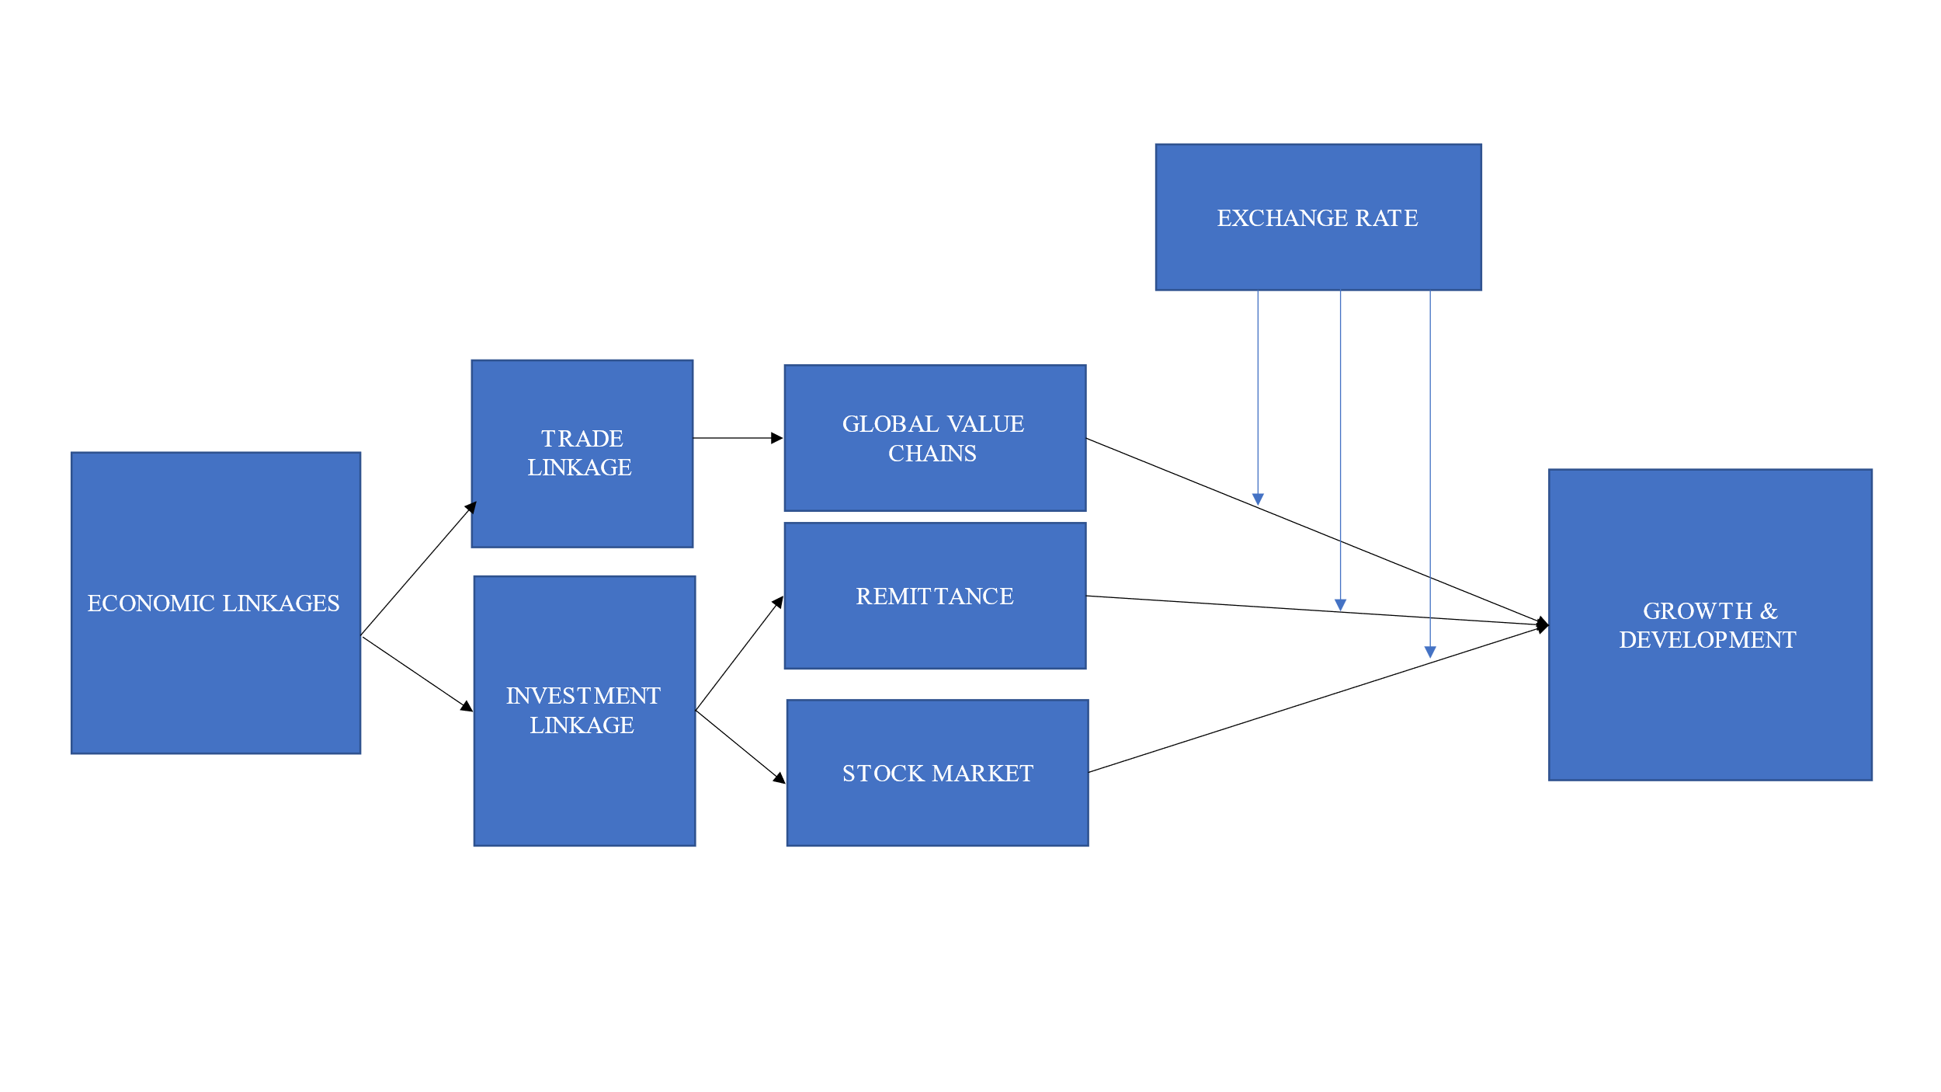

Figure 1.0 Moderating effect of Exchange Rates on Economic Fundamentals and Growth

**Source: Authors’ Construct**

In Figure 1.0, the main construct for the study is shown. The figure presents a unique view of how the author views the individual effect of exchange rate fluctuation on the economic fundamental and growth development nexus. The study considers the effect of the spread of volatility in the currency markets on other economic fundamentals (such as trade and investment) based on internal and global events. The study thus examines the moderating effect of exchange rate volatility by examining co-movement linkages between the selected variables.

The most common point for contagion studies has been the trade channel. Trade linkages include direct trade and competitive devaluations that burst out in one country and reduce import demand. The linkage affects the aggregate demand of the trade partners. Economic downturns in one country are argued to cause a reduction in income and a corresponding reduction in demand for imports, affecting trade balance, exports, and macroeconomic variables. Adverse effects on trade accounts due to export shocks undermine growth and development. Investors in such economies reassess their investments risk exposures in situations where contagion is relatively large.

### 2.7.2 Contagion

The concept of contagion can be viewed as the transmission of a crisis from one economy to another or the situation in which a currency crisis in one country increases the probability of a currency crisis in another (Fane, 2000; Goldstein et al., 2000). Empirical literature defines contagion as an investigation into currency crisis events where all unexplained turmoil (the residual effect) is denoted as a contagion (Fane, 2000; Goldstein et al., 2000). Similarly, Maaon (1996) characterizes contagion in currency markets as a combination of country-specific events and common events that affect all markets due to the linkages between economies.

Empirical studies in the last decade on contagion have emphasized the geographical component of the transmission during periods of the currency crisis and found that contagion tends to trend in a regional direction as they affect countries with geographical proximity (Grabowski and Welfe, 2016). Accordingly, contagion consists of a rise in cross-market linkages after a shock in a country's market. For example, when two markets show a high degree of co-movement during periods of stability, even if the markets are highly correlated, a shock to one market may cause interdependence instead of contagion. Conversely, suppose the cross-market co-movement rise after the shock and the co-movement does not increase. In that case, any continued high rise in the level of correlation will suggest a strong linkage between the economies in all states of the world (Forbes and Rigobon, 2002). Broadly defining contagion can offer advantages by distinguishing between temporal and permanent transmission of crisis and implementing prudent policies (Cubillos-Rocha et al., 2019; Forbes and Rigobon, 2001).

This study argues from the fundamental-based theory on contagion as the transmission of risk or shocks through real and financial linkages (Calvo,1999; Calvo et al., 1992). The study examines the spillover effects, co-movements, and interdependencies within African countries through real and financial economic associations. The study also examines the excess co-movement that occurs during global economic shocks.

### 2.7.2.1 Exchange Rate Contagion Methodologies

Large-scale global crises are recurrent today, prompting economists and policymakers to pay more attention to the contagion phenomenon. Contagion lies in the ability of a shock or wave to approach vulnerable sectors of the economic and financial system. Considering that shocks from economic, finance, and health can easily spread across all economic and social systems if the channels of contagion are functional, the more active a transmission channel is, the greater the degree of vulnerability shock (Masson, 1998).

Economic viewpoints on contagion have been examined for years based on asymmetric and symmetric shocks, emphasizing single-currency economies. Fundamental-based theories argue from the point of the role of real shock correlation, which could be found across economies in terms of trade, liquidity, and macroeconomic shocks. Thus, a global shock from a developed country’s currency can be transmitted to developing economies that trade with them. For example, the 2008/2009 global crisis and Covid-19 health pandemic. These types of shocks fall under symmetric shocks. Symmetric shocks in exchange rate contagion during such general global recessions or events have a uniform effect. When the effect is asymmetric, the shock or wave does not affect all sectors or regions uniformly when it occurs. Symmetric shocks have triggered numerous economic crises in Africa over the last decade leading to a massive outflow of investments.

The economic downturn in one trading partner could reduce the income and import demands of another. Consequently, export, trade balance, and other economic fundamentals directly linked to trade are influenced. Such adverse effects on trade undermine economic growth as investors reassess their risk exposure and hedging options. Furthermore, loss of competitiveness could lead to devaluation of a country's currency which causes a reduction in investment and a decline in currency demand and capital flight. Failures or extreme negative events propagated over time and not caused by synchronized effects of common shocks may cause the spread of contagion. In the same way, positive contagion may also spill over to other economies through direct or indirect means.

On the other hand, where theories on contagion are belief-based economic agents form their expectations based on what other agents do; thus, when others run, the individual investor assumes it is optimal for them to run. Belief-based theories are explained through self-fulfilling, herding, and wake-up call channels. Stop-gap measures and capital controls have been used to defend and prevent the spread of contagion under the belief-based theory.

From this background, this research aims to contribute to the contagion literature by investigating how contagion spillovers, interdependencies, and moderation of exchange rate fluctuations influence different sectors of African economies.

**2.7.2.2 Models for Contagion Linkages**

Most studies examine contagion through no identified transmission channels, which stems from the latent factor model by Sharpe (1964). Using the latent factor model allows for examining unanticipated shock on assets return from one economy to another. On the other hand, other researchers consider the identified channels. This study investigates spillover effects across economic sectors. The study considers both channels in the study to bring understanding to how contagion spreads within African economies.

Empirical research studying contagion has grown in the past decades drawing on a range of quantitative methodologies; this study adopts the World Bank's categorization of contagion. The categorization is based on the specific contagion definition, as shown below.

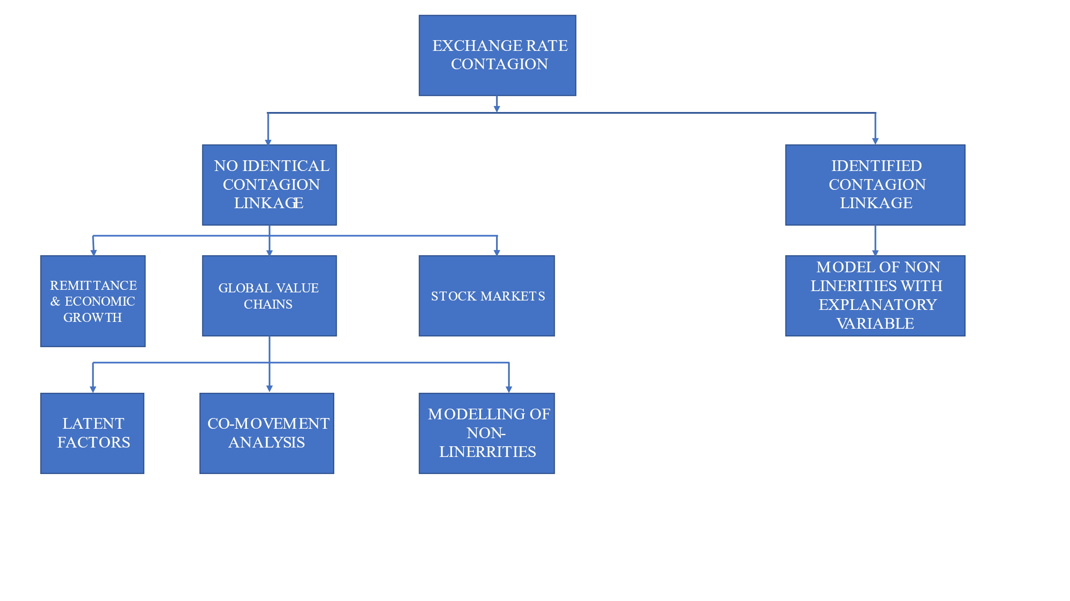

Figure1.1 Conceptual Framework on Contagion Adapted from

Source: Cheung et al., (2009)

There are two forms of contagion linkages: no identified channel and identified channels. Under the identified channels, there are three main models in the literature (i) latent factor, (ii) co-movement analysis, and (iii) models of asymmetries and nonlinearities (Dungey et al., 2004).

The latent factor model examines shocks that are unanticipated or triggered by the beliefs or expectations of investors. The model allows for the examination of non-observable exogenous shocks to be investigated (Fry et al., 2002; González-Hermosillo et l., 2003; González -Hermosillo and Johnson, 2014; Dornbusch et al., 2000). Under the co-movement analysis, exogenous shocks are argued to be transmitted from the first point of impact to others where the subsequent markets of others are likely to respond similarly to the first one causing co-movements (Kaminsky and Reinhart, 2001; Forbes and Rigobon,2002; Psalida and Sun, 2009). For modeling non-linearities, this model assumes that linearity exists between one market and another considering the strength and extreme nature of the shock episodes (Favero and Giavazzi, 2002).

Models for identifiable channels consider the relative significance of the transmission channels of shock, such as trade, financial flows, and economic similarities. Under this model, the focus is given to contagion risk transmission and not only on its existence. Examining trade channels, for instance, can provide an understanding of the international trade channels that facilitate the spread of risk and the level of vulnerability in a firm or economy (Van Rijckeghem and Weder, 2001; Caramazza et al.,2000). While the literature on this area is vast, there is little consensus on the definitions, causes, and measurements of the contagion effect, which policymakers can draw on to manage and prevent its spread. Contagion does not require irrationality for transmitting risks and shocks; however, market imperfections, multiple equilibria based on information asymmetries, and price fluctuations in one market can lead to contagion spread.

## 2.8 Empirical Literature

### 2.8.1 Stock Markets and Exchange Rates

The association between exchange rates and stock prices has gained attention in recent years by using new methodologies to examine the underlying trends between the variables (Reboredo et al., 2016; Chkili and Nguyen, 2014). Recent stock price and exchange rate studies often test for Granger causality and linear relationship and short run, with possible long-run relationships (Tang and Yao, 2018; Bajo-Rubio et al., 2017; Kandir et al., 2015; Effiong and Bassey, 2018; Effiong, 2016; Fowowe, 2015; Lee and Zhao, 2014). Bagh et al. (2017) found a unidirectional relationship between exchange rate to stock markets, whiles other studies have found a bidirectional relationship (Sikhosana and Aye, 2018; Panda et al., 2019; Khan, 2019; Ürkmez and Bölükbaşı 2021).

Earlier findings have supported a positive correlation between the variable for emerging markets(Aloui and Ben Aïssa, 2016). Similarly, negative relationships were found (Ajayi and Mougoue, 1996). Javangwe and Takawira (2022), using an autoregressive distributed lag (ARDL) approach on quarterly data, found a negative relationship between stock markets and exchange rates for South Africa from 1980 to 2020. From examining the nonlinear relationship Cuestas and Tang (2017), examining asymmetric exchange rate sensitivity using the NARDL framework on 31 Chinese firms, found that non-export industries experience asymmetric exchange rate effects. Cheah et al. (2017) found no asymmetrical relationship between the variables for Malaysia.

Other studies have used different variations of GARCH models to examine volatility spillover transmissions (Salisu and Oloko,2015). Zivkov et al. (2015) used fractionally integrated generalized autoregressive conditional heteroscedastic (FIGARCH) models under multiple structural breaks exchange rates to impact stock markets in Eastern Europe. Tule et al. (2018) found a significant unidirectional relationship using vector autoregressive moving average with asymmetric generalized autoregressive conditional heteroscedasticity (VARMA-AGARCH) model for Nigeria. Sui and Sun (2016) investigated the dynamic relationship between stock markets and exchange rates for four emerging economies and found spillover effects between the variables. Vo and Tran (2020), using exponential general autoregressive conditional heteroskedastic (EGARCH), found a significant volatility spillover from US markets to ASEAN markets. Using the quantile-on-quantile approach, Gokmenoglu et al. (2021), exchange rates do not impact stock market returns. The study examined eight emerging markets and credited any impact in the relationship on the presence of other market conditions. Conversely, emerging African markets continue to be measured and examined based on the causality of the volatility spillover effect. Boako and Alagidede (2017, 2016) examine regional and global stock market co-movement, while Junior et al. (2017) examine the exchange rate co-movements in the West African Monetary Zone using wavelet analysis.

The movement of investment and cash across markets continues to impact the interdependence between stock and exchange rate markets as economic growth expands in African frontier markets. Interdependence between stock markets and currency markets, according to Zivkov et al. (2021), using maximal overlap discrete wavelet transformation (MODWT), the study provided the time horizon effect of the variables which occur for emerging markets in Africa, focusing on South Africa, Morocco, Nigeria, and Egypt in cycles. Zivkov et al. (2021) found that only South Africa was the most liquid Stock market among emerging African markets; however, investors are prone to volatility spillovers in the short term. The results from Hamrita and Trifi (2011) found significant dependence between exchange rates and stock prices in the US market.

Understanding the different methodologies used in examining the direction of causality in previous studies point to the lack of time-horizon analysis on frontier markets and the extent to which volatility spillover from the exchange rate market affects the stock markets (Hashmi et al., 2020; Afshan et al., 2018; Kumar et al., 2020; Delgado et al., 2018). For this reason, we contribute to studies on frontier markets by examining the time horizon to provide a clear picture of the extent to which volatility spillovers from the exchange rate market to their stock markets. The wavelet transformation and the non-linear parametric analysis suggest which theory better explains sharp rises or falls in stock prices. The results give investors time to implement their investment and hedging strategies.

### 2.8.2 GVC and Exchange Rate

The effect of exchange rate on GVC participation as a transmission channel and the dynamic influence of exchange rates on international trade as goods and services flow across borders have been examined directly and indirectly through production structures, investment, and national policies (De Backer and Flaig, 2017; Marcolin et al., 2016; Broda and Weinstein, 2006). Exchange rate appreciation (depreciation) has a negative (positive) effect on exports under international trade to underscore the economic uncertainties and volatilities underlying exchange rates (Auboin and Ruta, 2013; Mayer and Steingress, 2020). Moreover, aggregation bias negatively affects exchange rate and trade (Mayer and Steingress, 2020; Auboin and Ruta, 2012; Bussière et al., 2016; Sato et al., 2016).

Bahmani-Oskooee et al. (2016), using non-linear ARDL, found that exchange rate, appreciation, and depreciation have a significant short-term effect on domestic production, affecting trade. Middle East and North African (MENA) countries' exchange rates have been found to have a positive effect on trade for Morocco using aggregated series under the vector error correction model (VECM) through export demands (Louati et al., 2022). Using annual series from 1990 to 2018 for 15 MENA countries, Elsherif and Mohieldins’ generalized autoregressive conditional heteroscedasticity (GARCH) and threshold-generalized autoregressive conditional heteroscedasticity (TGARCH) found exchange rates to affect international trade negatively (Elsherif and Mohieldin, 2020). Bahmani-Oskooee and Gelan (2018) found that exchange rates have a long-term effect on exports in their study of twelve (12) African economies on the relationship between trade and exchange rates. From their studies, the exchange rate volatilities of exports and imports are inconsistent in the short term.

Nevertheless, following up, Bahmani-Oskooee et al. (2017), using non-linear ARDL, found that exchange rate, appreciation, and depreciation have a significant short-term effect on domestic production, affecting trade. The use of the US dollar as the major trading currency in global trade invoicing coupled with high trade prices impacts expenditure switching through exports in the short-term, impacting growth in emerging and frontier economies (Boz et al., 2019; Borin and Mancini, 2019; Bayoumi et al.,2018; Leigh et al., 2017). Exchange rates are still found to negatively impact exports, although effects on GVC participation are still mixed.

Exchange rates pass through import prices to affect global value chains, as Auer's (2015) work on government-controlled appreciation of the Yuan against the US dollar depicts. Consequently, the US producer price rose for imported inputs from China from the exchange rate pass-through effect. Additionally, regional-level producer prices have been documented to strongly influence import input prices for the Asia-Pacific region as the cost of intermediates increases (Auer and Mehrota, 2014). Examining the impact of the exchange rate pass-through effect, Casas (2019) found a positive relationship with import prices for small open economies and not with other trading partners in the global value chain. They were found to be the result of the strategic placement of complementarities (Casas et al., 2017). Tang (2014) found that integration into GVC makes economies susceptible to exchange rate uncertainties. Ahmed et al. (2017) and Sato and Zhang (2017) posit that exchange rate elasticity is lowered when GVC participation increases for exports; this is disputed (Leigh et al.,2017).

Structural change for transformation and development is favored as labor flows redirect to high production activities when exchange rate prices and value-added products from the manufacturing sector decline, followed by a fall in employment (McMillan and Rodrik, 2014; Rebelo and Vegh, 1995). Furthermore, exporting firms and countries (manufacturing industry) experience growth decline when exchange rate appreciation mechanisms are implemented (Prasad et al., 2007). For such economies, exchange rate depreciation has been found to increase the manufacturing sector's (industry) share of GDP and employment as the share of agriculture declines (Caglayan and Demir, 2014; Rodrik, 2008).

Exchange rate changes influence long-term growth through trade channels, specifically for export-led growth channels. Developed economies' trade response to exchange rates leads to an increase in market entry and exported products. Technological upgrades and high-skill production must boost export diversification to achieve growth during currency depreciation (Goya,2020). In contrast, resource policies must be reallocated in developing economies to achieve the expected export-led growth desired when prices depreciate (Demir and Razmi, 2022).

Bilateral exchange rate changes significantly positively influence developing economies, conditional on the direction composition of traded goods during exchange rate depreciation (Cagalayan and Demir, 2019). However, from the firm level, to achieve structural change, investment and discovery of new lines of the market are needed for a positive diversification impact right after the devaluation of the currency (Iacovone and Javorcik, 2008). The length of time needed for the depreciation mechanism to be effective in achieving long-term development has not been well addressed in recent literature, as the effects may vary across countries, firms, and regions. When currency appreciation mechanisms are implemented, considering firm heterogeneity, domestic-oriented firms do not benefit as export-oriented firms (Caglayan and Demir,2014). At the regional level, exported-oriented firms with strong research and development (R&D) culture are likely to experience growth during currency depreciation compared to regions where R&D is low (Alfaro et al., 2018).

### 2.8.3 Remittance-Growth Nexus and Exchange Rates

Empirical evidence on the effect of remittance on growth has found a positive impact among developing countries (Bucevska, 2022; Chaudhary, 2022; Safadar, 2022; Bashir, 2020; Oteng-Abayie et al., 2020; Ekanayake et al., 2020; Ellahi and Omer, 2020)[3]. In the case of remittances, exchange rates, and economic growth, very few studies have been conducted examining their relationship. Rapetti (2020), examining exchange rate and economic growth using a systematic survey, significant positive relationship for developing economies; however, it does not consider the impact of remittances. Thus, examining all their variables is not often examined, as in the following studies. McFarlane et al. (2022) examined the relationship between remittances and exchange rates in Jamaica from 1977 to 2019 and found that remittance leads to an increase in the value of the exchange rates. They conclude that the Dutch disease effect exists using autoregressive bounds and the Granger causality test. In Bangladesh, the exchange rate positively impacted growth using time series data from 1990 to 2020, applying the standard Least Squares method (Khan, 2021).

Nguyen (2017), examining Vietnam, found a significant positive effect of remittances on economic growth enabled by the exchange rate regime. Thus, a rise in remittance inflow could lead to a fall in exchange rates. Senadza and Diaba (2017) found that the eleven sub-Saharan markets examined had no significant impact from exchange rate variations. The study used pooled mean group estimators for dynamic data from 1993 to 2014. They found that exports experienced a significant negative relation with imports in the short run.

A few panel studies have been conducted in recent years which examined this relationship. Hien et al. (2019), examining exchange rates, remittance, and economic growth relationships for thirty-two countries in Asia, found a positive and meaningful relationship. The study used the Generalized Methods of Moments (GMM) and Linear Dynamic Panel Data (DPD) model from 2006 - 2016. They found that a low remittance-to-GDP ratio and vice versa characterized the Dutch disease effect on the Asian economies. Using autoregressive distributed lag bounds, Jena and Sethi (2019) found economic growth and remittances to positively impact the real exchange rate.

Chaudhary et al. (2016) found a statistically positive relationship between exchange rate and trade through exports for Indonesia and a negative for Malaysia, Singapore, and Thailand. Their study employed time series data from 1979 to 2010 using a co-integration and error correction model to establish the relationships. Through export, exchange rates negatively affected trade performance for eight (8) Asian countries and the US. The study employed a gravity model with a series from 1980 to 2012 and found that exchange rate volatilities dampened exports.

The movement of people across borders continues to impact the interdependence of economies at economic, social, governance, and environmental levels. African countries are a part of this impact. Despite the importance of remittance inflow on economic development, the effect moderated by the exchange rate has received little to no attention in the literature. Studies on the subject have consistently examined the causality effect due to neglecting the moderating effect of exchange rate and the nonlinear causal effect. The few studies that examined the relationship included one or two in their group study without investigating the moderating effect of the exchange rate effect (Senadza and Diaba 2017).

### 2.8.4 **African** Stock **M**arkets **and** Exogenous Shocks

In the past few years, African stock markets have undergone rapid development, including the introduction of automated trades, demutualization, derivative products, exchange-traded funds, and US-dollar-denominated trades (Kunle and Omoruyi, 2014). African stock exchanges have grown from eight (8) to twenty-nine (29) since 1989, with a presence in over thirty-eight (38) countries (Solyman, 2017). Despite the growth and advancement, African markets remain segmented and weakly integrated into Africa (Kumah and Odei-Mensah, 2021).

In literature, volatility has been found to exist in financial markets. Although not observable, their increase raises concerns about market development strategies. Volatilities are highly persistent, emanating from different sources such as economic shock or often exogenous events. Exogenous Shocks have been studied in macroeconomics, supply chain management, and information systems (Fridgen et al., 2015). Macroeconomics perceives exogenous shocks as either long-term or short-term unpredictable, unfavorable internal and external conditions that impact the economy's growth (Noy and Nualsri, 2007). The effects of the condition may be temporary or permanent based on the level and magnitude of influence on the target market. The effect could also limit access to important resources and growth opportunities (Chakrabarti, 2015).

Moreover, exogenous shocks force markets to adapt their strategies and structure to respond responsibly to the changing environmental conditions (Martins rt al., 2015). The number of transmission models applied to classify the dynamics embedded in exogenous shock varies from the break to regime identification. Studies on volatility crisis and commodity markets, and financial instruments have grown (Ciarreta et al.,2020; Li et al.,2020; Tiwari et al., 2020; Taylor, 2019; Nademi and Nademi, 2018; Pappas et al., 2016). Examining the impact of COVID-19 on G7 stock markets, Izzeldin et al. (2021) used the smooth-transition HAR (ST-HAR) and found strong evidence of the transition of crisis in all the countries. However, they conclude that crisis intensity and timing vary for all countries. Bannigidadmath et al. (2022), investigating Covid-19 in 25 countries, found that 48% of the countries responded to government policies on Covid-19 negatively. Al-Awadhi et al. (2020) found the Covid-19 negatively affected Chinese stock market returns. Watugala (2019) found that economic uncertainty significantly influences the volatility of future returns on commodity markets. Macroeconomic news has been shown to influence major stock exchanges, especially during the 2008/2009 global financial crisis (GFC) (Omarane and Saveser, 2017). On geopolitical conflicts, using a Markov-switching HAR model found stock markets to respond rapidly to the Russia-Ukraine war at smaller intensity levels (Izzeldin et al.,2023). In examining 447 global political crises, Berkman et al. (2011) found that global stock market returns declined by 3.6 percent. In their work, Wisniewski and Nolte (2017) found the world stock market index fell to 3.4% before and after the wars. Bello et al. (2022) found that Brexit, GFC, and Covid-19 African markets were highly susceptible to contagion effects confirming the results of Boako and Alagidede (2017).

## 2.9 Conclusion

In this chapter, the researcher reviewed concepts, theories, and empirical studies relating to all thematic topics in the research. The chapter presents the possible influence of exchange rate fluctuations as a moderating variable and direct variable effect on the linkages established in the study.

# CHAPTER THREE

# MODERATING REMITTANCE AND ECONOMIC GROWTH RELATIONSHIP WITH EXCHANGE RATE: WHAT NEW CAN WE LEARN FROM AFRICA'S ECONOMY?

# CHAPTER THREE

# MODERATING REMITTANCE AND ECONOMIC GROWTH RELATIONSHIP WITH EXCHANGE RATE: WHAT NEW CAN WE LEARN FROM AFRICA'S ECONOMY?

## Abstract

The study investigates the comovements of remittance and economic growth from 1980 to 2020. The study employs partial and biwavelet coherence techniques to examine the time-frequency dependence structure of international remittance inflow on economic growth by moderating the effect of exchange rates. The researcher observed heterogeneous patterns in the comovements structure of international remittance inflow and economic growth at various timescales. By examining the biwavelet coherence, the comovements are noticeable at elevated occurrences, implying that exchange rates, moderators in the nexus between remittance and economic growth, can hamper economic growth. The partial wavelet coherence findings reveal that exchange rates influence remittance and economic growth connectedness in emerging and frontier economies in Africa.

Consequently, in situations where radical changes occur in exchange rates, the implemented policies of emerging African countries seem to have largely influenced the comovements between remittance inflow and economic growth. The risk posed by exchange rates on remittance inflow requires sustainable policies to prevent widespread spillovers, mostly during severe economic downturns. The researcher posits that implementing exchange rate mechanisms is central to parity and essential to mitigating potential risk.

## 3.1 Introduction

International remittance serves as one of the main sources of foreign exchange, often exceeding export revenues, official development assistance (ODA), and foreign direct investment (FDI) (Gheasi and Nijkamp, 2017). Remittance represents more than twice the size of official aid and two-thirds of FDI for emerging economies. African economies account for a third of the total remittance inflow in the world. African member states often struggle to meet import demands as domestic investment increases.

In Africa, the composition of remittances is gradually shifting to intraregional flows over the past ten (10) years (Arizala et al.,2018). Financial crises, the COVID-19 pandemic, and FDI have impacted international remittance inflow. Remittances declined more stably for emerging economies and, in some cases, increased for frontier economies as opposed to FDI inflows (World Bank, 2022). The resilience of remittance far outstrips FDI, especially in middle-income and low-income economies (Maslii et al., 2022). The rise in remittance to Africa is attributed to the high level of migration from African countries and the decline in transaction costs as technology improves with a faster and lower transfer cost. Notwithstanding, Hien et al. (2019) found that there is a probability that a rise in remittance inflow could impact developing and frontier economies if real exchange rates rise.

In West Africa, Nigeria is the highest remittance receiver, followed by Ghana. In 2021, Nigeria's remittance inflow increased by 11.2 percent after a fall of 28 percent in 2020 due to an increase in the use of informal channels (World Bank, 2022). Sub-Saharan Africa, excluding Nigeria, experienced a surge in inflow by a 16 percent margin, which accounted for 30 billion USD in 2021. Egypt is the largest remittance receiver in North Africa, accounting for 7.6 percent of the 61 billion USD inflow in 2021. Morocco received 10.4 billion USD, representing a 40 percent increase (World Bank, 2022). These North African countries also serve as transit migration routes for migrants from West Africa. They are stages for prospective migrants to Europe and receivers of in-transit migrant remittances, making them temporary host countries (World Bank, 2022). South Africa may be a host and transit country for West, Central, and East African migrants. South Africa, however, received 0.9 billion USD in Remittance in 2021. Kenya received 3.7 billion in 2021, and Uganda's 1.1 billion USD in remittances. Severe droughts in parts of East Africa saw a rise in migration trends, leading to increased remittances to the region (World Bank, 2022).

This upsurge in remittances has several implications for the host and countries of origin as the mass movement of people continues to increase[4] (Kumar et al., 2021; Kumar, 2021;2019). The volume of financial remittance from African migrants to their home countries has also increased. Remittance has become one of Africa's main important sources of international capital inflow in size and growth. However, with unrecorded flows through informal channels, the true size is undetermined, affecting economic growth (Meyer and Shera, 2017).

African economies in recent years have seen a rise in economic growth (Salisu et al., 2020; Lawal et al., 2020). However, the impact of exchange rate variations on remittances could impede growth in these economies. The rural nature of African economies continues to make them a primary source of raw materials for trade with other developing and developed economies. These latter economies depend on the industrialized economies for finished goods through imports. The economy of African countries will, thus, experience a dampening trade effect (Hu and Oxley 2017). Exchange-rate variations shape growth as growth in domestic currency through appreciation could significantly decrease remittance inflow. Exchange rate variations can alter remittance inflow and further influence economic growth (Dutta and Sengupta, 2018).

However, a continuous flow of international remittance to African economies affects the exchange rates and economic growth, which remains contested in the literature. The variance in the literature is perhaps attributed to the variations in methodology and challenges in assessing plausible and consistent data. Regardless of the inflow of remittances and its importance as part of international capital inflow, empirical studies on the moderating effect of exchange rates on the relationship between remittances and economic growth in African economies is rare.

We contribute to the literature on the remittance and growth effect on African economies, focusing on exchange rate volatility. Despite the interest in exchange rate volatility in academia and policy circles, no study has systematically reviewed the moderating effect of exchange rates on international remittance inflow and economic growth in the African context. Even those in other jurisdictions have overlooked the international remittance inflow impact during exchange volatility. The research employs linear and nonlinear causality tests and wavelet (biwavelet and partial wavelet) coherence analyses to bring a renewed focus and understanding to the relationship. The study employs annual data from 1980 to 2021 for South Africa, Uganda, Morocco, and Ghana.

Foreshadowing the results of this study, evidence from the literature shows that the exchange rate has no substantial effect on remittances and economic growth in Ghana. At the same time, countries with stabilization policies, such as Morocco, Uganda, and South Africa, are impacted by exchange rates.

## 3.2 Literature Review

This section begins with a discussion of the two theories selected to guide the studies. It is followed by a review of the literature on exchange rates, remittance, and economic growth concepts.

### 3.2.1.0 Theoretical Review

This section presents theories and arguments related to the study of exchange rates, remittance, and economic growth,

### 3.2.1.1The Solow Growth Model

The Solow Growth Model[5], built on the Keynesian-Harrod-Domar model, is the basis for modern theories on economic growth under the neoclassical growth model. The model examines changes in economic growth output as population growth, savings, and technology rates change. When economies have the same rate of population saving and technology growth rate, the model predicts that they will converge as they have the same steady state. However, economies with variations in population, savings, and technology models have no absolute convergence. In these economies where the initial capital stock is low, variations in savings rates do not encourage growth.

The Solow growth model assumes an exogenous savings rate, whereas extending the Solow growth model to the Ramsey growth model considers the household which chooses the optimal saving rate. In the Solow growth model, although the savings rate does not affect the long-run growth rate, it affects capital and output. On the other hand, the Ramsey growth model[6] explores variations in savings rates across different economies, which explains the variations in income levels. Extensions of these neoclassical models to include remittances are premised on the role of remittances in the household budget constraint.

It is argued in both models that if there is no change in savings and investment rates, there will be no impact on the economy. However, where there is convergence in growth with other countries, economies with low economic activity would potentially positively impact productivity. Supposing that remittance is channeled through investment which changes the growth path towards convergence, growth is achieved in the short term, and remittance is channeled through capital investment; both human, physical, and new enterprises will act to reduce macroeconomic volatility (Hosny, 2020; Kumar et al., 2021; Kumar, 2021). Nevertheless, channeling through consumption has a limited impact on competitiveness in trade and economic growth (Feeny et al., 2014).

### 3.2.1.3 Marshall-Lerner Theory

In 1946 Marshall-Lerner proposed changes to the Marshall (1923) theoryon the price elasticity of demand using exchange rate policy as a tool to bring balance to trade (Dong, 2017). The Marshall-Lerner condition through the exchange rate policy uses the devaluation or depreciation of a country's local currency to improve trade balance by summing demand elasticity for exports and imports. When the total sum of exports and imports exceeds the sum of 1, depreciation is used to improve the trade balance. From this proposition, countries of origin can improve their trade balance eventually by using a currency depreciation strategy.

Based on price elasticities, developed countries have been found to satisfy the Marshall-Lerner condition as demand for export and import increases due to their ability to specialize in production and goods, improving their trade balance (Bussière et al., 2020). However, when the summation is lower than one, the Marshall-Lerner condition would not be satisfied, which worsens the trade balance for the economy. Thus, devaluation improves long-term trade balance (Warner and Kreinin, 1983).

The Marshall-Lerner theory, which argues the effect of exchange rates on economic growth, is seen in how tariffs and subsidies affect imports and exports (Boyd et al., 2001). In countries of origin where tariffs and quotas are used as control measures, appreciation of the country's currency may occur. However, the theory argues that countries of origin can improve their trade balance by depreciating their local currency under these circumstances. For example, when the demand for imported goods falls, the prices of imported goods increase. The effect of a general rise in the prices of goods and services will eventually lead to a decline in aggregate demand. A decline in demand, in turn, changes economic growth and causes unemployment.

However, in the case of exports, a depreciation in the local currency leads to a rise in exports as prices for exported goods decline. This effect impacts host countries and often puts up barriers through tariff imposition on imported goods from the country of origin. This position has been debated among economists in the global trade market. By extending the M-L theory, Bahmani-Oskooee et al. (2016) examined the effect of change mechanisms employed by countries of origin during the currency depreciation process. Developed economies, through specialization, structure, and size of their markets, improve their trade balance using exchange rate policies. The effect of this policy is rapid economic growth as measures such as tariffs and subsidies control and regulate imports and exports (Bahmani-Oskooee et al., 2016; Boyd et al., 2001). As seen in the US-China case, the resulting possibility of a trade war between the countries is a clear example.

Imposing tariffs and quotas as policy control measures improves import demand and currency appreciation. For example, when the demand for imported goods falls, the prices of imported goods increase. An appreciation of the local currency is, thus, achieved. However, when currency depreciation is used as a control mechanism, in the case of exports, a depreciation in the local currency leads to a rise in exports as prices for exported goods decline. The extent to which the estimated impact of the Marshall-Lerner condition impacts growth varies for different reasons among countries. For example, in developed economies, the general perception is that the degree of power and size of the market and greater differentiated goods (they tend to have fewer substitutes) would make their economies price setters on the international markets against developing countries with small market size, structure, and high substitutable homogeneous goods (they have a larger set of substitutes). Imperfect competition and high product differentiation make the demand for developed countries' exports less than perfectly elastic for manufacturing, and their share of differentiated goods rises in international trade. African economy's trade exports are homogeneous primary goods by nature coupled with soft and undifferentiated manufacturing skills and technology (Lall, 2000).

### 3.2.1.4 J-curve Theory

In African economies, in particular, such a devaluation in the short run could lead to economic contraction, reduced spending, and redistributive effects, valuation effects, wealth, and portfolio balance effects altogether impact economic activity, which in turn slows down growth (Krugman and Taylor, 1978). In the short run, the dynamics between the exchange rate and trade balance are expressed through the J-curve approach. The J-curve effect, first observed by Stephen Magee (1973), argued that the devaluation of a currency in the short run does not improve trade balance, growth, and development. Theoretically, he traces the initial deterioration in the trade balance in the short run with improvement and growth effects only experienced in the long run. The J-curve theory suggests that a short-run currency value decline leads to increased import spending. Consumers pay a higher price for imported goods using the local currency as foreign currency values rise; this results in a rise in the cost of imports. If an increase in import prices occurs, prices quoted in a foreign currency for contracts take longer to adjust, although current market prices change occurs with immediate effect. This effect is due to the rise in foreign currency value in the country of origin. However, the price of exports is less expensive in the short term after a fall in currency value. The country-of-origin firms receive lower pay for goods and services than the initial price. This opposite effect is based on the demand for imported goods, which will decline eventually in the country of origin. The same goes for the effect on exports (Ivanovski et al., 2020; Dogru et al., 2019; Bahmani-Oskooee and Aftab, 2018; Arize et al., 2017; Bahmani-Oskooee et al., 2016; Bahmani-Oskooee and Fariditivana.2015; Bahmani-Oskooee and Baek, 2016).

Small economies may have their aggregate trade elasticities decline or be misleading in the short term. Through econometric evidence, average elasticities are higher among countries that trade in commodities (Soderbery, 2018). Developed economies produce differentiated products compared to developing countries that trade in homogeneous products (Soderbery, 2018). One would expect that trade tariffs for countries (developing economies) that export primary homogenous goods would have higher trade volumes in response to bilateral tariff imposition (Fontagne et al., 2019). However, regarding market size and power, export supply for disaggregated trade is high-income economies with large GDPs due to their market power as importing economies trade in higher product volumes as their supply elasticities increase.

These two theories have been used to examine various economic data by Dogru et al. (2019) on exchange rate fluctuations in tourism in Canada, Mexico, and the U.S. using monthly data from 1996 to 2017. Using autoregressive distributed lag cointegration and error correction mode, we found that the M-L proposition and the J-curve positively impact the U.S. trade balance when there is a decline in the U.S. dollar value. They found that an appreciation in the U.S. dollar negatively impacts U.S. tourism to Canada and the U.K. However, there is no known impact on US-Mexico tourism. Thus, the study supports the M-L condition while rejecting the J-curve proposition. The appropriate theory for analysis should be considered when using exchange rate policy to increase growth through trade (Orcutt, 1950; Imbs and Mejean, 2015; Bussiere et al., 2020).

## 3.2.2 Empirical Literature

Empirical evidence on the effect of remittance on growth has found a positive impact among developing countries (Bucevska, 2022; Chaudhary, 2022; Safadar, 2022; Bashir, 2020; Oteng-Abayie et al., 2020; Ekanayake et al., 2020; Ellahi and Omer, 2020)[7]. In the case of remittances, exchange rates, and economic growth, very few studies have been conducted examining their relationship. Rapetti (2020), examining exchange rate and economic growth using a systematic survey, significant positive relationship for developing economies; however, it does not consider the impact of remittances. Thus, examining all their variables is not often examined, as in the following studies. McFarlane et al. (2022) examined the relationship between remittances and exchange rates in Jamaica from 1977 to 2019 and found that remittance leads to an increase in the value of the exchange rates. They conclude that the Dutch disease effect exists using autoregressive bounds and the Granger causality test. In Bangladesh, the exchange rate positively impacted growth using time series data from 1990 to 2020, applying the standard Least Squares method (Khan, 2021).

Nguyen (2017), examining Vietnam, found a significant positive effect of remittances on economic growth enabled by the exchange rate regime. Thus, a rise in remittance inflow could lead to a fall in exchange rates. Senadza and Diaba (2017) found that the eleven sub-Saharan markets examined had no significant impact from exchange rate variations. The study used pooled mean group estimators for dynamic data from 1993 to 2014. They found that exports experienced a significant negative relation with imports in the short run.

A few panel studies have been conducted in recent years which examined this relationship. Hien et al. (2019), examining exchange rates, remittance, and economic growth relationships for thirty-two countries in Asia, found a positive and meaningful relationship. The study used the Generalized Methods of Moments (GMM) and Linear Dynamic Panel Data (DPD) model from 2006 - 2016. They found that a low remittance-to-GDP ratio and vice versa characterized the Dutch disease effect on the Asian economies. Using autoregressive distributed lag bounds, Jena and Sethi (2019) found economic growth and remittances to positively impact the real exchange rate.

Chaudhary et al. (2016) found a statistically positive relationship between exchange rate and trade through exports for Indonesia and a negative for Malaysia, Singapore, and Thailand. Their study employed time series data from 1979 to 2010 using a co-integration and error correction model to establish the relationships. Through export, exchange rates negatively affected trade performance for eight (8) Asian countries and the US. The study employed a gravity model with a series from 1980 to 2012 and found that exchange rate volatilities dampened exports.

The movement of people across borders continues to impact the interdependence of economies at economic, social, governance, and environmental levels. African countries are a part of this impact. Despite the importance of remittance inflow on economic development, the effect moderated by the exchange rate has received little to no attention in the literature. Studies on the subject have consistently examined the causality effect due to neglecting the moderating effect of exchange rate and the nonlinear causal effect. The few studies that examined the relationship included one or two in their group study without investigating the moderating effect of the exchange rate effect (Senadza and Diaba 2017).

## 3.3 Methodology

## 3.3.1 Research Design

This study employed a quantitative approach by using secondary data to examine the moderating role of exchange rates on remittance and economic growth nexus in Africa. Secondary data is deemed appropriate since it can provide the desired information for measuring variables and the study’s models.

## 3.3.2 Data Sources and Collection

The study used data from the World Development Indicator database [WDI]. The series is based on the availability of data. The study employed yearly time series for remittances, economic growth (proxied by changes in gross domestic product $\left[GDP\right]$) and exchange rate from 1980 to 2020 (World Bank, 2022).

Table A3: Selected variables

|  |  |  |  |  |
| --- | --- | --- | --- | --- |
| **Variables** | **Abbreviation** | **Variable Explanation** | **Data span** | **Source** |
| Remittance | Remit | Personal remittances, paid (current US$) | 1980-2020 | World Bank staff estimates based on IMF balance of payments data. |
| Expenditure | Expend | General government final consumption expenditure (current US$) | 1980-2020 | World Bank national accounts data, and OECD National Accounts data files. |
| Capital | Capital | Gross fixed capital formation (current US$) | 1980-2020 | World Bank national accounts data, and OECD National Accounts data files. |
| Education | Educ | School enrolment, tertiary (% gross) | 1980-2020 | UNESCO Institute for Statistics (http://uis.unesco.org/). Data as of June 2022. |
| GDP | GDP | GDP (current US$) | 1980-2020 | World Bank national accounts data, and OECD National Accounts data files. |
| Broad Money | Bm | Broad money (% of GDP) | 1980-2020 | International Monetary Fund, International Financial Statistics and data files, and World Bank and OECD GDP estimates. |
| Exchange Rates | Exc | Real effective exchange rate index (2010 = 100) | 1980-2020 | International Monetary Fund, International Financial Statistics. |
| Inflation | Inf | Inflation, consumer prices (annual %) | 1980-2020 | International Monetary Fund, International Financial Statistics and data files. |

### 3.3.2.1 Measurement of Variables

### 3.3.2.1.2 Dependent Variable

Consistency with prior studies (see Bucevska, 2022; Chaudhary, 2022; Safadar, 2022; Bashir, 2020), remittance inflow from African migrants is of interest with a dataset drawn from selected African countries is shown in Table A1.

### 3.3.2.1.3 Control Variables

The existing literature has revealed several variables that are recognized to be associated with remittance inflow. Thus, several control variables are employed to control these items' influences on the outcome variable. For example, a country’s economic growth is impacted by the rise or fall in exchange rates could lead to a fall or rise in remittance. Therefore, for the country to be able to develop, the contribution of migrants to their households is crucial (Nguyen (2017). The study also examines the influence of GDP, broad money, capital, education, and government expenditure on remittance inflow.

Table A1: Selected variables, measurement, and explanation.

|  |  |  |  |  |
| --- | --- | --- | --- | --- |
| **Variables** | **Abbreviation** | **Variable Explanation** | **Data span** | **Source** |
| Remittance | Remit | Personal remittances, paid (current US$) | 1980-2020 | World Bank staff estimates based on IMF balance of payments data. |
| Expenditure | Expand | General government final consumption expenditure (current US$) | 1980-2020 | World Bank national accounts data, and OECD National Accounts data files. |
| Capital | Capital | Gross fixed capital formation (current US$) | 1980-2020 | World Bank national accounts data, and OECD National Accounts data files. |
| Education | Educ | School enrolment, tertiary (% gross) | 1980-2020 | UNESCO Institute for Statistics (http://uis.unesco.org/). Data as of June 2022. |
| GDP | GDP | GDP (current US$) | 1980-2020 | World Bank national accounts data, and OECD National Accounts data files. |
| Broad Money | Bm | Broad money (% of GDP) | 1980-2020 | International Monetary Fund, International Financial Statistics and data files, and World Bank and OECD GDP estimates. |
| Exchange Rates | Exc | Real effective exchange rate index (2010 = 100) | 1980-2020 | International Monetary Fund, International Financial Statistics. |
| Inflation | Inf | Inflation, consumer prices (annual %) | 1980-2020 | International Monetary Fund, International Financial Statistics, and data files. |

### 3.3.2.1.4 Dataset Analysis

The study obtained data uniformity by matching to downplay on nonsynchronous timestamps and further converted to growth rates. The researcher analyzed the data and filled in the missing values. It should be noted that when using a collected dataset containing incomplete data, missing attribute values lead to wrong analysis. An incomplete dataset could be due to variations in source, network, or mistaken entries, among others. In our dataset, the nature of the missing data (missing at random) MAN was filled using the missing value imputation (MVI) technique of the under-moving average (Lin and Tsai, 2019).

To ensure consistency, we obtained three (3) macroeconomic datasets for selected remittance-dependent countries: changes in GDP, exchange rates, and remittances from the four selected African countries, namely Ghana, South Africa, Morocco, and Uganda. These countries were selected based on the amount of remittance inflow that explains the changes in their GDP. Consideration of the countries was based on the leading receiver of remittance subject to the availability of data. These selected countries are, respectively, the second largest recipients of international remittance inflows within their African regional economic communities (ECOWAS, AMU, SADC, and EAC). It should be noted that based on missingness in the datasets for exchange rates, Nigeria, Egypt, and Kenya were dropped. The researcher did so because of the inconsistencies in the data for exchange rates which are crucial to the study.

## 3.4 Empirical Model and Estimation Technique

This study tests the association between remittance inflow and African economic growth. The researcher employs causality tests and transformation methodologies to examine the relationship between the variables.

## 3.4.1 Linear Granger causality test

Empirical evidence on causality has been invariably based on the Granger test (Granger, 1969) as a conventional method for testing causality. In this study, the researcher employed the standard Granger Causality to assess the existence or non-existence of a linear association between remittances and economic growth (i.e., changes in GDP) for the selected African economies. The Granger test assumes a parametric linear, time series model for estimating the conditional mean. However, it requires the linearity assumption to be present as the test estimates the whether the lags of one variable fit in the equation of another variable. The test is based on residuals sensitive only to causality in the conditional mean. However, the covariables from this approach may influence the conditional distribution in responding to nonlinear ways for which a nonlinear causality test is performed (Bekiros & Diks, 2008a).

The study assumes that ($A_{t}$, $R_{t}$,t $≥$ 1) to scalars rated strictly as stationary time series datasets (namely, *I(0)*). We assert that ($A_{t}$) time series granger causes another time series ( $R_{t})$ (Granger, 1969). If the current value of one variable is related to the previous value of itself and another variable. The vector autoregression (VAR) model is employed (Sims, 1980).

$y_{1}= α_{0}+α_{1}y_{1}+…+α_{ρ}y_{1-ρ}+b_{1}x_{i-1}+…+b_{ρ}x_{1-ρ}+e_{1}$ (1)

$x_{1}= b_{0}+α_{1}x_{1}+…+b_{ρ}x_{1-ρ}+d_{1}y_{i-1}+…+d_{ρ}y_{1-ρ}+u_{1}$ (2)

Where $y_{1}$ and $x_{1}$ are the endogenous variables, $e_{1}$ and $u_{1}$ represent the residuals from the model. To test the causality of $x_{1}$ on $y_{1}$ we set the null hypothesis of $x_{1}$ does not cause $y_{1}$, as $H_{0}: b_{1}= b_{2}=…=b_{p}=0$. The second null hypothesis is of $y_{1}$ does not cause $x_{1}$ as $H_{0}: d_{1}= d_{2}=…=d_{p}=0$.

The model is as follows.

$∆{REM}_{t}$ = $a_{1}+\sum_{i=1}^{n}{β_{1i}{∆GDP}_{t-1}+}\sum_{j=1}^{n}{γ_{1j}{∆REM}_{t-j}+μ_{t}}$ (1)

$∆{GDP}_{t}$ = $a_{2}+\sum_{i=1}^{n}{β_{2i}{∆REM}_{t-1}+}\sum_{j=1}^{n}{γ_{2j}{∆GDP}_{t-j}+μ_{t}}$ (2)

Where $a_{1}$ and $a_{2}$ represent the intercept, REM is the remittance inflow, GDP is economic growth, $β$ and $γ$ are the coefficients to be estimated, and $n$ represents the lag order selected based on the Akaike Information Criteria (AIC). The null hypothesis for equation (1) states that remittances do not cause economic growth. For equation (2), economic growth does not cause Granger remittance. Furthermore, we apply the Wald test to examine the joint hypothesis for $β_{1i}$ =0 and $γ_{2j}$ = 0.

### 3.4.1.2 Nonlinear Granger causality test

The researcher embarked on this study assuming that remittance and economic growth relationships are linear. However, it is reasonable to examine the argument for nonlinearity[8]. Parametric linear Granger causality tests have been shown to have low power when nonlinear alternatives are present[9]. Nonparametric approaches have become appealing as they directly emphasize the prediction without imposing a linear functional form.

Over the years, the different nonparametric test has been proposed by (Hiemstra and Jones, 1994), modifying the work of (Baek and Brock, 1992). The resulting nonlinear dynamic relationship test can detect a nonlinear Granger-causality relationship between variables. The test examines whether past values influence present and future values. This test, however, is not generally compatible with the Granger causality test, which leads to spurious rejections for the null hypothesis (Diks and Panchenko, 2006).

The limitations of the (Hiemstra and Jones, 1994) test are overcome with the test statistic developed by (Diks and Panchenko, 2006). The study employed the D&P test (Diks and Panchenko, 2005; 2006) over the (Hiemstra and Jones, 1994), an altered test developed by Baek and Brock in 1992. The Hiemstra and Jones approach set the lower stringent *i.i.d* hypothesis. However, the D&P test has no general compatibility with the Granger causality. The H&J test leads to a parasitic rebuff of the stated null hypothesis for testing Granger causality. Thus, the study uses the D&P test, which does not exhibit this limitation.

The research assumed static and feeble dependents, namely, $S_{t}$, $A_{t}$ , allow $W_{t}^{k}$ , be the **k**  length leading to the vector of $S_{t}$ and $A_{t}^{l_{a}}$, the $l_{a}$ the lag length of $A_{t}$ and finally, $S_{t}^{l_{s}}$ the $l_{s}$ lag length of $S_{t}$ ($l_{a}$, $l_{s}$ $≥$ 1). The study assumed a null hypothesis; on Granger causality regarding the fixed distribution of the ($l_{a}$ + $l_{s}+$ k) vector component $X_{t}$ =($A_{t}^{l_{a}}$**, $S_{t}^{l_{s}}$, $W_{t}^{k}$**), the time subscript can be dropped. The joint probability density function $f_{A,S,W}$ (a,s,w) along with its marginals, under the null, should ensure:

$\frac{ f_{A,S,W}(a, s, w) }{ f_{A,S}(a, s) }$ = $\frac{f_{S,W}(s, w)}{f_{S}(s)}$ (1)

The latter states that S and W are independently conditionally on X=x for each fixed value of x. D&P demonstrates that this reformulated null hypothesis implies:

q= E $\left[f_{A,S,W}\left(A, S, W\right)f_{S}\left(S\right)-f_{A,S}\left(A, S\right)f_{S,W}\left(S, W\right)\right]=0$ (2)

where the proposed estimator for q is:

$T_{n}$ ($δ_{n}$) = $\frac{ {\left(2δ_{n}\right)}^{{-d}_{s}{-2d}_{g}{-d}_{z}}}{n(n-1)(n-2)}$ $\sum_{t}{\left[\sum_{k,k≠ij}{\sum_{j≠i}{\begin{aligned}( I_{ik}^{ASW}I_{ij}^{S}- I_{ik}^{XS}I_{ij}^{SW}) \\ \end{aligned}}}\right]}$ (3)

Where, $I_{y}^{x}$ =I(||), with I($∙$) being the metered function and $δ_{n}$, the sample size of the series relies on the bandwidth. Therefore, by denoting $\hat{f_{x}}$ ( $φ_{t})$ as the local concentration of the assessor of the vector $φ$ at $φ_{t}$, will be:

$\hat{f_{φ}}$ ($φ_{t})$ = ${( {2δ}_{n}) }^{{-d}_{φ}}$ ${(n-1)}^{-1}\sum_{j,j≠1}{I_{y}^{φ}}$ (4)

The $T_{n}$ ($δ_{n}$), Statistics is expressed as follows:

$T_{n}$ ($δ_{n}$)= $\frac{(n-1)}{n(n-2)}\sum_{t}{\left(f_{A,S,W}\left(A, S, W\right){\hat{f}}_{S}\left( S_{t}\right)-{\hat{f}}_{A,S}\left(A_{t} {,S}_{t}\right){\hat{f}}_{S,W}(S_{t} {,W}_{t} \right))}$ (5)

D&P test proves if $δ_{n}$ = ${Dn}^{-β}$ with (D>0,1/4< $β$ <1/3), thus, $T_{n}$ ( $δ_{n})$ converged the series for the standard normal distribution:

$√n\frac{\left( T_{n}\left(δ_{n}\right)-q\right)}{A_{n}}\underset{→}{d}N(0,1)$ (6)

Where $A_{t}$ is the projected as the standard error, $T_{n}$ ($∙$). The probability of eliminating the null is decreased using the D&P nonparametric test.

## 3.4.2 Wavelet methods

Wavelet transformation is widely used in financial analysis to deal with problems of non-stationarity in time series. Wavelet transformation comprises two types: Continuous Wavelet Transformation (CWT) and Discrete Wavelet Transformation (DTW). The discrete transformations are centered on an orthogonal wavelet. However, these wavelet transformations are used for nonorthogonal wavelet functions (Aloui et al., 2018)[10]. The research used CWT, which is good for identifying and isolating periodic signals. It provides stability between time-frequency localization to improve the trade-off between the detected undulations, peaks, and gaps. However, DWT is only appropriate for reducing and compressing noise in the data (Wu et al., 2020)[11].

### 3.4.2.1 Continuous Wavelet Transformation (CWT) and Coherence

CWT is a useful method for assessing the changing aspects of nonstationary variables across time and domain space. The study decomposed the time series using the wavelet function to ensure a localized time-frequency space and zero means. Information about the local neighborhood was obtained based on the decomposition. Morlet wavelet was employed by examining the frequency and time-space behavior of the time series data. Specification of the wavelet coherence (W.C.) is specified below:

(1)

If, is the stabilization component certifying unit for the variation of wavelet =1; represents the location boundary, giving the precise location of the wavelet, where *s* represents the level of expansion in the boundary. It defines in what manner the wavelet is spread out.

The Morlet wavelet:

(2)

Where represents the main occurrence of the wavelet. Extracting from the literature,is to 6. Moreover, with the convolution employed on a discrete sequence, a scaled and translated wavelet, the CWT is given as:

=) (3)

Estimating the exact wavelet onto a time series, we obtained . Similarly, the key benefit of a CWT lies in its ability to decompose and rebuild the function of

:=  (4)

The power spectrum evaluation was assessed using Eq (4) with the variance measurement.

= (5)

The AR (1) allows for modeling the red noise in the background of the spectrum. Given the null hypothesis, we allow for the pockets found in the wavelet power spectrum (WPS) peaks to be evaluated for their significance level. The study uses the Monte Carlo simulation. The resulting local WPS is found in the distribution of the individual time *n* and scale *s* (Torrence and Webster, 1999)[12].

Given:

D (6)

*f*  is denoted , representing the mean spectrum at Fourier frequency in the given data. Given that the wavelet scale aligns with the Fourier frequently (s1/*f*), v=1 represents a real wavelet, and v=2 represents a complex wavelet. Given as as the variance of the variable.

The study probes the combined behavior of time and frequency in the economy; a CWT must be given to pinpoint the common power amongst the variables (Aloui et al., 2018). CWT power allows for the region's location for which the macroeconomic variable co-moves in time and frequency. In the case of a particular macroeconomic variable series (χ) and another macroeconomic series (*Y*), given the individual wavelet spectra  and the CWT for the macroeconomic series can be given as follows:

=  (7)

Given that “*u*” represents the position of *s*, the scale *represents the complex conjugation. The CWT indicates the area, time, and space have the highest common power. Thus, (s) represents the complicated conjugate of . The cross-wavelet power || evaluates the shared area covariance on every individual level. W.C. for two-time series is given as χ= and y=The research allows for the detection of comovements among macroeconomic variables. They represent the frequency groups and time gaps for which the series covary. The W.C. is, thus, the absolute square value of the normalized WPS. Hence, the squared wavelet coefficient is expressed as follows:

(8)

Given *S* as the smoothing parameter, it seeks to balance the resolution and significance level. Any problems in the WPS and the wavelet cross-spectrum (WCS) are removed. The same principle is applied in the stabilizing function of W.C. for PWC and multiple wavelet coherence (MWC) cases.

The expression "coherence" fulfills the inequality equation 0. Values near 0 point to a low correlation; however, values near 1 point to a robust correlation. In examining macroeconomic comovements, coherence is the most suitable.

The phase form is centered on the lag of oscillation between two the variables as a frequency, assuming that , explains the phase difference in the economy; the phase difference between χ(t) and y(t) is given as:

= (9)

Given and , we assume that smoothed CWT has two parts: the imaginary and real. The wavelet coherence map shows the directional arrows. The arrows distinguish the various phase forms. For example, where x(t) and y(t) are in-phase (antiphase), the arrow points to the right (left). Equally, when the arrows point downwards (or upward), it indicates y(t) / x(t) is in the lead.

### 3.4.2.2 Partial Wavelet Transform and Coherence

Partial wavelet coherence follows a simple concept of correlation: the comovements between two series. The PWC cancels the effects of any other confounding variable. Wavelet coherence was employed to measure the linear correlations while highlighting the intermittent correlations. The PWC map highlights the significance level for real correlation among the variables. It should be noted that it does not produce a pure correlation between the macroeconomic variables. The possibility that other factors may influence them in the economy. This possibility is dealt with using partial correlation.

The following comovements under wavelet transform coherence represent the different possible variable combinations.

It follows as follows:

(1)

(2)

(3)

(4)

(5)

(6)

In the application of the wavelet measure PWC, in this study, the researcher eliminated the influence of other factors in the time series data, given s (t) wavelet coherence between χ(t) and y (t) (see Gurley, Kijewski & Kareem, 2003: Ng and Chan, 2012). The equation below shows PWC partial correlation in its squared form.

Given:

(7)

Given  is like as ; interpretations for the equations range from 0 to 1. From the results of the PWC, where a low region , and high region ; shows time series *y* does not affect *x.* Alternatively, the variance of *x* is dominated by the *z* time series. In the case where there is no significant level of difference among and , it means there is no significant influence from *y* and *z* on *x*. For our study, we denote our variables as a remittance by *x* and economic growth (GDP) by *y,* while the exchange rate denotes *z*. The wavelet transformation could potentially result in a random number when the process is mixed. Leading to identification problems in the independent process during the significance test. The study employed Monte Carlo methods in examining PWC, just as in the case of W.C.

## 3.5 Results and Interpretations

### 3.5.1 Descriptive Statistics

The study examined and presented summary measures of the relationship between remittances and economic growth moderated by the exchange rate for four African economies. The growth data were used for the analysis. In the analysis, the growth data is annual. Descriptive statistics of the macroeconomic data are represented in Table 1, which demonstrates the variations in the distribution of the series. The sample period is from 1980 to 2020, with 41 observations. The descriptive statistics of the selected variables are reported in Table 1.

|  |  |  |  |  |  |  |  |
| --- | --- | --- | --- | --- | --- | --- | --- |
| Table1: Descriptive Statistics | | |  |  |  |  |  |
|  |  | **GHANA** |  |  | SOUTH AFRICA | | |
|  | **Remit** | **GDP** | **Exc** |  | Remit | GDP | Exc |
| Mean | 0.107882 | 0.06975 | -0.05398 |  | 0.000162 | 0.037729 | -0.01846 |
| Maximum | 5.675233 | 0.64313 | 0.801856 |  | 0.333651 | 0.422811 | 0.261243 |
| Minimum | -1.10783 | -0.43769 | -1.84277 |  | -0.32917 | -0.27509 | -0.27587 |
| Std. dev. | 0.936149 | 0.16661 | 0.352895 |  | 0.136584 | 0.132589 | 0.095636 |
| Skweness | 5.058752 | 0.43396 | -2.7755 |  | 0.164561 | 0.459796 | 0.274753 |
| Kurtosis | 27.60094 | 3.28561 | 14.17571 |  | 0.042416 | 0.51285 | 0.882295 |

*Remit: Remittance, GDP: Gross Domestic Product, Exc: Exchange Rate*

|  |  |  |  |  |  |  |  |
| --- | --- | --- | --- | --- | --- | --- | --- |
| Table 1: Cont. Descriptive Statistics | | | |  |  |  |  |
|  | **UGANDA** | | |  | MOROCCO | | |
|  | **Remit** | **GDP** | **Exc** |  | Remit | GDP | Exc |
| Mean | 0.03937 | 0.0849 | -0.07615 |  | 0.014837 | 0.044138 | -0.00028 |
| Maximum | 0.471395 | 0.55394 | 0.269962 |  | 0.459198 | 0.261004 | 0.031988 |
| Minimum | -0.3912 | -0.25915 | -1.05818 |  | -0.48052 | -0.2001 | -0.04894 |
| Std. dev. | 0.145617 | 0.18038 | 0.22238 |  | 0.218978 | 0.092709 | 0.018872 |
| Skweness | 0.177465 | 0.79387 | -2.1708 |  | -0.12742 | -0.17247 | -0.72432 |
| Kurtosis | 2.554401 | 0.7311 | 7.116857 |  | -0.50538 | -0.02138 | 0.5304 |

*Remit: Remittance, GDP: Gross Domestic Product, Exc: Exchange Rate*

### 3.5.1.2 Linear and Nonlinear Causality Analysis

Table A1 shows the linear causality test for Ghana, South Africa, Uganda, and Morocco. The results show no direct relationship between remittance and GDP for all four selected countries at all the optimal lag lengths. Thus, no significant relationship exists between remittance and economic growth, confirming the results of Lawal et al. (2020). By examining the causality relationships, we employ linear and nonlinear analysis to confirm or reject the existence of causality among the macroeconomic variables. In line with the above reasoning, the researcher relaxed the assumption of linearity between remittance and economic growth.

|  |  |  |  |
| --- | --- | --- | --- |
| Table A1: Linear Granger causality test results | | | |
| **REMITTANCE & GDP** | | | |
| **Direction** | **T-statistics** | **p-value** | **Optimal Lag** |
| **GHANA** |  |  |  |
| Remit ↛ GDP | 7.8 | 0.26 | 6 |
| GDP↛Remit | 2.3 | 0.89 |
|  |  |  |  |
| **SOUTH AFRICA** |  |  |  |
| Remit ↛ GDP | 7.7 | 0.26 | 6 |
| GDP↛Remit | 9.5 | 0.15 |
|  |  |  |  |
| **UGANDA** |  |  |  |
| Remit ↛ GDP | 0.0015 | 0.97 | 1 |
| GDP↛Remit | 1.3 | 0.26 |
|  |  |  |  |
| **MOROCCO** |  |  |  |
| Remit ↛ GDP | 1.3 | 0.53 | 2 |
| GDP↛Remit | 3.3 | 0.19 |

$(↛)$ represents the linear causality of the null hypothesis under the standard Granger causality test. AIC approach was employed to ascertain the optimal lag lengths for VAR(p). The results of the p-value are the corresponding p-values $.^{c}$, $,^{b}{and}^{a}$ signify the significant levels of 10%, 5% and 1% respectively**.**

The study employed the D&P test, which allows for nonlinearity testing to be conducted for all four countries—first, the evaluated stationarity in the series for nonlinear causality. The study applied the D&P test to the transformed series by eliminating the linear predictive power using a vector autoregressive (VAR) model. The VAR measurement determines the lag length based on the Akaike information criteria (AIC). Thus, casual linkages from the selected residual to the next are considered a nonlinear prognostic power.

|  |  |  |  |  |  |  |  |  |
| --- | --- | --- | --- | --- | --- | --- | --- | --- |
| Table A2: Nonlinear Granger causality estimated results | | | | | | | | |
|  | **REMITTANCE & GDP** | | | | | | |  |
| **Direction** | **ε = 0.5** |  |  | **ε = 1.5** |  |  | **ε = 2.0** |  |
| **T statistic** | **p-value** |  | **T statistic** | **p-value** |  | **T statistic** | **p-value** |
| **GHANA** |  |  |  |  |  |  |  |  |
| Remit ↛ GDP | **** | **** |  | -0.302 | 0.61858 |  | -0.899 | 0.81568 |
| GDP↛Remit | **** | **** |  | 1.141 | 0.12698 |  | 1.036 | 0.15013 |
|  |  |  |  |  |  |  |  |  |
| **SOUTH AFRICA** |  |  |  |  |  |  |  |  |
| Remit ↛ GDP | **** | **** |  | 1.019 | 0.15418 |  | -0.434 | 0.66784 |
| GDP↛Remit | **** | **** |  | 0.716 | 0.23697 |  | 0.279 | 0.38996 |
|  |  |  |  |  |  |  |  |  |
| **UGANDA** |  |  |  |  |  |  |  |  |
| Remit ↛ GDP | 0.709 | 0.23931 |  | 0.071 | 0.47167 |  | 0.467 | 0.32033 |
| GDP↛Remit | 0.713 | 0.2379 |  | -1.832 | 0.96653 |  | -2.558 | 0.99474 |
|  |  |  |  |  |  |  |  |  |
| **MOROCCO** |  |  |  |  |  |  |  |  |
| Remit ↛ GDP | **** | **** |  | -0.246 | 0.59726 |  | -1.724 | 0.95765 |
| GDP↛Remit | -0.634 | 0.73705 |  | 0.866 | 0.19316 |  | 0.016 | 0.49368 |

Table A2 accounts for the nonlinear causality test of Remittance and GDP. (↛) represents the non-causality null hypothesis. The AIC approach was applied to establish the optimal lag lengths for VAR(p). The corresponding p-values are presented. $.^{c}$, $,^{b}{and}^{a}$ represent the significant levels of 10%, 5% and 1% respectively

Table A2 presents the D&P test outcomes where the variables of interest for all four countries are found, and they do not have any nonlinear causal linkages. The researcher cannot reject the nonlinear causality relationship of the VAR residual series for the selected African countries, given that there is no indication of nonlinear dependence. The researcher implemented the same approach as Bekiros and Diks (2008a,b) with our expansion of the bandwidth set equal to 0.5,1.5, and 2.0 for the test. The researcher can argue that no significant linear, unidirectional causality exists from remittance to economic growth for all the countries examined. Thus, there is weak evidence of nonlinear causal linkages in the series examined.

### 3.5.1.3 Bivariate and Partial wavelet coherence results

Next, the study employed a second approach by examining the relationship between remittance and changes in GDP for four (4) remittance-dependent economies. The study employed biwavelet Coherence (W.C.) to evaluate the strength of interdependence for the examined domain. In this step, the pairwise wavelet coherence plots were considered a reference point before delving into the PWC (partial wavelet coherence). From the biwavelet coherence plots, we displayed time on the horizontal axis and frequency on the vertical axis.

A warm color region is displayed on the plot where time-frequency space has a pairwise time series covarying. Again, areas, where the region's color is represented by red (warmer color) indicate a significant interrelation between the paired time series. Regions, where the regions are blue (colder colors), reflect a significantly lower dependence. These explain the color pallet on the W.C. plot, which explains the level of strength when measuring the interdependence among the paired time series. The region of color found within the cone of influence (COI) is called the crosshatch. In the plots presented, the thick grey contour represents 95% significance and confidence level of interdependence. The confidence level is attained from the Monte Carlo model employed in the analysis.

Regions found beyond the area of significance, be it blue (cold color), indicate the time and frequency where no level of dependence exists among the series under examination. However, the area where red (warmer color) is found indicates interdependence among the series. In the plotted W.C., the lead/lag phase is represented by black arrows. The arrows point out the relationship that exists between the paired series. In W.C. plots, a zero-phase variation can be observed. The plot indicates that a paired series moves simultaneously at any point due to a specific measure. Arrows pointing to the right on a W.C. plot indicate that the series is in phase and moving in the same direction. However, arrows that point to the left indicate antiphase.

When the arrows move right-down or in a (left-up) form, it indicates that the first series in the pair is leading. On the other hand, where the arrows are right-up (left-down), the second series in the pair is said to be leading. Furthermore, where an antiphase is observed, the movement of the paired series is found to be in opposing directions. Figs 1-4 highlight the biwavelet and partial wavelet coherence plots for remittance, GDP, and exchange rates. These maps cover Ghana, South Africa, Uganda, and Morocco. The exchange rate is examined as a covariate variable for this study. The results from the bivariate investigation can be found on the left-hand side. The study presents the PWC plots, which can be found on the right-hand side.

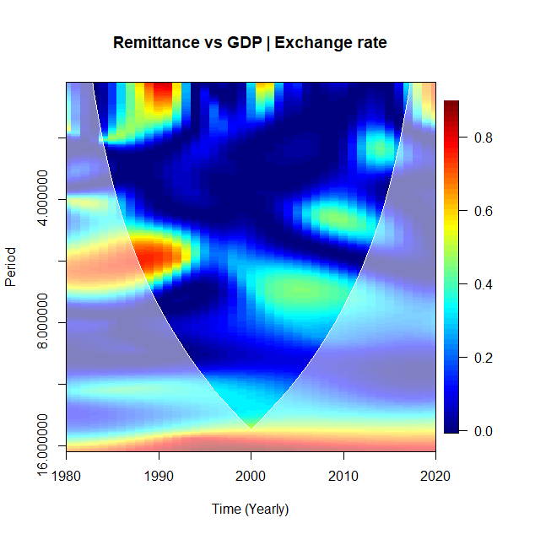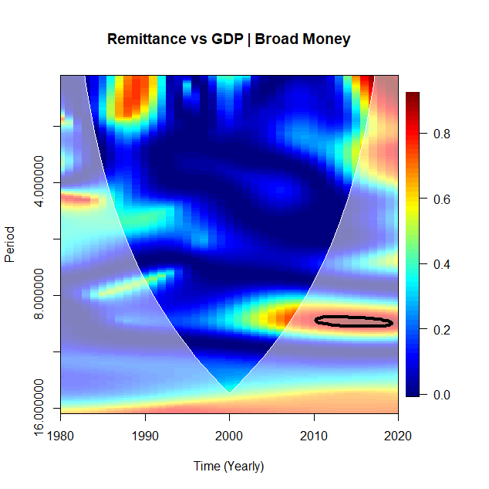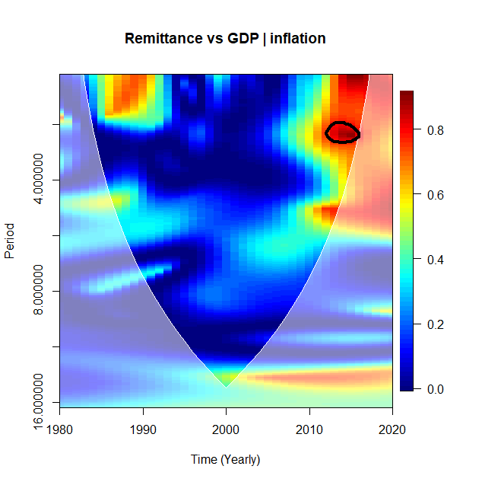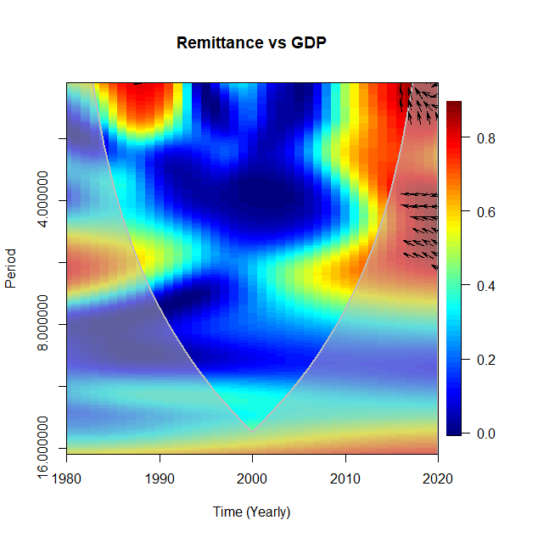

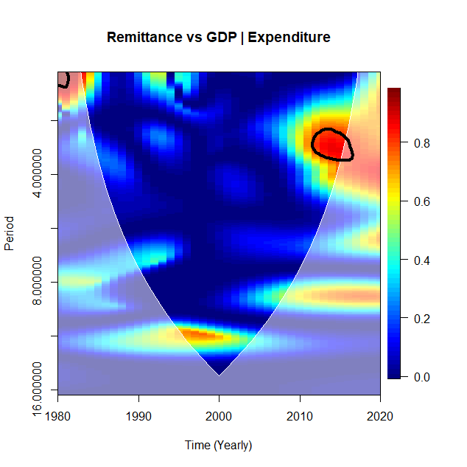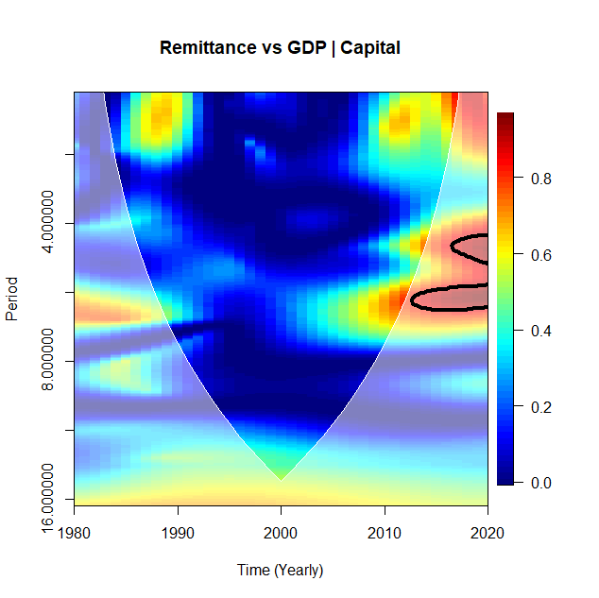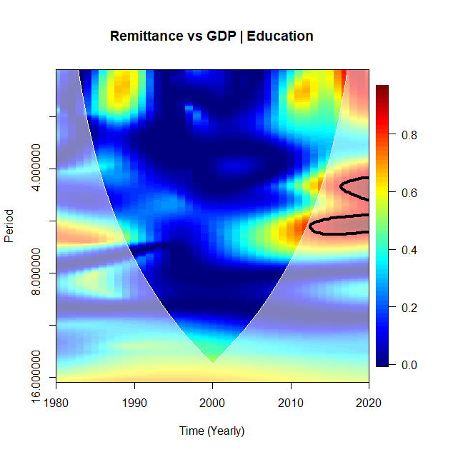

**GHANA**

Figure B1: Ghana

The left-hand side of the plot represents the wavelet coherence between remittance and GDP. Right-hand position plots of partial wavelet coherence show remittance and GDP, removing the effect of exchange rates. The crosshatch reveals regions within the cone of influence (COI). The thick gray contour signifies the 95% confidence level. Arrows on the right-hand side suggest the comparative phase connection, leftward arrows represent antiphase, and upward pointing arrows imply remittance as leading.

From Figure B1, Ghana's comovements between remittances and GDP are primarily concentrated in a 0–8-year cycle. Pockets of islands were observed during the 0-7-year cycle. An intense connectedness between 1990 to 1995 and 2005 to 2010 occurred twice during the study period, from an overvalued currency under the fixed exchange rate system, where the cedi was pegged to one or more currencies, to the managed float, where exchange rates were determined weekly at auction. This system moved the pegged rate to a flexible or floating exchange rate regime. The country moved to a flexible exchange rate system in June 1978. Under the flexible exchange rate system, the Ghana cedi in terms of the US dollar was adjusted to account for the country's economic, financial, and balance of payment issues at the time.

However, over the years, the currency has continued to depreciate because the positive impact of the flexible exchange rate was short-lived as GDP increased and inflation declined during the period with government trade liberalization policies being implemented (Nimoh and Addai-Asante, 2018). The years to follow, with Ghana coming off recession in 1994 based on the economic reform backed by the Bretton Woods system. Ghanaian households’ dependent on remittances for livelihoods received an elevated level of inflow for support.

With the uneven economic recovery of Ghana, with exports on the rise, foreign exchange inflows rose, backed by crop production (cocoa) and minerals. Nevertheless, with low salaries and public service rates, the highly poor Ghanian bore the negative effect of the austerity program, leading to a rise in remittance dependency. During the 1980s, much-skilled labor emigrated to greener pastures in the West under the austerity program. These people, in turn, supported their families through remittances in the face of difficulty.

From 1999 to 2007, the discovery of commercial oil production quantities and the rebasing of its accounts pushed the per capita gross domestic product (GDP) above USD1000. From the plot in 2007, interdependence between remittance and economic growth was low as confidence in the market grew (Aryeetey and Baah-Boateng 2015). This feat was furthered by Ghana's heavy debt forgiveness and commitment to the United States Millennium Challenge Corporation support, among other programs (Osei et al., 2020). The forgiveness of Ghana's debt led to strong projections and capital inflows (investment), reducing the dependency level on remittances. However, these structural changes in the economy were led by a decline in the agriculture sectors' share in employment, leading to low productivity and a muting economic growth effect (Osei and Jedwab, 2016). From 2008, however, Ghana was heavily impacted by the financial crisis, which saw the reversal of the gains. For the average Ghanaian, the decline in growth momentum translated into their livelihoods as the level and quality of education and skills declined. Since 2010, we find the interdependence has been high as levels of unemployed graduates rise, coupled with a rise in interest rates and inflation, and job creation continues to decline, increasing the dependence on remittance. The financial crisis of 2008 has continued to impact growth in Ghana.

The pattern of comovements between remittance and economic growth is in antiphase and points straight up to a clear case of remittance from 2016 to 2020. We find that remittance leads to due to several factors. A rise in emigration from the country due to a lack of decent jobs and low-income levels among graduates and skilled employees was seen. Thus, increasing remittance dependency among Ghanaian households.

After emerging from the health pandemic, Ghana continues grappling with its lingering effects on its economy. The COVID-19 pandemic from 2019 to 2020 was a major factor in remittance dependency increment as quarantine and closure of borders reduced trade and slowed growth. The effect is seen in the 2022 World Currency Report, with Ghana's currency ranked as the worst-performing currency in the world based on a 30-year analysis (Bloomberg, 2022). With a low level of competitiveness in foreign goods on which Ghana is highly dependent, depreciation in the currency has averted slowed growth. However, competitiveness in domestic goods has risen as the trade balance increased.

Ghana's fuel is purchased overseas in the petroleum sector as it does not refine its oil products. The rise in fuel prices in Ghana has been due to, in part, the war between Russia and Ukraine, leading to a price hike in all other fuel-dependent businesses (for example, the transport sector) in the country. Again, the prices of cereals and agricultural products (for example, wheat and fertilizers from Ukraine) have increased, affecting all sectors of the economy. Prices have risen (inflation), which the country has struggled with since 2003, as seen on the WC plot. The right-hand side of Figure B1 demonstrates the PWC plot between remittance and economic growth by excluding the influence of exchange rates. In Figure (B1), for Ghana, at a 95% confidence level inside the cone of influence, we found a low level of dependence between the remittance and changes in GDP. However, in the years leading up to 2000, the dependence level excluding the exchange rate showed significant interrelation from 6% to 8%. Comparing bivariate wavelet coherence and PWC, we found that the influence of exchange rate on remittance and GDP is no longer significant when excluded from the relationship. Lower levels of significance below 5% are seen declining beyond 2005.

The results show the significance of monetary policy uncertainty on the exchange rate as a driver of economic growth decline. The high informal structure of the Ghanaian economy, which has gradually shifted to low-value service activities, and the continuous decline in the manufacturing of value-added products in Ghana hampers growth. Economic transformation efforts by the government to promote job creation, highly secure incomes, and livelihoods have made little to no impact. Moreover, there is a considerable decline in the region of warmth between remittance and changes in GDP on the PWC plot, which implies the exchange rate is the main driver of comovements between selected variables.

The level of economic complexity is low in Ghana, with a comparative advantage mainly in producing agricultural and natural resource products as raw materials (Baah-Boateng and Twum, 2020). Exposure to fluctuations in exchange rates and macroeconomic fundamentals cannot explain the fall in growth in Ghana. This lack of control deteriorates economic growth and recovery. A rise in the dollar on the cedi has made it difficult for Ghanaian businesses to export to the US. Again, issues such as unemployment and high inflation have been exacerbated. The study finds this happening in the country as the cedi depreciates further, and inflation increases as demand for goods rises. Furthermore, the country’s current account worsens as the import price increases. Ghana needs policies that reduce its dependency on crucial goods such as fuel, which is largely imported[13].

The exchange rate effect in Ghana is transmitted through fuel prices to transportation costs to the agriculture, service, and manufacturing sectors, negatively impacting the livelihoods of the average Ghanaian whose income is declining. In the case of remittance-dependent households, the need for support increases from migrant relations increases, indicating the dire need for structural change toward high-value-added sectors to meet global technological change and increase income. Structural transformation backed by complex technologies, research, and development is needed to increase the production, development, and refinement of oil products in the manufacturing sector for export. Structural transformation hinges on improving human resources to create sustainable employment and skills, positively impacting the economy (Osei et al., 2020).

The results obtained for Ghana were further confirmed by the PWC plots for other selected macroeconomic variables, as shown by inflation, general government expenditure, money supply (broad money), capital (gross fixed capital formation), and education (school enrollment), which the low interdependence on the relationship between remittance and GDP when moderated by the selected variables.

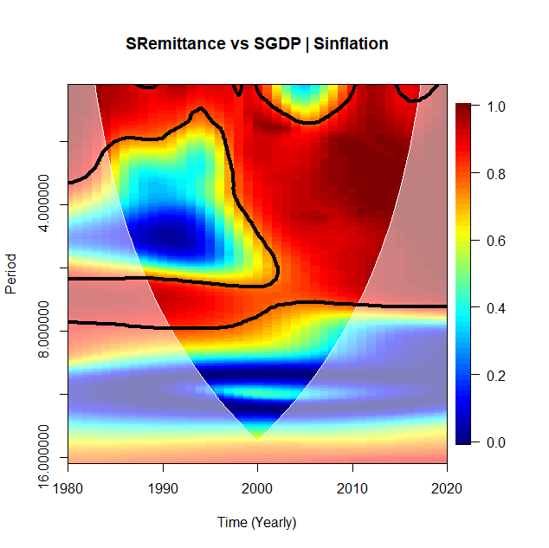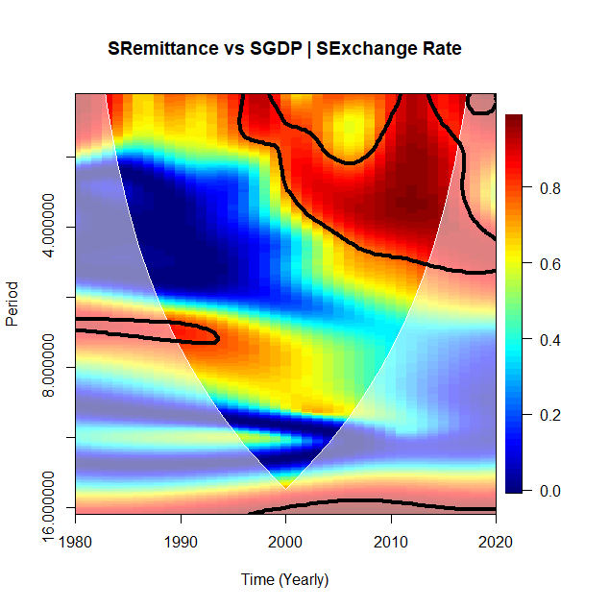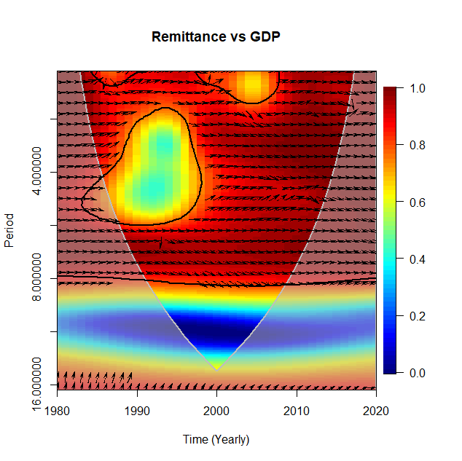

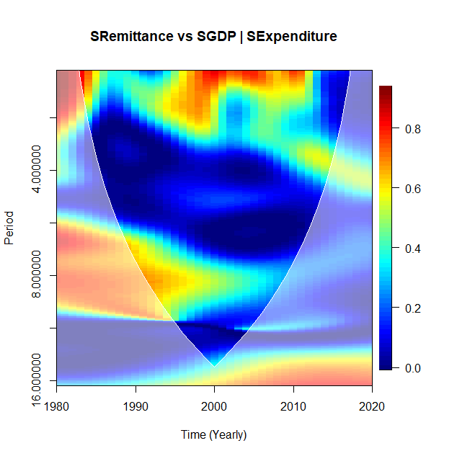

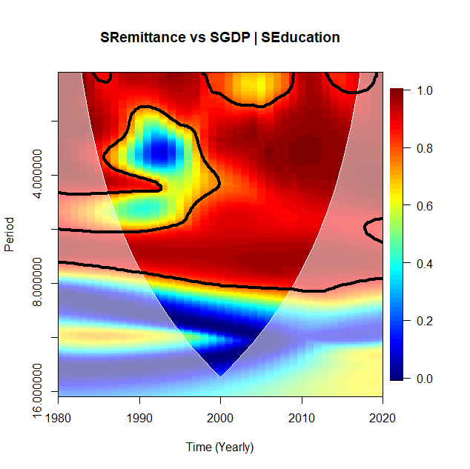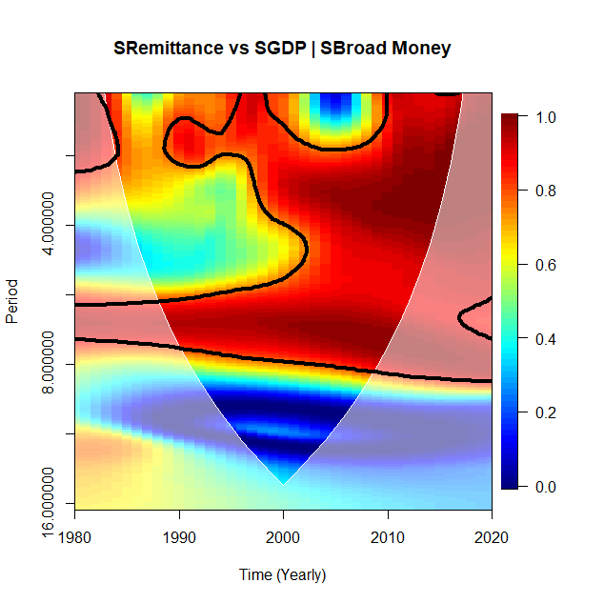

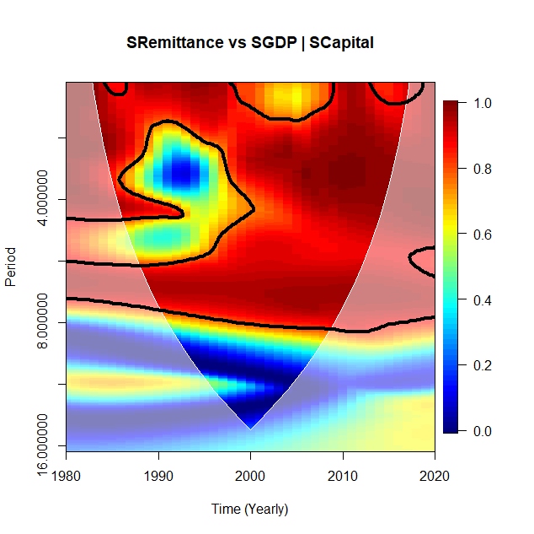

**SOUTH AFRICA**

Figure B2: South Africa

The left-hand side of the WC plot shows remittance and GDP. The right-hand side represents the PWC plot between remittance and GDP, removing the effect of exchange rates. The crosshatch reveals regions within the cone of influence (COI). The thick gray curve denotes the 95% confidence degree. Where arrows on the left-hand side reveal the comparative phase connection, a right-pointing arrow represents in-phase, upward-pointing arrows suggest remittance, and pointing directly down implies the leading of GDP.

In the case of South Africa, figure B2, comovements between remittance and GDP, showed a string of interdependence. It is worth noting that South Africa's inability to translate the positive factor price movements of the 1970s into the price of gold reduced confidence in the country's economy in the 1980s. Falls in monetary supply, stock capital investments, high inflation, and exchange rate controls hampered growth when poor governmental policies were implemented, accompanied by a fall in gold prices, a major source of revenue for the country. Capital erosion plus population boom drove GDP per capita down, and job availability did not march population growth.

Additionally, a rise in restrictive regulations in the private sector, inefficiency in managing capital in the public sector, and financial sanctions continue to impact growth. South Africa joined the Southern African Development Community (SADC) to stimulate growth in the 1980s, which only compounded the poor growth issue as ill-advised policies from the government were taking a toll on the economy.

Furthermore, capital flight as a percentage of GDP hovered around 5.4 percent per annum from 1980 -1993. It, however, rose by an average of 9.2 percent from 1994 to 2000, impeding the economy by reducing capital for investment. Over the years, human capital (skilled labor) emigration rose among white and black professionals in the engineering, medicine, and I.T. fields. The exodus of black professional migrants in the country, growing xenophobic sentiments, and low economic opportunities increased the level of brain drain in the country. As South Africa's remittance inflow increased, it was often eclipsed by the corresponding outflow.

South Africa is considered the most developed country; even so, remittance has grown since 1998 as emigration levels increased. South Africa received an all-time high of USD 1.2 billion in 1998, representing 3 percent of GDP; as of 2019, according to the World Bank, the total remittance inflow was USD 1.5 billion. Saddled with volatility, economic growth, however, has had to sustain since the 2008 financial crisis leading to a decline in growth rate to about 1.4 percent, with a low of 0.6 percent in 2016 (StatsSA, 2019). The volatile nature of growth in the country calls for South Africa to harness the benefits of remittances for economic growth.

The South African economy is plagued with an unstable currency; although it adopted a flexible exchange rate regime in 2000, currency volatilities have caused complications for economic growth. The devaluation of the South African Rand had a knock-on effect on consumers in the country, rendering monetary policy intervention unfeasible. The devaluation of the Rand affected small businesses and homeowners by raising debt levels as the Rand weakened against the major currencies.

South Africa has since advanced in implementing financial inclusion policies which have led to an increase in savings with a highly developed financial sector. Thus, with a high degree of integration in domestic financial systems, remittance is less likely to stimulate investment for growth. Nonetheless, the impact of the exchange rate on the remittance economic growth relationship cannot be overlooked as the exchange rate impacts growth. The moderating effect of the exchange rate is strong on the South African economy even as remittance is channeled through investment ventures due to the high level of integration of the financial market. In the biwavelet plot, the arrows are in phase, but it is unclear whether remittance or GDP is leading. The plot highlights the real impact of the exchange rate on the remittance economic growth relationship, among other factors.

Conversely, the partial wavelet coherence plot in Figure B2 showed a strong relationship between remittance and GDP, excluding the exchange rate. For regions with warmer colors from 2000 to 2020, we found a strong interdependence as high as 8%. We further found that greater portions of red regions are observed from 2000 onwards, primarily for the intermediate and long-time spheres. Thus, there is a high degree of comovements between the macroeconomic variables reflecting their shared reliance and not just the outcome of their combined comovements.

The mediating function of the exchange rate in stimulating comovements between remittance and economic growth leads to a reduction in the proportion of warmer regions, as seen through the comparison of bivariate wavelet coherence and corresponding PWC. For South Africa, we found that if the exchange rate is involved, the comovements between remittance and GDP will be significant. However, excluding the exchange rate, the study finds that other macroeconomic variables, such as inflation, strongly affect the remittance and economic growth relationship (Olamide, Ogujiuba, and Maredza, 2022).

South Africa remains one of the continent's highest remittances (receiving and sending) countries. With its strong financial development and policies, contractionary measures should be implemented to boost a strong currency, control inflation, and correct the balance of payment equilibrium. The introduction of good monetary policies, export-led growth, fiscal reforms, and industrialization will continue to strongly impact the South African economy. The results obtained for South Africa were further confirmed by the PWC plots for other selected macroeconomic variables, as shown by inflation, general government expenditure, money supply (broad money), capital (gross fixed capital formation), and education (school enrollment). The research finds high interdependence on the relationship between remittance and GDP when moderated by the selected variables except for general government expenditure, which indicates a low interdependence.

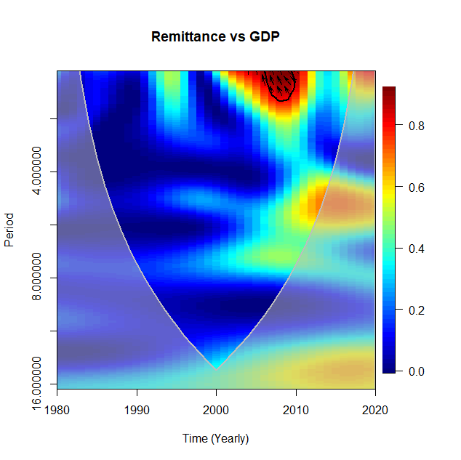 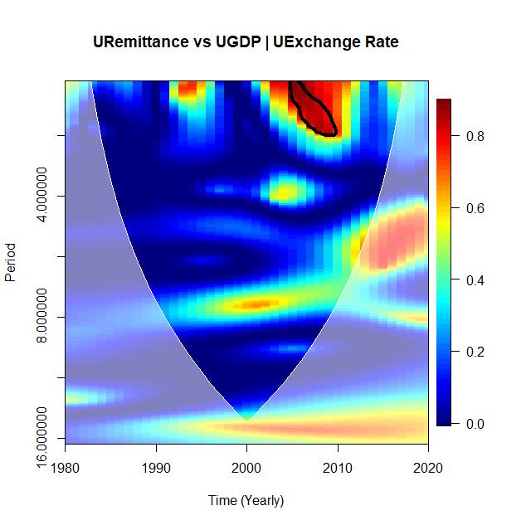

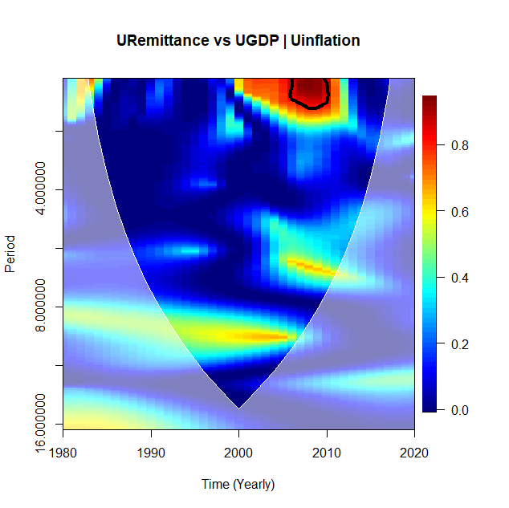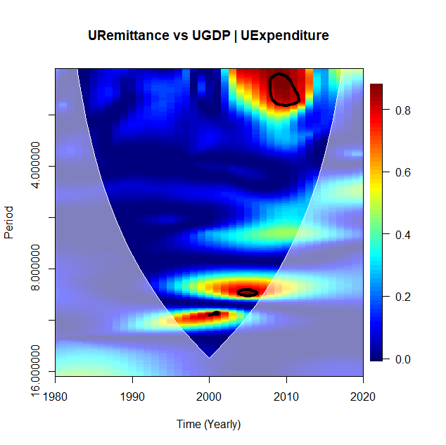

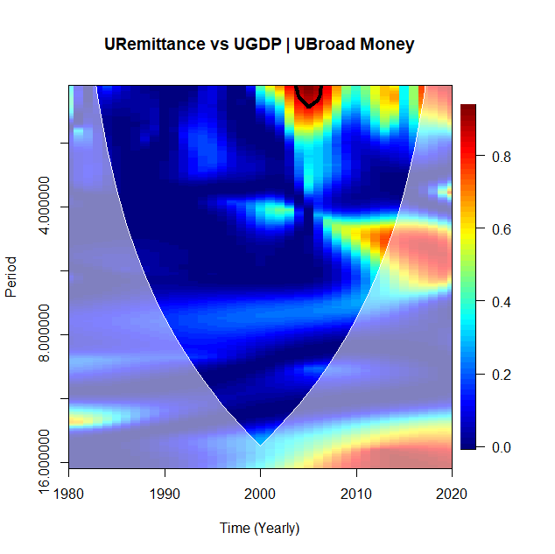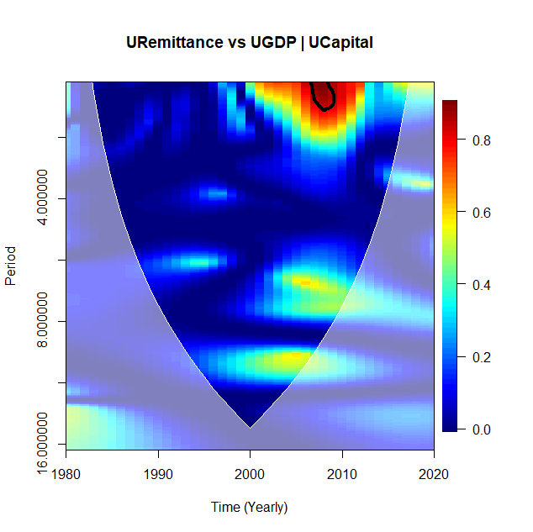

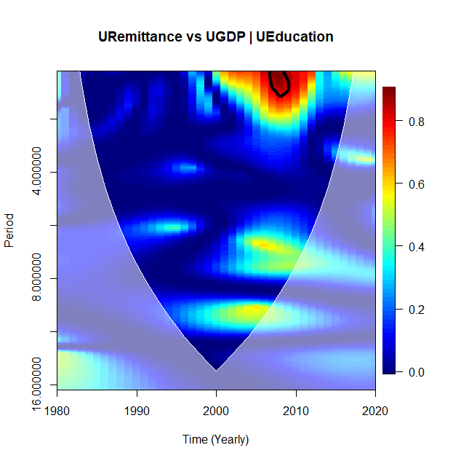

**UGANDA**

Figure B3:Uganda

The left-hand side of the WC plot shows the remittance and GDP relationship. The right-hand side shows the PWC plots for remittance and GDP, removing the effect of exchange rates. The crosshatch signifies regions inside the cone of influence (COI). The thick gray curve suggests the 95% confidence point. The right-hand side arrows reveal the comparative phase connection; arrows pointing left suggest antiphase and arrows pointing straight up imply the leading of remittance.

In Figure B3, Uganda's comovements between remittance and GDP are primarily concentrated between 0 to 2-year cycles. One small island is noted throughout the period under study, with intense connectedness from 2009 to 2010. With Uganda’s emergence from the war, the economy has grown due to recovery programs and macroeconomic and structural reforms. The growth rate rise averaged 7.7 percent per annum until the financial crisis of 2008, leading to a decline of about 1.4 percent from 2008 to 2009 in growth rates. The decline in economic growth and limited employment opportunities have spurred the emigration of Ugandans abroad for better work opportunities, leading to a rise in remittances of about 14 percent (Mohamed, 2019).

The erratic nature of the growth rate in Uganda from 2010 to 2020 is highlighted in the build-up of warmth (interdependence) in the remittance and economic growth relationship. Remittances accounted for 6% of the country's GDP from 2008 to 2010 (UNCTAD, 2012). Remittance continues to grow concerning tourism as the higher exchange earner for the country exceeds the foreign direct investment. Uganda's sensitivity to exchange rate volatility and uncertainty arising from global shocks, the balance of payments deficits, and speculation on the currency threatened the economy[14]. The implementation of a flexible exchange rate regime since 1993 is attributed to the positive effects on the economy of Uganda. Thus, Uganda's economy is insulated from economic shocks in Uganda.

In the case of partial wavelet coherence, plot Figure B3 for Uganda before the year 2000 reveals the low dependence relationship between remittance and GDP. From 2005 -2010, interrelation is about 8% within the cone of influence, excluding the influence of the exchange rate. When we compare the proportion of warm regions between remittance and GDP for bivariate wavelet coherence and corresponding PWC, an increase in the area of dependence indicated a strong level of interdependence within a limited time frame. An increase in the warmer region shows that the influence of the exchange rate is less significant and occurs in shorter cycles as there are other potential influences from different macroeconomic variables, such as inflation.

The results obtained for Uganda were further confirmed by the PWC plots for other selected macroeconomic variables, as shown by inflation, general government expenditure, money supply (broad money), capital (gross fixed capital formation), and education (school enrollment). The study finds high interdependence on the relationship between remittance and GDP when moderated by the selected variables in short cycles (Hoanga et al., 2020).

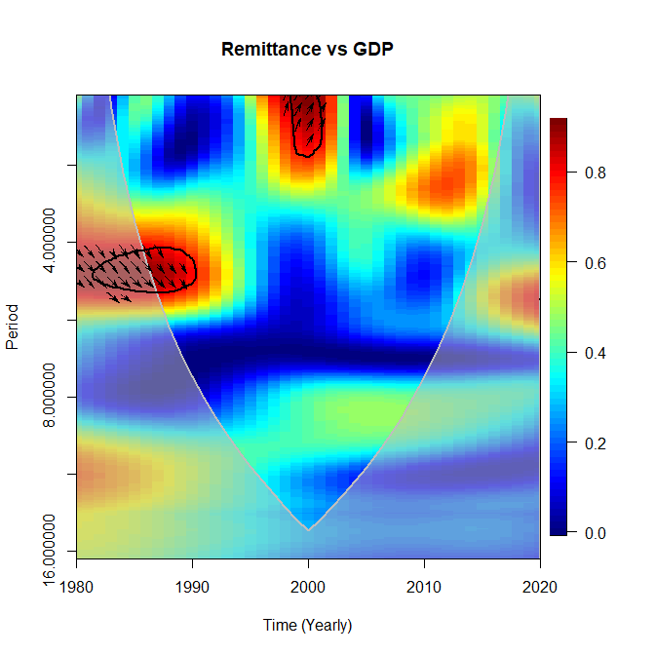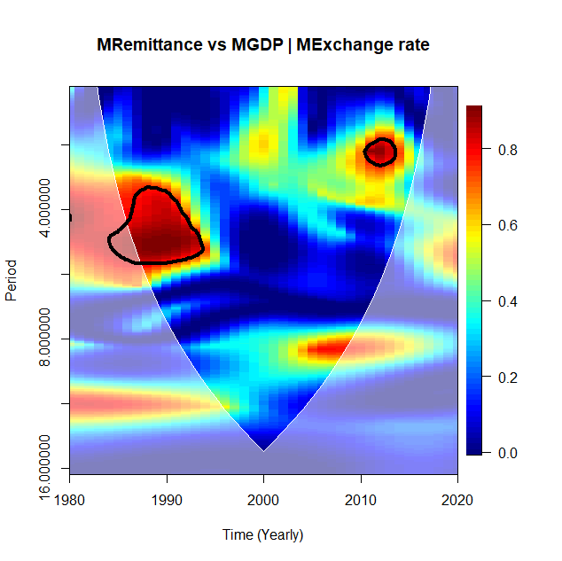

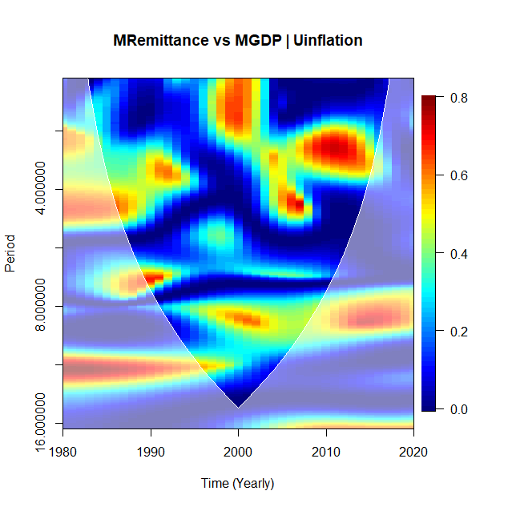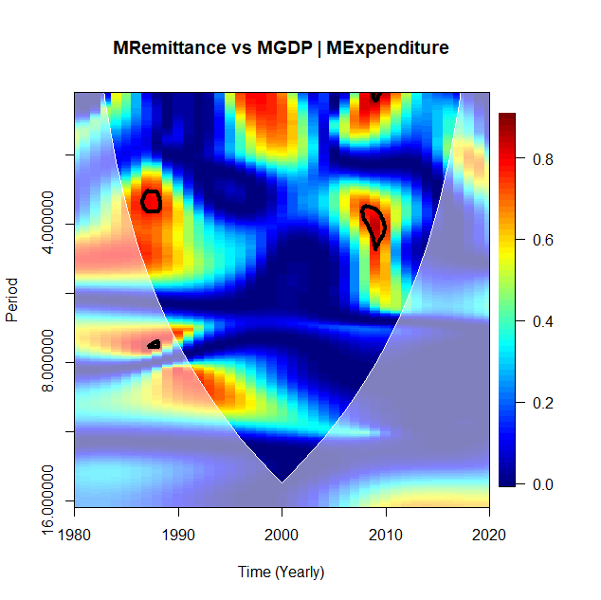

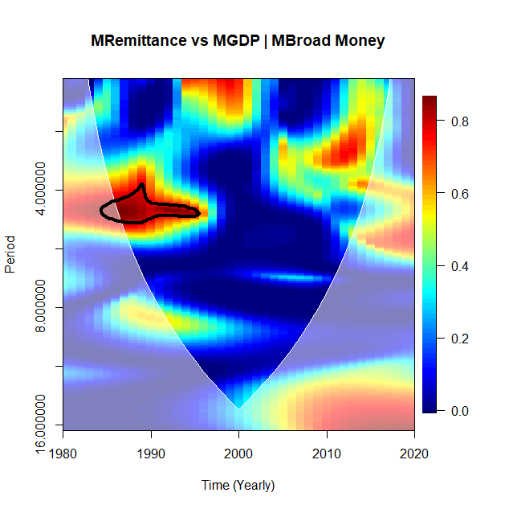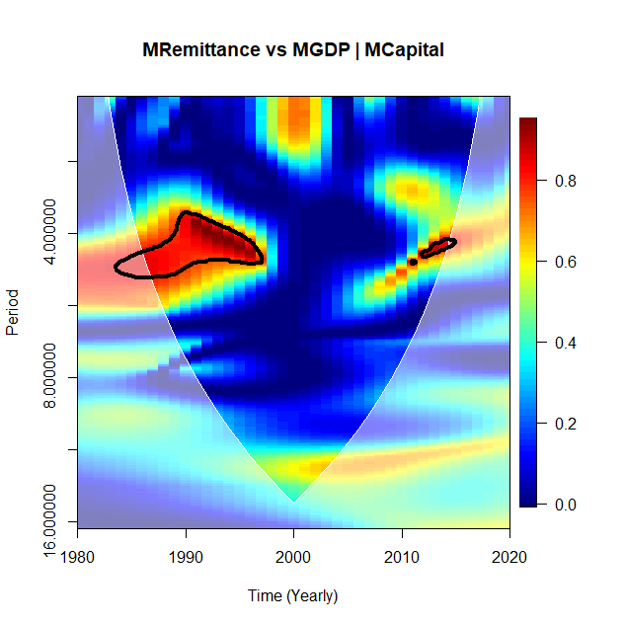

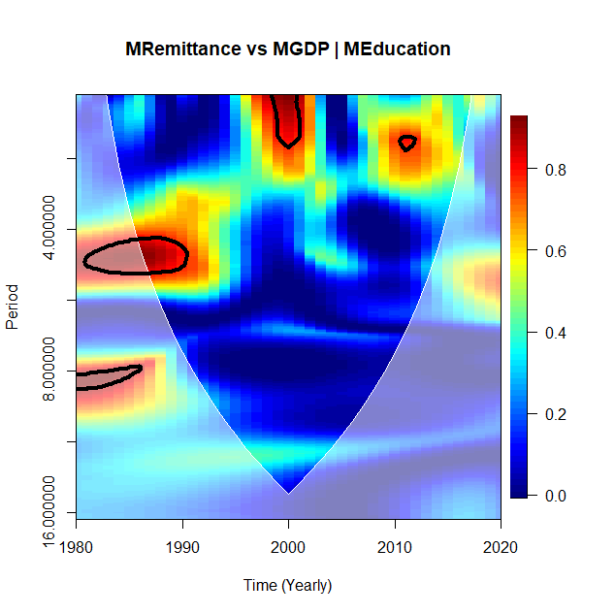

**MOROCCO**

Figure B4: Morocco

The left-hand side of the WC plot shows the remittance and GDP relationship. The right-hand side shows the PWC plots of Remittance and GDP, removing the effect of exchange rates. The crosshatch signifies regions inside the cone of influence (COI). A thick gray curve suggests the 95% confidence point. On the left-hand side, arrows reveal the comparative phase connection; arrows pointing right suggest in-phase, and arrows pointing straight up implies remittance leads, and pointing straight down indicates GDP lead.

From Figure B4, Morocco's comovements between remittance and GDP are concentrated within 0-6-year cycles. Two (2) small islands are found on the plot to occur throughout the study period, one with an intense concentration between the 4-6-year cycle (1980-1995) and 0-2-year cycles (1998-2000). Morocco remains one of the main countries of emigration in North Africa, with over 2.8 million people since 2013. Morocco is ranked the second largest recipient of remittance due to the emigration of skilled and unskilled labor, usually towards the European area and the Gulf States, for better opportunities. Deepening financial development in Morocco has spurred remittance inflow through formal channels. Remittance inflow increased six-fold from USD 1.3 to 7.3 billion in 2013.

Implementing the basket peg of the exchange rate has been a strong anchor for the dirham against the euro. It has limited the volatility effect of the euro-dirham, leading to a stabilized value in the currency. From the biwavelet coherence plot, appreciation in the euro for which the dirham is pegged saw a high interdependence between remittance and economic growth from 2000 to 2004. Thus, the Moroccan exchange rate policy has ensured a stable and dynamic economy leading to positive export competitiveness (Guechati and Chami, 2021). The arrows in the biwavelet coherence plot were found to be in phase, but it is unclear whether remittance or GDP is leading.

In Figure B4, for the partial wavelet coherence plot, Morocco highlights that from 1980 to 1995, the interrelations between remittance and GDP, excluding the exchange rate, increased. However, in 2010, after the financial crisis of 2008/2009, an island of high interdependence was seen at 8% within the COI. Comparing bivariate wavelet coherence and the corresponding PWC, we find that the warmer regions increased before 2000 within 2–6-year and 0-2-year cycles after the financial crisis 2009/2009. The processes show the significant impact of the exchange rate effect on the remittance and GDP relationship.

The research finds that other macroeconomic variables could influence the relationship during periods of interdependence, such as spending behavior in remittance-receiving households. The basket peg system adopted by Morocco has limited the effect of currency appreciation on the national currency when the remittance is converted, reducing demand volatility to ensure stable economic growth.

The results obtained for Morocco were further confirmed by the PWC plots for other selected macroeconomic variables, as shown by inflation, general government expenditure, money supply (broad money), capital (gross fixed capital formation), and education (school enrollment) (Hoanga et al., 2020). The study found that high interdependence occurs more frequently and in short cycles when examining the relationship between remittance and GDP when moderated by the selected variables.

## 3.6 Conclusion

The study presents an advanced assessment of the dynamic interrelationship between remittance and economic growth (measured by changes in GDP) with a mediating variable (in our case, the exchange rate) in selected remittance-dependent African economies. As a result, the biwavelet and partial wavelet analyses were employed. The uniqueness of this paper is that it uses wavelet coherence to detect the identified time-varying comovements in the African remittance-economic growth relationship. The study presents the lead-lag interactions given a set frequency and use of remittance in their development prospects. Moreover, the intermediating role of exchange rate inducing comovements between remittances and changes in GDP for remittance-dependent African economies was examined by applying biwavelet and PWC analysis, which evaluated the degree of comovements between remittance and economic growth by controlling for the mutual effect of the exchange rate.

The findings reveal that remittance impacts economic growth, as seen in Solow's extension. The researcher argues that there will be no economic impact if there is no change in savings and investment rates. However, as noted in Ghana's biwavelet coherence case, interdependence rises when the exchange rate mediates the remittance economic growth relationship (Feeny et al., 2014; Ratha, 2013).

Alternatively, there is little impact on Ghana's remittance-economic growth relationship from the exchange rate under the partial wavelet coherence. When the exchange rate is excluded, the remittance and economic growth relationship have limited interdependence. However, the remittance-GDP relationship is significant in the cases of Morocco, Uganda, and South Africa. The exchange rate intermediating role in inducing remittance and changes in GDP is substantial. Overall, the results show that exchange rate policies that attach a certain level of importance to stability in their currencies for all three African countries except Ghana will impact the remittance-economic growth relationship. The study supports the J-curve and the M-L condition by either maintaining export competitiveness, promoting bilateral trade, or depreciating or appreciating the local currency.

African countries and others characterized by significant migration outflows and high incidence of remittance inflow, the impact on economic growth cannot be overemphasized, with exchange rate policy playing a pivotal role. It must be noted that when the exchange rate mediates the remittance and economic growth relationship, there are two possible outcomes; on the one hand, a change in the exchange rate will influence the monetary value of remittances, leading to an income effect, whiles on the other hand, it can lead to changes in exchange rates resulting in exchange rate effect. The income effect is experienced between the remittance origin and the receiving country as variations in exchange rates are direct. The value of the receiving country's currency from migrant transfers influences the spending behavior and decisions of the receiving households. Thus, an appreciation in the sending country's currency increases its value for the receiving country. Appreciation leads to a rise in spending, impacting economic growth dynamics. However, a volatile exchange rate will lead to an unsteady economic growth dynamic for countries characterized by high levels of emigration.

In the case of the exchange rate effect, there are two possible consequences: direct and indirect effects. The natural result of the exchange rate effect is related to the impact of remittance on the foreign exchange market when the remittance is converted into the national currency of the receiving country. In small and open economies, remittances serve as sources of foreign exchange as their conversion leads to an appreciation of the nominal exchange rate. However, in the case of indirect effect, the impact from the conversion of remittances is channeled through income. As spendable income rises, aggregate demand increases, leading to a rise in prices and exchange rates. For small open developing economies, when relative prices change in favor of non-tradable goods, reallocation of production occurs. However, the impact on tradeable goods is more susceptible to international competition and exports, which leads to the Dutch Disease phenomenon[15]. An inflow of remittances in foreign currency to countries with high emigration and conversion of remittances to local currency could lead to exchange rate appreciation, adversely impacting local production competitiveness, discouraging exports, and improving imports. However, when such countries are beset with high inflation and unemployment rates, economic growth declines in response (Marzovilla and Mele, 2015).

# CHAPTER FOUR

# ECONOMIC TRANSFORMATION THROUGH GLOBAL VALUE CHAINS; NEW INSIGHT FROM EXCHANGE RATE EFFECTS ON THE AFRICAN ECONOMY.

# CHAPTER FOUR

# ECONOMIC TRANSFORMATION THROUGH GLOBAL VALUE CHAINS; NEW INSIGHT FROM EXCHANGE RATE EFFECTS ON THE AFRICAN ECONOMY.

## Abstract

The study investigated GVC and exchange rate comovements from 1990 to 2018. The study employed continuous wavelet coherence techniques to examine the time-frequency dependence structure of global value chain (GVC) participation and exchange rate in Africa. The researcher observed no individual heterogeneous patterns in comovements structure at the various timescales for the exchange rate, trade, and inflation against GVC participation. The researcher examines the biwavelet coherence; the comovements were non-existent with no high occurrences. The study implies that the exchange rate does not act to hamper value chain participation directly. Findings reveal that economic growth coupled with strong policies could influence the connectedness of trade activities in African economies. Consequently, radical change and enforcement of trade agreements should account for both forward and backward GVC participation to influence value chain activities and growth. The study postulates that implementing macroeconomic mechanisms is needed to mitigate a decline in value chain participation.

## 4.1 Introduction

Exchange rates greatly impact shaping macroeconomic and financial cycles (Antwi et al., 2020; Adusie and Gyampong, 2017). Exchange Rates are the most quoted indices in international economics and finance. They measure competitiveness by quantifying the sensitive nature of a country's output demand as a function of global prices (Chinn and Ito, 2006; Obstfeld and Rogoff, 2005). Central banks devote time, effort, and resources to computing and analyzing their effect (Patel et al., 2019). Specifically, exchange rates are often cited by central banks, the financial press, and business investors as one of the determinants of investment decisions (Avdjiev et al., 2019; Kearns and Patel, 2016). Exchange rates under flexible exchange rate regimes have been traditionally criticized for negatively impacting international trade (Auboin and Ruta, 2012). Extant empirical studies investigating global value chains (GVCs) and exchange rates cover development, inclusive growth, employment, economic growth, investment decisions, and determinants with no or little focus on the effect of constant changes in the exchange rate at high frequency on low frequency macroeconomic (for example, GVCs, GDP growth rate, migration, among others) indicators (Mao, 2021; Obeng et al., 2021; Aydjiev et al., 2019; Hernandez and Pedersen, 2017; Jouanjean et al., 2017; Taglioni and Winkler, 2016).

Empirical studies investigating how global value chains (GVC) participation reacts to exchanges rates fail to account for the changes that may occur during trading days of the local currencies against the US dollar and its impact on GVC activities in trade ( Sato and Zhang, 2017; Leigh et al.,2017; Ahmed et al., 2016; Cheng et al., 2020; Hooy et al., 2016). Subsequently, empirical studies have shown how global value chain (GVC) participation reacts to exchange rates without accounting for underlying issues (for example, peaks and gaps at different periods) in the relationship (Sato and Zhang, 2017; Leigh et al.,2017; Ahmed et al., 2016; Cheng et al., 2020; Hooy et al., 2016; Cheng et al., 2015).

Sato and Zhang (2019) state that global trade has changed tremendously in the past 20 years. Global value chains have become a major part of international trade, influencing societal development. With global trade tensions placing strain on global economic and financial systems, the impact of exchange rates on value chains has attracted wide attention. Based on emerging streams of literature investigating global value chains participation, the effect and implications of macroeconomic variables (for example, exchange rates, interest rates, inflation, among others) call for a re-examination of the relationship between exchange rates and global value chains (Sato and Zhang, 2019; Auer et al., 2017; Auboin and Ruta, 2012). Recent studies by Sato and Zhang (2017) on trade effects on exchange rate volatility have shown that exogenous changes in exchange rates can significantly affect economic trade activity and production structures. Essentially, economic agents in emerging markets (EMs) and frontier markets (FMs) need to examine and understand the periods which capture market trends (peaks and gaps) by assessing past and real-time information (Yang and Yang, 2021).

Most studies in emerging and frontier markets assumed that countries export only primary or final goods produced without the use of imported intermediate goods and that a single representative production line characterizes each country. The pitfall associated with these assumptions is that several activities with differentiated products across multiple production countries characterize the level of participation in GVCs per country. Suppose that fish products (fish feed) are sourced from Nigeria as a raw material for fish farming in Morocco helps in the production of the final product of canned fish for Ghanaian consumers. The level of participation of each country needs to be examined, considering their activity and individual market conditions (Patel et al., 2019).

The inability to recognize the GVC participation structure by traditional models, which operate under the assumption that Nigeria exports the final good to Morocco; hence a depreciation in Nigeria’s currency hurts Morocco’s competitiveness and stands to be re-examined. In reality, however, a decline in the price of Nigeria’s fish feed could increase demand for Morocco’s output, improving Morocco’s competitiveness (Patel et al., 2019). It shows that exchange rates computed using the standard framework are not accurate in their measure of magnitude, influence, and identification of underlying periodic trends in the production and sale of final products exported by emerging and frontier markets as intermediate goods in production structures grow (Wang et al., 2022; Patel et al., 2019). Addressing these issues through the lens of statistical models, we capture GVC participation and volatilities in exchange rates within African markets as the contribution of this paper. Leveraging this new development and big data, we construct a comprehensive macroeconomic series (exchange rates) that capture the various changes and waves that directly influence African markets' global value chain participation at any point in time.

We provide policy recommendations based on the effect of exchange rates on GVC participation levels as cross-border trade increases on the African continent (World Bank, 2019). Consequently, this novel data construct which has not yet been fully investigated in literature in the context of African markets is examined. Given our objective to examine undulations from the exchange rate and GVC data relationship, we present the periodic levels of participation of selected countries in achieving competitiveness and growth as they engage in GVC activity trade patterns as Africa’s economy changes.

## 4.2 Theoretical Background and Review of Literature

This section examines the theoretical constructs surrounding the concepts, words, and phrases. The researchers used this opportunity to bring meaning to the questions, relationships, and the validity of the posited phenomena in this study (Marie L’Huillier, 2014).

### 4.2.1.1 Global Value Chain (GVC) Theory

The GVC theory was built on the World System theory (Gereffi,1994,1999; Cameron and Wallerstein, 1981). Gereffi used the term “global commodity chain” following the path of  Cameron and Wallerstein (1981); he altered the conceptual framework, which is the basis for modern theories of value chains by reframing globalization and inter-connectedness to focus on inter-firm relationships. Subsequently, theorists adopted the “global value chain”; due to the association of the word “commodity” to only standardized products, although the theory covered differentiated products (Gereffi et al., 2001). The objective of the theory focuses on organizational fragmentation and geographical dispersion of value chain activities for production. Gereffi (1999) highlights this by pointing out the role of lead firms in establishing GVC networks based on location, allocation, and distribution of value-added resources and activities in production structures.

The GVC theory presents the contribution of non-manufacturing organizations (retailers) that shape interconnections and integration with manufacturing firms in the global economy (Bernard and Fort, 2015; Buckley and Strange, 2015). With manufacturing firms seeking to sell their products, they seek out retailer and brand companies, among others, to promote and sell their products, forming a chain of production to distribution. However, the GVC theory does not consider the relationships between center and fringe states in production structures (Strange and Humphrey,2019). The theory illustrates different forms of governance crucial to the flow of information and power among GVC partners (Benito, 2019).

The bedrock of the GVC theory is the resource-based view which presents how organizations yield power to coordinate externalized activities using different determinants to ensure sectoral structures, power asymmetries, and codified information to secure business transactions to ensure efficiency (Grereffi et al., 2005; Sturgeon, 2002). Under the GVC theory, the flow of goods from one organization to the other is often guarded and does not allow for dispersed interdependencies (Benito et al.,2019). For example, the flow of oil products from an oil mining firm to retailers under the concentrated GVC theory does not allow retailers to adjust transportation routes which could lead to lowering the cost of the product (prices) upon delivery or against any unforeseen circumstances.

### 4.2.1.2 The Internationalization Theory

The internationalization theory concerns inter-firm relationships in the global economy but is based on transaction cost economies (Narula and Wahed, 2016; De Marchi et al., 2014; Humphrey, 2014). The theory seeks out efficiency, building on economic actors’ desire to select efficient governance to carry out their business activities in ways that minimize their cost exposure. The internationalization theory seeks to reduce production costs by considering location, technology, production scale, governance of how and who organizes the level of involvement, and the remuneration of economic actors. However, it does not consider governance interdependencies across borders as the GVC theory does (Benito et al., 2019).

The inflexible nature of power asymmetries and standardization of products leads to low investment inflows and high coordination and control costs as lead firms seek to lower their specific transaction cost along the chain (Gereffi et al., 2005). Additionally, when exchange rate prices appreciate or depreciate in the production or receiving country, retailers (distributors) cannot adjust prices without managerial consent. By this, the lead organizations can suppress any possible opportunistic inclinations among the GVC participatory organizations for the good of the entire production structure (Kano, 2018).

The internationalization theory does not effectively deal with changing dynamics along the international production lines due to its inflexible style of operations, which leads to low levels of integration due to a lack of access to relevant information (Petersen et al., 2010). Firms under the internationalization theory are continuously faced with instability, unreliability, and inefficiency issues as more complex situations emerge, with network partners unable to make their arrangements for production and distribution and networks (Contractor et al., 2010; Petersen et al., 2010). GVC networks under this theory provide a platform for competitive forces over time, which drives out inefficient production methods (Benito et al.,2019). Under this theory, production is uncompetitive and unstable in cases where actors may be disinterested. On the other hand, where economic actors are heavily invested in the GVC networks, ensuring reliability, quality, and efficiency, production firms are competitive and stable (Benito et al., 2013; Petersen et al.,2010).

GVC networks with existing concentrated power seek efficiency by employing a combination of factors from the market (for example, exchange rate prices, inflation), modular (codification and standardization of information transfer), relational (tacit information and transaction-specific investment), captive (lead buyers with detailed specifications for dependent suppliers) and hierarchy (power structures such as managerial control) to lower transaction cost. The capabilities of suppliers, complexity in the exchange of transaction information, and its codification determined the power asymmetry between, for example, oil-producing (firms) countries and their buyers (Gereffi et al., 2005).

Internationalization theories seek the flexibility of arrangements focusing on the market (prices), hybrid (tacit information and transaction-specific investments), and hierarchy (firm strategies on ownership and location decisions). GVCs operating by this theory are more concerned with their internal structures, while GVCs under the GVC theory are focused on consolidating power through externalization (Sako and Zylberberg, 2017; Humphrey, 2014; Strange and Newton,2006).

## 4.2.2 Empirical Literature Review

The effect of exchange rate on GVC participation as a transmission channel and the dynamic influence of exchange rates on international trade as goods and services flow across borders have been examined directly and indirectly through production structures, investment, and national policies (De Backer and Flaig, 2017; Marcolin et al., 2016; Broda and Weinstein, 2006). Exchange rate appreciation (depreciation) has a negative (positive) effect on exports under international trade to underscore the economic uncertainties and volatilities underlying exchange rates (Auboin and Ruta, 2013; Mayer and Steingress, 2020). Moreover, aggregation bias negatively affects exchange rate and trade (Mayer and Steingress, 2020; Auboin and Ruta, 2012; Bussière et al., 2016; Sato et al., 2016).

Bahmani-Oskooee et al. (2016), using non-linear ARDL, found that exchange rate, appreciation, and depreciation have a significant short-term effect on domestic production, affecting trade. Middle East and North African (MENA) countries' exchange rates have been found to have a positive effect on trade for Morocco using aggregated series under the vector error correction model (VECM) through export demands (Louati et al., 2022). Using annual series from 1990 to 2018 for 15 MENA countries, Elsherif and Mohieldins’ generalized autoregressive conditional heteroscedasticity (GARCH) and threshold-generalized autoregressive conditional heteroscedasticity (TGARCH) found exchange rates to affect international trade negatively (Elsherif and Mohieldin, 2020). Bahmani-Oskooee and Gelan (2018) found that exchange rates have a long-term effect on exports in their study of twelve (12) African economies on the relationship between trade and exchange rates. From their studies, the exchange rate volatilities of exports and imports are inconsistent in the short term.

Nevertheless, following up, Bahmani-Oskooee et al. (2017), using non-linear ARDL, found that exchange rate, appreciation, and depreciation have a significant short-term effect on domestic production, affecting trade. The use of the US dollar as the major trading currency in global trade invoicing coupled with high trade prices impacts expenditure switching through exports in the short-term, impacting growth in emerging and frontier economies (Boz et al., 2019; Borin and Mancini, 2019; Bayoumi et al.,2018; Leigh et al., 2017). Exchange rates are still found to negatively impact exports, although effects on GVC participation are still mixed.

Exchange rates pass through import prices to affect global value chains, as Auer's (2015) work on government-controlled appreciation of the Yuan against the US dollar depicts. Consequently, the US producer price rose for imported inputs from China from the exchange rate pass-through effect. Additionally, regional-level producer prices have been documented to strongly influence import input prices for the Asia-Pacific region as the cost of intermediates increases (Auer and Mehrota, 2014). Examining the impact of the exchange rate pass-through effect, Casas (2019) found a positive relationship with import prices for small open economies and not with other trading partners in the global value chain. They were found to be the result of the strategic placement of complementarities (Casas et al., 2017). Tang (2014) found that integration into GVC makes economies susceptible to exchange rate uncertainties. Ahmed et al. (2017) and Sato and Zhang (2017) posit that exchange rate elasticity is lowered when GVC participation increases for exports; this is disputed (Leigh et al.,2017).

Structural change for transformation and development is favored as labor flows redirect to high production activities when exchange rate prices and value-added products from the manufacturing sector decline, followed by a fall in employment (McMillan and Rodrik, 2014; Rebelo and Vegh, 1995). Furthermore, exporting firms and countries (manufacturing industry) experience growth decline when exchange rate appreciation mechanisms are implemented (Prasad et al., 2007). For such economies, exchange rate depreciation has been found to increase the manufacturing sector's (industry) share of GDP and employment as the share of agriculture declines (Caglayan and Demir, 2014; Rodrik, 2008).

Exchange rate changes influence long-term growth through trade channels, specifically for export-led growth channels. Developed economies' trade response to exchange rates leads to an increase in market entry and exported products. Technological upgrades and high-skill production must boost export diversification to achieve growth during currency depreciation (Goya,2020). In contrast, resource policies must be reallocated in developing economies to achieve the expected export-led growth desired when prices depreciate (Demir and Razmi, 2022).

Bilateral exchange rate changes significantly positively influence developing economies, conditional on the direction composition of traded goods during exchange rate depreciation (Cagalayan and Demir, 2019). However, from the firm level, to achieve structural change, investment and discovery of new lines of the market are needed for a positive diversification impact right after the devaluation of the currency (Iacovone and Javorcik, 2008). The length of time needed for the depreciation mechanism to be effective in achieving long-term development has not been well addressed in recent literature, as the effects may vary across countries, firms, and regions. When currency appreciation mechanisms are implemented, considering firm heterogeneity, domestic-oriented firms do not benefit as export-oriented firms (Caglayan and Demir,2014). At the regional level, exported-oriented firms with strong research and development (R&D) culture are likely to experience growth during currency depreciation compared to regions where R&D is low (Alfaro et al., 2018).

## 4.3 Methodology

### 4.3.1 Research Design

This study employed a quantitative approach using secondary data to examine the relationship between global value chain participation and African exchange rates. Secondary data is deemed appropriate for providing the derivable information for measuring variables and the study’s models.

### 4.3.2 Data Sources and Collection

The study used data from the World Development Indicator database [WDI] and UNCTAD-Eora Global Value Chain (GVC). The study employed yearly time series for global value chain participation and exchange rate from 1990 to 2018, as shown in Table A1(World Bank, 2022; UNCTAD-EORA, 2022). The series is based on the availability of data.

Table A2:Selected Variables, measurement, and explanation.

|  |  |  |  |  |
| --- | --- | --- | --- | --- |
| **Variables** | **Abbreviation** | **Variable Explanation** | **Data span** | **Source** |
| Global Value Chains participation | GVC | Global Value Chain Participation by Country | 1990-2018 | UNCTAD-Eora Global Value Chain |
| Real Exchange Rates | EXC | Real effective exchange rate index (2010 = 100) | 1990-2018 | International Monetary Fund, International Financial Statistics. |
| Gross Domestic Product per capita | GDPpc | GDP, per capita (current US$) | 1990-2018 | World Bank national accounts data, and OECD National Accounts data files. |
| Trade (% of GDP) | TR | Trade is the sum of exports and imports of goods and services measured as a share of gross domestic product. | 1990-2018 | World Bank national accounts data, and OECD National Accounts data files. |
| Inflation, consumer prices (annual %) | INF | Inflation as measured by the consumer price index | 1990-2018 | International Monetary Fund, International Financial Statistics, and data files. |

The researcher did so because of the inconsistencies in data for exchange rates which are vital for the study. To ensure consistency, we obtained five (5) macroeconomic datasets, which are GVC participation and gross domestic product per capita [gdppc], inflation consumer prices [inf], trade as a percentage of GDP, real exchange rates [exc] for four(4) African countries, namely, Ghana, Nigeria, Morocco, South Africa. The countries are grouped based on their level of participation in global value chain activities and the direct influence of exchange rates. The researcher considered the countries based on their maximum participation in GVC trade subject to data availability. The selected countries are, respectively, the foremost and second largest participants in GVC activities within their African regional economic communities (ECOWAS, AMU, SADC). It should be noted that Egypt and Kenya were dropped based on missingness in the datasets for exchange rates and GVC participation.

## 4.4 Empirical Model and Estimation Technique

This study tests the association between global value chain participation and African exchange rates. The researcher employs transformation methodologies to examine the relationship between the variables.

### 4.4.1 Wavelet methods

The research employed Continuous Wavelet Transformation (CWT) to identify and isolate periodic signals for the variables of interest. CWT provides stability for the localized time frequency to improve the trade-off between crests, gaps, detected waves, and extraction in the data (Aloui et al., 2018; Wu et al., 2020). The extension of wavelet transformations is used in macroeconomic analysis to manage problems of nonstationary time series.

### 4.4.2 Continuous Wavelet Transformation (CWT) and Coherence

CWT is a useful method for assessing the changing aspects of nonstationary variables across time and domain space. The study decomposed the time series using the wavelet function to ensure a localized time-frequency space and zero means. Information about the local neighborhood was obtained based on the decomposition. Morlet wavelet was employed by examining the frequency and time-space behavior of the time series data. Specification of the wavelet coherence (W.C.) is specified below:

(1)

If, is the stabilization component certifying unit for the variation of wavelet =1; represents the location boundary, giving the precise location of the wavelet, where *s* represents the level of expansion in the boundary. It defines in what manner the wavelet is spread out.

The Morlet wavelet:

(2)

Where represents the main occurrence of the wavelet. Extracting from the literature,is to 6. Moreover, with the convolution employed on a discrete sequence, a scaled and translated wavelet, the CWT is given as:

=) (3)

Estimating the exact wavelet onto a time series, we obtained . Similarly, the key benefit of a CWT lies in its ability to decompose and rebuild the function of := (4)

The power spectrum evaluation was assessed using Eq (4) with the variance measurement.

${||χ||}^{2}$ = $\frac{1}{c_{φ}}\int_{0}^{∞}{\left[\int_{-∞}^{∞}{ {|W_{s}\left(u,s\right)||}^{2}du}\right]}\frac{ds}{s^{2}},s>0$ (5)

The AR (1) allows for modeling the red noise in the background of the spectrum. We use the Monte Carlo simulation. Given the null hypothesis, we allowed for the pockets found in the wavelet power spectrum (WPS) peaks to be evaluated for their significance level. The resulting local WPS is found in the distribution of the individual time *n* and scale *s* (Torrence and Webster, 1999)[16].

Given:

D (6)

*f*  is denoted , representing the mean spectrum at Fourier frequency in the given data. Given that the wavelet scale aligns with the Fourier frequently (s $≈$ 1/*f*), v=1 represents a real wavelet, and v=2 represents a complex wavelet. Given as $δ_{x}^{2}$ as the variance of the variable.

### 4.4.3 Wavelet Coherence

The combined behavior of time and frequency in the economy is probed, as a CWT must be given to pinpoint the common power amongst the variables (Aloui et al., 2018). CWT power allows for the region's location for which the macroeconomic variable co-moves in time and frequency. In the case of a particular macroeconomic variable series (χ) and another macroeconomic series (*Y*), given the individual wavelet spectra and the CWT for the macroeconomic series can be given as follows:

= (7)

Given that “*u”* represents the position of *s*, the scale *represents the complex conjugation. The CWT indicates the area, time, and space have the highest common power. Thus, (s) represents the complicated conjugate of . The cross-wavelet power || evaluates the shared area covariance on every individual level. W.C. for two-time series is given as χ= and y=.They represent the frequency groups and time gaps for which the series covary. We allow for the detection of comovements among macroeconomic variables. The W.C. is, thus, the absolute square value of the normalized WPS. Hence, the squared wavelet coefficient is expressed as follows:

(8)

Given *S* as the smoothing parameter, it seeks to balance the resolution and significance level. Any problems in the WPS and the wavelet cross-spectrum (WCS) are removed. The same principle is applied in the stabilizing function of W.C. for PWC and MWC cases.

The expression "coherence" fulfills the inequality equation 0. Values near 0 point to a low correlation; however, values near 1 point to a robust correlation. In examining macroeconomic comovements, coherence is the most suitable.

The phase form is centered on the lag of oscillation between two the variables as a frequency, assuming that , explains the phase difference in the economy; the phase difference between χ(t) and y(t) is given as:

$∅_{xy}$ = $\tan{-1}\left(\frac{I\left\{W_{n}^{xy}\right\}}{R\left\{W_{n}^{xy}\right\}}\right), ∅_{xy}∈\left[-π, π\right]$ (9)

Given $I$ and $R$, we assumed that smoothed CWT has two parts: the imaginary and real. The wavelet coherence map shows the directional arrows. The arrows distinguish the various phase forms. For example, where x(t) and y(t) are in-phase (antiphase), the arrow points to the right (left). Equally, when the arrows point downwards (or upward), it indicates y(t) / x(t) is in the lead.

## 4.5 Results and Interpretation

## 4.5.1 Descriptive Statistics

The study examines and presents summary measures of the relationship between global value chain participation and exchange rate for four African economies. Growth data was used for the analysis. The annual growth data is presented in Table 1 on the descriptive statistics of the macroeconomic data, indicating the variants present in the distribution. The sample is from 1990 to 2018, with 29 observations based on data availability for dependent variable global value chain participation. The descriptive statistics of the selected variables are reported in Table 2.

|  |  |  |  |  |  |  |  |  |  |  |  |  |
| --- | --- | --- | --- | --- | --- | --- | --- | --- | --- | --- | --- | --- |
| Table 2: Descriptive Statistics | | | | |  |  |  |  |  |  |  | |
|  | **GHANA** | | |  |  |  |  | **SOUTH AFRICA** | | | | |
|  | **GVC** | **GDPpc** | **Exc** | **Trade** | **Inf** |  | **GVC** | **GDPpc** | **Exc** | **Trade** | **Inf** | |
| Mean | 1.21E+06 | 9.08E+02 | 1.00E+02 | 7.52E+01 | 2.05E+01 |  | 3.42E+07 | 5.16E+03 | 1.00E+02 | 2.17E+01 | 6.92E+00 | |
| Maximum | 2.89E+06 | 2.28E+03 | 1.44E+02 | 1.16E+02 | 5.95E+01 |  | 6.75E+07 | 8.74E+03 | 1.34E+02 | 4.43E+01 | 1.53E+01 | |
| Minimum | 1.84E+05 | 2.53E+02 | 6.82E+01 | 4.25E+01 | 4.87E+00 |  | 7.52E+06 | 2.71E+03 | 7.07E+01 | 1.30E+00 | -6.92E-01 | |
| Std. dev. | 9.62E+05 | 6.85E+02 | 1.97E+01 | 1.90E+01 | 13.2298 |  | 2.20E+07 | 1.86E+03 | 1.89E+01 | 1.28E+01 | 3.50E+00 | |
| Skweness | 0.49495 | 0.69403 | 0.453625 | 0.261056 | 1.267 |  | 0.24315 | 0.27722 | 0.26291 | -0.1338 | 0.59707 | |
| Kurtosis | -1.4681 | -1.13089 | -0.49405 | -0.67373 | 0.81506 |  | -1.7231 | -1.4291 | -1.1807 | -0.9902 | 0.42732 | |
| *GVC: Global Value Chain participation, GDPpc: Gross Domestic Product per capita, Exc: Exchange Rate* | | | | | | | | | | | |  | |

|  |  |  |  |  |  |  |  |  |  |  |  |
| --- | --- | --- | --- | --- | --- | --- | --- | --- | --- | --- | --- |
| Table 2 Cont. Descriptive Statistics | | |  |  |  |  |  |  |  |  |  |
|  | **NIGERIA** | | |  |  |  |  | **MOROCCO** | | | |
|  | **GVC** | **GDPpc** | **Exc** | **Trade** | **Inf** |  | **GVC** | **GDPpc** | **EXC** | **Trade** | **Inf** |
| Mean | 8.16E+06 | 1.36E+03 | 1.07E+02 | 3.74E+01 | 1.85E+01 |  | 6.57E+06 | 2.15E+03 | 1.04E+02 | 6.42E+01 | 2.57E+00 |
| Maximum | 1.63E+09 | 3.20E+03 | 2.73E+02 | 5.33E+01 | 7.28E+01 |  | 1.27E+07 | 3.49E+03 | 1.15E+02 | 8.57E+01 | 7.99E+00 |
| Minimum | 1.84E+06 | 2.70E+02 | 4.97E+01 | 2.07E+01 | 5.39E+00 |  | 1.37E+06 | 1.22E+03 | 9.54E+01 | 4.71E+01 | 4.42E-01 |
| Std. dev. | 5.60E+06 | 9.50E+02 | 5.18E+01 | 8.68E+00 | 1.71E+01 |  | 4.37E+06 | 8.18E+02 | 5.61E+00 | 1.24E+01 | 2.08E+00 |
| Skweness | 0.25139 | 0.40267 | 1.756703 | -0.07905 | 1.916 |  | 1.86E-01 | 0.28095 | 0.23423 | 0.19874 | 1.09181 |
| Kurtosis | -1.7496 | -1.42703 | 2.589091 | -0.71335 | 2.50697 |  | -1.72396 | -1.6765 | -1.3142 | -1.3875 | -0.02924 |
| *GVC: Global Value Chain participation, GDPpc: Gross Domestic Product per capita, Exc: Exchange Rate* | | | | | | | | | | |  |

### 4.5.2 Bivariate wavelet coherence results

The research employs continuous wavelet coherence to examine the influence of selected macroeconomic variables on GVC participation for the four (4) largest GVC participating economies. The pairwise wavelet coherence (W.C.) plots aid in evaluating the strength of interdependence among the selected variables and GVC participation. From the biwavelet coherence plots, we present time on the horizontal axis and frequency on the vertical axis. On plots where a warm color (red) is shown, a time-frequency space is known to have a pairwise time series covarying presence and interrelation among the variables. Areas of colder colors (blue) indicate a significantly lower dependence among the variables.

The cone of influence (COI) shows the crosshatch, with a 95% significance level of confidence for interdependence where the contour is thick and grey. All regions found outside the area of significance, be it blue, show a lower frequency with no interdependence among the series. However, red regions indicate a higher frequency of interdependence among the series. The black arrows represent the lead/lag phase directing where the relationship exists for the paired series; however, in some cases where there are no arrows, a zero-phase variation is said to occur on the W.C. plots indicating a concurrent movement due to a specific measure. Where arrows point in the same direction (right), the series are said to be in phase, antiphase (left). In antiphase, movement occurs in opposite directions. Right-down arrows (left-up) arrows show that the first variable in the pair leads, whereas right-up (left-down) indicates the second variable leads.

The researcher presents the CWT plots for GVC participation, GDP per capita, exchange rates, and trade. The maps cover Ghana, South Africa, Nigeria, and Algeria. The exchange rate is the covariate series for this study. The bivariate investigation is aimed to establish whether the selected macroeconomic variables influence the level of participation of economies in GVC activities.





**GHANA**

Figure B2.1:Ghana

The left-hand side of the plot represents the wavelet coherence between GVC and EXC. The plots of wavelet coherence show the direct relationship between GVC participation and EXC, GDPpc, TRADE, and INF. The crosshatch reveals regions within the cone of influence (COI). The thick gray contour signifies a 95% confidence level. Arrows on the right-hand side suggest the comparative phase connection, leftward arrows represent antiphase, and upward pointing arrows imply GVC as leading.

From Figure B2.1, the research presents the comovements between GVC participation and real exchange rates and other selected macroeconomic variables. For Ghana, the researcher finds the GVC vs. EXC within the COI has a low level of interdependence. However, outside the COI, the plot shows the left-down around in warmer colors indicating interdependence with the real exchange rate leading GVC participation levels on the market. Although not at significant levels, we find that exchange rates from 1990 to 2018 contributed to the participation levels of firms in GVC activities. The study further considers GDPpc, Inf, and Trade, for GVC vs. GDPpc growth in the gross domestic product per capita, influences the participation levels in GVC trade activities.

The COI indicates a higher level of interdependency at significant levels with minimum low-frequency dependence. Outside the COI, the study finds an equally higher interdependence with right-up arrows, which indicate the leading role of GDPpc. Regarding trade and inflation, the cold-colored regions within the COI indicate a low frequency of dependence. A zero phase on the plots indicates a concurrent movement between the two series.

Over the years, Ghana has been over-reliant on exploiting natural resources, much like other resource-rich African economies with low value-added service activities. Exports in these sectors are often led by multinational corporations, for which the laws of Ghana favor the repatriation of net profits and dividends, among others, at the expense of re-investment in the country. These laws continue to push the agenda for GVC participation in upstream trade activities rather than downstream.

The economy’s over-dependence on imported inputs impacts the agricultural, mining, and industrial sectors impacts trade. The net combined effect of unconditional repatriation and currency depreciation has increased investment in export-led raw materials production compared to value-added intermediate products (Nuhu and Bukari, 2021). Growth in GDP per capita in recent years has, in turn, widened the inequality gap and increased unemployment (World Bank, 2020a). The rebasing of the national accounts brought a boost in GDP per capita, with the W.C. plot confirming the lead position of GDP per capita in the drive for higher participation in GVC activities. However, the study finds that despite this, the economic complexity in Ghana remains low, with comparative advantage only in natural resources and agricultural production networks (Baah-Boateng and Twum, 2020; Genevieve et al., 2023).

Ghana’s low competitiveness in foreign trade is propelled by the taste and preference of Ghanaians with the belief that foreign products are of high quality than locally made goods. Governmental initiatives to promote the Ghanaian taste for locally made goods have often been unsuccessful (Yussif et al., 2022). The inability of producers to source quality material for production, as companies are more focused on producing raw materials for upstream production than value-added intermediate goods for the domestic market.

The research finds that exchange rates, inflation, and trade activities impact GVC participation rather than at their levels. The volatile exchange rate prices and uncontrolled inflation rates continue to weaken the private sector's and investors' desire to participate in downstream GVC activities, which require huge amounts of direct investment from domestic banks and foreign investors. Trade activities, inflation, and exchange rates have had no significant direct impact on the drive to increase participation in value chains, as is seen in the W.C. plots for Ghana.

Economic transformation must be backed by strong policies that account for the concerted impact of exchange rates and inflation through trade activity innovations to improve participation in value chain activities (Genevieve et al., 2023: Osei et al., 2020). Governmental initiatives such as the 1D1F (One District One Factory) program support enterprises seeking to increase Ghana’s participation in GVC production structures and networks. Skills development in creating sustainable development through job creation to diversify trade in the Ghanaian economy is crucial for growth.





**NIGERIA**

Figure B2.2: Nigeria

The left-hand side of the plot represents the wavelet coherence between GVC participation and EXC. The plots of wavelet coherence show the direct relationship between GVC participation and EXC, GDPpc, TRADE, and INF. The crosshatch reveals regions within the cone of influence (COI). The thick gray contour signifies a 95% confidence level. Arrows on the right-hand side suggest the comparative phase connection, leftward arrows represent antiphase, and upward pointing arrows imply GVC as leading.

From Figure B2.2, the study presents co-movements between GVC participation, real exchange rates, and other selected macroeconomic variables for Nigeria. The W.C. plots for GVC vs. EXC show low-frequency dependence between the series. Few patches of warmer regions are found within the COI. A zero phase on the plot indicates a concurrent movement between the two series from 1990 to 2018. Outside the COI, the study finds a large spread of warm regions, indicating a higher frequency of interdependence, although not significant. The response of GVC participation to changes in exchange rates is low. For the GDPpc, the W.C. plot indicates a growing effect of GDPpc on GVC participation levels. Right-facing arrows are observed within the COI regions indicating the in-phase comovements of the series in 0–8-year cycles. Outside the COI, right-down arrows indicate GVC participation lead on GDPpc, although not at significant levels. The W.C. plot for trade and inflation shows a zero phase and largely colder region, indicating the concurrent movement between the series in value chain trade activities for Nigeria.

Nigeria continues to face limited economic transformation and diversification, evident in the low dynamic value-added domestic activities and trading systems. From the 1970s, with a relatively strong diversified economy, a major reversal has been seen since the 1980s, with continued reliance on natural resource exports for growth. However, the fall in oil and foreign exchange receipts has reduced the country’s ability to meet its international financial commitments. The persistent rise in imports and a decline in external reserves continue to hamper the country's credibility on the international financial market.

The rise in import substitution industrialization and capital goods continues to feed the growth structure of the country. Exchange rate price increases and volatilities have affected the volume of imports at the expense of exports. Nigeria’s over-dependence on imported products has led to low investment in infrastructure to boost the production of value-added products for domestic and foreign markets. This weak production base, import-dependent production structure, and capital flight have not impacted GVC participation (Inyang and Effiong, 2021).

Nigeria, an open economy that relies heavily on imports, is threatened by price instability in the domestic market when exchange rate fluctuations occur, hindering growth. Economic and structural transformation through diversification has taken center stage in the country's economic policies with the call for Nigeria’s increased participation in GVCs. Economic policies transform and improve inclusive growth and employment (Igue and Ogunleye, 2014). The sensitive and controversial conversations around exchange rate policies and the required transformation, such as import reduction expansion in exports for both forward and backward production structures, have invariably not been implemented or only achieved in the short term to help the government achieve its set of objectives. Nigeria’s GVC participation has mostly been through forward integration in raw material export covering petroleum, crude oil, and natural and liquified gas, among others.

Participation in GVC networks has been low, with little impact on the economy due to participation in forward integration at the expense of the domestic market, which needs value-added intermediate goods for production activities. Economic growth and transformation have not materialized as a change in the status quo demands a change in the orientation of the production structures and networks in favor of development in value chains.

Over the years under study, Nigeria's strength has often been dominated by raw inputs signaling its strength in forward GVC participation and integration. The W.C. plots indicate the minimal effect of total trade, inflation, and exchange rate on the country’s GVC participation. However, the GDP per capita plot shows that economic growth and backward (downstream) diversification and integration could lead to transformation, job creation, and poverty reduction.

Structural transformation initiatives in priority sectors are vital to Nigeria’s growth and GVC participation. The Nigeria Industrial Revolution Plan (NIRP), which sought to improve competitiveness, needs to be revamped to consider new growth areas to break into new GVC lines (Ogunleye, 2014). A strong value chain participation is a vehicle for increased production, technology transfer, and logistic development for the country and across Africa. Leveraging reforms to deepen engagement in value chain activities by the private sector contributes to the retention of labor skills, industrial upgrading, global networking, and inclusive growth (Ogunleye, 2014). From the W.C. plots, exchange rate, inflation, and trade have not directly influenced the level of participation of firms and investors in GVCs in the country. The policies designed by the Nigerian government need to be targeted at the country’s ability to build and improve infrastructure for active value chain participation in international and domestic trade.





**SOUTH AFRICA**

Figure B2.3: South Africa

The left-hand side of the plot represents the wavelet coherence between GVC participation and EXC. The plots of wavelet coherence show the direct relationship between GVC participation and EXC, GDPpc, TRADE, and INF. The crosshatch reveals regions within the cone of influence (COI). The thick gray contour signifies a 95% confidence level. Arrows on the right-hand side suggest the comparative phase connection, leftward arrows represent antiphase, and upward pointing arrows imply GVC as leading.

In South Africa, Figure B2.3, the W.C. plots show the comovements between GVC participation and exchange rates, GDP per capita, trade, and inflation in GVC trade activities. The blue region on the plot indicates that within the COI, there is a low dependence level between GVC participation and exchange rates with a zero phase. The concurrent movement between GVC and the exchange rate within the COI is contrasted by the right-down arrows in the warmer areas outside the COI, indicating the lead of GVC participation level over the exchange rate.

In the W.C. plot, for GVC and GDPpc, there is a significantly high interdependence between the series with islands of the warm (red) region within the COI with right arrows indicating the comovements in the same direction in phase. The W.C. trade plot shows low levels of dependence for trade, inflation, and zero phase comovements with GVC participation for South Africa. The right-down arrows indicate the occasional lead of GDP per capita on the participation levels of GVC activities in the economy. The explosive economic growth before and after the 2008 global financial crisis has seen South Africa strive to harness economic growth through improving trade diversification. Nevertheless, population boom, human and capital flight, and decline in capital investment continue to impact economic growth (Lwesya, 2022; Olamide et al., 2022).

South Africa is an open economy with integration into GVCs production networks. Despite this, satisfactory performance is based on backward GVC participation in trade is largely resource-based exports made up of mining and basic metal products. In this respect, South Africa’s GVC integration, which measures around 40%, is equal to OECD countries and is the highest in Africa. In value-added exports with digital intensity, South Africa accounted for 46% of total exports in 2018 against the global share of 30% covering agriculture, fishing, mining, transport, and storage services. Nonetheless, South Africa's inability to translate the positive factor price movements into growth and industrialization to capitalize on its trade influence globally and the African continent has seen low participation levels in downstream GVC activities.

The private sector, the growth engine, is less inclined to invest in value-added production structures because of inefficient management of capital and financial assets to boost economic growth. The flight of capital needed for investment has been low. Foreign direct investment outflows continue to rise. This phenomenon has reduced GVC participation and integration (Kowalski et al. 2015; Ziemann and Guérard 2017). The poor direction of financial policies towards domestic financial systems to stimulate investment impedes trade and growth activities. Sustained exchange rate depreciation from 2009 to 2014 affected small manufacturing businesses’ response to demand along value chain routes across Africa.

South Africa has become a major hub for non-resource manufactured products, which tend to be sensitive to movement in exchange rates, as depreciation in the Rand below the export destination currency lowered the export stimulus (Edwards and Hlatshwayo, 2020). Irrespective of this explanation, we find from the heat maps that exchange rate, inflation, and trade do not significantly impact the GVC participation levels in South Africa, be it forward or backward integration. The W.C. plots indicate the concurrent movement between GDP per capita and GVC participation. Strong financial policies are needed to upgrade and downstream GVC participation activities in value chains to boost growth. The strengthening of investment vehicles and increasing opportunities for private sector participation in GVCs in value-added production will impact the South African trade growth, indicating a reassessment of policies towards the management and improvement of controls to improve GVC participation eventually.



 

**MOROCCO**

Figure B2.4: Morocco

The left-hand side of the plot represents the wavelet coherence between GVC participation and EXC. The plots of wavelet coherence show the direct relationship between GVC participation and EXC, GDPpc, TRADE, and INF. The crosshatch reveals regions within the cone of influence (COI). The thick gray contour signifies a 95% confidence level. Arrows on the right-hand side suggest the comparative phase connection, leftward arrows represent antiphase, and upward pointing arrows imply GVC as leading.

From Figure B2.4, there is low dependence between GVC participation and exchange rates for Morocco. An island is found in the W.C. plot, a right-up island at 0-8-year cycle between 2005 and 2010, indicating the influence of exchange rate on GVC participation levels. For GVC participation and GDP per capita, the W.C. plot is generally warm within the COI, indicating a significantly high level of interdependence.

The arrows on the plot are facing the same direction (right) in phase showing the comovements of the series along the same path. The trade W.C. plot shows a significantly high level of interdependence between GVC participation levels and trade with an in-phase path on the islands in the COI for 0-8-year cycles from 1990 to 1995 and a swift rise in interdependence from 2000 to 2018. Moreover, there is low dependence on the COI for the inflation W.C. plot, with a small island occurring between 2005 and 2010. The researcher observed a high level of interdependence outside the COI, with right-down and left-down arrows converging between 1990 to 2010.

Morocco remains a stable economy within the study period with a stabilized exchange rate regime which has spurred trade growth and, consequently, GVC participation, leading to competitiveness and growth (Genevieve et al., 2023; Guechati and Chami,2021). Although Morocco has not fully integrated global production networks, it remains a strong marginal player in Africa and globally. Despite this, Morocco’s trade, although low, it is largely increasing as it takes advantage of GVC-related trade within a constantly changing environment (Louati et al., 2022).

## 4.6 Conclusion

The results from thematic study two for selected African economies indicate that although they are factor endowed, over the years have primarily exported commodities and imported intermediate inputs marking the basis for the high levels of GVC participation in Africa. Though various governments, through different policies, have made concerted efforts to restructure their economies and lower dependence on imported manufactured products, the pattern of trade has remained the same with minimal value addition and over-reliance on imported products (Gyeke-Dako et al.,2017). These exported primary products continue to serve as inputs for further production down the value chain.

Low levels of technology need to be upgraded as manufacturing is one main reason for the inability of countries and firms in Africa to participate and integrate value-added products into their exports fully. With much of the exports from the nations and sectors involved in forward (upstream) production feeding into production and exports of downstream producers’ networks, GVC participation continues to be low compared to Asia economies.

The upstream production knowledge in Africa’s context is more evident at the beginning of the production process, with the production of raw materials leaving little room for the scope of upgrading (Foster-McGregor et al., 2015). Low production upgrade has lowered the propensity to introduce new products as an investment in research and development is relatively low. For countries such as Morocco and South Africa, value-added-related activities, mainly in upstream production networks, significantly contribute to their high levels of GVC participation in Africa (Del Prete et al.,2018).

African countries must utilize various value chain activities for structural and economic transformation through GVC development. Industrialization, technological advancement, new production networks and lines, export diversification, reduction in imports, investment promotion, and implementation of strong monetary and fiscal policies and measures are required to boost GVC participation. Targeted programs and innovative approaches are needed to enable countries to examine the natural direct effect of the exchange rate on GVC activities to increase competitiveness in domestic production, create jobs, reduce unemployment, reduce poverty, and close the inequality gaps in Africa.

# CHAPTER FIVE

# MULTIRESOLUTION DECOMPOSITION OF CO-MOVEMENT RELATIONSHIP BETWEEN FRONTIER AFRICAN STOCK MARKETS AND CURRENCY MARKETS: A BIWAVELET COHERENCE ANALYSIS

# CHAPTER FIVE

# MULTIRESOLUTION DECOMPOSITION OF THE CO-MOVEMENT RELATIONSHIP BETWEEN FRONTIER AFRICAN STOCK MARKETS AND CURRENCY MARKETS: A BIWAVELET COHERENCE ANALYSIS

## Abstract

The study employs the Markov regime-switching model, D&P Non-Linear test, and continuous Wavelet Transformation (CWT) coherence technique lead-lag causal relationship to examine four(4) frontier stock market in Africa and their respective currency markets using daily data from January 2010 to March 2023.

The researcher found a two-state regime switch for the frontier markets studied. The study found the speed of transition using daily rates for the selected countries indicates a high transition speed from regime 1 to 2 for Ghana and a low one for Kenya, Mauritius, and Tunisia. However, from regime 2 to 1 a high speed of transition was observed for Kenya, Mauritius, and Tunisia and a low one for Ghana. The two states found indicate regime 1 to be a low-volatility period and regime 2 a high-volatility period.

The researcher observed the heterogeneous patterns in comovements structure at different time scales with a mix of lead-lag interplay among the indices for Ghana, Kenya, Mauritius, and Tunisia. The results imply that stock markets are influenced by exchange rate variation and can determine investor revenue maximization.

There is a need for radical changes in economic policies and the implementation of frontier African countries' economic growth, development, and investment. The main risk to achieving sustainable growth is poor management of financial sector vulnerabilities, high-yielding governmental instruments, and poor inflationary measures. Sustainable policies must be implemented to prevent widespread spillovers, mostly during severe economic downturns, and mitigate potential risks.

## 5.1 Introduction

Financial markets have grown through a rise in trade, production, and foreign direct investment from global investors, with emerging and frontier markets in Africa benefiting from the inflows across multiple sectors (Sare et al., 2019). Although Africa has abundant natural resources, investment inflows remain low with share, global trade, foreign direct, and portfolio investment (Klagge and Zademach, 2018). Nonetheless, investment by global investors continues to grow, with Africa as the destination for portfolio diversification (Ncube and Mingiri, 2015). The growth is reflected in the increasing trend of international investment funds (Korley and Giouvris, 2021). These funds are mainly invested in a limited number of countries in a few listed stock markets (IFC, 2011). Stock markets are integral to the investment economy; technological advancements and open economic policies have been introduced in several African economies. Investors increasingly find the ease of access to stock markets a breath of fresh air in diversifying their portfolios. These stock markets provide channels for the flow of foreign portfolio investment. The volume of financial inflows focuses on the stable, liquid, and less concentrated stock in emerging markets. The bottlenecks from the frontier markets due to the size and illiquid nature weaken growth and development in the countries.

Despite the continued focus on emerging markets, existing studies find mixed results (Afshan et al., 2018; Mihkhaylov, 2018; Zivkov et al., 2018). The rise in innovation and trading routes in the world’s emerging, developed, and frontier markets continue to influence the flow of investment (Caporale et al., 2013). The harmonization of the African market in recent years has tripled the financial market inflow of investment for the ten largest African economies since 2002 (Borojo and Yushi, 2020). Cross-border bank inflows, equity, and private capital inflows to Sub-Saharan Africa have doubled and, in some cases, exceeded their targets (Boako et al.,2016; Bonga-Bonga and Hoveni, 2013).

Stocks represent the present value of an organization's future cash inflows and outflows in relationship decision-making on investing or consuming current and future income. Exchange rates refer to the price of a country’s currency against other currencies (Javangwe and Takawira, 2022). The interdependency between exchange rates and stocks in open frontier economies in Africa is rising. Changes in stock prices through interest rate hikes are one of the vehicles in that the power of the interdependency between stock markets and exchange rates occurs. Globalization has increased the link between developed and frontier financial markets, with the latter becoming attractive for investments, especially in the extractive sector. The flow of capital from foreign investors has increased as major trading partners of frontier economies increase their share of trade (Beckmann et al., 2015). The markets and economies suffer from political uncertainty, low levels of competition and transparency, inefficient information, differentiation in market size, liquidity, and risk than emerging markets in Africa (Gokmenoglu et al., 2021; Chortareas et al., 2012). However, African frontier markets offer an attractive long-term investment potential as their economies continue to develop from low-skill bases to outperforming other emerging and advanced economies during a crisis (Njenga et al., 2022; Alley, 2015).

Emerging African markets, on the other hand, comparatively have better risk management tools and higher performing indexes over the years, offering low-correlated assets, diversification, and opportunities for niche investments (Ntim, 2012; Ntim et al., 2008). The interdependency between exchange rate and stock markets is widely investigated in Africa, with fewer studies devoted to frontier market performance (Reboredo et al., 2016; Sui and Sun, 2016; Gokmenoglu et al., 2021).

African financial markets in recent years have seen a rise in investment inflows; however, variations in the exchange rates could impede growth in financial capital flows. A shift from agricultural economies to industrialization requires countries to participate in the trade of goods and services; when exchange rates are high, the cost of borrowing increases, leading to a decline in trade and investments. A rise in exchange rate prices without adding value to traded products may dampen the trade effect (Hu and Oxley, 2017). However, exchange rate variations have influenced a coherent and profound inflow of financial capital into frontier markets since the 2007-2008 global financial crisis (Dutta and Sengupta, 2018).

Literature on frontier markets is limited, varied, and contested; this perhaps is attributed to the variation in methodology and challenges in plausible, available, and consistent data. A continuous flow of investment into frontier stock markets affects exchange rates and their importance to development; empirical studies on the time-horizon effect of exchange rates on frontier stock market investment are rare. They only account for time domain effects, neglecting the horizons and undulations that may exist on the stock and exchange markets.

The study contributes to the literature on frontier stock markets and exchange rate volatility in African frontier economic and interest rates. Despite the interest in exchange rate variations and stocks in academia and policy, studies have not systematically reviewed the time horizon effect of exchange rates on financial stocks in frontier African markets context. The research employs linear and nonlinear causality and wavelet coherence analysis to bring focus and understanding to the co-movement relationship (Gokmenoglu et al., 2021; Tule et al., 2018; Asamoah et al., 2016; Golosnoy et al., 2015; Monfared and Enke, 2014). The study employs daily data from 2000 to 2021 for Ghana, Kenya, Mauritius, and Tunisia. The results from this study posit that the exchange rate has no significant effect on frontier stock markets in Ghana and Kenya. However, Mauritius and Tunisia show a nonlinear causal effect between stocks and exchange rates.

## 5.2 Theoretical Literature Review

Scholarly attention has been given to the relationship between exchange rates and stocks. In examining this relationship, arguments have been made with no specific theoretical solution. The arguments are inconclusive, negative, or positive based on the theoretical models and methodology used to examine the relationship. Under the Classical economic theory, stock markets are affected by exchange rate change at varying degrees. For markets to be impacted, reliable and realistic estimations of the sensitivity of stock returns concerning changes in exchange rates should be evident as such security exchanges commissions and governments implement policies that minimize financial markets' exposure to exchange rate risk (Alam et al.,2019).

### 5.2.1 The Arbitrage Pricing Theory

The arbitrage pricing model (APT) is a model that uses one or more common factors to price returns (Ross, 1976). The APT is a one-period model in which an investor believes that the stochastic properties of return on a capital asset consist of a factor structure. Ross argued that if and when equilibrium prices offer no arbitrage opportunities over a static portfolio of an asset, then the expected return on the asset is approximately linear to factor loadings.

The arbitrage pricing theory (APT) suggests that stock price performance depends on different economic variables with the potential to influence future dividends and discount rates on instruments on the market. Investors on the market where APT exist will prefer portfolios of investment where specific systemic risk vary as events that could potentially affect the exchange rate could affect stock prices (Gruber and Ross, 1978). Ross (1976) proposed that investors would sell their stock if the expected risk premium on a stock declined and would buy if the risk premium increased. The push and pull behaviour of the investor would continue until both sides of the equation are balanced.

The APT operates under two main assumptions: (1) only the systematic risk is relevant in determining the expected returns. However, it should be noted that several non-diversifiable risk factors may be underlying the asset. The nature of the risk factors could be systematic or macroeconomic and would influence all stock to some extent on the market; (2) firm-specific risk, which is easily diversified out of a well-diversified portfolio, is irrelevant in determining expected returns on security or asset. The choice of which factor to examine in different studies borders on the strength and weaknesses of the chosen factor. Factors chosen based on strength permit a researcher to explain the sample best. When the weakness of a factor is chosen, a comparison is expected to be cast with the capital asset pricing model (CAPM) as it cannot explain the variation in asset returns over a limited identifiable factor (MauriPaavola, 2006).

### 5.2.2 The Portfolio Balance Theory

The Portfolio balance theory argues that changes in stock prices affect exchange rate prices (Phylaktis and Ravazzolo, 2005). The theory posits that activities in capital accounts determine exchange rate prices; as stock prices increase, they attract investors into the domestic market and introduce capital (Cavusoglu et al., 2019). The influx of foreign investors to the domestic market is accompanied by currency conversion from foreign to local, leading to a rise in the demand for local currency. The demand leads to an appreciation of the local currency and potential inflationary activities for which the central bank’s monetary policies intervene through interest rate hikes, leading to a rise in capital inflows. Alternatively, when foreign investors convert their earnings from the local currency to foreign currencies, depreciation of the local currency occurs, leading to a fall in stock prices as capital flows out of the capital market. This fall in stock prices diminishes available wealth in the domestic host country, which could be used as a capital investment (Luo and Luo, 2018; Cenedese et al., 2015).

## 5.3 Empirical Literature Review

The association between exchange rates and stock prices has gained attention in recent years by using new methodologies to examine the underlying trends between the variables (Reboredo et al., 2016; Chkili and Nguyen, 2014). Recent stock price and exchange rate studies often test for Granger causality and linear relationship and short run, with possible long-run relationships (Tang and Yao, 2018; Bajo-Rubio et al., 2017; Kandir et al., 2015; Effiong and Bassey, 2018; Effiong, 2016; Fowowe, 2015; Lee and Zhao, 2014). Bagh et al. (2017) found a unidirectional relationship between exchange rate to stock markets, whiles other studies have found a bidirectional relationship (Sikhosana and Aye, 2018; Panda et al., 2019; Khan, 2019; Ürkmez and Bölükbaşı 2021).

Earlier findings have supported a positive correlation between the variable for emerging markets(Aloui and Ben Aïssa, 2016). Similarly, negative relationships were found (Ajayi and Mougoue, 1996). Javangwe and Takawira (2022), using an autoregressive distributed lag (ARDL) approach on quarterly data, found a negative relationship between stock markets and exchange rates for South Africa from 1980 to 2020. From examining the nonlinear relationship Cuestas and Tang (2017), examining asymmetric exchange rate sensitivity using the NARDL framework on 31 Chinese firms, found that non-export industries experience asymmetric exchange rate effects. Cheah et al. (2017) found no asymmetrical relationship between the variables for Malaysia.

In establishing the relationship between stock prices and exchange rates, using the dependence-switching copula approach, Wang et al (2013) investigated the interdependencies between foreign exchange markets and Stock markets for six (6) developed countries. Their studies find that the relationship between each regime can be associated with currency appreciation and depreciation. Walid et al. (2011) found strong evidence of regime-switching behavior for four (4) emerging stock markets. They find two regimes in all the sample markets and a regime dependency between the stock market and foreign exchange market using Markov-switching EGARCH. Chkili et al. (2011) used Markov-switching EGARCH to examine the linkages between stock price volatility and changes in exchange rates. They found two regimes characterized by high and low returns rotating in a regime-dependent market. Kanas (2005) found the prevalence of a high-volatility regime dependence for the Mexican currency market and stock markets using the Ms-VAR model. Li and Chiang (2017) using regime-switching GARCH found low and high volatility with low-volatility persisting across nine (9) Asain countries during the Asian Crisis.

Other studies have used different variations of GARCH models to examine volatility spillover transmissions (Salisu and Oloko,2015). Zivkov et al. (2015) used fractionally integrated generalized autoregressive conditional heteroscedastic (FIGARCH) models under multiple structural breaks exchange rates to impact stock markets in Eastern Europe. Tule et al. (2018) found a significant unidirectional relationship using vector autoregressive moving average with asymmetric generalized autoregressive conditional heteroscedasticity (VARMA-AGARCH) model for Nigeria. Sui and Sun (2016) investigated the dynamic relationship between stock markets and exchange rates for four emerging economies and found spillover effects between the variables. Vo and Tran (2020), using exponential general autoregressive conditional heteroskedastic (EGARCH), found a significant volatility spillover from US markets to ASEAN markets. Using the quantile-on-quantile approach, Gokmenoglu et al. (2021), exchange rates do not impact stock market returns. The study examined eight emerging markets and credited any impact in the relationship on the presence of other market conditions. Conversely, emerging African markets continue to be measured and examined based on the causality of the volatility spillover effect. Boako and Alagidede (2017, 2016) examine regional and global stock market co-movement, while Junior et al. (2017) examine the exchange rate co-movements in the West African Monetary Zone using wavelet analysis.

The movement of investment and cash across markets continues to impact the interdependence between stock and exchange rate markets as economic growth expands in African frontier markets. Interdependence between stock markets and currency markets, according to Zivkov et al. (2021), using maximal overlap discrete wavelet transformation (MODWT), the study provided the time horizon effect of the variables which occur for emerging markets in Africa, focusing on South Africa, Morocco, Nigeria, and Egypt in cycles. Zivkov et al. (2021) found that only South Africa was the most liquid Stock market among emerging African markets; however, investors are prone to volatility spillovers in the short term. The results from Hamrita and Trifi (2011) found significant dependence between exchange rates and stock prices in the US market.

Understanding the different methodologies used in examining the direction of causality in previous studies point to the lack of time-horizon analysis on frontier markets and the extent to which volatility spillover from the exchange rate market affects the stock markets (Hashmi et al., 2020; Afshan et al., 2018; Kumar et al., 2020; Delgado et al., 2018). For this reason, we contribute to studies on frontier markets by examining the time horizon to provide a clear picture of the extent to which volatility spillovers from the exchange rate market to their stock markets. The wavelet transformation and the non-linear parametric analysis suggest which theory better explains sharp rises or falls in stock prices. The results give investors time to implement their investment and hedging strategies.

## 5.4 Methodology

### 5.4.1 Research Design

This study employed a quantitative approach using secondary data to examine the relationship between African stock markets and exchange rates. Secondary data is deemed appropriate for providing the desired information for measuring variables and the study’s models.

### 5.4.2 Data Sources and Collection

The researcher selected the top-performing frontier markets in Africa subject to data availability. The data was sourced from stock market prices from the Ghana stock exchange platform, and for all other selected countries, stock market data and exchange rate series were sourced from investing.com (Boakye et al.,2023; Živkov et al., 2020). Based on data availability, the study employed daily time series for exchange rates and stock market daily closing prices from 2010 to 2023, as shown in Table A3.

Table A3: Selected variables, measurement, and explanation.

|  |  |  |  |  |
| --- | --- | --- | --- | --- |
| **Variables** | **Abbreviation** | **Variable Explanation** | **Data span** | **Source** |
| GSE Composite Index | GSE-CI | Ghana Stock Exchange (GSE) Composite Index (CI) | 2010-2023 | Ghana Stock Exchange |
| Exchange Rates | Exc | Exchange rate | 2010-2023 | Investing.com |
| Kenya NSE20 Index | NSE-20 | Nairobi Stock Exchange | 2010-2023 | Investing.com |
| Tunisia Index | TUNINDEX | Tunis Stock Exchange | 2010-2023 | Investing.com |
| SEM Index | SEMDEX | Stock Exchange Mauritius (SEM) | 2010-2023 | Investing.com |

### 5.4.3 Dataset Analysis

The study ensured consistency and obtained four (4) currency rate movements against the US dollar dataset and stock markets for four (4) frontier African countries: Ghana, Kenya, Mauritius, and Tunisia. The selected countries are respectively within their regional economic communities in Africa (ECOWAS, AMU, EAC, SADC). The countries are grouped based on investors' participation level, gross domestic product [gdp], and the direct influence of exchange rates. The study considered the countries based on market capitalization subject to data availability. It should be noted that some countries were dropped based on missingness in the datasets for exchange rates. The researcher did so because the inconsistencies in data for exchange rates and stock markets in Algeria, Zambia, and Uganda were dropped, which is vital for the study.

## 5.5 Empirical Model and Estimation Technique

This study tests the association between African frontier stock market returns and exchange rates. The researcher employs transformation methodologies to examine the relationship between the variables.

### 5.5.2 Markov Regime Switching Model

The study examines the relationship between stock market prices and exchange rates for the selected countries. The study used the baseline model to describe the relationship using the VAR model specified model.

$y_{t}=μ+\sum_{i-1}^{k}{γ_{i}y_{t-i}}+ε_{t}$ (1)

Where $y_{t}$ represents exchange rate price changes and stock prices. If the two series are cointegrated the VECM model is applied as follows.

$y_{t}=μ+\sum_{i-1}^{k}{γ_{i}y_{t-i}}+αβy_{t-1}+ ε_{t}$ (2)

Equations (1) and (2) assume that there is a linear relationship between the variables and cannot capture the sudden changes in the data. In equation (2), $α$ depicts the speed of adjustment, and $β$ represents the cointegrating vectors. However, where there is significant evidence that structural changes in the data series, there is the potential possibility of an influence on the relationship. The study accounts for the structural changes that exist in the series using the Markov-switching model proposed by Krolzig (2001).

The Markov regime-switching (MS) is a nonlinear model by Hamilton(1989), widely used in economics and finance literature (Jin et al., 2020; Ning and Zhang, 2018). The model was propounded as the leading test for the detection and dating of cycle turn points in business (Krolzig, 2001). The MS model uses a different structure that can capture the series in different regimes (Dogan and Bilgili,2014). The model allows for the switching of different states (regimes) from one to another to detect complicated dynamic behavior in the series. The MS model is controlled by an unobservable state parameter. It regulates the current value of the state variable that is instantly connected to past values in the series (Kuan,2002). The model examines the nexus among the regimens in the *‘i’* and *‘i -1’* periods. The regime switch is the probability function of the MS model which determines the regime periods in the model by $ω_{1}$. The random factor $ω_{1}$ cannot be straightly monitored.

$β\left\{ω_{1}=m | ω_{i-1}=n,ω_{i-2}=k,…\right\}=β\left\{ω_{1}=m | ω_{i-1}=n\right\}=β_{nm}$ (1)

Where { $β_{nm}$} and n,m = 1,2,3…., M

Transitioning from the Ms model for the regimes by first-order Markov process is as follows.

$y_{i}=δ_{i}+δ_{i}R_{i}+ε_{i}$ (2)

$β\left\{ω_{1}=1 | ω_{i-1}=1\right\}=α$ (3)

$β\left\{ω_{1}=0 | ω_{i-1}=1\right\}=1-α$ (4)

$β\left\{ω_{1}=0 | ω_{i-1}=0\right\}=b$ (5)

$β\left\{ω_{1}=1 | ω_{i-1}=0\right\}=1-b$ (6)

Where $α$ indicates the probability of being in a crisis, 1- $α$ indicates the probability of exiting the crisis, *b* is the probability of being in the stable period, and $1-b$ indicates the probability of exiting the stable period. Also, $ω_{1}=0$ or $ω_{1}=1$ shows the undetected state of the equation (Hamilton, 1980). The exogenous regime parameter will be determined by the Markov chain with the transition matrix $β$. A

### 5.5.2 Linear and Nonlinear Granger causality framework

In this study, the researcher employed the standard Granger Causality to assess the existence or non-existence of a linear association between stock markets and exchange for the selected frontier African economies.

Empirical evidence on causality has been invariably based on the Granger test (Granger, 1969) as a conventional method for testing causality. The Granger test assumes a parametric linear, time series model for estimating the conditional mean. However, it requires the linearity assumption to be present as the test estimates the whether the lags of one variable fit in the equation of another variable. The test is based on residuals sensitive only to causality in the conditional mean. However, the covariables from this approach may influence the conditional distribution in responding to nonlinear ways for which a nonlinear causality test is performed (Bekiros and Diks, 2008a; 2008b). The study employs the Granger technique (Granger,1969) in the VAR system to explore informational linkages between stock and currency markets. Given any two stationary data pairs, say $A_{t}$ and $B_{t}$, say variable $A_{t}$ Granger causes $B_{t}$ linearly provided lags of $A_{t}$ Offer useful information for explaining the current values of $B_{t}$, and vice versa. The bivariate Granger causality is specified in a VAR system as follows:

$A_{t}$ = $φ_{1}$ + $\sum_{i=1}^{k}{α_{1i}A_{t-i}}$ + $\sum_{j=1}^{k}{β_{1i}B_{t-j}}$ + $ε_{1t}$ (1)

$B_{t}$ = $φ_{2}$ + $\sum_{i=1}^{k}{α_{2i}A_{t-i}}$ + $\sum_{j=1}^{k}{β_{2i}B_{t-j}}$ + $ε_{2t}$ (2)

Where $φ_{1}$ and $φ_{2}$ are the constant terms of the system of the equation; $α$ and β denote estimated coefficients; *k* is the optimal lag order based on the Akaike Information Criterion (AIC) and $ε_{1t}$ and $ε_{2t}$ represent residuals from the VAR model. Due to the low power limitation that characterizes linear models when detecting nonlinear informational linkages between variables, models with higher nonlinear predictive power are often proposed (Omane-Adjepong and Alagidede,2019). There are various nonlinear models; however, the nonlinear Granger causality by Diks and Panchenko (2005,2006), hereafter D&P test, is used due to its flexibility and robustness. This test is built on the H&J and the initial nonparametric tests (Hiemstra and Jones,1994; Baek and Brock,1992). The D&P test decreases the issue of over-rejection rates that characterizes the H&J test under the null hypothesis of the Granger non-causality test among the examined variables. The D&P test detects Granger non-causality more consistently and robustly against other mean and nonlinear variance settings techniques. The study adoption is, thus, not misplaced as we denote the information set for the lags of $A_{t}$ and $B_{t}$ respectively as $C_{X,t}$ and $C_{Y,t}$, before time *t*=1; and ‘῀’ the equivalent distribution. Consequently, $A_{t}$ is said to Granger cause $B_{t}$ provided that,

(…, )| (…, )  (…, )| (3)

Where *k* is an integer k $≥$ 1, representing the forecasting horizon. For the lag vectors $A_{t}^{l_{r}}$ = ($A_{t-l_{r}+1},$ $A_{t}$) and $B_{t}^{l_{s}}$ = ($B_{t-l_{s}+1},$ $B_{t}$), given ($l_{r}$ + $l_{s}$ $≥$ 1) we test the conditional independence using a determinate number of lags $l_{r}$ and $l_{s}$ Under a null hypothesis of:

: | (:) | (4)

Considering that the null hypothesis of Granger non-causality is an assertion about the invariant distribution of ($l_{r}$ + $l_{s}$ +1) dimensional vector $Q_{t}$ = ($A_{t}^{l_{r}}$, $B_{t}^{l_{s}}$, $W_{t}$) where the lead vector $W_{t}$ = $B_{t+1}$, the time index is dropped and written as Q = (A, B, W). We set $l_{r}$ + $l_{s}$ =1, and k=1 and assume the trivariate in Q follows a continuous random variable. The null hypothesis of the non-causality in (4) may be redefined as a joint probability density function $f_{A,B,W}$ (a,b,w) with its marginal satisfying the following condition:

$\frac{ f_{A,B,W}(a, b, w) }{ f_{B}(b) }$ = $\frac{f_{A,B}(a, b)}{f_{B}(b)}$ $\frac{f_{B,W}(b, w)}{f_{B}(b)}$* (5)

For every determinate value of *b* from our test, the continuous random A and W are independent conditionally on Y = y.

Therefore, under the revised null hypothesis $H_{0}$,

q= E $\left[f_{A,B,W}\left(A, B, W\right)f_{B}\left(B\right)-f_{A,B}\left(A, B\right)f_{B,W}\left(B, W\right)\right]=0$ (6)

using the chosen weight function as d (a,b,w) = $f_{B}^{2}$ (b) to deduce an estimate of q expressed as;

$T_{n}$ ( $ε_{n})$ = $\frac{{{(2ε}_{n})}^{m_{A}-{2m}_{B}-m_{W}}}{n(n-1)(n-2)}$ $\sum_{i}{[\sum_{k,k≠i}{\sum_{j,j≠i}{I_{ik}^{ABW}I_{ij}^{B}}}}-I_{ik}^{AB}I_{ij}^{BW}$* (7)

Hither, $I_{ij}^{Q}$ =I (|||| ) and $ε_{n}$ denotes the bandwidth parameter, representing the local density estimators of a $m_{Q}$, variate random vector Q and $Q_{i}$ as

${\hat{f}}_{Q}$ ( $Q_{i})$ = $\frac{{{(2ε}_{n})}^{m_{Q}}}{n-1}$ $\sum_{jj≠i}{I_{ij}^{Q}}$* (8)

The $T_{n}$ ( $ε_{n})$ statistic of the DP test reduces to:

$T_{n}$ ($ε_{n})$ = $\frac{(n-1)}{n(n-2)}$ $\sum_{i}{({\hat{f}}_{A,B,W}}(A_{i},B_{i}, W_{i}$* ) ${\hat{f}}_{B}$ ($B_{i})$- ${\hat{f}}_{A,B}$*($A_{i},B_{i}) {\hat{f}}_{B,W}$ ($B_{i},W_{i}))$*  (9)

Given that $m_{A}=m_{B}=m_{W}$ =1 when, $ε_{n}$ = ${X_{n}}^{-β}$, for ($X>$ 0, β $ϵ$ (0.25, 0.67)), $T_{n}$ ( $ε_{n})$ converges in the distribution to the standard normal of:

$√n\frac{\left( T_{n}\left(δ_{n}\right)-q\right)}{A_{n}}\underset{→}{d}N(0,1)$ (10)

Where the asymptotic variance of $T_{n}$ ($∙$) is the $S_{n}$, the DP test improves the H&J test; therefore, it is advised based on its performance on filtered residuals from the VAR models. The VAR system allows for extracting any linear predictive power and leaves incremental predictive power that could be accounted for the nonlinear causality or predictive power.

### 5.5.3 Continuous Wavelet Transformation (CWT) and Coherence

CWT is a useful method for assessing the changing aspects of nonstationary variables across time and domain space. Morlet wavelet was employed by examining the frequency and time-space behavior of the time series data. The research decomposed the time series using the wavelet function to ensure a localized time-frequency space and zero means. Information about the local neighborhood was obtained based on the decomposition. Specification of the wavelet coherence (W.C.) is specified below:

$φ_{u,s}\left(t\right)=\frac{1}{\sqrt{s}}ψ\left(\frac{t-u}{s}\right)ψ(∙)∈L^{2}(R)$ (1)

If, $\frac{1}{\sqrt{s}}$ is the stabilization component certifying unit for the variation of wavelet =1; represents the location boundary, giving the precise location of the wavelet, where *s* represents the level of expansion in the boundary. It defines in what manner the wavelet is spread out.

The Morlet wavelet:

(2)

Where represents the main occurrence of the wavelet. Extracting from the literature,is to 6. Moreover, with the convolution employed on a discrete sequence, a scaled and translated wavelet, the CWT is given as:

$W_{s}(u,s)$ = $\int_{-∞}^{∞}{x(t)\frac{1}{\sqrt{s}}}ψ(\frac{t-u}{s}$) $dt$ (3)

Estimating the exact wavelet $ψ(∙)$ onto a time series, the researcher obtained $W_{s}(u,s)$. Similarly, the key benefit of a CWT lies in its ability to decompose and rebuild the function of $x (t)$ $∈L^{2}()$: $x(t)$ = $\frac{1}{c_{φ}}$ $\int_{0}^{∞}{\left[\int_{0}^{∞}{W_{s}\left(u,s\right)ψ_{u,s}\left(t\right)du}\right]}\frac{ds}{s^{2}},s>0$ (4)

The power spectrum evaluation was assessed using Eq (4) with the variance measurement.

${||χ||}^{2}$ = $\frac{1}{c_{φ}}\int_{0}^{∞}{\left[\int_{-∞}^{∞}{ {|W_{s}\left(u,s\right)||}^{2}du}\right]}\frac{ds}{s^{2}},s>0$ (5)

The AR (1) allows for modeling the red noise in the background of the spectrum. Given the null hypothesis, the study allows for the pockets found in the wavelet power spectrum (WPS) peaks to be evaluated for their significance level. The study uses the Monte Carlo simulation. The resulting local WPS is found in the distribution of the individual time *n* and scale *s* (Torrence and Webster, 1999)[17].

Given:

D (6)

*f*  is denoted , representing the mean spectrum at Fourier frequency in the given data. Given that the wavelet scale aligns with the Fourier frequently (s1/*f*), v=1 represents a real wavelet, and v=2 represents a complex wavelet. Given as as the variance of the variable.

The study probes the combined behavior of time and frequency in the economy; a CWT must be given to pinpoint the common power amongst the variables (Aloui et al., 2018). CWT power allows for the region's location for which the macroeconomic variable co-moves in time and frequency. In the case of a particular macroeconomic variable series (χ) and another macroeconomic series (*Y*), given the individual wavelet spectra and the CWT for the macroeconomic series can be given as follows:

= (7)

Given that “*u”* represents the position of *s*, the scale *represents the complex conjugation. The CWT indicates the area, time, and space have the highest common power. Thus, (s) represents the complicated conjugate of . The cross-wavelet power || evaluates the shared area covariance on every individual level. W.C. for two-time series is given as χ= and y=.They represent the frequency groups and time gaps for which the series covary. We allow for the detection of comovements among macroeconomic variables. The W.C. is, thus, the absolute square value of the normalized WPS. Hence, the squared wavelet coefficient is expressed as follows:

(8)

Given *S* as the smoothing parameter, it seeks to balance the resolution and significance level. Any problems in the WPS and the wavelet cross-spectrum (WCS) are removed. The same principle is applied in the stabilizing function of W.C. for PWC and MWC cases.

The expression "coherence" fulfills the inequality equation 0. Values near 0 point to a low correlation; however, values near 1 point to a robust correlation. In examining macroeconomic comovements, coherence is the most suitable.

The phase form is centered on the lag of oscillation between two the variables as a frequency, assuming that , explains the phase difference in the economy; the phase difference between χ(t) and y(t) is given as:

= (9)

Given and , we assume that smoothed CWT has two parts: the imaginary and real. The wavelet coherence map shows the directional arrows. The arrows distinguish the various phase forms. For example, where x(t) and y(t) are in-phase (antiphase), the arrow points to the right (left). Equally, when the arrows point downwards (or upward), it indicates y(t) / x(t) is in the lead.

## 5.6 Results and Interpretation

## 5.6.1 Descriptive Analysis

The study employs historical time series data for leading stock frontier markets with the highest market capitalization (as of January 04, 2010) and a relatively lengthier data span. In no particular order of arrangement, Stock markets; Ghana stock exchange composite index (GSE-CI), Kenya stock exchange NSE 20 (NSE), Tunisia stock market (TUNINDEX), the stock exchange of Mauritius (SEMDEX), the exchange rate market; the United States Dollar against the Ghanaian Cedi (US/GHS); Kenyan shilling (US/KES); Tunisian dinar (US/TND), Mauritian rupee (US/MUR), are examined.

The daily stock returns and local currency to the United States dollar rate dataset spans the period of January 4, 2010, to March 31, 2023. The data is sourced from investing.com and gse.com.gh, which provide average prices of stocks and currencies across multiple exchanges. Recent empirical studies, including Živkov et al. (2020), used data from the same platform. The study converted the daily prices into percentage log returns using , for i=1, …,2 and t=1,…3129 considering holiday effects; where , Are the closing prices for the market at days *t* and *t*-1, respectively.

The study presents summary measures of the relationship between exchange rates and stock market prices for four African economies. The growth data were used for the analysis, which is annual. Descriptive statistics of the macroeconomic data are represented in Table 1, which demonstrates the variations in the distribution of the series. The sample period is from 2010 to 2023, with over 3000 observations per country. The descriptive statistics of the selected variables are reported in Table 1.

|  |  |  |  |  |  |
| --- | --- | --- | --- | --- | --- |
| Table 3: Descriptive Statistics | | |  |  |  |
| **GHANA** | | |  | KENYA | |
|  | **GSE-CI** | **Exc** |  | NSE20 | Exc |
| Mean | -0.00023 | 0.000665 |  | -0.00022 | 0.000175 |
| Maximum | 2.307714 | 0.152763 |  | 0.086345 | 0.038789 |
| Minimum | -2.29858 | -0.15835 |  | -0.08602 | -0.02376 |
| Std. dev. | 0.106652 | 0.011109 |  | 0.007111 | 0.003022 |
| Skweness | -2.07324 | -0.35427 |  | -0.30151 | 0.708634 |
| Kurtosis | 441.7285 | 40.71652 |  | 17.25935 | 25.78101 |
|  |  |  |  |  |  |
| **TUNISIA** | | |  | MAURITIUS | |
|  | **TUNINDEX** | **Exc** |  | SEMDEX | Exc |
| Mean | 0.000199 | 0.000264 |  | 5.24E-05 | 1.26E-04 |
| Maximum | 0.14057 | 0.077209 |  | 0.102661 | 0.037286 |
| Minimum | -0.13549 | -0.09571 |  | -0.10104 | -0.04987 |
| Std. dev. | 0.006297 | 0.006964 |  | 0.005526 | 0.006057 |
| Skweness | -0.17656 | -0.58399 |  | -1.81926 | -0.21166 |
| Kurtosis | 150.4292 | 22.41139 |  | 106.9075 | 5.794401 |

*Exc: Exchange rates*

|  |  |  |  |  |  |  |  |  |  |  |  |  |
| --- | --- | --- | --- | --- | --- | --- | --- | --- | --- | --- | --- | --- |
| Table A3.1: Linear Granger Causality Test Results | | | | | | | | | | | | |
| **AFRICAN FRONTIER STOCKS AND EXCHANGE RATES** | | | | | | | | | | | | |
| **Direction** | | | **T-statistics** | | | | **p-value** | | | **Optimal Lag** | | |
| **GHANA** | | |  | | | |  | | |  | | |
| GSE-CI↛ EXC | | | 5.8 | | | | 0.45 | | | 6 | | |
| EXC↛GSE-CI | | | 3.5 | | | | 0.74 | | |
|  | | |  | | | |  | | |  | | |
| **KENYA** | | |  | | | |  | | |  | | |
| NSE20 ↛ EXC | | | 9.7 | | | | 0.14 | | | 6 | | |
| EXC↛NSE20 | | | 2.9 | | | | 0.82 | | |
|  | | |  | | | |  | | |  | | |
| **MAURITIUS** | | |  | | | |  | | |  | | |
| SEMDEX ↛ EXC | | | 12.1 | | | | 0.06 | | | 6 | | |
| EXC↛SAMDEX | | | 12.4 | | | | 0.054 | | |
|  | | |  | | | |  | | |  | | |
| **TUNISIA** | | |  | | | |  | | |  | | |
| TUNINDEX → EXC | | | 18 | | | | 0.00044 | | | 3 | | |
| EXC↛TUNINDEX | | | 5.9 | | | | 0.12 | | |
|  | | |  | | | |  | | |  | | |
|  | | |  | | | |  | | |  | | |
| Table A3.2 Nonlinear Parametric Granger Causality Test Results | | | | | | | | | | | | |
|  | | **AFRICAN FRONTIER STOCKS & EXCHANGE RATES** | | | | | | | | | |  |
| **Direction** | | **ε = 0.5** |  | |  | **ε = 1.5** |  | |  | **ε = 2.0** | |  |
| **T statistic** | **p-value** | |  | **T statistic** | **p-value** | |  | **T statistic** | | **p-value** |
| **GHANA** | |  |  | |  |  |  | |  |  | |  |
| GSE-CI↛ EXC | | 0.876 | 0.19058 | |  | -0.049 | 0.51956 | |  | -1.486 | | 0.93135 |
| EXC↛GSE-CI | | *** | *** | |  | 0.377 | 0.35308 | |  | 0.629 | | 0.26466 |
|  | |  |  | |  |  |  | |  |  | |  |
| **KENYA** | |  |  | |  |  |  | |  |  | |  |
| NSE20 ↛ EXC | | 1.379 | 0.08398 | |  | *** | *** | |  | *** | | *** |
| EXC↛NSE20 | | 0.321 | 0.37393 | |  | 1.407 | 0.07973 | |  | 1.525 | | 0.0636 |
|  | |  |  | |  |  |  | |  |  | |  |
| **MAURITIUS** | |  |  | |  |  |  | |  |  | |  |
| SEMDEX →EXC | | *** | *** | |  | *** | *** | |  | *** | | *** |
| EXC→SEMDEX | | *** | *** | |  | *** | *** | |  | *** | | *** |
|  | |  |  | |  |  |  | |  |  | |  |
| **TUNISIA** | |  |  | |  |  |  | |  |  | |  |
| TUNINDEX ↛ ETC | | 0.767 | 0.2215 | |  | *** | *** | |  | *** | | *** |
| EXC↛TUNINDEX | | *** | *** | |  | *** | *** | |  | *** | | *** |
|  | |  |  | |  |  |  | |  |  | |  |
|  | |  |  | |  |  |  | |  |  | |  |

### 5.6.1.1 Markov Regime Switching Results

This section presents the Markov regime-switching results to enable the study to detect the presence of different regimes. The study examines two main regimes namely, one in which the response variable stock returns is highly correlated and the other in which the response variable only depends on the exogenous variable of exchange rate. The stock returns are the response variable (dependent) variable and the exchange rate variable is the covariate (independent).



Ghana Kenya



Mauritius Tunisia

Figure 5.1: Time series plot of the country-specific data

Figure 5.1 show the historical daily time series of exchange rates and stock prices from January 2010 to April 2023. The figure shows the presence of considerable variability across the selected markets. The return plots show volatility clusters pointing to the need to use a regime-switching model on the data.

B) Exchange Rates Stock Returns



Ghana



Kenya



Mauritius



Tunisia

Figure 5.2: Plot of exchange rate changes and stock market returns in separate graphs

Figure 5.2 shows the movements of the daily changes in exchange rates and stock prices for all the selected frontier economies in Africa.



Ghana Kenya



Mauritius Tunisia

Figure 5.3: Plot of series

From the above plots figure 5.3which shows the intervals, where autocorrelation does not exist the response variable has a similar behavior as the covariant. A linear model is fitted to study how the covariate explains the variable response.

|  |  |  |  |  |  |
| --- | --- | --- | --- | --- | --- |
| Table 5.1 Linear regression models output. | | | |  |  |
|  | Constant | P-value | Exchange Rate | P-value | $$R^{2}$$ |
| Ghana | -0.0001811 | (0.924) | -0.0675773 | (0.694) | -0.0003 |
|  |  |  |  |  |  |
| Kenya | -0.0002057 | (0.1032) | -0.0787213 | (0.0592) | 0.00081 |
|  |  |  |  |  |  |
| Mauritus | 5.39e-05 | (0.582) | -1.172e-02 | (0.469) | -0.00014 |
|  |  |  |  |  |  |
| Tunisia | 0.0001568 | (0.154) | 0.1603606 | (<2e-16***) | 0.03114 |

*Note: The table shows regression results for the impact of exchange rate shocks on stock returns. (***), (**), and (*) indicate the significance levels at 1%,5%, and 10% respectively p-values are in parentheses*

|  |  |  |  |  |  |
| --- | --- | --- | --- | --- | --- |
| Table 5.2 Markov Regime Switching Results | | | |  |  |
|  | State | Intercept | Exchange Rate | SR(-1) | $$R^{2}$$ |
| Ghana | S1 | 0.0003 | 0.0091 | 0.0026 | 0.001648 |
|  |  | (0.0027***) | (0.3482) | (0.0455*) |  |
|  | S2 | -0.1017 | -0.6149 | -1.0488 | 0.471 |
|  |  | (3.788e-06***) | (0.9541) | (<2.2e-16***) |  |
| Kenya | S1 | -0.0002 | -0.8167 | 0.1997 | 0.06402 |
|  |  | (0.955660) | (0.012318) | (0.001579) |  |
|  | S2 | -0.0001 | 0.0120 | 0.2302 | 0.05962 |
|  |  | (0.3173) | (0.7541) | (<2e-16***) |  |
| Mauritus | S1 | 0.0000 | -0.0475 | 0.2752 | 0.07063 |
|  |  | (1.0000) | (0.7581) | (4.185e-06) |  |
|  | S2 | 0.0000 | -0.0073 | 0.2755 | 0.09373 |
|  |  | (1.0000) | (0.4517) | (<2e-16***) |  |
| Tunisia | S1 | -0.0026 | 1.2567 | 0.0583 | 0.356 |
|  |  | (0.0455*) | (<2e-16***) | (0.3675) |  |
|  | S2 | 0.0003 | 0.0083 | 0.2178 | 0.05469 |
|  |  | (0.0027**) | (0.4065) | (<2e-16***) |  |

*Note: The dependent variable is the daily stock returns. Exchange rates are daily prices that show regression results for the impact of exchange rate shocks on stock returns. (***), (**), and (*) indicate the significance levels at 1%,5%, and 10% respectively p-values are in parentheses*

From the model, the study finds a regime-dependence when the covariant exchange rate is more significant than the other regime. The R-squared is high in regime 1 for Ghana, Tunisia, and Kenya. In the case of Mauritius, the study finds a high R-squared in regime 2.

|  |  |  |  |  |
| --- | --- | --- | --- | --- |
| Table 5.3 Transition Probabilities and Expected Durations | | | | |
|  | Ghana | Kenya | Mauritius | Tunisia |
|  | Regime1 |  |  |  |
| Regime1 | 0.98217519 | 0.7738144 | 0.755948 | 0.7454189 |
| Regime2 | 0.01782481 | 0.2261856 | 0.244052 | 0.2545811 |
|  |  |  |  |  |
|  | Regime 2 |  |  |  |
| Regime1 | 0.6402139 | 0.02272448 | 0.02380666 | 0.01676033 |
| Regime2 | 0.3597861 | 0.97727552 | 0.97619334 | 0.98323967 |

*Note: The transition probabilities are reported for the selected countries*.

The transition probabilities matrix has high values which indicate that it's difficult to change from one regime to another. From the transition probabilities, the study finds that Ghana has a 98% probability of being in Regime 1 and staying in it. However, there is a 64% probability of change from regime 1 to regime 2. When in regime 2 the probability of staying in regime 2 is 36% and switching to regime 1 from regime 2 is 0.02%. For Kenya the probability of staying in regime 1 is 77% and moving to regime 2 is at 0.02%, the markets’ probability of staying in regime 2 when a switch occurs is 98% percent, and 22% chance of switching to regime1. Mauritius has a 76% chance of staying in Regime 1 and a 0.02% chance of switching from Regime 1 to 2. Under regime 2 there is a 97% chance of staying in Regime 2 and a 24% chance of switching to Regime 1. In the case of Tunisia, the study finds that the markets show a 74% chance of staying in Regime 1 and 0.02% of switching to Regime 2. However when in regime 2 the probability of staying in regime 2 is 98% and switching to regime is 26%.

The study finds that for Kenya, Mauritius, and Tunisia regime 1ther is low volatility and high volatility in regime 2. The transition probability from Regime 1 to 2 is low but high from regime 2 to 1. Tunisia has the highest transition probability from regime two, followed by Mauritius and Kenya with Ghana showing the slowest transition. In regime 1 Ghana has the highest volatility and transition. Kenya is followed by Mauritius and then Tunisia. The finds that the probability of staying in low-volatility ranges from 0.74 to 0.98 and for high probability is 0.35 to 0.98. The probability of staying in low-volatility periods for frontier markets is higher that in higher-volatility periods based on their transition speed confirming the results from other studies (Korley and Giouvris, 2021).



Figure 5.1a Filtered and Smoothed Probabilities for both regimes in the MSM-AR model



Figure 5.2a Residuals



Figure 5.3a Normal QQ plots

 

Figure 5.4a ACF and PACF of residuals and square residuals for regimes 1 and 2



Figure 5.5a Response variable indicating which observations are associated with regime 1



Figure 5.6a Response variable indicating which observations are associated with regime 2





Figure 5.7a Relationship between Exchange rates and Kenya Stock market returns locating the two regimes



Figure 5.1b Filtered and Smoothed Probabilities for both regimes in the MSM-AR model

 

Figure 5.2b Residuals



Figure 5.3b Normal QQ plots regime 1 and 2



Figure 5.4b ACF and PACF of residuals and square residuals for regimes 1 and 2



Figure 5.5b Response variable indicating which observations are associated with Regime 1



Figure 5.6b Response variable indicating which observations are associated with Regime 2





Figure 5.7b Relationship between Exchange rates and Kenya Stock market returns locating the two regimes



Figure 5.1c Filtered and Smoothed Probabilities for both regimes in the MSM-AR model

 

Figure 5.2c Residuals



Figure 5.3c Normal QQ plots for regimes 1 and 2



Figure 5.4c ACF and PACF of residuals and square residuals for regimes 1 and 2



Figure 5.5c Response variable indicating which observations are associated with regime 1



Figure 5.6c Response variable indicating which observations are associated with regime 2





Figure 5.7c Relationship between Exchange rates and Mauritius Stock market returns locating the two regimes

**Mauritius**



Figure 5.1d Filtered and Smoothed Probabilities for both regimes in the MSM-AR model



Figure 5.2d Residuals



Figure 5.3d Normal QQ plots



Figure 5.4d ACF and PACF of residuals and square residuals for regimes 1 and 2



Figure 5.5d Response variable indicating which observations are associated with regime 1



Figure 5.6d Response variable indicating which observations are associated with regime 2





Figure 5.7d Relationship between Exchange rates and Mauritius Stock market returns locating the two regimes

The Markov regime-switching model was used to examine if the selected countries were regime-dependent. The study finds two prevailing regimes for all the selected African countries capturing the possible non-linear and time-varying relationship between stock market returns and exchange rates which could not be defined using linear models (Enwereuzoh et al.,2021). The study finds a low and high-volatility regime and is noted as regime 1 (S1) and regime 2 (S2). The study finds that of the two different regimes, one is more volatile than the other. The Markov regime-switching model finds evidence that exchange rates have an impact on stock returns in frontier countries. However, stock markets do not significantly influence exchange rate changes.

The application of the model with two regimes supports the finding that there is an underlying non-linear relationship between the variables. For this reason, the study further applies the causality and wavelet transformation methods to find strong evidence and the period when the change occurs.

### 5.6.1.2 Linear and Nonlinear Causality Analysis

The study uses the standard Granger causality test to examine the presence of a linear relationship between African stock markets and their currency markets. Table A3.1 shows the linear causality test for Ghana, Kenya, Mauritius, and Tunisia. The results show no direct relationship between remittance and GDP for all four selected countries at all the optimal lag lengths. Thus, no significant relationship exists between the selected stock markets and the respective countries' currency markets. However, in the case of Tunisia, the research finds a significant transfer of shock from the stock market to the currency market but not vice versa.

The researcher tests the relationship for the presence of a nonlinear relationship between African stock markets and currency markets. The study employs nonlinear analysis to confirm or reject the existence of causality among the markets. In line with the above reasoning, the researcher relaxed the assumption of linearity between stock and currency markets. The study employed the D&P test, which allows for nonlinearity testing to be conducted for all four countries. First, we evaluated stationarity in the series for nonlinear causality. The study applied the D&P test to the transformed series by eliminating the linear predictive power using a vector autoregressive (VAR) model. The VAR measurement determines the lag length based on the Akaike information criteria (AIC). Thus, casual linkages from the selected residual to the next are considered a nonlinear prognostic power.

Table A3 presents the D&P test outcomes where the variables of interest for all four countries are found, and they do not have any nonlinear causal linkages. The study cannot reject the nonlinear causality relationship of the VAR residual series for the selected African countries, given that there is no indication of nonlinear dependence for Ghana and Kenya. Ghana only shows a unidirectional nonlinear relationship between the currency and stock markets when the bandwidth is set at 0.5.

In the case of Kenya, there is a significant unidirectional nonlinear relationship from the stock market to the currency markets with bandwidths of 1.5 and 2.0. For the case of Mauritius, we reject the null hypothesis as we find a bidirectional nonlinear relationship between the stock market and the currency market across all bandwidths.

For Tunisia, the researchers reject the hypothesis only for bandwidth set at 1.5 and 2.0, which indicate a bidirectional relationship; conversely, they find a unidirectional relationship between the currency and stock market at a bandwidth of 0.5. The study implemented the same approach as Bekiros and Diks (2008a, b) with our expansion of the bandwidth set equal to 0.5,1.5, and 2.0 for the test. The researcher can argue that for all the countries examined, there is no significant linear relationship from stock to currency markets for Ghana, Kenya, and Mauritius but rather a unidirectional relationship between Tunisia. The study finds strong evidence of bidirectional nonlinear causal linkages in the series for Mauritius and Tunisia. Kenya showed a unidirectional nonlinear relationship, whiles Ghana showed weak evidence of nonlinear causal linkages in the series examined.

### 5.6.1.3 Co-movement of African Indices on African Stock Exchanges

The researcher employs a second approach by examining the relationship between stock and currency markets for four (4) frontier African economies. In this step, the pairwise wavelet coherence plots were considered a reference point before the examination. The study employed biwavelet Coherence (W.C.) to evaluate the strength of interdependence for the examined domain. These plots examine the bivariate co-movements in the frequency-time domains with wavelet coherency as a correlation measure among our variables.

The phase differences indicate the lag or lead relationship between the markets. From the biwavelet coherence plots, we displayed time on the horizontal axis and frequency on the vertical axis. A warm color region is displayed on the plot where time-frequency space has a pairwise time series covarying. Again, areas, where the region's color is represented by red (warmer color) indicate a significant interrelation between the paired time series.

Regions, where the regions are blue (colder colors), reflect a significantly lower dependence. These explain the color pallet on the W.C. plot, which explains the level of strength when measuring the interdependence among the paired time series. The region of color found within the cone of influence (COI) is called the crosshatch. In the plots presented, the thick grey contour represents 95% significance and confidence level of interdependence. The confidence level is attained from the Monte Carlo model employed in the analysis. Regions found beyond the area of significance, be it blue (cold color), indicate the time and frequency where no level of dependence exists among the series under examination. However, the area where red (warmer color) is found indicates interdependence among the series.

In the plotted W.C., the lead/lag phase is represented by black arrows. The arrows point out the relationship that exists between the paired series. In W.C. plots, a zero-phase variation can be observed. Zero-phase indicates that a paired series moves simultaneously at any point due to a specific measure. Arrows pointing to the right on a W.C. plot indicate that the series is in phase and moving in the same direction. However, arrows that point to the left indicate antiphase.

Furthermore, where an antiphase is observed, the movement of the paired series is found to be in opposing directions. When the arrows move right-down or in a (left-up) form, it indicates that the first series in the pair is leading. On the other hand, where the arrows are right-up (left-down), the second series in the pair is said to be leading. Figures 1-4 highlight the biwavelet wavelet coherence plots for stock markets and exchange rates. These maps cover Ghana, Kenya, Mauritius, and Tunisia.

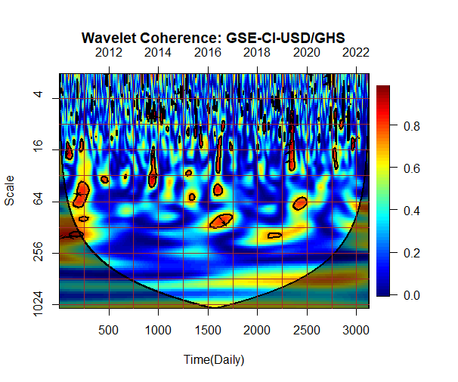

**GHANA**

Figure B3.1: Ghana

The plot represents the wavelet coherence between the stock market and exchange rates. The crosshatch reveals regions within the cone of influence (COI). The thick gray contour signifies the 95% confidence level. Arrows on the right-hand (left-hand) side suggest the comparative phase connection, rightward (leftward) arrows represent in-phase (antiphase), and upward (downward) pointing arrows imply stock markets (exchange rate) as leading.

From Figure B3.1, Ghana's comovements between stocks and exchange rates are primarily concentrated from 0 to 64 days cycle in the short run. Pockets of islands were observed during these cycles with an intense connectedness between 2011, 2016, and 2019 at an intensity of 0.8 during the study period. The exchange rate's role in Ghana's trade activities cannot be overemphasized. The US dollar, including the Ghanaian market, is Africa's dominant international trade currency. The dominance is attributed to the international demand for the US dollar based on its well-developed financial market hence the choice for trade and our analysis (Owusu Junior et al.,2018). Exchange rates are used as determining factors in the competitiveness of the country on the global market (Adusie and Gyampong, 2017). Volatility in the exchange rate has impacted business since adopting the flexible exchange rate system. Exchange rate movements are attributed to domestic and international market fundamentals (Junior et al., 2019). The Ghana stock exchange was set to generate sustainable funds for growth and development during the 1980 economic reforms (Kwofie and Ansah, 2018). Prospective and existing investors must account for the effect of exchange rates on stock markets. Stock markets serve as a source of capital mobilization for productive investment opportunities.

From the W.C. plot, co-movement of stock market prices and exchange rates weak and occur in the short term of at most the last quarter of the year for 2011 and 2016. In the case of 2019, the study finds the exchange rate in the lead against stock markets occurring in the short term (month). The researcher finds that the weak association between the GSE-CI and the US dollar provides investors with a hedging instrument. This instrument cannot be used as a hedging tool for medium- and long-term investors as they may incur losses in the middle and low-frequency periods, defeating diversification's purpose and potential benefits.

The research finds in line with the conclusion of (Dahir et al., 2017; Owusu Junior et al., 2018). During periods when the exchange rate is in external lead factors such as (the Europe debt crisis), recession fears, pent-up pressures, and rate hikes combined with a weak cedi were some of the reasons why this relationship occurred found in this study. All these events dampened investor appetite for risk on the market. In 2016 Ghana’s economy grew by 8.5%, the fastest rate in the last five previous years, backed by increased oil and gas production, and the International Monetary Fund credit deal narrowed deficit, debt, and increased growth.

Moreover, the Ghana stock exchange in 2016 was weaned of Ghana government payroll with the Securities Industry Act 2016, 929. However, the stock market persisted in its bearish state, recording a negative return of 15.33%. Economic uncertainty caused investors to diversify their risk into short-term financial instruments and low-risk investment products (government securities). According to the SEC annual report, the dominance of government bonds on the markets as the government borrowed heavily to meet its financial obligations led to a disinterest in corporate and other bonds (SEC,2016). The resulting financial and operational independence meant the GSE could discharge its mandate effectively and efficiently.

Again, in the first quarter of 2019, the Ghana cedi depreciated against the US dollar with a sharp contraction in the energy sector amid the oil price fall, the slowdown in manufacturing activity, and key trading partners from 2018 last quarter. Markets were unsettled after the premature rate cut by the Central Bank in January 2019, which weighed heavily on the local currency as IMF program targets constrained the Central Bank to sustain a set level of international reserves. As such, the Bank could not intervene in the weakening of the currency fueling a sharp selloff due to speculation in the short term until the currency rebounded in the second quarter and further growth in the stock market returns in the economy.

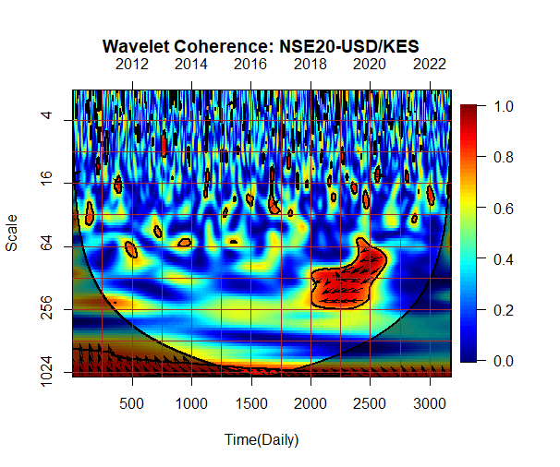

**KENYA**

Figure B3.2:Kenya

The plot represents the wavelet coherence between the stock market and exchange rates. The crosshatch reveals regions within the cone of influence (COI). The thick gray contour signifies the 95% confidence level. Arrows on the right-hand (left-hand) side suggest the comparative phase connection, rightward (leftward) arrows represent in-phase (antiphase), and upward (downward) pointing arrows imply stock markets (exchange rate) as leading. \

In the case of Kenya, as shown in Figure 3.2, co-movements between the stock and currency markets showed a strong level of interdependence from 2018 to 2020 in the mid to long-term 64–256-day cycle. The intense level of interdependence of 0.8 on the scale for the pocket island from the 2000th day to a little over the 2500th day indicates an antiphase with exchange rate leading the relationship mixed with short turns of stock leads. The reforms of the 1990s to increase investment and economic growth in Kenya saw the adoption of the flexible exchange rate and the removal of capital flow restrictions on the market.

The introduction of the flexible exchange regime continues to expose the Kenyan shilling to external shocks, such as the recent COVID-19 and Ukraine war leading to a rise in volatility. The lockdown disrupted global value chains, leading to a foreign currency shortage and a fall in exports as the local currency tumbled. On the other hand, the Nairobi Securities Exchange (NSE) is a hub for foreign and domestic investors. The NSE20 plays the vital role of encouraging savings, investment, and access to cost-effective capital for companies in the Kenyan economy (NSE Annual Report, 2021). The Kenyan economy contracted by 0.3% in 2020 and grew by 6.7% in 2021, driven by services and private consumption in supply and demand, respectively.

The economic performance of Kenya has been a strong indicator of growth for NSE (Kirui et al., 2014). The NSE20 has, over the years, been impacted by external and internal shocks from the Kenyan post-election chaos, global financial recession and recovery, the rise and fall of international and domestic interest rates, and the depreciation of the local currency from 2009 to 2015. In 2019-2020 a decline in returns was recorded on the stock markets due to the recent health pandemic (Koskei,2021; Ouma and Kihiu, 2018).

In 2022 foreign investors pulled out 170 million USD due to escalating global risks leading to a plunge in NSE-listed firms' share prices. The NSE20 lost 36.4% of its value, adding to investors' woes. This decline has been attributed to a hike in the US interest rate, exchange rate depreciation, and declining investment appetite for the African capital market among soaring inflation (Quartz Africa, 2023). This effect was observed on the wavelet coherence plot for Kenya as within the COI, comovements of the variables occurred from 2017 to 2021 with exchange rate and stock markets alternating lead over the period at a high intensity of 0.8 to 1.

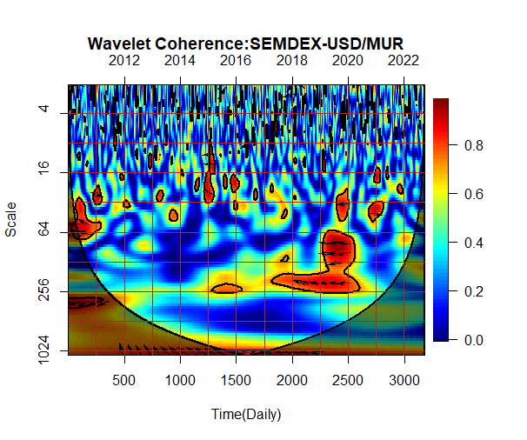

**MAURITIUS**

Figure B3.3: Mauritius

The plot represents the wavelet coherence between the stock market and exchange rates. The crosshatch reveals regions within the cone of influence (COI). The thick gray contour signifies the 95% confidence level. Arrows on the right-hand (left-hand) side suggest the comparative phase connection, rightward (leftward) arrows represent in-phase (antiphase), and upward (downward) pointing arrows imply stock markets (exchange rate) as leading.

In Figure B3.3, Mauritius co-movements show a mix of movements from stock markets to exchange rates and vice versa. From 2010 to 2011 and 2017 to 2021, a right-hand phasing arrow indicates in-phase on the island with 0.8 intensity. Mauritius was the latest high-income country as of 2020; due to the COVID-19 pandemic, the country slipped to upper-middle-income in 2021. Like most African economies, Mauritius is an import-driven economy; the sharp currency depreciation impacted household budgets and the economy. Compared to other African economies Mauritius despite the Ukraine war, health pandemic, and global slowdown in demand, a 4% rise in inflation has seen moderate growth rates (World Bank, 2023). One of the significant sources of income for the economy is the tourism sector (drop from 1.4 million in 2019 to 180,000 in 2021) which was hard hit from 2019 to 2020, reducing the entry of foreign currency into the market. The estimated cumulative fall in foreign currency entry was more than 120bn Rupees, a 33% fall in foreign exchange receipts.

The Stock Exchange of Mauritius (SEM), having crossed a market capitalization of 12 bn US dollars since its 30-year journey from 1989, has been a ripe international and multi-currency listing trading platform among African frontier markets. A strategic shift in its orientation in 2010, embarking on the internationalization of its regulatory and operational functions, has grown investor participation in stock markets excluding South Africa on the continent. The average turnover of SEM in 2019 grew by 57% to about 15 million USD, the highest daily turnover, whiles other African stock markets dropped compared to 2018 (MFW4A,2020). However, as of December 2020, official market capitalization stood at 7.0 billion USD, an 18% fall. The external impact of COVID-19 contributed to the drastic decline in returns. Foreign investors accounted for 41.2% of trading volumes on SEM from 2020 to 202, the highest foreign investor participation since 2015-2016.

From the biwavelet coherence map, the study finds high co-movement intensity due to the volatility spillover from the stock market and currency markets occurring only based on external shocks. Significant volatility in the exchange was due to the slowdown of domestic economic activity due to the health pandemic and the Ukraine war, causing a reduction in the earning and deferred dividend payments published in the listed company’s financial reports (Khemraz-Chikhuri, 2022). The prolonged effect of 256 (annual) impact was due to external and internal shocks from both markets.

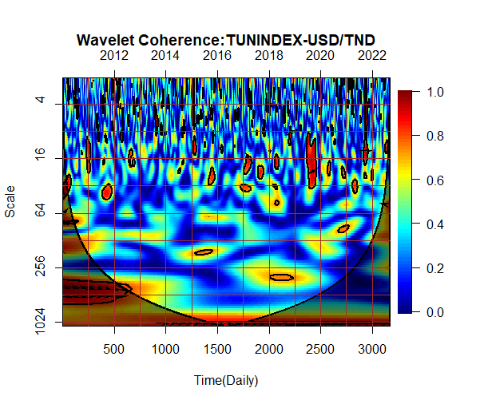

**TUNISIA**

Figure B3.4: Tunisia

The plot represents the wavelet coherence between the stock market and exchange rates. The crosshatch reveals regions within the cone of influence (COI). The thick gray contour signifies the 95% confidence level. Arrows on the right-hand (left-hand) side suggest the comparative phase connection, rightward (leftward) arrows represent in-phase (antiphase), and upward (downward) pointing arrows imply stock markets (exchange rate) as leading.

From Figure B3.4, the relationship between the two markets for Tunisia is much more limited, with a high intensity occurring in the short run and often zero-phased. In zero-phase, the study observes that the stock market and exchange rates move simultaneously at any point due to a specific measure. However, from 2019 to 2020, the researchers find a left-ward downward pointing arrow indicating an exchange rate lead over stock prices in the market. Compared to the US dollar, the researcher finds that a rise in monetary policies and exchange rates in Tunisia tends to increase investment in the stock market. The results explain the exchange rate's positive impact on the stock market (Mechri et al., 2018; Barakat et al., 2015). Tunisia was severely affected by the Arab Spring revolution in 2011, which led to political, economic, and financial instability. This turbulence influenced investors' behavior spanning 16 weeks (a month) in the short term, decreasing the flow of capital to the financial market as exchange rates depreciated. In the long term, the study finds that within the COI, co-movements between the variables are positively related (Jeribi et al., 2015). From 2019 to 2020, during the lock, the researcher finds that stock markets are influenced by exchange rate fluctuation early on during the COVID-19 pandemic; however, this effect is short-lived close to a month (16-32) according to the time scale on the WC plot at an intense rate of 0.8. A positive relationship is observed in the long run between the variables (Ben Ayed et al., 2020; Fakhfekh et al., 2021).













## 5.6 Conclusion

Frontier markets in Africa are often labeled as small and illiquid; however, they possess the potential to mobilize financial resources to drive investment in infrastructure and development in Africa. Capital inflow into frontier markets continues to grow and is often targeted at natural resource production firms listed on stock markets. Such equity inflows allow organizations to invest in technology, research, and development to expand the companies. However, for funds to be used in these economies, they need to be converted into local currency to satisfy all kinds of local/foreign currency debt.

Over the past decade, most frontier economies in Africa have moved from the fixed exchange rate regime to the institution of a flexible exchange rate system. Positive effects from the institution of flexible exchange rates have been short-lived, with demand and supply forces from internal and external markets impacting the volatility and spillover effects experienced in the currency markets. Macroeconomic fundamentals such as increased inflation and interest rates, and exchange rate fluctuations have slowed economic growth across the continent. Subsequently, frontier economies continue to experience depreciation in their local currency against the US dollar, which impacts funds or investments intended for growth and development. Unlike the stock market, fluctuation in the currency market has been a concern to investors and economists (Nimoh and Addai-Asante, 2018).

The low level of financial and economic complexity in African frontier markets, with a comparative advantage mainly in producing agricultural and natural resource products as raw materials, has been detrimental to the expansion of stock market activities (Baah-Boateng and Twum, 2020). Coupled with exposure to fluctuations and high volatility in the exchange rates, local investors' low interest in stock trade continues to hamper the ability of the market to raise funds for investments. Thus, a rise in the dollar over the cedi, rupee, shilling, or dinar makes it difficult for African businesses to export to the US and other markets—the spillover effects from the currency fluctuations into their daily lives (Aryeetey and Baah-Boateng, 2015).

Many frontier markets in Africa have faced a combination of export disruption and worsening terms of trade as export growth has slowed since the opening of the 2020s compared to the late 2010s. The health pandemic lockdown of 2019 and 2020 quarantine, the closure of borders which reduced trade, and the associated global recession, continue to drive down prices of crucial sources of foreign earnings. These issues have in no small way contributed to the shortage of foreign currency for trade and investment activities.

Depreciation in African currencies against the US dollar has been attributed partly to these events above and low levels of competitiveness after the events of large-scale companies from developed markets due to the cost of trade with developed nations. The resurgence of global inflation and tightening of monetary policies have contributed to the rise in the cost of borrowing and imports, with spikes in the prices of food, crude oil, and fertilizer due to the Ukraine war having harmed African economies. Reduction in investment and savings due to high import prices and inflation continue to lower growth and development. After emerging from the health pandemic, African frontier economies continue to grapple with the lingering effects on their economy. In the 2022 World Currency Report, Ghana’s currency ranked as the worst-performing currency in the world based on a 30-year analysis. The other three African economies maintained their position or declined (Bloomberg, 2022).

In this study, the researcher answers the question regarding the time and scale dynamics of stock market indices and currency markets. Using the wavelet analysis, we examine concurrently how the variables are related at different frequencies and their evolution over time and capture non-stationary features within the series. This technique is an essential feature that other approaches cannot assess. By capturing the varying behavior of the series at both the time and frequency domains where different systems have failed with conflicting findings, the wavelet techniques perform better (Aloui and Hikiri, 2014; Rua, 2010). The study finds that long-term stock market indices and currency markets forecast beyond the four-year scale fall outside the COI. Thus, significant co-movements are only noticeable within the 1024 days and not the 2048 days or beyond, as noticed in similar studies (Owusu Junior, 2018). The pattern of comovements observed is found in a mix of in-phase (antiphase) and pointing upwards (downwards), indicating a clear case of stock markets (exchange rates) leading Ghana, Kenya, Mauritius, and Tunisia.

The study observes that stock market fluctuations are based on the events of the period, which had the potential to impact exchange rates in the long term. Disruptions that affect potential future dividends are expected to cause investors to withdraw their funds and invest in short-term instruments on the frontier market to avoid the fluctuations caused by those events. As such, investors tend to invest in portfolios where systemic risk exposure varies on frontier markets in Africa to prevent the potential of exchange rate volatilities impacting their returns. Frontier markets exhibit APT behavior as markets are sensitive to stock fluctuations in prices in the long term but not in the short term. Investors will seek to hedge and diversify their risk exposure through their portfolios quickly for safety and gains (Hammami and Boujelbene, 2022; Zaiane and Jrad, 2020). The study shows that overall, stock market fluctuations increase the risk-averse investors' need to reduce transaction volumes whiles the risk takers increase their transaction volumes. Fluctuations lead to a rise (fall) in transaction cost and decreasing (increasing) market liquidity, depending on the diversification portfolio the investor uses.

# CHAPTER SIX

# FINANCIAL CONTAGION OF MAJOR GLOBAL EVENTS ON AFRICAN FRONTIER CURRENCY AND STOCK MARKETS

# CHAPTER SIX

# FINANCIAL CONTAGION OF MAJOR GLOBAL EVENTS ON AFRICAN FRONTIER CURRENCY AND STOCKS MARKETS

## Abstract

## 6.0 Introduction

Global shock events have gripped the world economy since 2008, widely viewed as unprecedented. These increasingly popular events have given rise to waves of crises, evidenced by the varied experiences about the source of each episode. The events have been following turbulence leading to a significant reduction in global economic activities. Moreover, countries have witnessed substantial losses in the value of their currencies. Against this background, and from the viewpoint of African economies, a sharp reduction in capital flows and a substantial fall in trade exports as consumer spending in industrial industries declines is motivated by this paper. The study investigates the possible spillover effects of global events from developed markets on African frontier markets. The paper considers two frontier economy sectors exhibiting the following characteristics: whose investments are financed by a large share of external resources and debts by foreign currency.

In this paper, we investigate three recent crises, two global policy changes in African frontier economies, including the coronavirus pandemic(COVID-19), the Russia-Ukraine Unrest (R-U), the United Kingdom’s vote and exit from the European Union (Brexit), the end of the Millennium Development Goals (MDGs) and the start of the Sustainable Development Goals (SDGs). The US subprime credit crisis was the source of the global financial crisis in 2008/2009. The credit crisis caused stock values to fall as they were linked to the US real estate market, which spread all markets globally. In 2013, the tension in the UK rose with Britain’s requesting for the UK to pull out of the European Union (EU), and with a referendum vote in June 2016, a resounding 51% voted to leave the EU. The divorce from the EU was finally made official in January 2020, confirming Brexit as a new reality. The relationship between the United Kingdom (UK) and the rest of the world rose with Brexit as uncertainty, migration, and trade relationships had to be redefined between the UK and the EU and with all trading partners(Bello et al., 2022). The health pandemic (Covid-19) declared an international health crisis in January 2020, and a pandemic in March 2020 led to a crash in most stock markets and shut down trade activities globally. The crash, fueled by the closure of the border, lockdowns, and quarantines, was based on the novelty and the virus's global spread, which originated in the Chinese city of Wuhan in December 2019 (Bello et al., 2022). The Russia-Ukraine unrest from March 2014 and its resurgence by Russia’s invasion in February 2022 had a far-reaching impact globally, with disruptions to supply chains, trading routes, and markets leading to an upsurge in commodity prices (Fuel and grains) and immigration (refugee) issues (Izzeldin et al.,2023).

In terms of governance policy framework, the 2000 Millennium Declarations with its Millennium Development goals (MDGs) was the first comprehensive global governance framework to achieve developmental goals (UN,2000). The end of the MDGs, which saw countries strive to improve the living standards of their citizen through eradicating poverty and improving health and education, among others, opened up countries to capital flows for investment and development, with a majority of countries achieving most of their targets. However, with the end of the MDGs in 2015 and the worldwide crises, a slowdown and derailment were noticed, with developing nations falling behind their set targets. The introduction of the follow-up 2030 Agenda for Sustainable Development with 17 sustainable development goals (SDGs) in 2016 sought to promote new and sustainable was of development amidst growing global uncertainty, the need to understand how global events impact growth and development in the financial markets is ever more evident (de Jong and Vijge, 2021).

Literature on developed and emerging markets is abundant in academia, with little focus on African frontier markets. The study primarily focuses on stock and currency markets in frontier economies in Africa. The recent surge in the inflow of funds and new investment products on frontier equity and financial markets during periods of uncertainty in developed countries has positioned these markets as a “haven” (de Groot et al., 2012). Policy makers and academia have viewed Africa’s position as a haven for foreign investors from varying positions based on the diversification of benefits available to investors. Moreover, developments in African markets are growing, making them increasingly attractive to investors (Adams and Opoku, 2015). The unique distinction of African markets based on low institutional strength, regulatory conditions, and weak stochastic trends exacerbated the segmentation of African markets from global markets (Boako and Alagidede, 2017; Boamah et al., 2017).

However, with the rising integration of regional economies and trade, African markets are becoming interdependent and could potentially impact the diversification benefits of the markets. Again, the possible non-translation of market development into the economy due to immaturity exhibited by currency and stock markets, African frontier markets will remain relatively isolated (Yartey and Adjasi, 2007). Despite the interest in African market segmentation discourse in academia and policy circles, few studies have examined the moderating effect of exchange rates on global events and stock market performance relationships in the African context. The research employs….. to bring renewed focus and understanding to the relationship. The study employs monthly data from January 2008 to April 2023 for Kenya, Morocco, Tunisia, and Ghana at the individual country level. The study contributes to the literature on the stock market performance and global event nexus on African economies focusing on exchange rate volatility effects.

The study foreshadows results, with evidence from the literature showing that exchange rate volatility has ………………….. conversely, countries with stabilized exchange rate policies, for example …………….. are impacted by the exchange rate and global events.

The study is organized into sections: Section 2 covers the theoretical and empirical background, Section 3 discusses the data and methodology, Section 4 presents the results, while Section 5 gives the study's policy implications and conclusions.

## 6.1 Theoretical Literature Review

The relationship between stock market returns and global events has received scholarly attention. In examining the relationship, many studies have posited inconclusive, positive, or negative arguments with no specific theoretical solution.

The International Monetary Fund (IMF) defines exogenous shocks as “sudden event(s) beyond the control of the authorities that have a significant negative impact on the economy” (Geithner 2003). The theory theorizes crisis by highlighting the peripheral origin of the shock(s) creating event. There is, however, no agreed definition for exogenous shocks across disciplines; as such, the study adopts the following definition “an unexpected, low-likelihood, hypothetically high-impact event originating from a firm, country or individual’s environment”(Chakrabarti, 2015). Exogenous shocks could present the affected market, firm, individual, or economy with opportunities or risks that cannot be fully anticipated (Trkman and McCormack, 2009). Exogenous shocks require a simultaneous and discontinuous shift in a country's structures, processes, and control mechanisms, even when they have been accounted for. They can force the realignment of strategies and structures to fit the newly created environment shaped by the shock event in the long run (Li and Tallman, 2011).

Exogenous shocks may arise from diverse events and origins, such as political or health crises, natural disasters, policy changes, and military conflicts. In this research, exogenous shocks are viewed from country-specific perspectives, thereby theorizing the magnitude and direction of the originating shock event and the moderating effect of exchange rate volatility on market returns (Morgeson et al., 2015; Li et al., 2017).

The study examines the uncertainty relationship between exogeneous shock(s) and the stock markets based on the efficiency market hypothesis (EMH), a central concept of the financial market (Fama,1970). The study posits that African stock market prices will incorporate all information rationally and instantaneously. The study, however, temper and extend the assumption by moderating the relationship with exchange rate volatility information. The maturity and size of the markets set the country's economic health prospects, attracting foreign investors. In markets with weak efficiency, the market uses information based on historical or past prices to set today’s price. For strong markets, public and private information is fully reflected in the current price of a stock on the market. However, for semi-strong markets, publicly available information is incorporated (Ullah et al., 2017; Hillier and Loncan, 2017).

Additionally, the Macroeconomic expectations hypothesis (MEH) suggests that stock markets are forward-looking and asset returns would reflect all financial information (DeStefano, 2004). Consequently, prices of stocks on the markets respond immediately to the change in investor behavior as information becomes available, leading to a profit or loss for investors (Andrianto and Mirza, 2016). When markets pick up information based on unanticipated events and uncertain policies, returns may be positively or negatively influenced (Das and Kumar,2018; Yesuf and Avci,2019). The ensuing consequence emanating from exogenous shock events and macroeconomic uncertainties have the potential to have a pervasive and fa-reaching effect on markets, although the combined and moderated effect for African markets is missing from existing literature (Baker et al., 2016; Ko and Lee,2015; Christou et al., 2017; Li et al., 2020).

## 6.2 Empirical Literature Review

African stock markets have developed rapidly in the past few years, including introducing automated trades, demutualization, derivative products, exchange-traded funds, and US-dollar-denominated trades (Kunle and Omoruyi, 2014). African stock exchanges have grown from eight (8) to twenty-nine (29) since 1989, with a presence in over thirty-eight (38) countries (Solyman, 2017). The emergence of African markets as a potential portfolio diversification instrument for international investors has increasingly integrated markets with the world. The exposure of African markets to exogenous shocks is rising as global uncertainty increases (Seck, 2016; Bodomo and Che, 2019). Despite the growth and advancement, African markets remain segmented and weakly integrated with Africa (Kumah and Odei-Mensah, 2021).

In literature, volatility has been found to exist in financial markets. Although not observable, their increase raises concerns about market development strategies. Volatilities are highly persistent, emanating from different sources such as economic shock or events often exogenous. Exogenous Shocks have been studied in macroeconomics, supply chain management, and information systems (Fridgen et al., 2015). Macroeconomics perceives exogenous shocks as either long-term or short-term unpredictable, unfavorable internal and external conditions that impact the economy's growth (Noy and Nualsri, 2007). The effects of the condition may be temporary or permanent based on the level and magnitude of influence on the target market. The effect could also limit access to important resources and growth opportunities (Chakrabarti, 2015).

Moreover, exogenous shocks force markets to adapt their strategies and structure to respond responsibly to the changing environmental conditions (Martins rt al., 2015). The number of transmission models applied to classify the dynamics embedded in exogenous shock varies from the break to regime identification. Studies on volatility crisis and commodity markets, and financial instruments have grown (Ciarreta et al.,2020; Li et al.,2020; Tiwari et al., 2020; Taylor, 2019; Nademi and Nademi, 2018; Pappas et al., 2016). Examining the impact of COVID-19 on G7 stock markets, Izzeldin et al. (2021) used the smooth-transition HAR (ST-HAR) and found strong evidence of the transition of crisis in all the countries. However, they conclude that crisis intensity and timing vary for all countries. Bannigidadmath et al. (2022), investigating Covid-19 in 25 countries, found that 48% of the countries responded negatively to government policies on Covid-19. Al-Awadhi et al. (2020) found the Covid-19 negatively affected Chinese stock market returns. Watugala (2019) found that economic uncertainty significantly influences the volatility of future returns on commodity markets. Macroeconomic news has been shown to influence major stock exchanges, especially during the 2008/2009 global financial crisis (GFC) (Omarane and Saveser, 2017). On geopolitical conflicts, using a Markov-switching HAR model found stock markets to respond rapidly to the Russia-Ukraine war at smaller intensity levels (Izzeldin et al.,2023). In examining 447 global political crises, Berkman et al. (2011) found that global stock market returns declined by 3.6 percent. In their work, Wisniewski and Nolte (2017) found the world stock market index fell to 3.4% before and after the wars. Bello et al. (2022) found that Brexit, GFC, and Covid-19 African markets were highly susceptible to contagion effects, confirming Boako and Alagidede's results (2017).

## 6.3 Methodology

### 6.3.1 Research Design

This study employed a quantitative approach using secondary data to examine the moderating effect of exchange rates on the African stock markets and exogenous events relationship. Secondary data is deemed appropriate for providing the desired information for measuring variables and the study’s models.

### 6.3.2 Data Sources and Collection

The researcher selected the top-performing frontier markets in Africa subject to data availability. The data was sourced from stock market prices from the Ghana stock exchange platform, and for all other selected countries, stock market data and exchange rate series were sourced from investing.com (Boakye et al.,2023; Živkov et al., 2020). Based on data availability, the study employed daily time series for exchange rates and stock market daily closing prices from 2010 to 2023.

### 6.3.3 Dataset Analysis

The study ensured consistency and obtained four (4) currency rate movements against the US dollar dataset and stock markets for four (4) frontier African countries: Ghana, Kenya, Morocco, and Tunisia. The selected countries are respectively within their regional economic communities in Africa (ECOWAS, AMU, EAC). The countries are grouped based on investors' participation level, gross domestic product [gdp], and the direct influence of exchange rates. The study considered the countries based on market capitalization subject to data availability. It should be noted that some countries, for example, Mauritius, were dropped based on missingness in the datasets for exchange rates. The researcher did so because of the inconsistencies in data for exchange rates and uncertainty indices, which is vital for the study.

## 6.4 Empirical Model and Estimation Technique

This study tests the moderation effect of exchange rate volatility between African frontier stock market returns and exogenous events. The researcher employs transformation methodologies to examine the relationship between the variables.

### 6.4.1 DCC GARCH Model

The study employs the dynamic conditional correlation (DCC) GARCH to examine the relationship between the stock market and exchange rates for the four selected African frontier markets (Ghana, Kenya, Mauritius, and Tunisia). The study uses the bivariate GARCH model to examine the price changes between $φ_{1}$ and $ω_{1}$ for the stock and currency markets in each country.

Let $y_{1}=\left[y_{1t}-y_{2t}\right]$ be a 2x1 vector containing changes in stock prices and exchange rates in a conditional mean equation as follows.

$y_{1}=μ+ε_{t}$ and $ε_{t}|ξ_{t-1}$ ̴ *N(O, $S_{t}$**)* (1)

Where $μ$ is a 2x1 vector of constant and $ε_{t}$ = [$ε_{1t}$, $ε_{2t}$] is the vector of innovations conditional on the information at time *t-1* ($ξ_{t-1}$). The error term is assumed to be conditionally multivariate normal with mean zero and variance-covariance matrix as

$S_{t}$ = $P_{t}D_{t}P_{t}$ (2)

Where $P_{t}$ is the 2 x 2 diagonal matrix for the time-varying standard deviations from the univariate GARCH model with $\sqrt{h_{i,t}}$ on the $i^{th}$ diagonal $D_{t}$ is the 2 x2 time-varying symmetric conditional correlation matrix.

The elements in $P_{t}$ employ the univariate GARCH process as follows.

$h_{i,t}$ = ${ w}_{1}+α_{1}ε_{i,t-1}^{2}+β_{i}h_{i,t-1}$ (3)

Where $w_{1}$ is the constant term, $α_{1}$ captures the ARCH effect (conditional volatility) and $β_{i}$ measures the persistence of volatility level. The evolution of the correlation in the DCC model is given as follows.

$K_{t}=\left(1-k_{a}-k_{b}\right)\overline{K}+k_{a}ε_{t-1}ε_{t-1}^{'}+k_{b}K_{t-1}$ (4)

Where $K_{t}$ = {$k_{ij}$} is the 2 x 2 conditional variance-covariance matrix for the residuals in the time-invariant variance-covariance matrix $\overline{K}$ =H($ε_{t}$, $ε_{t}^{'}$), and $k_{a} and k_{b}$ are nonnegative scalar parameters satisfying $k_{a}+k_{b}<1$. Implying $K_{t}$ in (4) does not have a unit diagonal element, it is thus, scaled to derive a proper correlation matrix $D_{t}$,

$D_{t}=diag{(K_{t})}^{1/2}K_{t}diag{(K_{t})}^{-1/2}$ (5)

For a typical element of $D_{t}$ has the form of $p_{ij}=k_{ij,t}/\sqrt{k_{ii,t}k_{ij,t}}$ where i,j = 1,2 and i $≠$ j, which is the key element and represents the conditional correlation between stock price and exchange rate changes.

### 6.4.2 Wavelet methods

Wavelet transformation is widely used in financial analysis to deal with problems of non-stationarity in time series. Wavelet transformation comprises two types: Continuous Wavelet Transformation (CWT) and Discrete Wavelet Transformation (DTW). The discrete transformations are centered on an orthogonal wavelet. However, these wavelet transformations are used for nonorthogonal wavelet functions (Aloui et al., 2018)[18]. The research used CWT, which is good for identifying and isolating periodic signals. It provides stability between time-frequency localization to improve the trade-off between the detected undulations, peaks, and gaps. However, DWT is only appropriate for reducing and compressing noise in the data (Wu et al., 2020)[19].

### 6.4.2.1 Continuous Wavelet Transformation (CWT) and Coherence

CWT is a useful method for assessing the changing aspects of nonstationary variables across time and domain space. The study decomposed the time series using the wavelet function to ensure a localized time-frequency space and zero means. Information about the local neighborhood was obtained based on the decomposition. Morlet wavelet was employed by examining the frequency and time-space behavior of the time series data. Specification of the wavelet coherence (W.C.) is specified below:

(1)

If, is the stabilization component certifying unit for the variation of wavelet =1; represents the location boundary, giving the precise location of the wavelet, where *s* represents the level of expansion in the boundary. It defines in what manner the wavelet is spread out.

The Morlet wavelet:

(2)

Where represents the main occurrence of the wavelet. Extracting from the literature,is to 6. Moreover, with the convolution employed on a discrete sequence, a scaled and translated wavelet, the CWT is given as:

=) (3)

Estimating the exact wavelet onto a time series, we obtained . Similarly, the key benefit of a CWT lies in its ability to decompose and rebuild the function of

:= (4)

The power spectrum evaluation was assessed using Eq (4) with the variance measurement.

= (5)

The AR (1) allows for modeling the red noise in the background of the spectrum. Given the null hypothesis, we allow for the pockets found in the wavelet power spectrum (WPS) peaks to be evaluated for their significance level. The study uses the Monte Carlo simulation. The resulting local WPS is found in the distribution of the individual time *n* and scale *s* (Torrence and Webster, 1999)[20].

Given:

D (6)

*f*  is denoted , representing the mean spectrum at Fourier frequency in the given data. Given that the wavelet scale aligns with the Fourier frequently (s1/*f*), v=1 represents a real wavelet, and v=2 represents a complex wavelet. Given as as the variance of the variable.

The study probes the combined behavior of time and frequency in the economy; a CWT must be given to pinpoint the common power amongst the variables (Aloui et al., 2018). CWT power allows for the region's location for which the macroeconomic variable co-moves in time and frequency. In the case of a particular macroeconomic variable series (χ) and another macroeconomic series (*Y*), given the individual wavelet spectra and the CWT for the macroeconomic series can be given as follows:

= (7)

Given that “*u*” represents the position of *s*, the scale *represents the complex conjugation. The CWT indicates the area, time, and space have the highest common power. Thus, (s) represents the complicated conjugate of . The cross-wavelet power || evaluates the shared area covariance on every individual level. W.C. for two-time series is given as χ= and y=The research allows for the detection of comovements among macroeconomic variables. They represent the frequency groups and time gaps for which the series covary. The W.C. is, thus, the absolute square value of the normalized WPS. Hence, the squared wavelet coefficient is expressed as follows:

(8)

Given *S* as the smoothing parameter, it seeks to balance the resolution and significance level. Any problems in the WPS and the wavelet cross-spectrum (WCS) are removed. The same principle is applied in the stabilizing function of W.C. for PWC and multiple wavelet coherence (MWC) cases.

The expression "coherence" fulfills the inequality equation 0. Values near 0 point to a low correlation; however, values near 1 point to a robust correlation. In examining macroeconomic comovements, coherence is the most suitable.

The phase form is centered on the lag of oscillation between two the variables as a frequency, assuming that , explains the phase difference in the economy; the phase difference between χ(t) and y(t) is given as:

= (9)

Given and , we assume that smoothed CWT has two parts: the imaginary and real. The wavelet coherence map shows the directional arrows. The arrows distinguish the various phase forms. For example, where x(t) and y(t) are in-phase (antiphase), the arrow points to the right (left). Equally, when the arrows point downwards (or upward), it indicates y(t) / x(t) is in the lead.

### 6.4.1.3 Partial Wavelet Transform and Coherence

Partial wavelet coherence follows a simple concept of correlation: the comovements between two series. The PWC cancels the effects of any other confounding variable. Wavelet coherence was employed to measure the linear correlations while highlighting the intermittent correlations. The PWC map highlights the significance level for real correlation among the variables. It should be noted that it does not produce a pure correlation between the macroeconomic variables. The possibility that other factors may influence them in the economy. This possibility is dealt with using partial correlation.

The following comovements under wavelet transform coherence represent the different possible variable combinations.

It follows as follows:

(1)

(2)

(3)

(4)

(5)

(6)

In the application of the wavelet measure PWC, in this study, the researcher eliminated the influence of other factors in the time series data, given s (t) wavelet coherence between χ(t) and y (t) (see Gurley, Kijewski & Kareem, 2003: Ng and Chan, 2012). The equation below shows PWC partial correlation in its squared form.

Given:

(7)

Given is like as ; interpretations for the equations range from 0 to 1. From the results of the PWC, where a low region , and high region ; shows time series *y* does not affect *x.* Alternatively, the variance of *x* is dominated by the *z* time series. In the case where there is no significant level of difference among and , it means there is no significant influence from *y* and *z* on *x*. For our study, we denote our variables as a remittance by *x* and economic growth (GDP) by *y,* while the exchange rate denotes *z*. The wavelet transformation could potentially result in a random number when the process is mixed. Leading to identification problems in the independent process during the significance test. The study employed Monte Carlo methods in examining PWC, just as in the case of W.C.

## 6.5Results and Interpretation

## 6.5.1 Descriptive Analysis

The study employs historical time series data for leading stock frontier markets with the highest market capitalization (as of January 04, 2010) and a relatively lengthier data span. In no particular order of arrangement, Stock markets; Ghana stock exchange composite index (GSE-CI), Kenya stock exchange NSE 20 (NSE), Tunisia stock market (TUNINDEX), the stock exchange of Mauritius (SEMDEX), the exchange rate market; the United States Dollar against the Ghanaian Cedi (US/GHS); Kenyan shilling (US/KES); Tunisian dinar (US/TND), Mauritian rupee (US/MUR), are examined.

The daily stock returns and local currency to the United States dollar rate dataset spans the period of January 4, 2010, to March 31, 2023. The data is sourced from investing.com and gse.com.gh, which provide average prices of stocks and currencies across multiple exchanges. Recent empirical studies, including Živkov et al. (2020), used data from the same platform. The study converted the daily prices into percentage log returns using , for i=1, …,2 and t=1,…3129 considering holiday effects; where , Are the closing prices for the market at days *t* and *t*-1, respectively.

The study presents summary measures of the relationship between exchange rates and stock market prices for four African economies. The growth data were used for the analysis, which is annual. Descriptive statistics of the macroeconomic data are represented in Table 1, which demonstrates the variations in the distribution of the series. The sample period is from 2010 to 2023, with over 3000 observations per country. The descriptive statistics of the selected variables are reported in Table 1.

|  |  |  |  |  |  |
| --- | --- | --- | --- | --- | --- |
| Table 3: Descriptive Statistics | | |  |  |  |
| **GHANA** | | |  | KENYA | |
|  | **GSE-CI** | **Exc** |  | NSE20 | Exc |
| Mean | -0.00023 | 0.000665 |  | -0.00022 | 0.000175 |
| Maximum | 2.307714 | 0.152763 |  | 0.086345 | 0.038789 |
| Minimum | -2.29858 | -0.15835 |  | -0.08602 | -0.02376 |
| Std. dev. | 0.106652 | 0.011109 |  | 0.007111 | 0.003022 |
| Skweness | -2.07324 | -0.35427 |  | -0.30151 | 0.708634 |
| Kurtosis | 441.7285 | 40.71652 |  | 17.25935 | 25.78101 |
|  |  |  |  |  |  |
| **TUNISIA** | | |  | MAURITIUS | |
|  | **TUNINDEX** | **Exc** |  | SEMDEX | Exc |
| Mean | 0.000199 | 0.000264 |  | 5.24E-05 | 1.26E-04 |
| Maximum | 0.14057 | 0.077209 |  | 0.102661 | 0.037286 |
| Minimum | -0.13549 | -0.09571 |  | -0.10104 | -0.04987 |
| Std. dev. | 0.006297 | 0.006964 |  | 0.005526 | 0.006057 |
| Skweness | -0.17656 | -0.58399 |  | -1.81926 | -0.21166 |
| Kurtosis | 150.4292 | 22.41139 |  | 106.9075 | 5.794401 |

*Exc: Exchange rates*

## 6.5.2 DCC GARCH Model

|  |  |  |  |  |
| --- | --- | --- | --- | --- |
| Table 6.1: Estimates from the bivariate DCC-GARCH model | | | | |
|  | Ghana | Kenya | Mauritius | Tunisia |
| |  | | --- | | Stock returns | |  |  |  |  |
|  | *** | *** | *** | *** |
| |  | | --- | |  | | 0.1850 | *** | 0.8787 | *** |
|  | 0.2050 | 0.1472 | 0.2143 | 0.3273 |
| |  | | --- | |  | | *** | *** | 0.1675 | *** |
|  | 0.2688 | 0.7397 | 0.7378 | 0.4164 |
|  | 0.3383 | *** | *** | *** |
| |  | | --- | | Exchange Rates | |  |  |  |  |
|  | *** | *** | *** | *** |
| |  | | --- | |  | | 0.7013 | 0.9501 | 0.6466 | 0.2790 |
|  | 0.1594 | 0.1345 | 0.0906 | 0.0901 |
| |  | | --- | |  | | *** | *** | *** | *** |
|  | 0.8396 | 0.8631 | 0.8951 | 0.8903 |
|  | *** | *** | *** | *** |
| |  | | --- | | DCC parameters | |  |  |  |  |
|  | 0.026 | 0.002 | 0.013 | 0.011 |
| |  | | --- | |  | | *** | 0.840 | 0.3177 | 0.273 |
|  | 0.857 | 0.884 | 0.875 | 0.892 |
|  | *** | *** | *** | *** |
| AIC | 92.839 | -16.9310 | -16.1260 | -14.8610 |
| Obs | 2739 | 2739 | 2739 | 2739 |
| Log likelihood | -1271128.10 | 23201.62 | 22099.68 | 20366.77 |

Table 6.1 presents the etimated results from the DCC GARCH models for four African frontier economies. The model examined the dynamic conditional correlation between their stock market returns and exchange rate changes. The model generated the consistent standard errors that are robust to non-normality. The study found that the estimated parmeters for the ARCH parameter indicated by $α$ are significant with p-values less than 0.05% as such the researcher rejects the null hypothesis as there is ARCH effect. The coefficient of the lagged conditional voaltility ($β$) for all the countries were found to be significant. The study finds a high persistence of of shocks in the conditional volatility. The time-varying correlation effect is captured by the coefficients of $k_{a}$ and $k_{b}$ which are significant confirming the long term persistence for the selected markets.

Corelation and Covariance plots



Ghana





Kenya





Mauritius





Tunisia

## 6.5.3 Wavelet Analysis

The study under the wavelet analysis first examines the wavelet coherency and phase difference of the selected frontier markets. The plots show the bivariate co-movements in the frequency-time domains with the wavelet coherency (W.C) measuring the local correlation among the variables as a confirmation to the DCC results for the various countries and variables. The phase difference in the plot indicate all lag or lead relationship that may exist among the variables on the markets. The W.C plot presents a significant level of 5% confidence with arrows ploted only within the contour with Barlett default smoothing window.

The arrows to the right on the plots suggests that the series are in-phase, right and up arrows indicate that the first series lags. For right and down arrows they indicate that the first series leads. Left facing arrows indicate that the two series are out-of-phase, left and up mean the first series leads. In the case of left and down arrows, the first series lags (Roesch and Schmidbauer,2014). The red coloured area within the contour of the plot at the bottom(top) of the plot represent a strong co-movement at low (high) frequency whils a red colour in the contour at the left-hand (right-hand) indicate a strong co-movement at the beginning (end) of the period. The arrows indicate the phase difference btetween the selected series 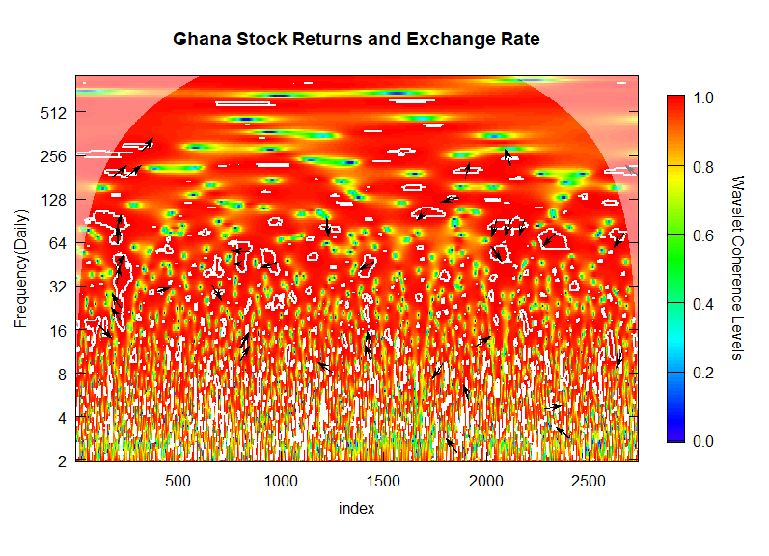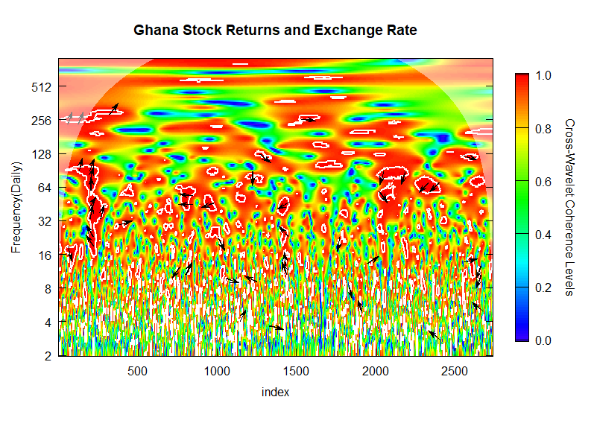



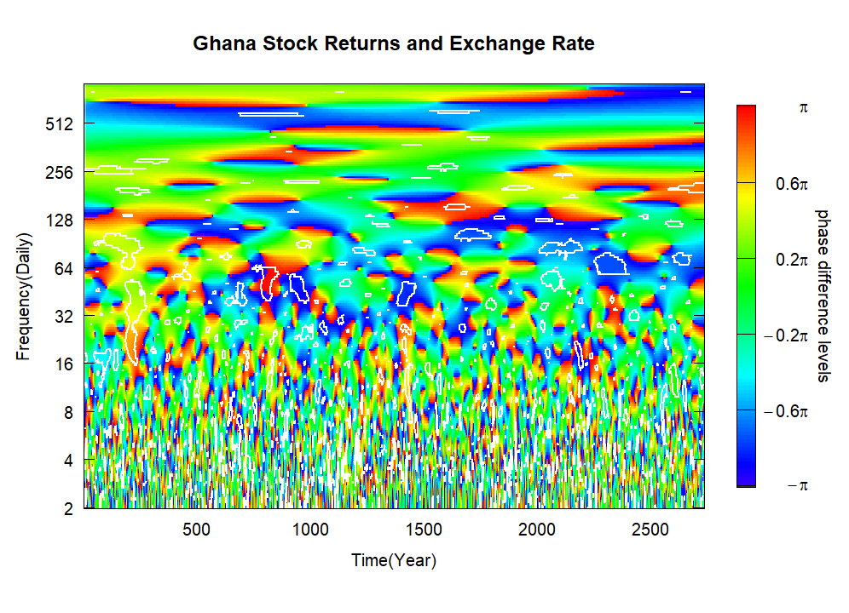

**Ghana**

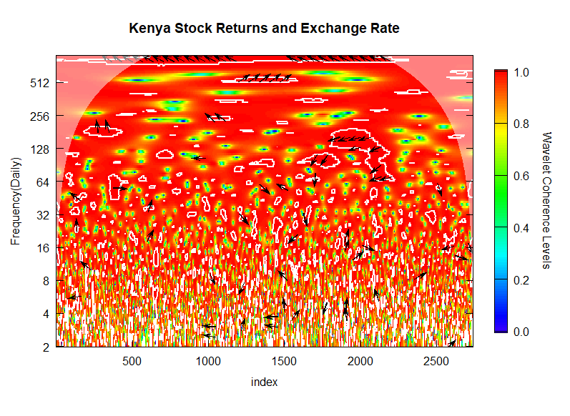





**Kenya**

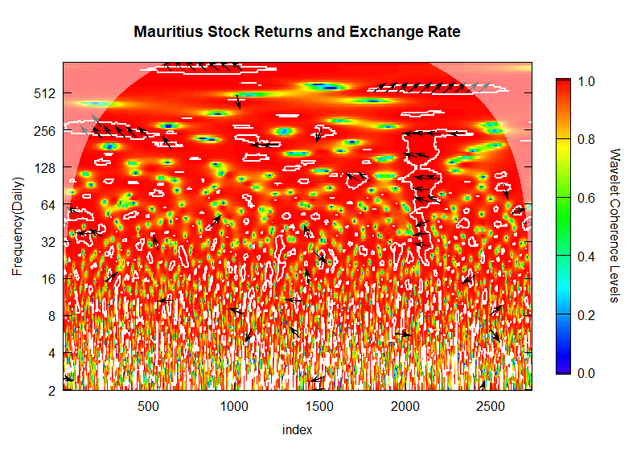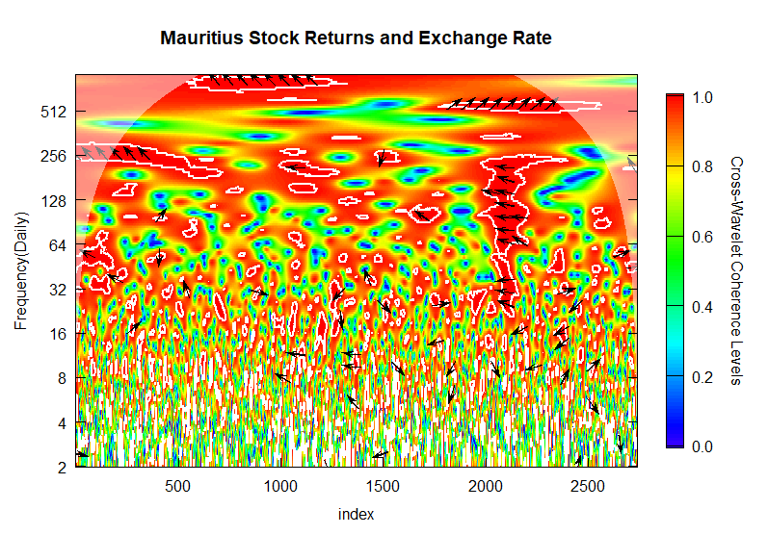





**Mauritius**

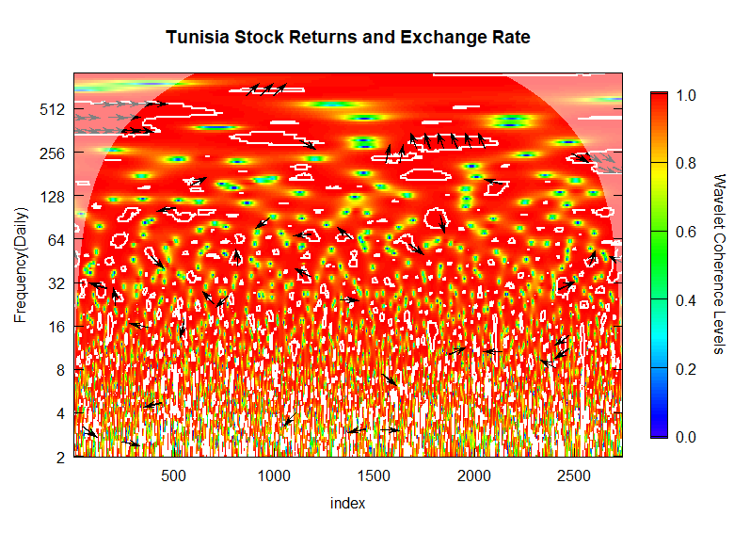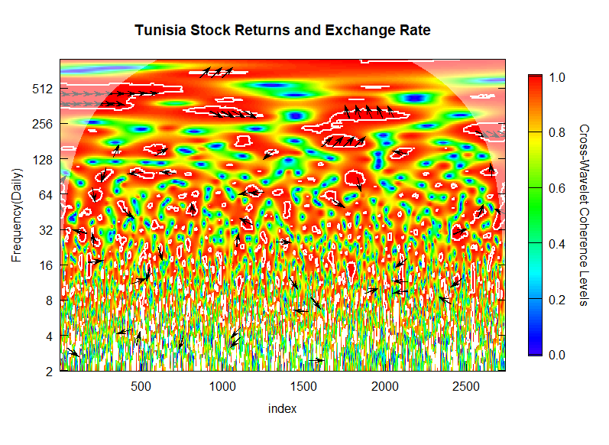





**Tunisia**

## 6.5.3 Partial Wavelet

# CHAPTER SEVEN

# SUMMARY, CONCLUSIONS, AND RECOMMENDATIONS

## 7.1 Introduction

This chapter presents the summary, conclusions, and recommendations for the entire study. The chapter first presents the summary of the whole study, followed by the conclusions and recommendations. The study’s limitations, contribution, and future research direction have also been highlighted. This section presents the argument presented in the previous chapters whiles emphasizing the results drawn from the data analyzed. Therefore section 6.2 presents the general summary of the thesis, which outlines each chapter's objectives and key outcomes. The section also explains the main findings reached in this study. Section 6.3 discusses the study's conclusions from the perspective of the key objectives from the empirical chapters. Section 6.4 outlines the recommendations to advance future research. Section 7.5 acknowledges the limitations met during the study’s execution. Finally, section 6.6 presents the contributions/policy implications of the study. which outlines

## 7.2 Summary

Exchange rates play an important role in open economies and are major determinants of global output levels, growth, and development (Chaudhary et al., 2016). The backbone of modern commercial relationships revolves around the movement of people, goods, and services across borders as firms in various countries seek to profit from the expanded market and, in turn, contribute to the development of the nations. Participation in the movement of people, goods, and services occurs due to different reasons such as lack of or surplus resources, differences in taste, preference and wages, specialization of industries, diversification of supply chains, and geographic conditions, among others (Chaudhary et al., 2016).

However, the factors that affect the movement of people, goods, and services within and between countries vary (Senadza and Diaba, 2017). Exchange rate volatility is one such condition that can affect trade directly through the spread of contagion during periods of uncertainty, and cost adjustments, and indirectly through investment, government policies, and output structures (Fofanah, 2020). Volatility in exchange rates can potentially influence a country's growth and development.

Against this backdrop, the undermentioned bothered questions for which this research addressed :

1. Does exchange rate volatility moderate the remittance and economic growth nexus within the selected African economies?
2. What co-movement patterns exist between GVCs' participation and exchange rate volatility within the selected African economies?
3. What is the degree, magnitude, and direction of the interdependence between stock returns and exchange rates within African countries?

In answering these questions, this study empirically investigated the exchange rate mechanisms, remittance inflow, economic growth, global value chain participation, and stock market returns of African countries. These objectives were approached quantitatively, and results from the three research objectives, each presented as empirical chapters. Precisely the study: (1) examined the moderating effect of exchange rates on remittance and economic growth nexus; (2) examined the co-movement pattern between global value chain participation and exchange rate for economic transformation; and (3) investigated the effect of stock market returns on exchange rates for structural transformation.

The first chapter of the study presented a general introduction to the study. This chapter deals with the background of the study, statement of the problem, objectives of the research, overview of an overall conceptual framework, methodological approach of the study, significance of the study, and scope of the study.

The second chapter deals with the exchange rate's evolution in the study context. The chapter presents a systematic review of the exchange rates, measurement, conceptual issues with models, and channels of transmission in the economy.

The third chapter, the first empirical chapter, examined the moderating effect of the exchange rate on remittance and economic growth nexus in Africa. The purpose was to determine the extent to which exchange rate fluctuation influences the inflow of migrant remittance to the country of origin and its impact on growth. Secondary data was gathered from the World Development Indicator Database [WDI] for the selected African countries from four Regional Economic Communities (REC) from 1980 to 2020. The study used single-country analysis, causality, and transformation approaches to test the assumptions. Specifically, the linear Granger causality test, the DP nonparametric test, and Wavelet transformation were performed and deemed appropriate for the study. The study showed a significant co-movement relationship between remittance and economic growth. Also, the level of interdependence between the two variables was adequately moderated by exchange rates for countries under the flexible exchange rate regime.

The fourth chapter presented the second empirical paper that examined the co-movement patterns between global value chain participation and exchange rates. Based on extant literature, the study did not categorize global value chain (GVC) participation into forward and backward participation. Previous studies found that exchange rate volatility influences market and output structures. The study examined the movement patterns using data from 1990 to 2018 between a country’s level of participation in the movement of goods and services as the exchange rate fluctuated. The study finds that because of the low levels of value-added production and participation in the supply chains, exchange rate fluctuation has no significant influence on global value chain participation in Africa. Moreover, no co-movement patterns were found, as forward participation in African countries remains high.

The fifth empirical paper was presented in chapter five. The chapter assessed the direct relationship between stock market returns and exchange rates for African frontier economies. Based on the findings, the stock market is influenced by exchange rate fluctuation and vice versa. The study used daily data from the 2010 to 2023 period for the trading economies to capture the global events and financial boosts after the global economic recession in 2008/2009. The study employed the linear and nonparametric test along with the continuous wavelet transformation approach to bring understanding to the level of interdependence between stock market returns and exchange rates.

## 7.3 Conclusions

The study aimed to achieve three objectives related to exchange rate mechanisms, growth, trade, and development in Africa. Based on the key objectives of the study, the conclusions are presented as follows:

### 7.3.1 Moderating the Effect of Exchange Rates on Remittance and Economic Growth Nexus

The study concludes that the migration of people across borders impacts economic growth through remittance. Migrant remittances are crucial to household income of receiving families and nations. However, remittance inflow was found to be impacted by exchange rates as they are converted to the local currency in other for the funds to be used. The study shows that remittance inflows support economic growth when exchange risk is controlled or minimized. The mediating effect of exchange rates stimulated comovements between remittance and economic development. Furthermore, the results indicate that a contraction or expansion may occur in converting funds for consumption, savings, or investment depending on the exchange rate system adopted.

### 7.3.2 Examining the Co-movement Pattern between GVC Participation and Exchange Rates

The study considered the movement of goods across borders through global value chain participation. The study concludes that supply chains are crucial in trade activities as they aid the transfer of goods for consumers, organizations, and countries. The study finds that the African economy's exports and imports are heavily characterized by producing primary or final goods without value addition or using intermediate goods in the production process. Moreover, the results indicate that with the level of participation, African economies should not only focus on forward participation without value addition and increase backward involvement in their respective economies; they will not benefit from the myriad benefits of GVCs.

### 7.3.3 The effect of stock market returns on exchange rates

The study examines the time-horizon comovements effect and the extent of volatility spillover effect between the stock and currency markets in Africa’s frontier economies. The study examined the relationship at different frequencies and their evolution over time. An observed pattern of co-movements was found in a mix of in-phase (antiphase) and pointing upwards (downwards), indicating a clear case of stock markets (exchange rates) leading Ghana, Kenya, Mauritius, and Tunisia. Frontier markets were found to exhibit APT behavior as markets were sensitive to stock fluctuations in prices in the long term but not in the short time. Hence, the study concluded that stock market fluctuations are based on events that can potentially impact exchange rates in the long term. Disruptions that would potentially affect future dividends were concluded could make investors withdraw their funds and invest in short-term instruments on the frontier market. The study would help investors avoid the fluctuations caused by global events as investors tend to invest in portfolios where systemic risk exposure varies on frontier markets in Africa to prevent the potential of exchange rate volatilities impacting their returns.

## 7.4 Recommendation

The study investigated the effects of exchange rate mechanisms on growth, trade, and development. It also assessed the mediating role of exchange rates on the remittance-growth nexus, the direct effect on global value chain participation, and stock market returns. Based on the above findings and conclusions as regards the relationships, the following recommendations have been made.

First, the movement of goods and services on the African continent is essential to the ecosystem of growth and development. Exchange rates play a significant role in this regard, as their impact on income, savings, consumption, investment, and dividends cannot be overemphasized. Exchange rates impact remittance, growth, value chains, and stock markets, as the study finds in diverse ways. However, if not managed efficiently and effectively, its effect will worsen countries already beset by high inflation, interest rates, and unemployment. African economies are factor endowed and have participated in trade activities primarily by exporting commodities and importing intermediate inputs. Different governments, through other policies, have made concerted efforts to restructure their economies and lower dependence on imported manufactured products; however, the pattern of trade has remained the same with minimal value addition and over-reliance on imported products (Gyeke-Dako et al.,2017).

African economies must take advantage of the vast array of trade activities for structural and economic transformation for development. Industrialization, technological advancement, new production networks and lines, export diversification, reduction in imports, investment promotion, and implementation of strong monetary and fiscal policies and measures are required to boost growth on the continent. The strengthening of African economies, rise in the appetite of local investors on the stock market, building capacity value-added products, and importing only essential products such as medicines, food, and fuel where capacity is low in the short term. Over the medium- and long-term African economies need to improve their industries by producing self-sufficient products and depend less on exports. Technological advancements in payment systems must be introduced and regulated to support foreign currency inflow onto the stock market. Capital inflows can support export-led growth strategies for development.

Governments must control public spending, reduce imports, and encourage export using substitutes where necessary. Reforms in comparative and competitive advantages, research and development investment, exchange rate stability and inflationary measures, and value-added export-led policies are needed. The need for effective adjustments with external support for the balance of payment timelines from international and multilateral institutions and development banks toward debt restructuring would benefit African economies.

Furthermore, the implementation of trade agreements with other African countries which is essential in increasing downstream production in GVCs, lowing the cost of production, stabilizing negative exchange rate spillovers, implementing exchange rate mechanisms central to parity, and improving economic growth, should be considered in the developmental policies for their respective economies to mitigate potential shocks. The introduction of targeted programs and innovative approaches is needed to enable countries to examine the natural direct effect of the exchange rate on their economies to boost competitiveness and domestic production, create jobs, reduce unemployment, reduce poverty, close the inequality gaps, and achieve the transformation agenda of Africa.

## 7.5 Limitations of the Study

The main limitation of this study is related to the number of countries examined and the observation periods. Although the number of emerging African and frontier countries is growing, the sample was based on data availability.

The period for the study was also limited to yearly and daily data to focus on the periods before, during, and after the 2008/2009 global financial crises and the COVID-19 pandemic. Also, measures for the study of exchange rates were limited to no exhaustive and restrictive datasets based on the variables selected.

Moreover, the study relied on adapted measures in the extant literature and other guidelines using wavelet transformation to measure movements. Lastly, there was a limitation regarding control variables which were restricted due to the insignificant impact on the relationships under study.

## 7.6 Contributions of the Study

### 7.6.1 Contribution to Policy

This study is one of the first to test the wavelet transformation and the nonparametric causality on exchange rates based on the intervening effect of macroeconomic and financial linkages in emerging and frontier economies. To the best of the researcher’s knowledge, this is the first study that logically examines the influence of exchange rates across three specific sectors of the economy under the movement of people, goods, and services in Africa. The findings have implications for the development of clear guidelines for sustainability at various government policy levels in African countries. The study calls for policy direction beyond the general volatility study in the countries studied.

### 7.6.2 Contribution to Literature

Furthermore, the study provides evidence suggesting that including the intervening effect of the exchange rate in moderating relationships under remittance adds to existing literature and growth for developing countries. The study contributes to the extant literature by considering all-inclusive exchange rate mechanisms and their association with development. The study place exchange rates as the central theme rather than solely growth or development. Also, the study provides baseline measures for measuring the magnitude, direction, and intensity of exchange rate impact.

### 7.6.3 Contribution to Theory

The study postulates that exchange rates have no significant correlation with global value chain participation in Africa without an increase in value addition. The study further provides evidence that migrant remittance inflow, when influenced by the exchange rate, impacts economic growth negatively for African countries.

### 7.6.4 Contributions to Practice

The study contributes to governance by providing insight into how countries should participate in global value chains, structure remittance costs, and the optimum strategic interventions needed for exchange rate stability. Based on this, the countries will be aided in understanding those exchange rate aspects essential for growth. Furthermore, the findings call for African economies to adopt and implement measures that foster exchange rate stability and increase trade and movements on the continent. The study calls for governments to ensure that stakeholders and not just internal actors in developing exchange rate mechanisms consider the long-term effect of their policies. Governance must be based on proactive considerations with specific diverse strategies for their countries rather than relying on global trends and policies.

## 7.7 Further Research

Further research should analyze the combined effect of exchange rate policies on macroeconomic variables and different economic sectors to determine contagion due to internal shocks on development in Africa.

# REFERENCES

Abdulrazak, A. (2021). Effect of remittances on the economic growth of Uganda (Doctoral dissertation, Makerere University).

<http://dissertations.mak.ac.ug/handle/20.500.12281/8663>.

Abduvaliev, M., & Bustillo, R. (2019). Impact of remittances on economic growth and poverty

reduction amongst CIS countries. Post-Communist Economies, 32(4), 525-546. <https://doi.org/10.1080/14631377.2019.1678094>.

Adams, S., & Opoku, E. E. O. (2015). Foreign direct investment, regulations, and growth in

sub-Saharan Africa. Economic Analysis and Policy, 47, 48–56. <https://doi.org/10.1016/j.eap.2015.07.001>.

Adusei, M., & Gyapong, E. Y. (2017). The impact of macroeconomic variables on exchange

rate volatility in Ghana: The Partial Least Squares Structural Equation Modelling approach. Research in International Business and Finance, 42, 1428–1444. <https://doi.org/10.1016/j.ribaf.2017.07.08>.

AfDB/OECD/UNDP (2016), African Economic Outlook 2016: Sustainable Cities and

Structural Transformation, OECD Publishing, Paris, <https://doi.org/10.1787/aeo-2016-en>.

Afshan, S., Sharif, A., Loganathan, N., & Jammazi, R. (2018). Time–frequency causality

between stock prices and exchange rates: Further evidence from cointegration and wavelet analysis. Physica A: Statistical Mechanics and Its Applications, 495, 225–244. <https://doi.org/10.1016/j.physa.2017.12.033>.

Ahmed, S., Appendino, M., & Ruta, M. (2016). Global value chains and the exchange rate

elasticity of exports. The B.E. Journal of Macroeconomics, 17(1). <https://doi.org/10.1515/bejm-2015-0130>.

Ajayi, R. A., & Mougouė, M. (1996). On the Dynamic Relation Between Stock Prices and

Exchange Rates. Journal of Financial Research, 19(2), 193–207. <https://doi.org/10.1111/j.1475-6803.1996.tb00593.x>.

Alam, Md. M., Uddin, G. S., & Taufique, K. Md. R. (2019). The Relationships between

Exchange Rates and Stock Prices: Empirical Investigation from Johannesburg Stock Exchange. <https://doi.org/10.31219/osf.io/fvdqc>.

Alley, I. (2015). Private Capital Flows and Economic Growth of Sub-Saharan African

Countries. African Development Review, 27(4), 469–483. Portico. <https://doi.org/10.1111/1467-8268.12162>.

Aloui, C., Hkiri, B., Hammoudeh, S., & Shahbaz, M. (2018). A multiple and partial wavelet

analysis of the oil price, inflation, exchange rate, and economic growth nexus in Saudi Arabia. Emerging Markets Finance and Trade, 54(4), 935-956. <https://doi.org/10.1080/1540496X.2017.1423469>.

Aloui, R., & Ben Aïssa, M. S. (2016). Relationship between oil, stock prices, and exchange

rates: A vine copula based GARCH method. The North American Journal of Economics and Finance, 37, 458–471. <https://doi.org/10.1016/j.najef.2016.05.002>.

Aloui, C., & Hkiri, B. (2014). Co-movements of GCC emerging stock markets: New

evidence from wavelet coherence analysis. Economic Modelling, 36, 421–431. <https://doi.org/10.1016/j.econmod.2013.09.043>.

Aloui, R., Aïssa, M. S. B., & Nguyen, D. K. (2011). Global financial crisis, extreme

interdependences, and contagion effects: The role of economic structure? Journal of Banking &amp; Finance, 35(1), 130–141. <https://doi.org/10.1016/j.jbankfin.2010.07.021>.

Alper, A. E. (2017). Exchange Rate Volatility and Trade Flows . Fiscaoeconomia , 1 (3) , 14-

39. <https://doi.org/10.25295/fsecon.307331>.

Andrianto, Y., & Mirza, A. R. (2016). A Testing of Efficient Markets Hypothesis in Indonesia

Stock Market. Procedia - Social and Behavioral Sciences, 219, 99–103. <https://doi.org/10.1016/j.sbspro.2016.04.048>.

Annazah, N. S., & Suryono, I. (2021). The Impact of Remittance toward Indonesia's Economic Growth. Nusantara Science and Technology Proceedings, 369-378.

<https://doi.org/10.11594/nstp.2021.1042>.

Antwi, S., Issah, M., Patience, A., & Antwi, S. (2020). The effect of macroeconomic

variables on exchange rate: Evidence from Ghana. Cogent Economics &amp;

Finance, 8(1), 1821483. <https://doi.org/10.1080/23322039.2020.1821483>.

Areli Bermudez Delgado, N., Bermudez Delgado, E., & Saucedo, E. (2018). The relationship

between oil prices, the stock market, and the exchange rate: Evidence from Mexico. The North American Journal of Economics and Finance, 45, 266–275. <https://doi.org/10.1016/j.najef.2018.03.006>.

Arizala, F., Bellon, M., MacDonald, M., Mlachila, M., & Yenice, M. (2018). Regional

spillovers in Sub-Saharan Africa: Exploring different channels. IMF Spillover Notes no. 18/01. International Monetary Fund. 1-44.

<https://doi.org/10.5089/9781484367148.062>.

Aryeetey, E., & Baah-Boateng, W. (2015). Understanding Ghana's growth success story and

creation challenges. WIDER Working Paper.

<https://doi.org/10.35188/unu-wider/201029-4>.

Assoumou-Ella, G. (2019). Forecasting CEMAC’s foreign exchange reserves in presence of

unanticipated changes in oil prices: an interrupted time series modelling. Journal of Central Banking Theory and Practice, 8(2), 65–83.

<https://doi.org/10.2478/jcbtp-2019-0014>.

Asamoah, M. E., Adjasi, C. K. D., & Alhassan, A. L. (2016). Macroeconomic uncertainty,

foreign direct investment and institutional quality: Evidence from Sub-Saharan Africa. Economic Systems, 40(4), 612–621. <https://doi.org/10.1016/j.ecosys.2016.02.010>.

Auboin, M., & Ruta, M. (2012). The Relationship between Exchange Rates and International

Trade: A Literature Review. SSRN Electronic Journal.

<https://doi.org/10.2139/ssrn.2101047>.

Auboin, M., & Ruta, M. (2013). The relationship between exchange rates and

international trade: a literature review. World Trade Review, 12(3), 577–605.

<https://doi.org/10.1017/s1474745613000025>.

Auer, R., Borio, C. E. V., & Filardo, A. J. (2017). The Globalisation of Inflation: The

Growing Importance of Global Value Chains. SSRN Electronic Journal.

<https://doi.org/10.2139/ssrn.2951012>.

Auer, R.A. (2015), Exchange Rate Pass-Through, Domestic Competition, and Inflation:

Evidence from the 2005–08 Revaluation of the Renminbi. Journal of Money, Credit

, and Banking, 47: 1617-1650. <https://doi.org/10.1111/jmcb.12286>

Auer, R. A., & Mehrotra, A. (2014). Trade linkages and the globalisation of inflation in Asia

and the Pacific. Journal of International Money and Finance, 49, 129–151.

<https://doi.org/10.1016/j.jimonfin.2014.05.008>.

Avdjiev, S., Bruno, V., Koch, C., & Shin, H. S. (2019). The Dollar Exchange Rate as a

Global Risk Factor: Evidence from Investment. IMF Economic Review, 67(1), 151–

173. <https://doi.org/10.1057/s41308-019-00074-4>.

Baah-Boateng, W., & Twum, E.K., (2020), Pathways to the structural transformation of the

Ghanaian economy-and some roadblocks.

<https://www.brookings.edu/blog/africa-in-focus/2020/09/03/pathways-to-structural-transformation-of-the-ghanaian-economy-and-some-roadblocks/>.

Bacchetta, P., & van Wincoop, E. (2000). Does Exchange-Rate Stability Increase Trade and

Welfare? American Economic Review, 90(5), 1093–1109.

<https://doi.org/10.1257/aer.90.5.1093>.

Baek, E. G., & Brock, W. A. (1992). A nonparametric test for independence of a multivariate

time series. Statistica Sinica, 137-156. <https://www.jstor.org/stable/24304123>.

Bae, K.-H., Karolyi, G. A., & Stulz, R. M. (2003). A New Approach to Measuring Financial

Contagion. Review of Financial Studies, 16(3), 717–763. <https://doi.org/10.1093/rfs/hhg012>.

Bahmani-Oskooee, M., & Aftab, M. (2018). Asymmetric effects of exchange rate changes on

the Malaysia-China commodity trade. Economic Systems, 42(3), 470-486.

<https://doi.org/10.1016/j.ecosys.2017.11.004>.

Bahmani-Oskooee, M., Halicioglu, F., & Hegerty, S. W. (2016). Mexican bilateral trade and

the J-curve: An application of the nonlinear ARDL model. Economic Analysis and Policy, 50, 23-40. <https://doi.org/10.1016/j.eap.2016.02.003>.

Bajo-Rubio, O., Berke, B., & McMillan, D. (2017). The behaviour of asset return and

volatility spillovers in Turkey: A tale of two crises. Research in International Business and Finance, 41, 577–589. <https://doi.org/10.1016/j.ribaf.2017.04.003>.

Bampinas, G., & Panagiotidis, T. (2015). Are gold and silver a hedge against inflation? A two- century perspective. International Review of Financial Analysis, 41, 267-276. [https://doi.org/ 10.1016/j.irfa.2015.02.007](https://doi.org/%2010.1016/j.irfa.2015.02.007).

Bank of International Settlement (2022). Harvesh Seegolam: Current economic conditions and

outlook. <https://www.bis.org/review/r221214g.htm>.

Bank of Uganda (2022). Annual Report 2021-22.

<https://www.bou.or.ug/bou/bouwebsite/bouwebsitecontent/publications/Annual_Reports/All/Annual-Report-2022.pdf>.

Bannigidadmath, D., Narayan, P. K., Phan, D. H. B., & Gong, Q. (2022). How stock markets

reacted to COVID-19? Evidence from 25 countries. Finance Research Letters, 45, 102161. <https://doi.org/10.1016/j.frl.2021.102161>.

Baker, S. R., Bloom, N., & Davis, S. J. (2016). Measuring Economic Policy Uncertainty*.

The Quarterly Journal of Economics, 131(4), 1593–1636. <https://doi.org/10.1093/qje/qjw024>.

Barakat, M. R., Elgazzar, S. H., & Hanafy, K. M. (2015). Impact of Macroeconomic

Variables on Stock Markets: Evidence from Emerging Markets. International Journal of Economics and Finance, 8(1), 195. <https://doi.org/10.5539/ijef.v8n1p195>.

Barguellil, A., Ben-Salha, O., & Zmami, M. (2018). Exchange Rate Volatility and Economic

Growth. Journal of Economic Integration, 33(2), 1302–1336.

<https://doi.org/10.11130/jei.2018.33.2.1302>.

Bashir, S. (2020). Exploring the Linkages between Remittances, Economic Growth and

Poverty: Empirical Evidence from Pakistan. The Economics and Finance Letters, 7(2), 268-275. <https://doi.org/10.18488/journal.29.2020.72.268.275>.

Bassett, C. (2017). Africa’s next debt crisis: regulatory dilemmas and radical insights. Review

of African Political Economy, 44(154), 523–540. <https://doi.org/10.1080/03056244.2017.1313730>.

Bayoumi, T., Appendino, M., Barkema, J., & Cerdeiro, D. (2018). Measuring

Competitiveness in a World of Global Value Chains. SSRN Electronic Journal.

<https://doi.org/10.2139/ssrn.3297650>

Beckmann, J., Belke, A., & Czudaj, R. (2015). Productivity Shocks and Real Effective

Exchange Rates. Review of Development Economics, 19(3), 502–515. <https://doi.org/10.1111/rode.12165>.

Bekiros, S., & Diks, C. (2008a). The Relationship Between Crude Oil Spot and Futures Prices:

Cointegration, Linear and Nonlinear Causality. Energy Economics, 30, 2673-2685. <https://doi.org/10.1016/j.eneco.2008.03.006>.

Bekiros, S., and Diks, C. (2008b). The Nonlinear Dynamic Relationship of Exchange Rates:

Parametric and Nonparametric Causality Testing. Journal of Macroeconomics, 30,

1641- 1650. <https://doi.org/10.1016/j.jmacro.2008.04.001>.

Bello, J., Guo, J., & Newaz, M. K. (2022). Financial contagion effects of major crises in African

stock markets. International Review of Financial Analysis, 82, 102128. <https://doi.org/10.1016/j.irfa.2022.102128>.

Ben Ayed, W., Medini, F., & LAMOUCHI, R. A. (2020). Stock market under the global

pandemic of COVID-19: Evidence from Tunisia. SSRN Electronic Journal. <https://doi.org/10.2139/ssrn.3598726>.

Ben Ltaifa, N., Kaendera, S., & Dixit, S. V. S. (2009). Impact of the Global Financial Crisis

on Exchange Rates and Policies in Sub-Saharan Africa. Departmental Papers, 2009(006), 1. <https://doi.org/10.5089/9781462389889.087>.

Benito, G.R.G., Petersen, B. & Welch, L.S. The global value chain and internalization theory.

J Int Bus Stud 50, 1414–1423 (2019). <https://doi.org/10.1057/s41267-019-00218-8>.

Benito, G. R. G., Dovgan, O., Petersen, B., & Welch, L. S. (2013). Offshore outsourcing: A

dynamic, operation mode perspective. Industrial Marketing Management, 42(2), 211–

222. <https://doi.org/10.1016/j.indmarman.2012.08.003>.

Bernardin, S., & Desmond, D. D. (2017). Effect of exchange rate volatility on trade: Evidence from selected Sub-Saharan African countries. Journal of African Trade, 4, 20-36. [https://doi.org/ 10.1016/j.joat.2017.12.002](https://doi.org/%2010.1016/j.joat.2017.12.002).

Bernard, A. B., & Fort, T. C. (2015). Factoryless Goods Producing Firms. American

Economic Review, 105(5), 518–523. <https://doi.org/10.1257/aer.p20151044>.

Bergin, P., & Tchakarov, I. (2003). Does Exchange Rate Risk Matter for Welfare?

<https://doi.org/10.3386/w9900>.

Bhattacharya, D. (2016). Southern Perspectives on the Post-2015 International Development

Agenda. <https://doi.org/10.4324/9781315643458>.

Boako, G., & Alagidede, P. (2016). African stock markets convergence: Regional and global

analysis. Finance Research Letters, 18, 317–321.

<https://doi.org/10.1016/j.frl.2016.05.007>.

Boako, G., & Alagidede, P. (2017). Co-movement of Africa’s equity markets: Regional and

global analysis in the frequency–time domains. Physica A: Statistical Mechanics and Its Applications, 468, 359–380. <https://doi.org/10.1016/j.physa.2016.10.088>.

Boako, G., & Alagidede, P. (2017). Examining evidence of ‘shift-contagion’ in African stock

markets: A CoVaR-copula approach. Review of Development Finance, 7(2), 142–156. <https://doi.org/10.1016/j.rdf.2017.09.001>.

Boako, G., Omane-Adjepong, M., & Frimpong, J. M. (2015). Stock Returns and Exchange

Rate Nexus in Ghana: A Bayesian Quantile Regression Approach. South African Journal of Economics, 84(1), 149–179. Portico. <https://doi.org/10.1111/saje.12096>

Boakye, R. O., Mensah, L. K., Kang, S. H., & Osei, K. A. (2023). Foreign exchange market

return spillovers and connectedness among African countries. International Review of Financial Analysis, 86, 102505. <https://doi.org/10.1016/j.irfa.2023.102505>.

Bodomo, A., & Che, D. (2019). The Globalisation of Foreign Investment in Africa: In Comes

the Dragon. Reconfiguring Transregionalisation in the Global South, 61–77. <https://doi.org/10.1007/978-3-030-28311-7_4>.

Bonga-Bonga, L., & Hoveni, J. (2013). Volatility Spillovers between the Equity Market and

Foreign Exchange Market in South Africa in the 1995-2010 Period. South African Journal of Economics, 81(2), 260–274. <https://doi.org/10.1111/saje.12001>.

Borojo, D. G., & Yushi, J. (2019). The impacts of institutional quality and business

environment on Chinese foreign direct investment flow to African countries. Economic Research-Ekonomska Istraživanja, 33(1), 26–45. <https://doi.org/10.1080/1331677x.2019.1696691>.

Borin, A., & Mancini, M. (2019). Measuring What Matters in Global Value Chains and

Value-Added Trade. <https://doi.org/10.1596/1813-9450-8804>.

Boyd, D., Caporale, G. M., & Smith, R. (2001). Real exchange rate effects on the trade balance: cointegration and the Marshall-Lerner condition. International Journal of Finance & Economics, 6(3), 187-200. <https://doi.org/10.1002/ijfe.157>.

Boz, E., Gopinath, G., & Plagborg-Møller, M. (2019). Dollar Invoicing and the

Heterogeneity of Exchange Rate Pass-Through. AEA Papers and Proceedings, 109,

527–532. <https://doi.org/10.1257/pandp.20191009>

Broda, C., and E. Weinstein. (2006). “Globalization and the Gains from Variety.” The

Quarterly Journal of Economics 121 (2): 541–585. <https://doi.org/10.3386/w10314>.

Broda, C., & Romalis, J. (2003). Identifying the effect of exchange rate volatility on trade.

Unpublished manuscript). Chicago: GSB.

Broda, C., & Romalis, J. (2011). Identifying the Relationship between Trade and Exchange

Rate Volatility. Commodity Prices and Markets, 79–110. <https://doi.org/10.7208/chicago/9780226386904.003.0004>.

Bucevska, V. (2022). Impact of Remittances on Economic Growth: Empirical Evidence from South-East European Countries. South-East European Journal of Economics and

Business, 17(1), 79-94. <https://doi.org/10.2478/jeb-2022-0006>.

Buckley, P. J., & Strange, R. (2015). The Governance of the Global Factory: Location and

Control of World Economic Activity. Academy of Management Perspectives, 29(2),

237–249. <https://doi.org/10.5465/amp.2013.0113>.

Bussiire, M., Gaulier, G., & Steingress, W. (2016). Global Trade Flows: Revisiting the

Exchange Rate Elasticities. SSRN Electronic Journal. <https://doi.org/10.2139/ssrn.2878624>

Calvo, S. (1999). Capital Flows to Latin America: Is There Evidence of Contagion Effects?

Policy Research Working Papers. <https://doi.org/10.1596/1813-9450-1619>

Calvo, G. A., Leiderman, L., & Reinhart, C. (1992). Capital Inflows and Real Exchange Rate

Appreciation in Latin America: The Role of External Factors. SSRN Electronic Journal. <https://doi.org/10.2139/ssrn.884895>.

Cameron, R., & Wallerstein, I. (1981). The Modern World-System II: Mercantilism and the

Consolidation of the European World-Economy, 1600-1750. Journal of

Interdisciplinary History, 12(2), 343. <https://doi.org/10.2307/203040>.

Caramazza, F., Ricci, L. A., & Salgado, R. (2000). Trade and Financial Contagion in

Currency Crises. SSRN Electronic Journal. <https://doi.org/10.2139/ssrn.879525>.

Casas, C., Diez, F. J., Gopinath, G., & Gourinchas, P. (2017). Dominant Currency Paradigm:

A New Model for Small Open Economies*, IMF Working Papers, 2017(264), A001.

<https://www.elibrary.imf.org/view/journals/001/2017/264/article-A001-en.xml>.

Cavusoglu, N., Goldberg, M. D., & Stillwagon, J. (2019). New Evidence on the Portfolio

Balance Approach to Currency Returns. SSRN Electronic Journal. <https://doi.org/10.2139/ssrn.3346757>.

Ceballos, F., Didier, T., & Schmukler, S. L. (2012). Financial Globalization in Emerging

Countries: Diversification vs. Offshoring. Policy Research Working Papers. <https://doi.org/10.1596/1813-9450-6105>.

Cenedese, G., Payne, R., Sarno, L., & Valente, G. (2015). What Do Stock Markets Tell Us

about Exchange Rates? Review of Finance, 20(3), 1045–1080. <https://doi.org/10.1093/rof/rfv032>.

Central Bank of Kenya (2022). Annual Report and Financial Statement 2021/2022

<https://www.centralbank.go.ke/uploads/cbk_annual_reports/319054182_2022%20Annual%20Report.pdf>.

Chakrabarti, A. (2014). Organizational adaptation in an economic shock: The role of growth

reconfiguration. Strategic Management Journal, 36(11), 1717–1738. Portico. <https://doi.org/10.1002/smj.2309>.

Chaudhary, G. M., Hashmi, S. H., & Khan, M. A. (2016). Exchange rate and foreign trade: a

comparative study of major South Asian and South-East Asian countries. Procedia-

Social and Behavioral Sciences, 230, 85-93.

<https://doi.org/10.1016/j.sbspro.2016.09.011>.

Chaudhary, S. K. (2022). Remittances Economic Growth and Investment Nexus: Evidence

From Nepal. NRB Economic Review, 34(1), 1–23.

<https://doi.org/10.3126/nrber.v34i1.47991>.

Cheah, S. P., Yiew, T. H., & Ng, C. F. (2017). A nonlinear ARDL analysis on the relation

between stock price and exchange rate in Malaysia. Economics Bulletin, 37(1), 336-346. <http://www.accessecon.com/Pubs/EB/2017/Volume37/EB-17-V37-I1-P30.pdf>.

Cheng, D., Wang, J., & Xiao, Z. (2020). Global value chain and growth convergence:

Applied especially to China. Pacific Economic Review, 26(2), 161–182. Portico.

<https://doi.org/10.1111/1468-0106.12322>.

Cheng, K. C., Rehman, S., Seneviratne, D., & Zhang, S. (2015). Reaping the Benefits from

Global Value Chains. SSRN Electronic Journal. <https://doi.org/10.2139/ssrn.2696062>.

Cheung, L., Tam, C. S., & Szeto, J. (2009). Contagion of financial crises: a literature review

of theoretical and empirical frameworks. Hong Kong Monetary Authority Research Paper, 2.

Chinn, M. D., & Ito, H. (2006). What matters for financial development? Capital controls,

institutions, and interactions. Journal of development economics, 81(1), 163-192.

<https://doi.org/10.1016/j.jdeveco.2005.05.010>.

Chit, M. M., Rizov, M., & Willenbockel, D. (2010). Exchange Rate Volatility and Exports:

New Empirical Evidence from the Emerging East Asian Economies. World Economy, 33(2), 239–263. <https://doi.org/10.1111/j.1467-9701.2009.01230.x>.

Chkili, W., Hammoudeh, S., & Nguyen, D. K. (2014). Volatility forecasting and risk

management for commodity markets in the presence of asymmetry and long memory. Energy Economics, 41, 1–18. <https://doi.org/10.1016/j.eneco.2013.10.011>.

Chortareas, G., Cipollini, A., & Eissa, M. A. (2012). Switching to floating exchange rates,

devaluations, and stock returns in MENA countries. International Review of Financial Analysis, 21, 119–127. <https://doi.org/10.1016/j.irfa.2011.09.003>.

Christoffersen, P., Errunza, V. R., Jacobs, K., & Langlois, H. (2012). Is the Potential for

International Diversification Disappearing? A Dynamic Copula Approach. SSRN Electronic Journal. <https://doi.org/10.2139/ssrn.2066076>.

Clark, P., Wei, S.-J., Tamirisa, N., Sadikov, A., & Zeng, L. (2004). A New Look at Exchange

Rate Volatility and Trade Flows. Occasional Papers. <https://doi.org/10.5089/9781589063587.084>.

Comes, C. A., Bunduchi, E., Vasile, V., & Stefan, D. (2018). The impact of foreign direct investments and remittances on economic growth: A case study in Central and Eastern Europe. Sustainability, 10(1), 1-238. <https://doi.org/10.3390/su10010238>.

Contractor, F. J., Kumar, V., Kundu, S. K., & Pedersen, T. (2010). Reconceptualizing the

Firm in a World of Outsourcing and Offshoring: The Organizational and

Geographical Relocation of High-Value Company Functions. Journal of Management

Studies, 47(8), 1417–1433. <https://doi.org/10.1111/j.1467-6486.2010.00945.x>.

CNBC Africa (2022). South African rand weakens as Dollar firms amid economic

uncertainty <https://www.cnbcafrica.com/2022/south-african-rand-weakens-as-dollar-firms-amid-economic-uncertainty/>.

Cristelli, M., Tacchella, A., & Pietronero, L. (2015). The Heterogeneous Dynamics of

Economic Complexity. PLOS ONE, 10(2), e0117174. <https://doi.org/10.1371/journal.pone.0117174>.

Cubillos-Rocha, J. S., Gomez-Gonzalez, J. E., & Melo-Velandia, L. F. (2019). Detecting

exchange rate contagion using copula functions. The North American Journal of Economics and Finance, 47, 13–22. <https://doi.org/10.1016/j.najef.2018.12.001>.

Cuestas, J. C., & Tang, B. (2017). Asymmetric exchange rate exposure of stock returns:

empirical evidence from Chinese industries. Studies in Nonlinear Dynamics &amp; Econometrics, 21(4). <https://doi.org/10.1515/snde-2016-0042>.

Das, D., & Kumar, S. B. (2018). International economic policy uncertainty and stock prices

revisited: Multiple and Partial wavelet approach. Economics Letters, 164, 100–108. <https://doi.org/10.1016/j.econlet.2018.01.013>.

David, O. O., & Grobler, W. (2020). Information and communication technology penetration

level as an impetus for economic growth and development in Africa. Economic Research-Ekonomska Istraživanja, 33(1), 1394–1418. <https://doi.org/10.1080/1331677x.2020.1745661>.

Dell’Ariccia, G. (1998). Exchange Rate Fluctuations and Trade Flows: Evidence from the

European Union. SSRN Electronic Journal. <https://doi.org/10.2139/ssrn.882634>.

De Backer, K., & Flaig, D. (2017). The future of global value chains: Business as usual or “a

new normal”?. <https://doi.org/10.1787/23074957>.

De Groot, W., Pang, J., & Swinkels, L. (2012). The cross-section of stock returns in frontier

emerging markets. Journal of Empirical Finance, 19(5), 796–818. <https://doi.org/10.1016/j.jempfin.2012.08.007>.

De Jong, E., & Vijge, M. J. (2021). From Millennium to Sustainable Development Goals:

Evolving discourses and their reflection in policy coherence for development. Earth System Governance, 7, 100087. <https://doi.org/10.1016/j.esg.2020.100087>.

De Marchi, V., Di Maria, E., & Ponte, S. (2014). Multinational Firms and the Management of

Global Networks: Insights from Global Value Chain Studies. Advances in

International Management, 463–486.

<https://doi.org/10.1108/s1571-502720140000027009>.

Del Prete, D., Giovannetti, G., & Marvasi, E. (2018). Global value chains: New evidence for

North Africa. International Economics, 153, 42–54.

<https://doi.org/10.1016/j.inteco.2017.03.002>.

DeStefano, M. (2004). Stock Returns and the Business Cycle. The Financial Review, 39(4),

527–547. <https://doi.org/10.1111/j.0732-8516.2004.00087.x>.

De Zwart, G., Markwat, T., Swinkels, L., & van Dijk, D. (2009). The economic value of

fundamental and technical information in emerging currency markets. Journal of International Money and Finance, 28(4), 581–604. <https://doi.org/10.1016/j.jimonfin.2009.01.004>.

Diks, C., & Panchenko, V. (2005). A note on the Hiemstra-Jones test for Granger non-

causality. Studies in Nonlinear Dynamics & Econometrics, 9(2) art 4, 1-7. <https://doi.org/10.2202/1558-3708.1234>.

Diks, C., & Panchenko, V. (2006). A new statistic and practical guidelines for nonparametric

Granger causality testing. Journal of Economic Dynamics and Control, 30(9-10), 1647-1669. <https://doi.org/10.1016/j.jedc.2005.08.008>.

Dogru, T., Cem I., & Ercan S.-T. (2019). The balance of trade and exchange rates: Theory and

contemporary evidence from tourism. Tourism Management, 74, 12-23. <https://doi.org/10.1016/j.tourman.2019.01.014>.

Dong, F. (2017). Testing the Marshall-Lerner condition between the U.S. and other G7 member

countries. The North American Journal of Economics and Finance, 40, 30-40.<https://doi.org/10.1016/j.najef.2017.01.003>.

Dornbusch, R., Park, Y. C., & Claessens, S. (2000). Contagion: Understanding How It Spreads.

The World Bank Research Observer, 15(2), 177–197.

<https://doi.org/10.1093/wbro/15.2.177>.

Dungey, M., Fry, R., Martin, V., & González-Hermosillo, B. (2004). Empirical Modeling of

Contagion: A Review of Methodologies. IMF Working Papers, 04(78), 1. <https://doi.org/10.5089/9781451850130.001>.

Dutta, U. P., & Sengupta, P. P. (2018). Remittances and Real Effective Exchange Rate. South

Asia Economic Journal, 19(1), 124–136. <https://doi.org/10.1177/1391561418761077>.

Edwards, L., & Hlatshwayo, A. (2020). Exchange rates and firm export performance in South

Africa. WIDER Working Paper. <https://doi.org/10.35188/unu-wider/2020/758-3>.

Effiong, E. L., & Bassey, G. E. (2018). Stock prices and exchange rate dynamics in Nigeria:

An asymmetric perspective. The Journal of International Trade &amp; Economic

Development, 28(3), 299–316. <https://doi.org/10.1080/09638199.2018.1531436>.

Effiong, E. L. (2016). Nonlinear dependence between stock prices and exchange rate in

Nigeria. <https://mpra.ub.uni-muenchen.de/74336/1/MPRA_paper_74336.pdf>.

Eggoh, J., Bangake, C., & Semedo, G. (2019). Do remittances spur economic growth?

Evidence from developing countries. The Journal of International Trade &amp; Economic Development, 28(4), 391-418.

<https://doi.org/10.1080/09638199.2019.1568522>.

Eichengreen, B., & Tong, H. (2015). Effects of renminbi appreciation on foreign firms: The

role of processing exports. Journal of Development Economics, 116, 146–157. <https://doi.org/10.1016/j.jdeveco.2015.04.004>.

Ekanayake, E. M., & Moslares, C. (2020). Do Remittances Promote Economic Growth and Reduce Poverty? Evidence from Latin American Countries. Economies, 8(2), 35. <https://doi.org/10.3390/economies8020035>.

Ellahi, S., & Omer, M. (2020). Do Workers' Remittances Promote Economic Growth? A Case Study of Pakistan. Journal of Islamic Monetary Economics and Finance, 6(4). <https://doi.org/10.21098/jimf.v6i4.1187>.

Elsherif, M., & Mohieldin, M.(2020). The Dynamic Interaction of Exchange Rates and

International Trade Flows in the MENA Region: GARCH Analysis.

<https://erf.org.eg/app/uploads/2020/09/1600353215_764_1474146_180_erf26th_elsherifmohieldin.pdf>.

Enwereuzoh, P. A., Odei-Mensah, J., & Owusu Junior, P. (2021). Crude oil shocks and

African stock markets. Research in International Business and Finance, 55, 101346. <https://doi.org/10.1016/j.ribaf.2020.101346>.

Erbahar, A. (2021). Migrants and Global Value Chains: Evidence from Dutch Firms. SSRN

Electronic Journal. <https://doi.org/10.2139/ssrn.3942506>

European Commission (EU). (2018). Expert Group on Refugee and Internally Displaced

Persons Statistics. International Recommendations on Refugee Statistics. <https://doi.org/10.2785/52866>.

Fakhfekh, M., Jeribi, A., & Ben Salem, M. (2021). Volatility dynamics of the Tunisian stock

market before and during the COVID‐19 outbreak: Evidence from the GARCH family models. International Journal of Finance &amp; Economics, 28(2), 1653–1666. Portico. <https://doi.org/10.1002/ijfe.2499>.

Fama, E. F. (1970). Efficient Capital Markets: A Review of Theory and Empirical Work. The

Journal of Finance, 25(2), 383. <https://doi.org/10.2307/2325486>.

Fofanah, P. (2020). Effects of Exchange Rate Volatility on Trade: Evidence from West Africa.

Journal of Economics and Behavioral Studies, 12(3(J)), 32–52. <https://doi.org/10.22610/jebs.v12i3(j).3009>.

Fayissa, B., & Nsiah, C. (2010). The Impact of Remittances on Economic Growth and

Development in Africa. The American Economist, 55(2), 92–103. <https://doi.org/10.1177/056943451005500210>.

Favero, C. A., & Giavazzi, F. (2002). Is the international propagation of financial shocks non-

linear? Journal of International Economics, 57(1), 231–246. <https://doi.org/10.1016/s0022-1996(01)00139-8>.

Feeny, S., Iamsiraroj, S., & McGillivray, M. (2014). Remittances and economic growth: larger impacts in smaller countries. The Journal of Development Studies, 50(8), 1055-1066. <https://doi.org/10.1080/00220388.2014.895815>.

Fitch Solutions (2022). Weaker Moroccan Dirham to push inflation up and weight on growth.

<https://www.fitchsolutions.com/country-risk/weaker-moroccan-dirham-push-inflation-and-weigh-growth-2022-23-09-2022?fSWebArticleValidation=true&mkt_tok=NzMyLUNLSC03NjcAAAGLhnxTaawg0_ajaksBlV6Vzbde52qNjjwSjyHD_AwVVtDorpZKh9TqGMleQlvbi0AZSJTRtywtzUrWiIUK_ZAc0nkQRgdDwTRkzIclpWYzZnT68ok_zQ>

Forbes, K. J., & Rigobon, R. (2002). No Contagion, Only Interdependence: Measuring Stock

Market Comovements. The Journal of Finance, 57(5), 2223–2261. Portico. <https://doi.org/10.1111/0022-1082.00494>.

Foster-McGregor, N., Kaulich, F., & Stehrer, R. (2015). Global value chains in Africa.

<http://www.merit.unu.edu/publications/wppdf/2015/wp2015-024.pdf>.

Fowowe, B. (2014). The relationship between stock prices and exchange rates in South Africa

and Nigeria: structural breaks analysis. International Review of Applied Economics, 29(1), 1–14. <https://doi.org/10.1080/02692171.2014.933786>.

Froot, K. A., & Stein, J. C. (1991). Exchange Rates and Foreign Direct Investment: An

Imperfect Capital Markets Approach. The Quarterly Journal of Economics, 106(4),

1191–1217. <https://doi.org/10.2307/2937961>.

Fry, R., Martin, V., González-Hermosillo, B., & Dungey, M. (2002). International Contagion

Effects from the Russian Crisis and the LTCM Near-Collapse. IMF Working Papers, 02(74), 1. <https://doi.org/10.5089/9781451849608.001>.

Geithner, T. (2003).Fund Assistance for Countries Facing Exogenous Shocks. Policy Papers,

03. <https://doi.org/10.5089/9781498329170.007>.

Genevieve, G., Frimpong, J. M., & Kwame, M. (2023). Moderating remittance and economic

growth relationship with exchange rate: What new can we learn from Africa’s

economy? Cogent Economics &amp; Finance, 11(1).

<https://doi.org/10.1080/23322039.2023.2167577>.

Georgiadis, G., Grab, J., & Khalil, M. (2020). Global Value Chain Participation and

Exchange Rate Pass-Through. SSRN Electronic Journal. <https://doi.org/10.2139/ssrn.3767294>.

Gereffi, G. (1994). The organization of buyer-driven global commodity chains: How US

retailers shape overseas production networks. Commodity chains and global

capitalism, 95-122. <https://doi.org/10.1017/9781108559423.003>.

Gereffi, G. (1999). International trade and industrial upgrading in the apparel commodity

chain. Journal of International Economics, 48(1), 37–70.

<https://doi.org/10.1016/s0022-1996(98)00075-0>.

Gereffi, G., Humphrey, J., & Sturgeon, T. J. (2005). The Governance of Global Value

Chains. Global Value Chains and Development, 108–134.

<https://doi.org/10.1017/9781108559423.005>.

Gereffi, G., Humphrey, J., Kaplinsky, R., & Sturgeon, T. J. (2001). Introduction:

Globalisation, Value Chains, and Development. IDS Bulletin, 32(3), 1–8.

<https://doi.org/10.1111/j.1759-5436.2001.mp32003001.x>.

Gereffi, G., Humphrey, J., & Sturgeon, T. (2005). The governance of global value chains.

Review of International Political Economy, 12(1), 78–104.

<https://doi.org/10.1080/09692290500049805>.

Gheasi, M., & Nijkamp, P. (2017). A brief overview of international migration motives and

impacts, with specific reference to FDI. Economies, 5(3), 31.

<https://doi.org/10.3390/economies5030031>.

Gjini, A. (2013). The role of remittances on economic growth: An empirical investigation of

12 CEE countries. International Business & Economics Research Journal (IBER), 12(2), 193-204. <https://doi.org/10.19030/iber.v12i2.7631>.

Giugale, M. M. (2017). Africa: The Last Frontier. Economic Development.

<https://doi.org/10.1093/wentk/9780190688417.003.0006>.

Global Value Chain Development Report, (2017). Measuring and Analyzing the Impact of

GVCs on Economic Development. <https://doi.org/10.1596/978-92-870-4125-8>.

Gokmenoglu, K., Eren, B. M., & Hesami, S. (2021). Exchange rates and stock markets in

emerging economies: new evidence using the Quantile-on-Quantile approach.

Quantitative Finance and Economics, 5(1), 94–110. <https://doi.org/10.3934/qfe.2021005>.

Golosnoy, V., Gribisch, B., & Liesenfeld, R. (2015). Intra-daily volatility spillovers in

international stock markets. Journal of International Money and Finance, 53, 95–114. <https://doi.org/10.1016/j.jimonfin.2015.01.002>.

González-Hermosillo, B., Martin, V., Fry, R., & Dungey, M. (2003). Unanticipated Shocks

and Systemic Influences: The Impact of Contagion in Global Equity Markets in 1998. IMF Working Papers, 03(84), 1. <https://doi.org/10.5089/9781451850666.001>.

González -Hermosillo, B., & Johnson, C. (2014). Transmission of Financial Stress in

Europe: The Pivotal Role of Italy and Spain, but not Greece. IMF Working Papers, 14(76), 1. <https://doi.org/10.5089/9781484368190.001>.

Grabowski, W., & Welfe, A. (2016). An Exchange Rate Model with Market Pressures and a

Contagion Effect. Emerging Markets Finance and Trade, 52(12), 2706–2720. <https://doi.org/10.1080/1540496x.2016.1216931>.

Granger, C. W. (1969). Investigating causal relations by econometric models and cross-

spectral methods. Econometrica: Journal of the Econometric Society, 424-438. https://doi.org/10.2307/ 1912791.

Greenaway, D., Morgan, W., & Wright, P. (2002). Trade liberalisation and growth in

developing countries. Journal of Development Economics, 67(1), 229–244.

<https://doi.org/10.1016/s0304-3878(01)00185-7>.

Gruber, M. J., & Ross, S. A. (1978). The Current Status of the Capital Asset Pricing Model

(CAPM). The Journal of Finance, 33(3), 885–901. Portico. <https://doi.org/10.1111/j.1540-6261.1978.tb02029.x>.

Grum, J. (2009). Book Review: Wavelet Methods for Time Series Analysis by Donald B.

Percival and Andrew T. Walden. International Journal of Microstructure and Materials Properties, 4(2), 270. <https://doi.org/10.1504/ijmmp.2009.028642>.

Guechati, I., & Chami, M. (2021). Impact of the exchange rate on economic growth in

Morocco. French Review of Economics and Management, 2, 10.

<https://doi.org/10.5281/zenodo.5570913>.

Gyeke-Dako, A., Oduro, A. D., Turkson, F. E., Baffour, P. T., & Abbey, E. N. (2017).

Ghana’s participation in global value chains: The employment effects. Zurich: Swiss

National Science Foundation.

[https://www.wti.org/media/filer_public/ed/ef/edefaa16-2e4b-4abf-92bb-](https://www.wti.org/media/filer_public/ed/ef/edefaa16-2e4b-4abf-92bb-66c3c23a9d89/wp_2017_05.pdf)

66c3c23a9d89/wp_2017_05.pdf.

Hamada, Y. (2016.). Migrant Labour in Global Value Chains in Asia. Labour in Global

Value Chains in Asia, 212–236. <https://doi.org/10.1017/9781316217382.012>

Hamrita, M. E., & Trifi, A. (2011). The Relationship between Interest Rate, Exchange Rate

and Stock Price: A Wavelet Analysis. International Journal of Economics and Financial Issues, 1(4), 220-228. <http://econjournals.com/index.php/ijefi/article/download/47/pdf>.

Hammami, H., & Boujelbene, Y. (2022). The effects of stock market crises shocks on market

liquidity, market volatility, and exchange rate volatility: Case of the Tunisian stock market. International Journal of Finance, 7(1), 40–58. <https://doi.org/10.47941/ijf.828>.

Hashmi, S. M., Chang, B. H., Huang, L., & Uche, E. (2022). Revisiting the relationship

between oil prices, exchange rate, and stock prices: An application of quantile ARDL model. Resources Policy, 75, 102543. <https://doi.org/10.1016/j.resourpol.2021.102543>.

Hathie, I. (2016). The post-2015 development agenda: favourable enough to Africans?. In

Southern Perspectives on the Post-2015 International Development Agenda (pp. 45-59). Routledge. <http://southernvoice.org/wp-content/uploads/2015/01/SV-OP-17.pdf>.

Hernández, V., & Pedersen, T. (2017). Global value chain configuration: A review and

research agenda. BRQ Business Research Quarterly, 20(2), 137–150.

<https://doi.org/10.1016/j.brq.2016.11.001>

Hiemstra, C., & Jones, J. D. (1994). Testing for linear and nonlinear Granger causality in the

stock price‐volume relation. The Journal of Finance, 49(5), 1639-1664. <https://doi.org/10.1111/j.1540-6261.1994.tb04776.x>.

Hien, N. P., Vinh, C. T. H., & Mai, V. T. P. (2020). Remittances, real exchange rate and the

Dutch disease in Asian developing countries. The Quarterly Review of Economics and Finance, 77, 131-143. <https://doi.org/10.1016/j.qref.2019.10.006>.

Hillier, D., & Loncan, T. (2017). Stock market integration, cost of equity capital, and

corporate investment: Evidence from Brazil. European Financial Management, 25(1), 181– 206. Portico. <https://doi.org/10.1111/eufm.12147>.

Hoang, T. T., Thi, V. A. N., & Minh, H. D. (2020). The impact of exchange rate on inflation

and economic growth in Vietnam. Management Science Letters, 1051–1060. <https://doi.org/10.5267/j.msl.2019.11.004>.

Hooy, C. W., Baharumshah, A. Z., & Brooks, R. D. (2016). The effect of exchange rate

volatility on the nexus of technology sophistication and trade fragmentation of

ASEAN5 exports to China. Journal of Asia-pacific business, 17(3), 206-228

<https://doi.org/10.1080/10599231.2016.1203717>.

Hosny, A. (2020). Remittance concentration and volatility: Evidence from 72 developing

countries. International Economic Journal, 34(4), 553-570.

<https://doi.org/10.1080/10168737.2020.1824008>.

Hostland, D., & Giugale, M. M. (2013). Africa's macroeconomic story. World Bank Policy

Research Working Paper, (6635). <https://doi.org/10.1596/1813-9450-6635>.

Humphrey, J. (2014). Internalisation theory, global value chain theory, and sustainability

standards. International Business and Sustainable Development, 91–114.

<https://doi.org/10.1108/s1745-8862(2013)0000008010>.

Hu, Y., & Oxley, L. (2017). Are there bubbles in exchange rates? Some new evidence from

G10 and emerging market economies. Economic Modelling, 64, 419–442.

<https://doi.org/10.1016/j.econmod.2017.02.022>.

Igue, N. N., & Ogunleye, T. S. (2014). Impact of Real Exchange Rate on Trade Balance in

Nigeria. African Development Review, 26(2), 347–358. Portico.

<https://doi.org/10.1111/1467-8268.12086>.

International Trade Administration (2022). Ghana Currency Depreciation.

<https://www.trade.gov/market-intelligence/ghana-currency-depreciation#:~:text=The%20Ghanaian%20cedi%20has%20depreciated,in%20the%20world%20this%20year>.

International Trade Center (2012). Move goods across borders effectively (pp 73-104).

https://doi.org/10.18356/c6267b86-en

International Finance Corporation (IMF). (2011). Sustainable Investment in Sub-Saharan

Africa. <https://doi.org/10.1596/27446>.

Inyang, N., & Effiong, U. (2021). Exchange Rate Effect on Import Volume in Nigeria (1981

– 2019). International Journal of Economics and Management Studies, 8(2), 30–40.

<https://doi.org/10.14445/23939125/ijems-v8i2p105>.

Ivanovski, Kris, Sefa Awaworyi Churchill, and Ahmed Salim Nuhu. (2020). Modelling the

Australian J-Curve: An ARDL Cointegration Approach. Economic Papers: A Journal of Applied Economics and Policy 39: 167-184. <https://doi.org/10.1111/1759-3441.12277>.

Izzeldin, M., Muradoğlu, Y. G., Pappas, V., & Sivaprasad, S. (2021). The impact of Covid-19

on G7 stock markets volatility: Evidence from a ST-HAR model. International Review of Financial Analysis, 74, 101671. <https://doi.org/10.1016/j.irfa.2021.101671>.

Izzeldin, M., Muradoğlu, Y. G., Pappas, V., Petropoulou, A., & Sivaprasad, S. (2023). The

impact of the Russian-Ukrainian war on global financial markets. International Review of Financial Analysis, 87, 102598. <https://doi.org/10.1016/j.irfa.2023.102598>.

Javangwe, K. Z., & Takawira, O. (2022). Exchange rate movement and stock market

performance: An application of the ARDL model. Cogent Economics &amp; Finance, 10(1). <https://doi.org/10.1080/23322039.2022.2075520>.

Jena, N. R., & Sethi, N. (2019). Interaction of real effective exchange rate with economic

growth via openness of the economy: Empirical evidence from India. Journal of Public Affairs, 20(2). Portico. <https://doi.org/10.1002/pa.2042>.

Jeribi, A., Fakhfekh, M., & Jarboui, A. (2015). Tunisian revolution and stock market

volatility: evidence from FIEGARCH model. Managerial Finance, 41(10), 1112–1135. <https://doi.org/10.1108/mf-12-2014-0310>.

Jouanjean, M. A., Gourdon, J., & Korinek, J. (2017). GVC Participation and Economic

Transformation Lessons from three sectors. OECD Trade Policy Papers.

<https://doi.org/10.1787/617d7a19-en>.

Joyce, J. P., & Nabar, M. (2009). Sudden stops, banking crises, and investment collapses in

emerging markets. Journal of Development Economics, 90(2), 314–322. <https://doi.org/10.1016/j.jdeveco.2008.04.004>.

Joyce, J. P. (2012). The IMF and Global Financial Crises.

<https://doi.org/10.1017/cbo9781139029735>.

Junior, P. O., Tweneboah, G., & Adam, A. M. (2019). Interdependence of Major Exchange

Rates in Ghana: A Wavelet Coherence Analysis. Journal of African Business, 20(3), 407–430. <https://doi.org/10.1080/15228916.2019.1583973>.

Kaminsky, G., & Reinhart, C. (2001). Financial Markets in Times of Stress.

<https://doi.org/10.3386/w8569>.

Kandır, S. Y., Akel, V., & Çetin, M. (2015). Investor Sentiment and Stock Returns. Advances

in Finance, Accounting, and Economics, 315–328.

<https://doi.org/10.4018/978-1-4666-7484-4.ch019>.

Kano, L. Global value chain governance: A relational perspective. J Int Bus Stud 49, 684–

705 (2018). <https://doi.org/10.1057/s41267-017-0086-8>

Kearns, J., & Patel, N. (2016). Does the financial channel of exchange rates offset the trade

channel?. BIS Quarterly Review December.

<https://ssrn.com/abstract=2888240>.

Kersan-Škabić, I. (2019). The drivers of global value chain (GVC) participation in EU

member states. Economic Research-Ekonomska Istraživanja, 32(1), 1204–1218.

<https://doi.org/10.1080/1331677x.2019.1629978>.

Khan, M. K. (2019), Impact of Exchange Rate on Stock Returns in Shenzhen Stock

Exchange. International Journal of Economics and Management Vol. 1 Issue (2) pp 15 - 26, 2019, Available at SSRN: <https://ssrn.com/abstract=3384828>.

Khan, Md. F. H. (2021). Impact of Exchange Rate on Economic Growth of Bangladesh.

European Journal of Business and Management Research, 6(3), 173-175.

<https://doi.org/10.24018/ejbmr.2021.6.3.891>.

Khemraz-Chikhuri, A. (2022). 2022 Investment Climate Statements Mauritius.

<https://www.state.gov/reports/2022-investment-climate-statements/mauritius/#nav__primary-nav>.

Kijewski, T., & Kareem, A. (2003). Wavelet transforms for system identification in civil engineering. Computer‐Aided Civil and Infrastructure Engineering, 18(5), 339-355. <https://doi.org/10.1111/1467-8667.t01-1-00312>.

Kirui, E., Wawire, N. H. W., & Onono, P. O. (2014). Macroeconomic Variables, Volatility and

Stock Market Returns: A Case of Nairobi Securities Exchange, Kenya. SSRN Electronic Journal. <https://doi.org/10.2139/ssrn.2400424>.

Klagge, B., & Zademach, H.-M. (2018). International capital flows, stock markets, and

uneven development: the case of Sub-Saharan Africa and the Sustainable Stock Exchanges Initiative (SSEI). Zeitschrift Für Wirtschaftsgeographie, 62(2), 92–107. <https://doi.org/10.1515/zfw-2017-0038>.

Ko, J.-H., & Lee, C.-M. (2015). International economic policy uncertainty and stock prices:

Wavelet approach. Economics Letters, 134, 118–122. <https://doi.org/10.1016/j.econlet.2015.07.012>.

Koopman, R., Powers, W., Wang, Z., & Wei, S.-J. (2010). Give Credit Where Credit Is Due:

Tracing Value Added in Global Production Chains. <https://doi.org/10.3386/w16426>.

Korhonen, I. (2015). Comments by Iikka Korhonen, on Detecting and Quantifying Insider

Trading and Stock Manipulation in Asian Markets. Asian Economic Papers, 14(3), 21–21. <https://doi.org/10.1162/asep_a_00369>.

Korley, M., & Giouvris, E. (2021). The Regime-Switching Behaviour of Exchange Rates and

Frontier Stock Market Prices in Sub-Saharan Africa. Journal of Risk and Financial Management, 14(3), 122. <https://doi.org/10.3390/jrfm14030122>.

Koren, Miklos, and Adam Szeidl, 2003, “Exchange Rate Uncertainty and Export Prices,”

mimeo, Harvard University.

Koskei, L. (2021). Exchange Rate Fluctuations and the Performance of Nairobi Securities

Exchange Market in Kenya During the Coronavirus Pandemic. International Journal of Business, Economics, and Management, 8(1), 1–9. <https://doi.org/10.18488/journal.62.2021.81.1.9>.

Kowalski, P., Lopez Gonzalez, J., Ragoussis, A., & Ugarte, C. (2015). Participation of

developing countries in global value chains: Implications for trade and trade-related

policies. OECD Trade Policy Papers. Paris: OECD Publishing.

<http://dx.doi.org/10.1787/5js33lfw0xxn-en>.

Kumah, S. P., & Odei-Mensah, J. (2021). Are Cryptocurrencies and African stock markets

integrated? The Quarterly Review of Economics and Finance, 81, 330–341. <https://doi.org/10.1016/j.qref.2021.06.022>.

Kumar, B., Ali, S. R., & Kibria, Md. G. (2021). International Remittances, Household Welfare,

and Women Empowerment. Advances in Religious and Cultural Studies, 174–190.

<https://doi.org/10.4018/978-1-7998-3737-4.ch012>.

Kumar, R. R. (2010). Does Remittances matter for Economic Growth of the Philippines?

An Investigation using Bounds Test Analysis. An Investigation Using Bounds Test

Analysis (February 25, 2010). <https://dx.doi.org/10.2139/ssrn.1565903>.

Kumar, B. (2019). Remittances, Poverty and Welfare: Evidence from Cumilla, Bangladesh.

American Journal of Data Mining and Knowledge Discovery, 4(1), 46.

<https://doi.org/10.11648/j.ajdmkd.20190401.17>.

Kumar, B. (2019). The Impact of International Remittances on Education and Health in

Bangladesh. International Journal of Science and Qualitative Analysis, 5(1), 6. <https://doi.org/10.11648/j.ijsqa.20190501.12>.

Kumar, B. (2021). Construction of Household Welfare Index and Welfare Impact of

International Remittances in Rural Bangladesh.

<https://doi.org/10.20944/preprints202105.0551.v1>.

Kumar, S., Kumar, A., & Singh, G. (2020). Causal relationship among international crude oil,

gold, exchange rate, and stock market: Fresh evidence from NARDL testing approach. International Journal of Finance &amp; Economics, 28(1), 47–57. Portico. <https://doi.org/10.1002/ijfe.2404>.

Kunle, A., & Omoruyi, P. (2014). Empirics of demutualization of African stock exchanges:

Lesson from Nigeria. Journal of Finance and Investment Analysis,3(2), 14.

<http://www.scienpress.com/Upload/JFIA%2fVol%203_2_5.pdf>.

Kwofie, C., & Ansah, R. K. (2018). A Study of the Effect of Inflation and Exchange Rate on

Stock Market Returns in Ghana. International Journal of Mathematics and Mathematical Sciences, 2018, 1–8. <https://doi.org/10.1155/2018/7016792>.

Lawal, A. I., Ilhan O., Ifedolapo O. O., & Abiola J. A. (2020). Examining the linkages between

electricity consumption and economic growth in African economies. Energy 208: 118-

363. <https://doi.org/10.1016/j.energy.2020.118363>.

Lee, J. W., & Zhao, T. F. (2014). Dynamic Relationship between Stock Prices and Exchange

Rates: Evidence from Chinese Stock Markets. Journal of Asian Finance, Economics, and Business, 1(1), 5–14. <https://doi.org/10.13106/jafeb.2014.vol1.no1.5>.

Leigh, D., Lian, W., Poplawski-Ribeiro, M., Szymanski, R., Tsyrennikov, V., & Yang, H.

(2017). Exchange Rates and Trade: A Disconnect? IMF Working Papers, 17(58), 1. <https://doi.org/10.5089/9781475587494.001>.

Li, J., Sun, W., Jiang, W., Yang, H., & Zhang, L. (2017). How the Nature of Exogenous

Shocks and Crises Impact Company Performance? International Journal of Risk and Contingency Management, 6(4), 40–55. <https://doi.org/10.4018/ijrcm.2017100103>.

Li, S., & Tallman, S. (2011). MNC strategies, exogenous shocks, and performance outcomes.

Strategic Management Journal, 32(10), 1119–1127. <https://doi.org/10.1002/smj.918>.

Li, Y., & Rengifo, E. W. (2018). The Impact of Institutions and Exchange Rate Volatility on

China’s Outward FDI. Emerging Markets Finance and Trade, 54(12), 2778–2798. https://doi.org/10.1080/1540496x.2017.1412302.

Lou, T., & Luo, W. (2018). Revisiting Quantile Granger Causality Between the Stock Price

Indices and Exchange Rates for G7 Countries. Asian Economic and Financial Review, 8(1), 8–21. <https://doi.org/10.18488/journal.aefr.2018.81.8.21>.

Louati, A., Echaoui, A., & Mouatassim, A. (2022). The Exchange Rate Volatility and

Moroccan Exports: An Empirical Investigation. International Journal of Business,

Economics and Management, 9(4), 109–120. <https://doi.org/10.18488/62.v9i4.3070>.

Lwesya, F. (2022). Integration into regional or global value chains and economic upgrading

prospects: an analysis of the East African Community (EAC) bloc. Future Business

Journal, 8(1). <https://doi.org/10.1186/s43093-022-00141-9>.

Maimbo, S. M., & Ratha, D. (Eds.). (2005). Remittances.

<https://doi.org/10.1596/0-8213-5794-8>.

Making Finance Work for Africa, (MFW4A). (2020). Average daily turnover on African stock

exchanges dropped in 2019, except for Mauritius. <https://www.mfw4a.org/news/average-daily-turnover-african-stock-exchanges-dropped-2019-except-mauritius>.

Mao, Z. (2021). Global Value Chains (GVCs) and Economic Growth: A

Nonlinear Analysis. The Singapore Economic Review, 67(03), 985–1004.

<https://doi.org/10.1142/s0217590821450028>.

Marcolin, L., S. Miroudot and M. Squicciarini (2016), "GVCs, Jobs and Routine Content of

Occupations", OECD Trade Policy Papers, No. 187, OECD Publishing, Paris,

<https://doi.org/10.1787/5jm0mq7kr6s8-en>.

Marie L’Huillier, B. (2014). What does “corporate governance” actually mean? Corporate

Governance, 14(3), 300–319. <https://doi.org/10.1108/cg-10-2012-0073>.

Marshall, A.(1923). Money, Credit, and Commerce. Pp. 369. London: Macmillan and

Company, 1923. (1924). The ANNALS of the American Academy of Political and Social Science, 111(1), 383–383. <https://doi.org/10.1177/000271622411100148>

Marzovilla, O., & Mele, M. (2015). Remittances, Economic Growth, Exchange Rate Regime:

The Case of Morocco. European Journal of Economics, Finance, and Administrative Sciences, (71), 106-123.

Maslii, N., Demianchuk, M., Britchenko, I., & Bezpartochnyi, M. (2022). Modelling migration

changing according to alternative scenarios in the context of the global COVID-19 pandemic: the example of Ukraine. Economic Studies

(IkonomicheskiIzsledvania),31(1),P58-71. RePEc:bas:econst:y:2022:i:1:p:58-71.

Masson, P. R. (1998). Contagion: Monsoonal Effects, Spillovers, and Jumps Between Multiple

Equilibria. IMF Working Papers, 98(142), 1.

<https://doi.org/10.5089/9781451856224.001>.

Mayer, T., & Steingress, W. (2020). Estimating the effect of exchange rate changes on total

exports. Journal of International Money and Finance, 106, 102184. <https://doi.org/10.1016/j.jimonfin.2020.102184>.

McGuire, P. (2022). FX swaps and forwards in global dollar debt: “Known knowns” and

“known unknowns.” Japan and the World Economy, 64, 101160. <https://doi.org/10.1016/j.japwor.2022.101160>.

Mechri, N., Ben Hamad, S., de Peretti, C., & Charfi, S. (2018). The Impact of the Exchange

Rate Volatilities on Stock Markets Dynamics: Evidence from Tunisia and Turkey. SSRN Electronic Journal. <https://doi.org/10.2139/ssrn.3304040>.

Melo, F. de, Maslennikov, V. V., Popova, E. V., Bezrukova, T. L., & Kyksova, I. V. (2015).

Quantitative Analysis in Economics Based on Wavelet Transform: A New Approach. Asian Social Science, 11(20). <https://doi.org/10.5539/ass.v11n20p66>.

Mevel, S., ‘Ofa, S. V., & Karingi, S. (2015). Illicit Financial Flows, Trade Mispricing, and

their impact on African economies. Regional Integration and Policy Challenges in Africa, 220–252. <https://doi.org/10.1057/9781137462084_11>.

Meyer, D., & Shera, A. (2017). The impact of remittances on economic growth: An

econometric model. EconomiA, 18(2), 147-155.

<https://doi.org/10.1016/j.econ.2016.06.001>.

Miroudot, S., & Ye, M. (2022). Decomposing value added in gross exports from a country

and bilateral perspective. Economics Letters, 212, 110272.

<https://doi.org/10.1016/j.econlet.2022.110272>.

Mohamed, A. O. (2019). Remittances and economic growth in Uganda (1993-2017) (Doctoral dissertation, Kampala International University).

Mojeed A. (2023). Key issues that shaped vale of the Naira in 2022.

<https://www.premiumtimesng.com/news/headlines/574096-key-issues-that-shaped-value-of-naira-in-2022.html>.

Monfared, S. A., & Enke, D. (2014). Volatility Forecasting Using a Hybrid GJR-GARCH

Neural Network Model. Procedia Computer Science, 36, 246–253. <https://doi.org/10.1016/j.procs.2014.09.087>.

Moore, T., & Wang, P. (2014). Dynamic linkage between real exchange rates and stock

prices: Evidence from developed and emerging Asian markets. International Review of Economics &amp; Finance, 29, 1–11. <https://doi.org/10.1016/j.iref.2013.02.004>.

Morgeson, F. P., Mitchell, T. R., & Liu, D. (2015). Event System Theory: An Event-Oriented

Approach to the Organizational Sciences. Academy of Management Review, 40(4), 515–537. <https://doi.org/10.5465/amr.2012.0099>.

Mosbaek, E. J., & Theil, H. (1962). Economic Forecasts and Policy. Econometrica, 30(3),

620. <https://doi.org/10.2307/1909918>.

Moshirian, F. (2011). The global financial crisis and the evolution of markets, institutions, and

regulation. Journal of Banking &amp; Finance, 35(3), 502–511. <https://doi.org/10.1016/j.jbankfin.2010.08.010>.

Mpofu, T. R. (2020). The determinants of real exchange rate volatility in South Africa. The

World Economy, 44(5), 1380–1401. Portico. <https://doi.org/10.1111/twec.13013>.

Narula, R., & Wahed, M. S. (2016). The Dominant Presence of MNES in Agro-Food GVCs:

Implications for the Developing Countries. Food Security and Sustainability, 71–88.

<https://doi.org/10.1007/978-3-319-40790-6_4>.

Ncube, G., & Mingiri, K. F. (2015). Stock Market Integration in Africa: The Case of the

Johannesburg Stock Exchange and Selected African Countries. International Business &amp; Economics Research Journal (IBER), 14(2), 367. <https://doi.org/10.19030/iber.v14i2.9169>.

Nguyen, P. H. (2017). Remittances and competitiveness: A case study of Vietnam. Journal of

Economics, Business and Management, 5(2), 79-83.

[https://doi.org/10.18178/joebm.2017. 5.2.490](https://doi.org/10.18178/joebm.2017.%205.2.490).

Ng, E. K. W., & J. C. L. Chan, (2012). Interannual variations of tropical cyclone activity over

the north Indian Ocean. International Journal of Climatology, 32, 819-830.

[https://doi.org/ 10.1002/ joc.2304](https://doi.org/%2010.1002/%20joc.2304).

Nimoh, S. A., & Addai-Asante, J. (2018). Exchange Rate Policy and GDP growth in Ghana. American Academic Scientific Research Journal for Engineering, Technology, and Sciences, 42(1), 265-283. ISSN (Online) 2313-4402.

Njenga, G., Machagua, J., & Gachanja, S. (2022). Capital markets in sub-Saharan Africa.

WIDER Working Paper. <https://doi.org/10.35188/unu-wider/2022/246-1>.

Nikkinen, J., Pynnönen, S., Ranta, M., & Vähämaa, S. (2010). Cross-dynamics of exchange

rate expectations: a wavelet analysis. International Journal of Finance &amp; Economics, 16(3), 205–217. <https://doi.org/10.1002/ijfe.423>

Ntim, C. G., Opong, K. K., Danbolt, J., & Dewotor, F. S. (2008). Can Emerging African

Stock Markets Improve Their Informational Efficiency by Formally Harmonising and Integrating Their Operations? SSRN Electronic Journal. <https://doi.org/10.2139/ssrn.1884262>.

Ntim, C. G. (2012). Why African stock markets should formally harmonise and integrate

their operations. African Review of Economics and Finance, 4(1), 53-72. <https://hdl.handle.net/10520/EJC130910>.

NSE Annual Report, (2021). A Promising Future. Integrated Report and Financial Statement.

<https://www.nse.co.ke/wp-content/uploads/NSE-2021-ANNUAL-REPORT-AND-FINANCIAL-STATEMENTS-1.pdf>.

Nuhu, P., & Bukari, D. (2021). An analysis of export, import, and exchange rate oscillation in

Ghana. International Journal of Economic Policy Studies, 15(2), 301–327.

<https://doi.org/10.1007/s42495-021-00060-7>.

Nxumalo, M., & Raju, D. (2020). Structural Transformation and Labor Market Performance in Ghana. <https://doi.org/10.1596/34849>.

Obashi, A. (2010). Stability of production networks in East Asia: Duration and survival of

trade. Japan and the World Economy, 22(1), 21–30. <https://doi.org/10.1016/j.japwor.2009.06.002>.

Obeng, K. C., Yeltulme Mwinlaaru, P., & Kwesi Ofori, I. (2021). Global Value Chain

Participation and Inclusive Growth in Sub-Saharan Africa. SSRN Electronic Journal.

<https://doi.org/10.2139/ssrn.3846969>.

Obstfeld, M., & Rogoff, K. (1998). Risk and Exchange Rates. <https://doi.org/10.3386/w6694>.

Obstfeld, M., & Rogoff, K. S. (2005). Global current account imbalances and exchange rate

adjustments. Brookings papers on economic activity, 2005(1), 67-146.

<https://doi.org/10.1353/eca.2005.0020>.

OECD Economic Outlook (2012), Interim Report September 2012. OECD Economic

Outlook. <https://doi.org/10.1787/eco_outlook-v2012-sup1-en>.

Ogunleye, E. K. (2014). Global value chain development and structural transformation in

Nigeria. Africa Economic Brief, 5(2), 1-12.

Özkan, S., Bindusara, G., & Hackney, R. (2010). Facilitating the adoption of e‐payment

systems: theoretical constructs and empirical analysis. Journal of Enterprise Information Management, 23(3), 305–325. <https://doi.org/10.1108/17410391011036085>.

Olamide, E., Ogujiuba, K., & Maredza, A. (2022). Exchange Rate Volatility, Inflation and

Economic Growth in Developing Countries: Panel Data Approach for SADC.

Economies,10(3):67. <https://doi.org/10.3390/economies10030067>.

Olarinde, M. O., & Yahaya, Z. A. (2018). African growth convergence: role of institutions

and macroeconomic policies. International Journal of Development Issues, 17(3), 346–371. <https://doi.org/10.1108/ijdi-12-2017-0212>.

Olayungbo, D. O., & Iqbal, B. A. (2021). An empirical analysis of African trade blocs effects

on the global economy: new evidence from the gravity model. Future Business

Journal, 7(1). <https://doi.org/10.1186/s43093-021-00089-2>.

Omane-Adjepong, M., & Alagidede, I. P. (2019). Multiresolution analysis and spillovers of

major cryptocurrency markets. Research in International Business and Finance, 49, 191–206. <https://doi.org/10.1016/j.ribaf.2019.03.003>.

Osei, R. D., Atta-Ankomah, R., & Lambon-Quayefio, M. (2020). Structural transformation

and inclusive growth in Ghana (No. 2020/37). WIDER Working Paper. The United

Nations University World Institute for Development Economics Research (UNU-

WIDER), Helsinki. <https://doi.org/10.35188/UNU-WIDER/2020/794-1>

Osei, R. D., & Jedwab, R. (2016). Structural change in a poor African country: New historical evidence from Ghana. Margaret McMillan, Dani Rodrick, and Claudia Sepúlveda (eds). <https://doi.org/10.2499/9780896292147_ch4>.

Osnago, A., Rocha, N., & Ruta, M. (2016). Do Deep Trade Agreements Boost Vertical FDI?

The World Bank Economic Review, lhw020. <https://doi.org/10.1093/wber/lhw020>.

Oteng-Abayie, E., Awuni, P. A., & Adjei, T. K. (2020). The Impact of Inward Remittances on Economic Growth in Ghana. African Journal of Economic Review, 8(2050-2021-187),

49-65. <http://dx.doi.org/10.22004/ag.econ.308775>.

Ouma, D. O., & Kihiu, E. (2018). Exchange rate fluctuations and stock market performance

in Nairobi securities exchange, Kenya. Journal of Emerging Issues in Economics, Finance, and Banking, 7(1), 2434-2451. <https://www.researchgate.net/publication/343126814_Exchange_Rate_Fluctuations_and_Stock_Market_Performance_in_Nairobi_Securities_Exchange>.

Owusu Junior, P., Kwaku Boafo, B., Kwesi Awuye, B., Bonsu, K., & Obeng-Tawiah, H.

(2018). Co-movement of stock exchange indices and exchange rates in Ghana: A wavelet coherence analysis. Cogent Business &amp; Management, 5(1), 1481559. <https://doi.org/10.1080/23311975.2018.1481559>.

Owusu J. P., Adam, A. M., & Tweneboah, G. (2017). Co-movement of real exchange rates in

the West African Monetary Zone. Cogent Economics & Finance, 5(1), 135-1807. <https://doi.org/10.1080/23322039.2017.1351807>.

Panda, A. K., Nanda, S., Singh, V. K., & Kumar, S. (2019). Evidence of leverage effects and

volatility spillover among exchange rates of selected emerging and growth leading economies. Journal of Financial Economic Policy, 11(2), 174–192. <https://doi.org/10.1108/jfep-03-2018-0042>.

Patel, N., Wang, Z. And Wei, S.-J. (2019), Global Value Chains and Effective Exchange

Rates at the Country-Sector Level. Journal of Money, Credit, and Banking, 51: 7-42.

<https://doi.org/10.1111/jmcb.12670>.

Petersen, B., Welch, L. S., & Benito, G. R. G. (2010). Managing the Internalisation Process.

Management International Review, 50(2), 137–154.

<https://doi.org/10.1007/s11575-010-0031-6>.

Philip Akani, O., & James Temitope, D. (2017). Real Exchange Rate, Exchange Rate

Volatility and Trade Balance in Sub-Saharan African Countries: A Generalized Method of Moment (GMM) Approach. International Journal of Scientific Research and Management. <https://doi.org/10.18535/ijsrm/v5i11.08>.

Phylaktis, K., & Ravazzolo, F. (2005). Stock prices and exchange rate dynamics. Journal of

International Money and Finance, 24(7), 1031–1053. <https://doi.org/10.1016/j.jimonfin.2005.08.001>.

Ploeg, F. V. D., & Krugman, P. R. (1990). Exchange-Rate Instability. The Economic Journal,

100(399), 284. <https://doi.org/10.2307/2233630>.

Psalida, L. E., & Sun, T. (2009). Spillovers to Emerging Equity Markets: An Econometric

Assessment. SSRN Electronic Journal. https://doi.org/10.2139/ssrn.1415168

Quartz Africa, (2023). Foreign Investment in Kenyan Stocks has Nosedived.

<https://www.africa.com/foreign-investment-in-kenyan-stocks-has-nosedived/>.

Ramsey, J. B. (1996). If nonlinear models cannot forecast, what use are they? Studies in

Nonlinear Dynamics & Econometrics, 1(2), 65-86.

<https://doi.org/10.2202/1558-3708.1013>.

Rapetti, M. (2020). The Real Exchange Rate and Economic Growth: A Survey. Journal of Globalization and Development, 11(2). <https://doi.org/10.1515/jgd-2019-0024>.

Ratha, D. (2013). The impact of remittances on economic growth and poverty reduction. Policy Brief, 8(1), 1-13. <https://doi.org/10.1080/14631377.2019.1678094>.

Ratha, D. (2013). Leveraging migration and remittances for development. UN Chronicle,

50(3), 26–29. <https://doi.org/10.18356/b1d84fc4-en>.

Ratha, D., & Mohapatra, S. (2013). Migrant Remittances and Development. The Evidence

and Impact of Financial Globalization, 121–130. <https://doi.org/10.1016/b978-0-12-397874-5.00035-x>.

Reboredo, J. C., Rivera-Castro, M. A., & Ugolini, A. (2016). Downside and upside risk

spillovers between exchange rates and stock prices. Journal of Banking &amp; Finance, 62, 76–96. <https://doi.org/10.1016/j.jbankfin.2015.10.011>.

Research Institute (IFPRI), I. F. P. (2017). Structural change in a poor African country: New historical evidence from Ghana. <https://doi.org/10.2499/9780896292147_ch4>.

Reuter (2022). Tunisian dinar slips to lowest vs U.S. dollar in 3 years.

<https://www.reuters.com/world/africa/tunisian-dinar-slips-lowest-vs-us-dollar-3-years-2022-04-09/>.

Rose, A., & Engel, C. (2002). Currency Unions and International Integration. Journal of

Money, Credit, and Banking, 34(4), 1067–1089.

<https://doi.org/10.1353/mcb.2002.0058>.

Rua, A. (2010). Measuring comovement in the time–frequency space. Journal of

Macroeconomics, 32(2), 685–691. <https://doi.org/10.1016/j.jmacro.2009.12.005>.

Rjumohan, A. (2019). Stock Markets: An Overview and A Literature Review. MPRA Paper

No. 101855. <https://mpra.ub.uni-muenchen.de/101855/>.

Safadar, N. (2022). The interrelationship between Remittances and Economic Growth:

Evidence from SAARC Countries. Pakistan Social Sciences Review, 6(II).

[https://doi.org/10.35484/ pssr.2022(6-ii)01](https://doi.org/10.35484/%20pssr.2022(6-ii)01).

Salisu, Afees A., Xuan Vinh Vo, and Adedoyin Lawal. (2020). Hedging oil price risk with gold during COVID-19 pandemic. Resources Policy 70: 101-897.

[https://doi.org/10.1016/j.resourpol. 2020.101897](https://doi.org/10.1016/j.resourpol.%202020.101897).

Salisu, A. A., & Oloko, T. F. (2015). Modelling spillovers between stock market and FX

market: evidence for Nigeria. Journal of African Business, 16(1–2), 84–108. <https://doi.org/10.1080/15228916.2015.1061285>.

Sako, M., & Zylberberg, E. (2017). Supplier strategy in global value chains: Shaping

governance and profiting from upgrading. Socio-Economic Review, 17(3), 687– 707.

<https://doi.org/10.1093/ser/mwx049>

Sare, Y. A., Aboagye, A. Q. Q., & Mensah, Lord. (2018). Financial development, sectoral

effects, and international trade in Africa: An application of pooled mean group (PMG) estimation approach. International Journal of Finance &amp; Economics, 24(1), 328–347. Portico. <https://doi.org/10.1002/ijfe.1665>.

Sato, K., Shimizu, J., Shrestha, N., & Zhang, S. (2016). Industry-specific exchange rate

volatility and intermediate goods trade in Asia. Scottish Journal of Political Economy, 63(1), 89–109. Portico. <https://doi.org/10.1111/sjpe.12112>.

Sato, Kiyotaka, and Shajuan Zhang. 2017. “Exchange Rate Volatility, Exports, and Global

Value Chains.” Mimeo

Sato, K., & Zhang, S. (2019). Do Exchange Rates Matter in Global Value Chains?. RIETI

Discussion Paper Series 19-E-059.

<https://www.rieti.go.jp/jp/publications/dp/19e059.pdf>.

Schmieg, E. (2019). Connections between trade policy and migration: A sphere of action for

the EU (No. 15/2019). SWP Research Paper. <https://doi.org/10.18449/2019RP15>.

Schmukler, S. L. (2004). Financial globalization: Gain and pain for developing countries.

Federal Reserve Bank of Atlanta Economic Review, 89(2), 39-66. t <http://worldbank.org/research/bios/schmukler/>.

Securities and Exchange Commission (SEC). (2016). The 2016 Annual Report.

<https://sec.gov.gh/wp-content/uploads/Annual-Reports/2016_Annual_Report.pdf>.

Seck, D. (2016). The Performance of African Stock Markets Before and After the Global

Financial Crisis. Investment and Competitiveness in Africa, 3–23. <https://doi.org/10.1007/978-3-319-44787-2_1>.

Seric, A., & Tong, Y. S. (2019). What are global value chains and why do they matter.

Industrial Analytics Platform,[Internet], dostupno na: https://iap. unido. org/articles/what-areglobal-value-chains-and-why-do-they-matter.

Sharpe, W. F. (1964). Capital Asset Prices: A Theory of Market Equilibrium under Conditions

of Risk. The Journal of Finance, 19(3), 425–442. Portico. <https://doi.org/10.1111/j.1540-6261.1964.tb02865.x>.

Sikhosana, A., & Aye, G. C. (2018). Asymmetric volatility transmission between the real

exchange rate and stock returns in South Africa. Economic Analysis and Policy, 60, 1–8. <https://doi.org/10.1016/j.eap.2018.08.002>.

Songi, O., & Dias, A. K. (2019). Sustainability Reporting in Africa. The Cambridge

Handbook of Corporate Law, Corporate Governance and Sustainability, 536–550. <https://doi.org/10.1017/9781108658386.045>.

Spence, M., & Leipziger, D. (Eds.). (2010). Globalization and Growth.

<https://doi.org/10.1596/978-0-8213-8220-2>.

Statistics South Africa. (2019). Quarterly Labour Force Survey-QLFS Q4:2018.

Retrieved from <http://www.statssa.gov.za/?page_id=6283>.

Strange, R., & Humphrey, J. (2018). What lies between market and hierarchy? Insights from

internalization theory and global value chain theory. Journal of International Business Studies, 50(8), 1401–1413. <https://doi.org/10.1057/s41267-018-0186-0>.

Strange, R., & Newton, J. (2006). Stephen Hymer and the externalization of production.

International Business Review, 15(2), 180–193.

<https://doi.org/10.1016/j.ibusrev.2005.07.007>

Sturgeon, T. J. (2002). Modular production networks: a new American model of industrial

organization. Industrial and Corporate Change, 11(3), 451–496.

<https://doi.org/10.1093/icc/11.3.451>

Sui, L., & Sun, L. (2016). Spillover effects between exchange rates and stock prices:

Evidence from BRICS around the recent global financial crisis. Research in International Business and Finance, 36, 459–471. <https://doi.org/10.1016/j.ribaf.2015.10.011>.

Taglioni, D., & Winkler, D. (2016). Making Global Value Chains Work for Development.

Making Global Value Chains Work for Development, i–xxii.

<https://doi.org/10.1596/978-1-4648-0157-0_fm>.

Tang, H.C. (2014), Exchange Rate Volatility and Intra-Asia Trade: Evidence by Type of

Goods. World Econ, 37: 335-352. <https://doi.org/10.1111/twec.12095>.

Tang, X., & Yao, X. (2018). Do financial structures affect exchange rate and stock price

interaction? Evidence from emerging markets. Emerging Markets Review, 34, 64–76. <https://doi.org/10.1016/j.ememar.2017.10.004>.

Tenreyro, S. (2007). On the trade impact of nominal exchange rate volatility. Journal of

Development Economics, 82(2), 485–508. <https://doi.org/10.1016/j.jdeveco.2006.03.007>.

Toda, H. Y., & Yamamoto, T. (1995). Statistical inference in vector autoregressions with

possibly integrated processes. Journal of Econometrics, 66(1-2), 225-250.

[https://doi.org/10.1016 /0304-4076(94)01616-8](https://doi.org/10.1016%20/0304-4076(94)01616-8).

Torrence C., Compo, G. P. (1998). A practical guide to wavelet analysis. Bulletin of the

American Meteorological Society, 79(1), 61-78. [https://doi.org/10.1175/1520-0477(1998)079<0061:APGTWA>2.0.CO;2](https://doi.org/10.1175/1520-0477(1998)079%3c0061:APGTWA%3e2.0.CO;2).

Torrence, C., & Webster, P. J. (1999). Interdecadal changes in the ENSO-Monsoon system.

Journal of Climate, 12(8), 2679-2690. [https://doi.org//10.1175/15200442(1999)012<2679:ICITEM>2.0.CO;2](https://doi.org/10.1175/15200442(1999)012%3c2679:ICITEM%3e2.0.CO;2).

Tian, G. G., & Ma, S. (2010). The relationship between stock returns and the foreign

exchange rate: the ARDL approach. Journal of the Asia Pacific Economy, 15(4), 490–508. <https://doi.org/10.1080/13547860.2010.516171>.

Trkman, P., & McCormack, K. (2009). Supply chain risk in turbulent environments—A

conceptual model for managing supply chain network risk. International Journal of Production Economics, 119(2), 247–258. <https://doi.org/10.1016/j.ijpe.2009.03.002>.

Tule, M., Dogo, M., & Uzonwanne, G. (2018). Volatility of stock market returns and the naira

exchange rate. Global Finance Journal, 35, 97–105. <https://doi.org/10.1016/j.gfj.2017.08.001>.

Türsoy, T. (2017). Causality between Stock Prices and Exchange Rates in Turkey: Empirical

Evidence from the ARDL Bounds Test and a Combined Cointegration Approach. International Journal of Financial Studies, 5(1), 8. <https://doi.org/10.3390/ijfs5010008>.

Ullah, G. M. W., Islam, A., Alam, Md. S., & Khan, Md. K. (2017). Effect of Macroeconomic

Variables on Stock Market Performance of SAARC Countries. Asian Economic and Financial Review, 7(8), 770–779. <https://doi.org/10.18488/journal.aefr.2017.78.770.779>.

UNCTAD (2017). Trade and Development Report 2017. United Nations Trade and

Development Report. <https://doi.org/10.18356/fa04fdca-en>.

UNCTAD (2021). Economic Development in Africa Report 2021. Economic

Development in Africa Report. <https://doi.org/10.18356/9789210056021>.

UNCTAD (2012). Maximizing the Development Impact of Remittances. United Nations publication. Sales No. UNCTAD/DITC/ TNCD/2011/8, New York, and Geneva.

United Nations Development Program (UNDP). (2014). MDG report 2014: Assessing

progress in Africa toward the millennium development goals. Analysis of the common African position on the post-2015 development agenda. New York, NY: UN. <http://www.undp.org/content/dam/uganda/docs/Africa%20MDG%20report%202014%20sumary_EN.pdf>.

Ürkmez, E. & Bölükbaşı, Ö. F. (2021). The Impact of Exchange Rates on Stock Prices for

Turkey: An Asymmetric Non-Linear Cointegration Analysis . Marmara Üniversitesi İktisadi ve İdari Bilimler Dergisi , 43 (1) , 42-56 . <https://doi.org/10.14780/muiibd.960267>.

Vo, X. V., & Tran, T. T. A. (2020). Modelling volatility spillovers from the US equity market

to ASEAN stock markets. Pacific-Basin Finance Journal, 59, 101246. <https://doi.org/10.1016/j.pacfin.2019.101246>.

Van der Marel, E. (2015). Positioning on the Global Value Chain Map: Where Do You Want

to Be? Journal of World Trade, 49(Issue 6), 915–949. <https://doi.org/10.54648/trad2015036>.

Van Rijckeghem, C., & Weder, B. (2001). Sources of contagion: is it finance or trade?

Journal of International Economics, 54(2), 293–308. <https://doi.org/10.1016/s0022-1996(00)00095-7>.

Wang, X., Wu, H., Li, L., & Liu, L. Uncertainty, GVC Participation and the Export of

Chinese Firms. Journal of Economic Surveys, 2022; 36: 634– 661.

<https://doi.org/10.1111/joes.12462>.

World Bank. (2019). World Development Report 2020: Trading for Development in the Age

of Global Value Chains. Washington, DC: World Bank

<https://doi.org/10.1596/978-1-4648-1457-0>.

World Bank. (2023). The World Bank in Mauritius.

<https://www.worldbank.org/en/country/mauritius/overview#1>.

World Development Indicators (2023), Growth and Structure.

<https://datatopics.worldbank.org/world-development-indicators/themes/economy.html#:~:text=Growth%20in%20an%20economy%20is,or%20income%20of%20its%20residents>.

Wu, K., Zhu, J., Xu, M., & Yang, L. (2020). Can crude oil drive the comovement in the

international stock market? Evidence from partial wavelet coherence analysis. The

North American Journal of Economics and Finance, 53, 101–194.

<https://doi.org/10.1016/j.najef2020.101194>.

Xu, W., Ma, F., Chen, W., & Zhang, B. (2019). Asymmetric volatility spillovers between oil

and stock markets: Evidence from China and the United States. Energy Economics, 80, 310–320. <https://doi.org/10.1016/j.eneco.2019.01.014>.

Yartey, C. A., & Adjasi, C. K. (2007). Stock Market Development in Sub-Saharan Africa:

Critical Issues and Challenges. SSRN Electronic Journal. <https://doi.org/10.2139/ssrn.1012992>.

Yang, S. & Yi, Y. (2021). Effect of Technological Innovation Inputs on Global Value Chains

Status. Journal of Global Information Management (JGIM), 29(5), 37-54. <http://doi.org/10.4018/JGIM.20210901.oa3>.

Yang, L., Cai, X. J., & Hamori, S. (2017). Does the crude oil price influence the exchange rates

of oil-importing and oil-exporting countries differently? A wavelet coherence analysis. International Review of Economics & Finance, 49, 536-547.

<https://doi.org/10.1016/j.iref.2017.03.015>.

Yesuf, A. J., & Avci, E. (2019). Economic Policy Uncertainty, Global Oil Prices, Interest Rate,

and Stock Market Returns - A Cointegration And Causality Analysis. International Review of Economics and Management, 6(2), 21–42.

<https://doi.org/10.18825/iremjournal.371896>.

Yussif, A.-R. B., Onifade, S. T., Ay, A., Canitez, M., & Bekun, F. V. (2022). Modeling the

volatility of exchange rate and international trade in Ghana: empirical evidence from GARCH and EGARCH. Journal of Economic and Administrative Sciences. <https://doi.org/10.1108/jeas-11-2020-0187>.

Zaiane, S., & Jrad, R. (2020). The Dynamic Linkages between Stock Market and Foreign

Exchange Market: Evidence from an Emerging Market. International Journal of Economics and Financial Issues, 10(3), 245–254. <https://doi.org/10.32479/ijefi.9623>.

Zhang, L., Perez-Saiz, H., & Iyer, R. (2023). Currency Usage for Cross Border Payments.

IMF Working Papers, 2023(072), 1. <https://doi.org/10.5089/9798400235375.001>.

Ziemann, V. and B. Guérard (2017), "Reaping the benefits of global value chains in Turkey",

OECD Economics Department Working Papers, No. 1366, OECD Publishing, Paris, <https://doi.org/10.1787/d054af64-en>.

Živkov, D., Njegic, J., & Milenkovic, I. (2015). Bidirectional Volatility Spillover Effect

between the Exchange Rate and Stocks in the Presence of Structural Breaks in Selected Eastern European Economies. Czech Journal of Economics and Finance (Finance auver), 65(6), 477-498. <http://journal.fsv.cuni.cz/storage/1344_njegic.pdf>.

Živkov, D., Njegić, J., & Balaban, S. (2018). Revealing the nexus between oil and exchange

rate in the major emerging markets—The timescale analysis. International Journal of Finance &amp; Economics, 24(2), 685–697. Portico. <https://doi.org/10.1002/ijfe.1686>.

Živkov, D., Kuzman, B., & Andrejević-Panić, A. (2020). Nonlinear bidirectional multiscale

volatility transmission effect between stocks and exchange rate markets in the selected African countries. Economic Research-Ekonomska Istraživanja, 34(1), 1623–1650. <https://doi.org/10.1080/1331677x.2020.1844585>.

1. See, Solow (1956).
2. See, Ramsey (1928); Cass (1965); and Koopmans (1965).
3. See, Eggoh et al., (2019); Olayungbo & Quadri, (2019); Abduvaliev & Bustillo, (2019); Kumar, B. (2019)

   Comes et al., (2018).
4. Kumar, R. R. (2010)
5. See, Solow (1956).
6. See, Ramsey (1928); Cass (1965); and Koopmans (1965).
7. See, Eggoh et al., (2019); Olayungbo & Quadri, (2019); Abduvaliev & Bustillo, (2019); Kumar, B. (2019)

   Comes et al., (2018).
8. See Ramsey (1996)
9. Baek & Brock (1992)
10. See, Yang et al., (2017).
11. See, Owusu Junior, Adam, and Tweneboah (2017, 2019).
12. See, Torrence and Compro (1998).
13. Aryeetey and Baah-Boateng (2015).
14. Bank of Uganda (2011)
15. see Acosta, Lartey, Mandelman (2007).
16. See, Torrence and Compro (1998).
17. See, Torrence and Compro (1998).
18. See, Yang et al., (2017).
19. See, Owusu Junior, Adam, and Tweneboah (2017, 2019).
20. See, Torrence and Compro (1998).